
THE QUEEN’S OWN CAMERON HIGHLANDERS OF CANADA
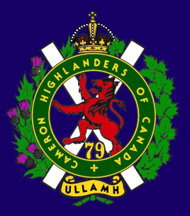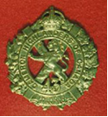
THE CAMERON ASSOCIATION IN CANADA
THE QUEEN’S OWN CAMERON HIGHLANDERS OF CANADA
MINTO ARMOURY, 969 ST. MATTHEWS AVE WPG, MB R3G 0J7
2015/2015 ASSOCIATION OFFICERS
PRESIDENT | Steve MacMillan | 351 Ainslie St  Wpg, MB R3J 2Z7 | sdmacmillan@shaw.ca | 204-831-0542
VICE-PRES | Marc Gautron |  |  | 204-296-7656
SECRETARY | Hugh O’Donnell | 713 Cambridge St Wpg, MB R3M 3G2 | hodonnell@shaw.ca | 204-285-7222
TREASURER | Dave Gibson | 104 William Gibson Bay Wpg, MB R3C 5L7 | dwgibson@mymts.net | 204-222-9509
2015/16 aSSOCIATION Executive Board
Past Pres | Taffy Gray | 198 Seekings St Headingly, MB R4J 1B1 |  | 204-889-5655
Director | Mike Nickerson | P.O.Box 122 Station L Wpg MB R3H0Z4 |  | TBC
Director | Karen Tyler | 255 Aldine St  Wpg, MB R3J 2A9 |  | 204-414-0973
Director | Sean Rivas | 164 Carroll Road  Wpg, MB R3K 1H5 |  | 204-802-2264
Director | Len Johnson | 1094 Bay Rd  St. Andrews, MB R1A 3L1 |  | 204-757-2023
Director | Tom Russell | 605 River Ave  Wpg, MB |  | 204-488-0088
Foundation Trustees |  | Blair Will  (2015-2017) | Fred Westphal  (2014-2016)

* Last Post *
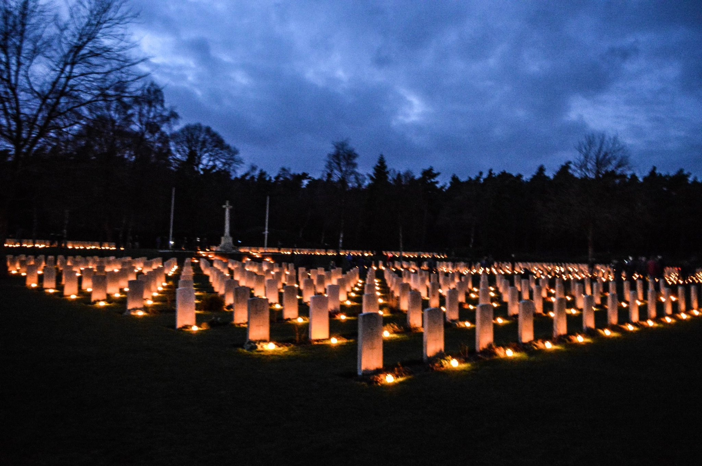
HOLTEN CWWG Cemetery Dec 2015, Netherlands.
JAMES JEFFRIES
Jim Jeffries full obituary
JAMES PATRICK JEFFRIES 1940 -2015 In loving memory of James Patrick Jeffries (Jim), beloved husband, father, brother, uncle and friend, who died on October 14, 2015, surrounded by his loved ones. He is remembered and greatly missed by his wife, Margaret; his daughter Fiona (Karen); his sister, Lynda; and by his nephew Sean and many more.
Jim grew up in St. Boniface and lived most of his life in Winnipeg. He lived a life of service to God and his community. He was a counsellor, teacher and principal in Youth Corrections for 26 years. He served his church community as a lay minister, chorister, and member of vestry for many years. He welcomed friends into his life as family, and maintained lifelong connections with many of them. Jim's military career began at age 12 when he joined the Winnipeg Grenadiers Cadet Corps. As an adult he joined the Army Reserves, serving with the Fort Garry Horse, Royal Winnipeg Rifles, and the 26th Field Regiment (Artillery). He rose to the rank of Colonel, commanding the Manitoba Lakehead District.
In retirement he continued to serve the military and the wider community through numerous boards and committees. His service was recognized most recently when he was made Commander of the Order of St. John of Jerusalem. Thanks to Dr. Aaron Mellon, everyone at CancerCare Manitoba, and to the nurses and doctors who cared for Jim at the Victoria General Hospital. In lieu of flowers, donations may be made in Jim's name to a charity of your choice.
A celebration of Jim's life was held at 11:00 a.m. on Wednesday, October 21, 2015, at St. Andrew's Anglican Church, 2700 Portage Avenue, Winnipeg. NEIL BARDAL FUNERAL CENTRE 204-949-2200 nbardalinc.com
Publish Date: Oct 20, 2015
Full obit published in the Winnipeg Free Press on October 20, 2015
Rosco Long
Rosco Eurett Long (Dec 11 1921 - Oct 02, 2015) was born on December 11, 1921 in Nokomis, Saskatchewan. He was the fourth child born to Bessie and Jasper Long. He had four brothers, Louis, Lloyd, Vic and Reigh and one sister, Fern.
The family moved north to the Lewis Lake area in 1928 to farm. Life was not easy on the farm, there were many jobs to do with no modern conveniences. During the depression, feeding six children proved to be challenging but Rosco always said they never went hungry but also you didn't waste anytime getting to the dinner table when mother called " supper".
He enlisted in the Army in November of 1942. He was shipped out on the Queen Mary from Halifax to Grennick, Scotland in August 1943. It was then that he was assigned to the Queens Own Cameron Highlanders. He was on the frontline for much of the war and took part in the liberation of Holland in 1945. Speaking of liberation, he tells a story in his book about "liberating" a tasty rooster from an unhappy French farmer. I quote "we liberated you and now I have liberated your rooster!"
Rosco met Doris while she was teaching at Lewis Lake School in 1946. They were married on October 9, 1950. Wendy was born in December of 1951, Diane in June of 1954, and Susan in February of 1965. He had several jobs throughout his working career. His first job was as a farm hand for their neighbors the Harry Thompson family. He worked in the mine in Flin Flon before getting married. He took over as postmaster in Lac Vert from his ailing brother, Louis, in November 1957. He held that position until he retired in 1981. He also continued to farm his own land and later worked for Lloyd Lyons during those years, so unofficially Doris was the postmistress!
There was never any doubt about where Rosco stood on the issue at hand. He was able to use a phrase or a tone in his voice that would get to the heart of the matter in a way only he could. He was famous or infamous for his many quotes & sayings. Very few can be repeated in this venue, but you might have heard him say "Busier than a one-legged man in an *ss-kicking contest" or "he was so ornery he could start a fight in an empty dance hall". But under that hard shell you found a kind heart. There were many acts of kindness both large and small for neighbours and friends that were done without fanfare and with no thought of repayment or recognition .
His community involvement was admirable. As the unofficial " mayor" of Lac Vert he helped out wherever help was needed. He was also involved with the church, the Legion, the Masons and Eastern Star. Unlike many of us who have recently jumped on the Toronto Blue Jays bandwagon, Rosco faithfully watched the team through the thick & thin years. They had better do well in the post season now, as he is probably watching!
His girls grew up thinking that it was common for Prairie people to enjoy fresh oysters. True to his mother & father's Nova Scotia roots, he had a love for sea food & regularly had several gallons of the delicacy shipped in by train. They also heard many a time about "Digby Chicks", but don't get the wrong idea, they were apparently dried, salted herring that substituted for chicken when supplies were scarce.
Rosco was an avid hunter and fisherman. Moose roasts, homemade deer sausage and fresh walleye were often on the menu. He even used his prized racks of horns to help Doris decorate the living room! Hunting trips were planned well in advance with the precision of a NASA space launch. He was into his 80's, when he learned how to use the computer to apply for moose licenses online- motivation works in mysterious ways! Oh, if one had a dime for every time he told the story of waiting 16 years to be drawn in one particular zone...no bitterness there of course!
He was tremendously proud of his children and grandchildren. He would share accomplishments with whoever would listen. He wasn't really into traveling for leisure but he'd have gone to the moon to see one of the boys play hockey or to be present for an awards or graduation ceremony.
Though Rosco had many accomplishments, his garden was probably what most of us will remember him for. Plants were aligned in perfectly straight rows. He always planted too much. Everything flourished in his garden but the potato was the king. At its peak, the annual hills planted exceeded 2300! Planting potatoes was a precise science with Rosco. Rows had to have 100 plants. Different varieties had to be stored in separate bins. Many a son in law (Ray) or grandsons in law (Colin & Brett) quavered in their boots after unintentionally breaking the rules! Timing for harvesting them in the fall was always a problem when your work crew only had the September long weekend to come out and help! He'd pick the potato bugs off the plants by hand and drop them in a small container of gasoline, taking great satisfaction in their untimely deaths.
The garden kept him young and as he aged he was fortunate to have great friends, family and neighbours to help him out with the bigger jobs. His family will miss this simple yet profound ritual of his garden. It was one of the few special ways they all connected. But I know where you'll find him. He'll be in every garden we grow. And if you just close your eyes and feel the breeze on your face, you'll be able to see him standing amongst the potatoes , head down , hoe in hand , hilling his precious plants. His family are thankful for the blessing of his 93 years and will take comfort in the many memories he left behind.
In summary, he was a good man, who lived a good life.
Eulogy courtesy of Mrs. Wendy Needham (nee Long), no known published obit.
Widow’s / Widower’s Supplement: There is income supplement for widows / widowers. They will mail out a form for the survivor to complete. You will need proof of marriage and the soldier’s regimental number etc. and the spouse’s income tax forms. If the financial situation is going badly the survivor should contact Veterans Affairs.
http://www.veterans.gc.ca/eng/services/financial/cf-income-support

* Sick & Visiting *
Gord Coutts (Korea, Militia) - Gord has been mostly shut in for quite a while now and plans stay that way for a while yet. Hugh called him on 14 Oct 2015 to say hi. Gord says hi to all and visitors are welcome. Hugh also popped in to visit a few weeks later and plans to drop by a bit more frequently now that he’s gotten to know St. Norbert a bit better.
Tim Gillespie (Army Reserve) – Tim’s doing much better now that he’s recovering from a bad shock on Boxing Day. He has some advice for those who need to use a CPAP machine – wear the damn thing or be prepared to wake up in the Next World !
Vi Miller (Russ’s widow) – No recent update.
Archie Moore (Korea, Post SWW Cameron) – Archie is now a resident at Riverwood Square in Room #8. He enjoys company and always has a quick joke for visitors.
Piper Bill MacKay (SWW) – Ken Smith still pops in to see Bill at Derby Center and tells me that Bill is doing OK. Bill still has his Dad’s pipes from the First War too. Quite a memento of that war, to say nothing of Bill’s own time as a Piper in the Second War on Nov 11th. Stay well Piper Bill !
Tom Munro (Borneo with the Imperials, Militia) – Hugh visited with Tom in late Oct 2015. Tom is at home these days and has rather limited mobility. He was quite happy with the visit and says hi to all.
Bill Naven (SWW, Post War) Bill made it out to represent the Camerons along with Association Secretary Hugh O’Donnell and his son William at the Remembrance Day service at Our Lady of Victory Church on 08 Nov 2015. Bill’s medal rack just got a bit heavier this December. Read more about it in the French Legion of Honour Update below.
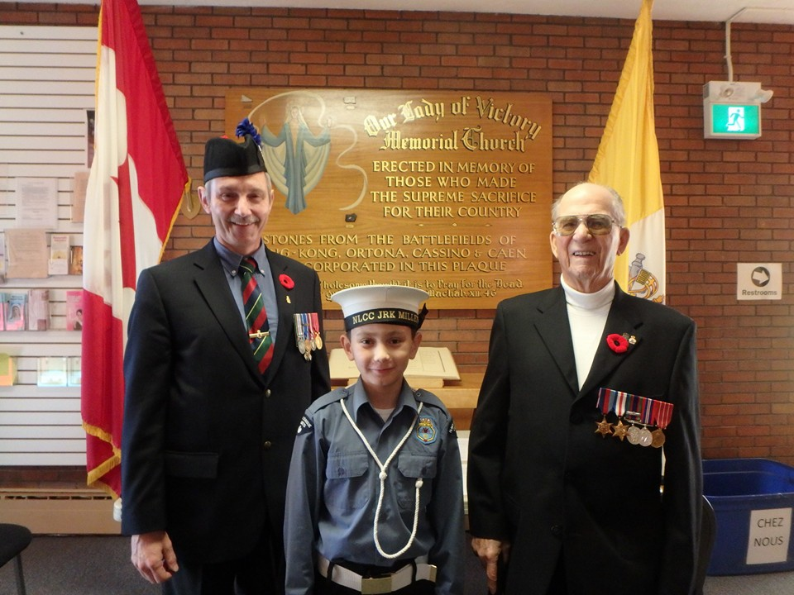
Mo Schultz (Drew’s Militia - 1990’s) – Hugh spoke to Mo in early Oct 2015. Mo is back on the go now. He can be contacted at 587-281-2840. Mo is looking at leaving AB now that the oil patch is doing nothing and there are lineups for jobs at Wal Mart.
Ken Smith (SWW) Hugh O’Donnell spoke to Ken on a number of occasions recently and is very happy to report that Ken is well and active. Ken is still getting around and showing the flag. Keep up the good work Ken !
Roy Taylor (SWW RAF, Post SWW Cameron) – Hugh called 14 Oct 2015 to say hi. Louise and Roy are doing OK, but of course Roy gets tired very easily. As Louise put it “We’re still here and we’re still smiling !”
PTSD Help Line: The toll-free number 1-855-373-8387 will be manned by veterans who will be available on a 24-hour basis. The callers will not be required to identify themselves. See also the Cameron “Links” section of the web page: Cameron web site "Links" section
* President's Message *
Hello to all,
I would like to take this opportunity to tell you about the updates to the memorial project the Association has been working on. We have permission to place it in Vimy Ridge Park at Portage Ave & Broadway Ave in Wpg. It will initially be sited near the 1st Presbyterian Kirk side, but the park is being renovated and the military monuments are going to be grouped together. Our bench will be sited with the other monuments at the end of this renovation.
This bench is currently due be dedicated in the Spring of 2016, on 31 May. This date will also be the Unit Stand Down day for Summer training so hopefully there’ll be a few of the lads left in town to parade with us.
I want to thank all of you who have donated your money towards this project; your generosity is most appreciated.
I will keep you posted.
* Vice-President's Message *
Editor’s Note: Nil at this time from our new VP, Mr. Marc Gautron. This is hardly a surprise as Marc has volunteered his time with the Army Cadets and a few other organizations. He has a lot on his plate right now and it is good of him to stand for office and attend the meetings of the Association as best he can.
* Reconnect with Former Camerons *
This is an important thing to do for the health of the Association. There are still lots of former Camerons out there that we don’t know about for various reasons. Just because you or they weren’t Second World War or Korea veterans doesn’t make them any less important to the Cameron Association. Please help us locate them and bring them back into the fold. The ranks of the SWW guys are almost non-existent now and the torch must pass to the following generations of Camerons that we may continue to serve our fellow Camerons.
We only have about 62 paid up members at this time. Thanks very much to those fine souls who have donated some of their hard earned dollars to keep hard copies of this newsletter going out to the guys without computers. Many are Second War men but some younger former Camerons live in areas with poor internet service or dial up, or are just plain happy to be off of the grid.
* Where Are They Now ? *
Bill Douglas is in his normal digs in Osborne Village and doing well. HO’D & son visited Bill 31 Oct 2015. The home is very quiet and not much to do Bill tells us. Bill appreciated the visit and more are welcome.
Dave Gibson just received his 40 year membership pin from his home branch of the Royal Canadian Legion, #7 out in the wilds of Transcona. According to Steve MacMillan this makes Dave very old indeed ! Congrats Dave and never mind Steve, he's just jealous.
Adam Petrin was promoted to Major with the Patricias just around Christmas time of Dec 2015. For those of you who have never had the pleasure, Adam was the eternal 1 Platoon Commander in our “A” Coy. Congrats from those of us from the old “A” Coy days Adam !

* 2015-16 Dues ($10) Still Payable until Aug 2016 *
As of any old time you can connect with Association Treasurer David Gibson (per the cover page of the Oatmeal Rag) who will take your payment. If you are not sure of your status please contact Dave and he’ll either be happy to take your $10.00 payment or be most unhappy that he doesn’t get to take any money from you - yet - this year.
A quick reminder that donations over $25 to Association done through the Cameron Foundation will be given a tax receipt ! This includes donations towards our project to commemorate the 100th Anniversary of the start of the Great War. Just mark your cheque as a donation towards the 100th Anniversary Bench Project and these fine gentlemen at the foundation will credit it appropriately.
* Cameron Association Activities *
100th Anniversary of the start of The Great War Bench Project - See the President’s Message from Steve MacMillan for the current state of play. You can still send your cheque to the Cameron Foundation at the address listed below. All donations are very welcome, believe me ! Donations for more than $25 will receive a charitable donation receipt.
Editor’s Note: These tax receipts come out fairly quickly too, or at least mine did. Thanks Julian !
The Queen’s Own Cameron Highlanders of Canada Regimental Foundation
Minto Armoury, 969 St. Matthews Avenue
Wpg, MB R3G 0J7
After a long hiatus the Cameron Association was finally able to send a $250 contribution to the MB Highland Dance crew that host the Mid-Canada Competition Cameron trophy. MB Highland Dance was very happy to receive the cheque for $250, especially because they can spend it as they see fit. This is only fair as for many years they have provided medallions to the Cameron Association Trophy competitors using someone else's money. Thanks to all who have paid their dues and made other donations to the Association so that we can help keep the old traditions alive.
From Xavier Allen Date: : Date: 12/28/2015
Good Evening Friends,
I will be renewing my dues this week, and looking forward to continuing Regimental support.
My band, Cabar Feidh, placed first in 2014 and third this year at Detroit's Highland Games, and was told we have enough points to compete in The World's in Scotland.
If there are any Regimental Family traveling in my neighbourhood (Detroit-Toledo-Chicago) and are in need of assistance, please let me know.
Xavier
734-731-7310
From ALISTER MORE Date: Wed, 23 Sep 2015
Hi All,
Thought that I would let you know that I attended the 75th Anniversary Memorial Service at Veurne last Sunday and was honoured to perform the eulogy.
Which I did and hope that I can get copies of the photo's from Jose to you soon. I also have a set of poppies Canada style and a few other bits to send to you, but I'll wait and make it a package as I thought that the Association would like to know.
Yours aye,
Alister
Editor’s note: “Dinty” More has been a friend of the regiment for quite a few years now. He makes a point of helping out with the Liberation of Veurne (aka Furnes) ceremony every year and laying a wreath or otherwise commemorating our Fallen Comrades along with those of the other Canadian, British, Polish, Dutch, and Belgian formations that liberated Europe in 1944-45.
The French Legion of Honour Medal Update
Some of you may recall that the French government had closed nominations for this award sometime prior to March of 2015. Well, they gave it a second thought and extended the deadline one last time !
In due course, several deserving and alive (a condition of the award is that you must be alive to receive it !) were so nominated by the Association. Sadly, I am sure that we missed some people but we did the best that we could with the information that we had.
Well the French certainly have had some tough sledding of their own for the past few months between terrorist attacks on their home soil and so on, but they have keep grinding away at this list, and they have been in touch.
The letters received by the Association so far from the Ambassador of France to Canada have confirmed that Floyd Bowman, John Johnson, Rosco Long, William (Bill) Mackay, and (William) Bill Naven “By order of the President of the Republic of France” been awarded the rank of Knight of the French National Order of the Legion of Honour.
The Association had a good turn out at the Christmas Dinner again this year with several of the old guys who had earned a bit of rank helping to serve the junior members of the regiment. A good time was had by all, especially those who missed the long speeches prior to the dinner.
;-)
* Regimental Web Sites *
The Unit web site is still up running. The links have recently had a much needed going over (April 2015) and most should now function properly. The unit web site continues to be a point of contact between ourselves, the families of those who served in the Camerons, and those who become interested in the Camerons for one reason or another. We continue to have a few requests through the unit web site for information from families about former Camerons. If anybody can help out with them please feel free to do so. You can find the web site at:
http://thequeensowncameronhighlandersofcanada.net/
Our Picasaweb site is also worth a look and is full of little details about our history. The Secretary will be updating the site with more pictures shortly. You can take a bit of a virtual tour of the Cameron Memorial Chapel and see some of the artifacts held by the Cameron Museum:
http://picasaweb.google.com/camsofc
The Cameron Highlanders of Canada Memorial Site, Recording the History of the Regiment, 1914-1919, web site is one that every Cameron should have a look at once during the 100th Anniversary of the Great War. The creator of this site, Mr. J. Stuart McLean has done a great job of helping out the Cameron regimental family. Thanks for sharing your hard work sir !
http://www.cameronhighlanderscanada.com
Wilfred Laurier University has a page devoted to the Canadian War Diaries of the Normandy Campaign. While not a complete collection (The Fort Garry Horse are missing as are many of the supporting arms and services War Diaries), ours and the rest of the 6th Brigade look to be complete.
http://lmharchive.ca/canadian-divisions-of-the-normandy-campaign/2nd-canadian-infantry-division/

* Unit Events *
Pipes & Drums Update: CO’s COMMENDATION presented to P/M WO Dawson at the Christmas Dinner - While maintaining a busy professional and family life he continues to guide the Pipes and Drums very professionally as Pipe Major.
He has been instrumental in recruiting high level candidates this past year such as a new Pipe Sergeant, Dan Locke, and Lead Drummer, Kurt Hunter.
WO Dawson as well has organized activities that promote the Camerons and also serves to develop junior members and act as motivational activities such as in August, 2015 several members travelled to Ontario to augment the Cameron Highlanders of Ottawa at the North American Pipe Band Championships, where the band took the Best Pipe Section award in Grade 4.
In the coming year, the band intends to support all local competitions and will be travelling to the Saskatchewan Highland Gathering. The band is also in the preliminary planning stages of a trip to the World Pipe Band Championships in 2017. This will be part of a larger tour through France and potentially Belgium and Holland to help commemorate the 75th anniversary of the Dieppe Raid. Early preparations are also underway to participate in the upcoming Canada 150 celebrations along with other regimental bands from across Canada.
“A” Company Update: The Company has been busy of late with preparations to go to the field and practice defensive operations. This has already involved a Computer Assisted Exercise using the VBS and JCATS systems to simulate the battle procedure behind the occupation of (and so on) a defensive position. The SK guys will be up next for this training and LCol Tony Engelberts, N Sask R, was on hand to see how things went with our lads.
Battalion: The CO has told us that the Bn will be conducting a CAX shortly. That is a Computer Assisted Exercise for those who left before such things came into common use. The next few years will feature the defence for those who recall the offence/defence cycle. The big Brigade Ex for the Camerons this year will be held in mid to late August of 2016 which may interfere with some of the usual crowd attending the Cameron Reunion. Hopefully the senior Cameron present will lead some sort of commemoration of the occasion, however Spartan the circumstances. Last but far from least the Annual Christmas Dinner presentations were made. Here are the brief write ups from Capt Stan Warsza’s speaking notes:
Russ Miller Cameron of the Year Award presented to Lt Reive Deamel - Lt RD has been a solid leader for the Cams and the WITG, volunteering his time to run a platoon as well as Course Officer several infantry – centric courses through the battle school. Lt RD led the 38CBG team through the Nijmegen march. Everywhere he goes he displays energy and a can do attitude that inspires those around him.
Cameron Top Senior NCO (George Harris Memorial Award) presented to Sgt Bernier - Sgt Bernier works as a class B in WITG as a release clerk. On top of this, he volunteers his time with unit exercises and training events. He is an excellent Sr NCO in his dress, deportment and professional conduct. He is instrumental in instill unit traditions in the men. Sgt Bernier was a member of the 38CBG team at the Nijmegen march.
Ed’s Note: He and his lady have also recently welcomed a new child into their family. Now that’s a hardworking man for you !
Top Cpl of the Year presented to Cpl Cayen - Cpl Cayen acted as a 2i/c for a tour at the national sentry program in Ottawa, and his professionalism and drill standard was excellent. At the unit he works Class A/B with the ARCG and attends the majority of unit training. At the Arctic Bison exercise, he was rolled into a section from the CQ with no notice and performed well. Cpl Cayen has the confidence of his superiors in 1 PL.
Ed’s Note: The ARCG is the Arctic Response Company Group which deploys way up north for most of its exercises. Often it has been deployed for a week or so up near Churchill, MB.
Soldier of the Year presented to Cpl Daulby - Cpl Daulby is an effective and reliable soldier in A Coy. He recently returned from a posting with 2VP on Ex Kapyong Matrix, where he did very well. Cpl Daulby maintains exemplary attendance at all unit training and extra regimental events.
That's all for now. Ullamh!
* Regimental Advisory Board Notes *
The Advisory Board continues to provide sound advice to the CO on all matters Cameron in “interesting times”. Good thing too with all of the stuff in the news these days ! This august body continues to try to support all ranks in their various endeavours. The latest topics have been the Association’s plans to commemorate all of the Camerons who have served, the Cadets Vimy Ridge pilgrimage, the Officer’s Mess amenities, and the WO’s and Sgt’s Burn’s Supper plans. In addition to all that they’re busy trying to find a way to help out the JR’s too.
* Regimental Foundation 2014-5 Notes *
Editor’s Note: I am a bit remiss in not reporting this earlier – my apologies to all.
The QOCH of C Cadets benefitted greatly from the Foundation in terms of new kit purchased and financial support to their 100th Anniversary dinner. ($12,500+)
MCpl (now Sgt) J. Bernier received a cash award to honour his having been named the Cameron of the Year. While not a considerable amount, it would still be enough to buy a Burn’s Supper ticket or two, and probably cover his drinks for the night too.
Thanks to a contribution from Mr. B. Graham the Foundation provided six 420.00 prizes to students at Dieppe School in the memory of one of our best known pipers, P/M Alex Graham of Dieppe raid fame.
The Foundation also provided some fiscal support to the JR’s run Cameron Highland Games as well as to the Unit Family day at Minto Armouries.
These are just some of the most notable items that the Foundation has been up to.
More recently the Foundation has been the repository for funds sent to support the Association newsletter (yes, this one !) and funds designated for the purchase of the Memorial Bench.
Thank you to all of you who have donated to the Foundation over the years, it has been well spent and very much appreciated !
* Cameron Cadet Events *
The Cadets will be busy this year. In addition to whatever else they plan, they are still planning to send some cadets on a pilgrimage to Vimy Ridge of the famed Easter 1917 battle. The intent is that Canadian cadets are on hand for the 100th Anniversary of the battle. Hopefully Lt. B. Will and Capt. K. Walker can keep that concept on track. Vimy is a “must see” kind of place for Canadians in Europe !
Please visit their new official web page and you will see how to sign up for REMIND. This will be a communications tool the Corps uses to notify all concerned of activities, notices, quick information etc.... sign up at: http://www.407army.ca/
* Regimental Reinforcements *
Justin Bernier and his lady, Diamond, have welcomed their newest family member Draven Bernier into the world on the 20th of Dec 2015. Congrats guys !
* OTHER Regimental NOTEs *
Rounds Completed:
Remembrance Day 2015: The Camerons presented the usual dignified spectacle of a good highland regiment on parade at Minto. I’m told by some of our former soldiers that it was a wonderful thing to see the younger guys in good form keeping up the high standards of dress, deportment, and staying in step on the march unlike some of the other regiments in the garrison.
Christmas Dinner 2015: There was a good turn out of the Association to join the troops for the Christmas Dinner and the usual forms were observed. The speeches and awards started at 1800 and dinner started at 1900. Some very impressive accomplishments were recognized by the CO and the unit with appropriate awards, which you saw listed above.
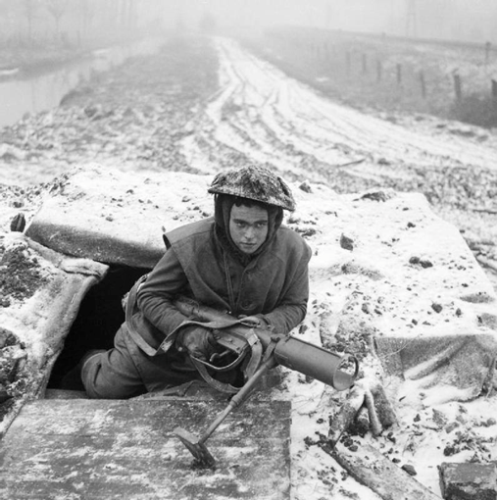
Sgt-Maj, anyone save me a scoop of mashed potatoes and gravy ? A mug of hot anything ?
Incoming Rounds:
2016 SATURDAY, 23 JANUARY The Cameron WO’s & Sgt’s Robbie Burn’s Supper
What: One of the finest Robbie Burn’s Suppers in Winnipeg.
Grid: The Fort Garry Hotel
Time: 1830 for 1910 hrs
Cost: $85 per ticket, see a member of the Cameron WO’s & Sgt’s Club for tickets. The secretary of the Association will be happy to help you to contact the members.
Dress: Mess kit, dark business suit, suitable attire for evening wear.
2016 SUNDAY, 07 february Cameron kirk parade
What: The usual Cameron Kirk Parade
Time: 1000 hrs for 1015 hrs at the Kirk.
Grid: 1st Presbyterian Kirk, 61 Picardy Place, Winnipeg, Manitoba
1st Presbyterian web page
Cost: Tuppence for the plate. Inflation you know.
Special Instructions: Please let the Association secretary know if you plan to attend. If we have more than 10 members I’ll need to let the Clerk of Session staff know for planning purposes.
Stuff for the Lassies for next year’s Robbie Burns: Jamberry Nails from Mrs. Erika Smith - WO (Ret’d) Steve Smith’s wife for those who aren’t quite sure of which Smith I mean. She’s got this line of Jamberry product for the girl who wants to be Cameron to the tip of her toes...
Cameron Junior Ranks Club Activities - Siloam Mission and Christmas Cheer Board
On the night of 26 November 2015, members of the Cameron Junior Ranks Club rendezvoused at the Siloam Mission to lend a helping hand. This was not their first volunteer effort, nor will it be their last.
The Cameron Junior Ranks Club comprises current and former members of the Queen’s Own Cameron Highlanders of Canada. The Cameron JR Club provides its members with organization to hold charitable and social events outside of Reserve military life. Members have organized volunteer efforts at Siloam Mission, the Christmas Cheer Board and helping out a fellow member in times of need. Social events include the annual Cameron Highland games, supporting participation at the annual Robert Burns dinner and participating in local competitions like Mud Hero and the Manitoba Marathon.
The Cameron JR Club was happy to help the good people at Siloam Mission. In operation since 1987, Siloam Mission has provided meals, clothing, and hope services to Winnipeg’s poor and homeless community. In 2005, Siloam moved from Main St into the newly renovated four-story facility at 300 Princess St, continuing the meal and clothing program. In 2006, Siloam started its employment training programs to help people re-enter the workforce, which includes offering clean clothes for interviews and on the job. The Cameron Junior Ranks Club has made previous trips to the 300 Princess St location to lend their support.
On 26 November 2015, the Cameron JR Club gathered at the Siloam Mission to volunteer in their clothes-sorting department. The Siloam Mission works with other local charities and collects clothing to distribute to those people who require clean clothing for work and/or basic comfort that many take for granted. The Cameron JR Club sorted clothes all night: some for distribution at Siloam Mission, some clothing was discarded, while other clothing will be sold to other organizations. Clothing ill-suited for the demand at Siloam Mission is sold to raise much needed operation funds. Warm clothing is always in high demand for distribution to the less fortunate, and the Cameron JR Club were happy to sort out those much-needed jackets.
Members of the Cameron JR Club are expected to participate in one volunteer event a year, and the members also raise funds to hold social and charitable events. Extra funds go to the purchase of clothing and memorabilia for the members. The Cameron JR Club understand that volunteering to wear a uniform is only one way to serve their country. Charitable efforts, like volunteering at Siloam Mission, help improve the local community around them.
On the night of 11 December 2015, members of the Cameron Junior Ranks Club participated in the annual Cameron Carolling with a night of hamper deliveries for Christmas Cheer Board. This is a continuation of the Cameron Highlanders commitment to service in and out of uniform.
The Christmas Cheer Board is one of Winnipeg’s oldest charitable organizations and the Cameron JR Club is happy to lend a helping hand each year. Established by a group of Winnipeg churches in 1919, the Christmas Cheer Board’s original intent was to provide Christmas hampers and toys for the widows and orphans of the soldiers lost during the First World War. The churches operated as a loose group for many years and quickly realized that many other families in the community also needed care at Christmas. As the project grew, it became necessary for the churches to work with each other to coordinate Christmas giving in the community. In the mid-1940s, the churches decided to create one organization, the Christmas Cheer Board, to organize and distribute Christmas hampers to needy families in Manitoba.
The Queen’s Own Cameron Highlanders of Canada have lent their support to the Christmas Cheer Board for over 15 years, and in the past with Milcots to deliver hampers. In the last few years, the Cameron JR Club has taken up the effort to support the delivery of hampers in the Christmas season. Cheer Board volunteers build over 20,000 hampers each year. Each hamper includes a box or two of food, toys and each house receives a turkey or a chicken for a nice Christmas Day meal. The Cheer Board is able to build hampers through the tireless efforts of their volunteers and through collecting donations and fundraising; however they lack a fleet of vehicles and drivers to deliver hampers. That is where the Cameron JR Club excels.
Seventeen members of the Cameron JR Club volunteered their time and vehicles to the Christmas Cheer Board this year. The Cameron JR Club delivered over 30 hampers to families in Winnipeg’s West End. Christmas Cheer Board hamper deliver brought Winnipeggers together for almost one hundred years. As members of the Cameron JR Club prepared for winter stand-down, they recommitted that service means more than Tuesday night drill practice.
The Cameron Junior Ranks Club has a simple motto: If you want to wear the Canadian flag on your shoulder, be Canadian in your actions; or “Wear the flag, be Canadian.” Cpl Jon Avey, who lives in the West End, commented, “I’ve been in two other regiments, one Regular and one Reserve, and volunteer work that we do in the Cameron’s is what build strong regimental spirit and teamwork. Nights like tonight hold the guys together.”
* Links *
Here’s a link for those interested in the current operating environment. Or whatever else they’re calling it these days:
http://smallwarsjournal.com/
Around 1,000 sets of new generation Ratnik combat gear have been supplied to the Southern Military District in 2015, Andrei Gurulyov, 58th Army Commander, has told TASS. The Ratnik is a project of Future Soldier system for the Russian army.
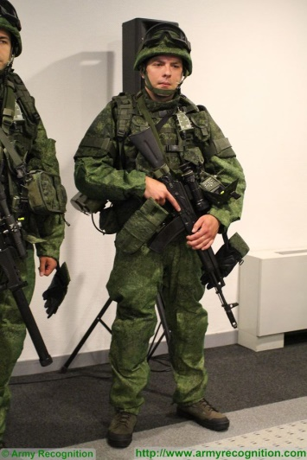
http://www.armyrecognition.com/december_2015_global_defense_security_news_uk/southern_military_district_of_russian_army_will_receive_1000_sets_of_ratnik_combat_gear_tass_13112152.html
Do you know your AFV's of the World ?
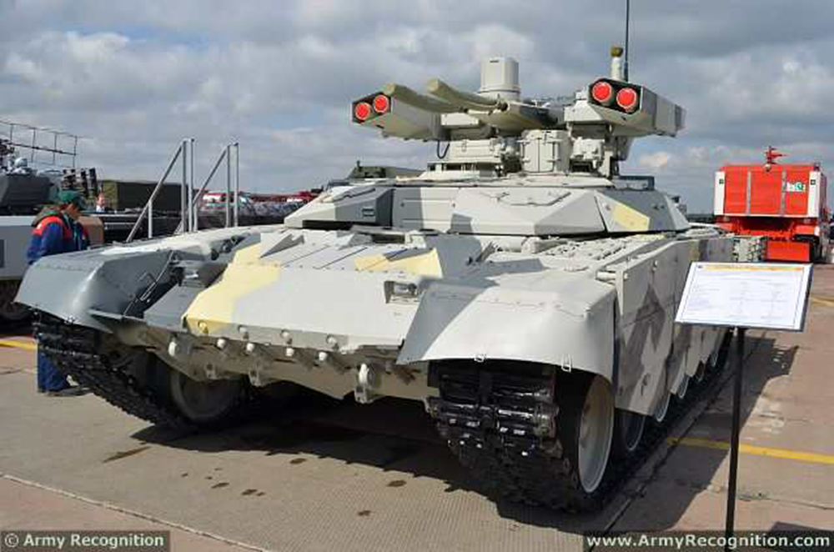
http://www.armyrecognition.com/russia_russian_army_light_armoured_vehicle_uk/bmpt-72_terminator_2_tank_support_armoured_fighting_vehicle_technical_data_sheet_specifications.html

World War 2: US-Canadian 1st Special Service Force (The Devil's Brigade)
Training &Combat Footage

https://www.youtube.com/watch?v=UacaNYLKLzE

* Historical Notes *
Cameron Pewter Art
A Facebook contact of Hugh O’Donnell’s named Will Martindale does some work in pewter. This may be of interest to any Cameron not in possession of a forge and some degree of talent but is interested in buying such works. Mr. Martindale’s interest in things of a Cameron bent ?
“My Father was with the QOCH of C. Him and a bunch of his friends were given an invitation to visit Germany by Hitler. Here is a pic of my rendition of him in pewter.”

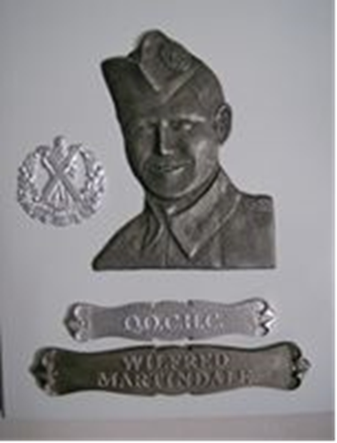

* More Links *
Canadian War Diaries Of The Normandy Campaign
http://lmharchive.ca/canadian-divisions-of-the-normandy-campaign/
2nd Canadian Infantry Division (that’d be us Camerons in 6 Bde)
http://lmharchive.ca/canadian-divisions-of-the-normandy-campaign/2nd-canadian-infantry-division/
For all of those of you who want to know what the Unit was up to in Normandy according to the War Diary – well, here it is.

* “It wouldn’t be an Oatmeal Rag w/o a Wee Joke” (Russ Miller) *
What to do with vodka
1. To remove a bandage painlessly, saturate the bandage with vodka. The solvent dissolves the adhesive.
2. To clean the caulking around bathtubs and showers, fill a trigger-spray bottle with vodka, spray the caulking, let set five minutes and wash clean. The alcohol in the vodka kills mold and mildew.
3. To clean your eyeglasses, simply wipe the lenses with a soft, clean cloth dampened with vodka. The alcohol in the vodka cleans the glass and kills germs.
4. Prolong the life of razors by filling a cup with vodka and letting your safety razor blade soak in the alcohol after shaving. The vodka disinfects the blade and prevents rusting.
5. Spray vodka on vomit stains, scrub with a brush, then blot dry.
6. Using a cotton ball, apply vodka to your face as an astringent to cleanse the skin and tighten pores.
7. Add a jigger of vodka to a 12-ounce bottle of shampoo. The alcohol cleanses the scalp, removes toxins from hair, and stimulates the growth of healthy hair.
8. Fill a sixteen-ounce trigger-spray bottle with vodka and spray bees or wasps to kill them.
9. Pour one-half cup vodka and one-half cup water in a Ziplock freezer bag, and freeze for a slushy, refreezable ice pack for aches, pain, or black eyes.
10. Fill a clean, used mayonnaise jar with freshly packed lavender flowers, fill the jar with vodka, seal the lid tightly and set in the sun for three days. Strain liquid through a coffee
filter, then apply the tincture to aches and pains.
11. Make your own mouthwash by mixing nine tablespoons powered cinnamon with one cup vodka. Seal in an airtight container for two weeks. Strain through a coffee filter. Mix with warm water and rinse your mouth. Don't swallow.
12. Using a q-tip, apply vodka to a cold sore to help it dry out.
13. If a blister opens, pour vodka over the raw skin as a local anesthetic that also disinfects the exposed dermis.
14. To treat dandruff, mix one cup vodka with two teaspoons crushed rosemary, let sit for two days, strain through a coffee filter and massage into your scalp and let dry.
15. To treat an earache put a few drops of vodka in your ear. Let set for a few minutes. Then drain. The vodka will kill the bacteria that is causing pain in your ear.
16.. To relieve a fever, use a washcloth to rub vodka on your chest and back as a liniment.
17. To cure foot odor, wash your feet with vodka.
18. Vodka will disinfect and alleviate a jellyfish sting.
19. To remove cigarette smoke in your home or office mix one part vodka and three parts water and spray the clothing, then launder and let dry.
20. Pour vodka over an area affected with poison ivy to remove the urushiol oil from your skin.
21. Swish a shot of vodka over an aching tooth. Allow your gums to absorb some of the alcohol to numb the pain.
If anybody has ever actually tried any of these methods please let the editor know if they work. Especially number 20 about poison ivy !

Verification of Former Service DS Solution: You can make a request under the Access to Information Act, which will provide you with proof of your service with the Camerons. Thanks very much to Sgt V. Sellars from Minto. Please click on the recently confirmed (May 03 2015) link:
http://www.tbs-sct.gc.ca/tbsf-fsct/350-58-eng.asp
We are always seeking sponsors or advertisers to help defray the cost of this publication. If anyone is interested or has any suggestions as to whom to contact please let us know and we'll be happy to do the follow up.
Sponsors to date are: Mr. Max Katz, our very first sponsor, of the Oatmeal Rag and the Jewish War Vets; Mr. Greg Flom, a former Cameron; Maj. Bill Gray, Cameron Advisory Board; Sgt Tim Seeley, Drum Sgt Extraordinaire; MCpl (Ret’d) Mark Silver, our “Eastern Branch” contact; Sgt (Ret’d) Roy Taylor, the Cameron WO’s & Sgt’s #1 choice for reading “Rab” Burn’s poetry; Maj. Ken Smith; Col. Bob Darling, President of the Cameron Advisory Board Mr. W L (Lloyd) Jones, SWW Cameron; P/M Donald Morrison; Major Ken Smith; Sgt. Bill Douglas.
Gentlemen, we thank you.
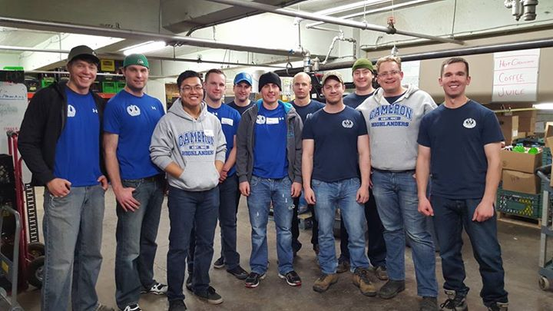
The Cameron Men helping out at the Siloam Mission Nov of 2015. Great job guys !
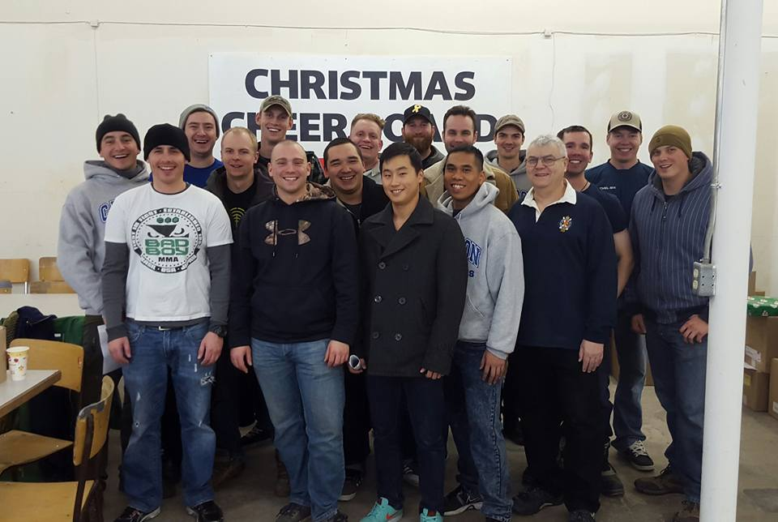
The Cameron Men helping out at the Christmas Cheer Board Dec 2015. Great job again guys !
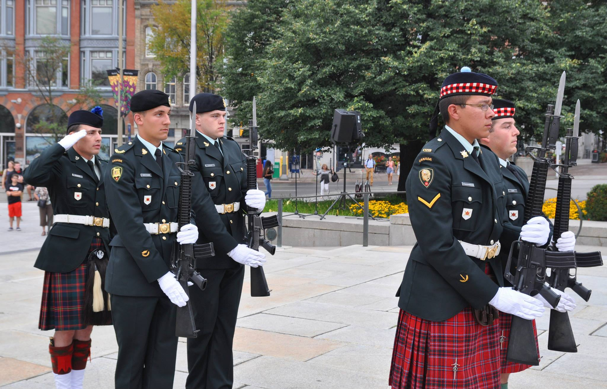
MCpl C. Brooker at the Cenotaph, National Sentry Program
Our Sponsors for this issue of The Oatmeal Rag are the members named above and as always our special thanks to The Commissionaires for their continued support !


