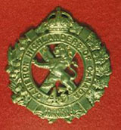 TheSgianDhu 
The Newsletter of The Queen’s Own Cameron Highlanders of Canada
Warrant Officers and Sergeants Club
Edited by CWO HJ O’Donnell #2 August 2008

Cameron Club Executive  2007-08  CWO Brian Boyd  RSM  AWAY  PMC  VPMC  Treasurer  Secretary  Sgt Dave Gibson  Housing | PMC’s Report:  Most serving members are deployed.

The Sgian Dhu

From the Editor’s Desk:  This is issue #2. I heard back from some of you and thank you for your support and suggestions.  The focus on this issue is mainly on what the Cameron Afghantsi are up to – such as I have from them. I have also thrown in some material about the role of the 43rd Bn CEF Camerons of Canada at the Battle of Amiens. This is the 90th Anniversary and it’s time we remembered those Camerons of long ago who advanced the position of Right Flank of the British Army. If the Right Flank is the position of Honour, we held the “Rightest position of the Right” on that fateful day that led to the end of the First World War.  As always any points, ideas, suggestions, etc come at the peril of the person making the suggestion being roped into the production of the next issue. I do remain open to suggestion.  I intend to send this out via email and print to former mbrs of the Regiment. My main target audience is the former mbrs of the Cameron WO’s & Sgt’s Club. My secondary audience is the other former mbrs of the Regiment, but this is subject to the approval of the still serving mbrs of the Club. Any thoughts or concerns on this point ?  Cheers for now,  CWO Hugh O’Donnell  Former RSM Camerons of Canada  Editor |  | Upcoming Events:  Known:  Cameron Association:  22-23 August 2008 Regimental Reunion  FGH Mess Dinner 29 Aug 08:  This one is for the appointment of CWO G. Crossley to the position of Brigade Sgt-Maj. If any Cameron WO’s, Sgt’s, or former Mbrs of the Club are interested in attending please contact me ASAP. There is room for you at the table !  Expected but dates TBC:  Return to Canada of Afghanistan TF pers  Useful Links  Reserve Force Pension Buyback Program  http://www.forces.gc.ca/hr/rfpb-rpfr/engraph/home_e.asp  Milnews  http://www.wednesday-night.com/mil.asp  Army News web site  www.army.gc.ca  The Maple Leaf newspaper (online)  www.forces.gc.ca/site/home_e.asp  Combat Camera (for images)  www.combatcamera.forces.gc.ca  Land Forces Western Area  www.army.forces.gc.ca/lfwa  38 Brigade  http://www.army.forces.gc.ca/38cbg_hq/
The Sgian Dhu

Pipes & Drums Pages

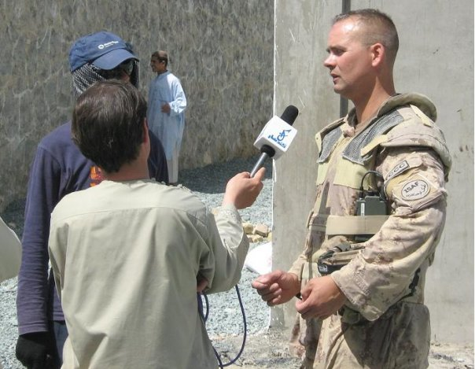
Boots on the Ground 6
Boots on the Ground 6
"Fighting Season"
Hello again to friends and neighbours. My work with the Kandahar
Provincial Reconstruction Team continues, mainly in the Panjwayi
district, with occasional forays into Zhari District north across the
Arghandab River. Both districts have been volatile since "fighting
season" started approximately two months ago. We knew that insurgent
(Taliban) activity would pick up when the poppy harvest wrapped up
around the middle of May; however the level of their activities this
year in Panjwayi and Zhari has been intense to say the least. Two
military acronyms that are in use daily are IED and TIC. Improvised
Explosive Devices (IEDs) have been used extensively by the insurgents
as a means of targeting our heavily armoured vehicles as we travel
around the country, and my team has encountered several in the last
several weeks. Luckily for us the worst injury thus far being a
broken leg – a testimony to the finest armoured vehicles in the

The Sgian Dhu
country. Troops In Contact (TIC) refers to good old fashioned gun
fights, as the insurgents engage us both our mounted (armoured
vehicle) and dismounted (on foot) patrols with small-arms fire and
rocket-propelled grenades. Our heavily armed patrols are usually no
match for the insurgents, so most of the time they utilize "shoot and
scoot" attacks, or fire a couple of rockets or mortars at our Forward
Operating Bases and then attempt to disappear into the countryside. I
have come to appreciate the value of some of our "force multipliers"
such as our highly accurate Canadian artillery batteries which can
drop rounds precisely from great distances. Our Leopard 2 tanks also
can provide accurate fire from a distance, and the insurgents rarely
hang around when the tanks roll up. Close Air Support from our
coalition allies, in the form of attack jets and helicopters, is
essential in providing ground troops with the assets necessary to deal
with many defensive positions available to the insurgents such as the
well-constructed grape huts made of thick brick and mud walls.
Another valuable asset provided by our coalition partners are the
Medevac helicopters which take the wounded Afghan and coalition
soldiers back to the Role 3 Hospital at Kandahar Air Field; these
extremely dedicated pilots and crews fly where few others would dare
to go.
Despite of the best efforts of the insurgents during fighting season,
we are making great strides towards our work in reconstruction and
development in Panjwayi. Many projects are underway, employing
hundreds of locals and increasing their quality of life through
infrastructure improvements such as roads, canals, wells, governance
structures, schools and medical facilities. The weekly District
Shura, which brings elders from all the far-flung villages to discuss
the important matters, continues on undeterred. Panjwayi also
recently hosted the first Women's Shura, a meeting for local women to
discuss their problems and potential solutions, something which would
have been unheard of under the Taliban regime where women were seldom
allowed outside their compounds. The main town in Panjwayi District
is called Bazaar-E Panjwayi, which is where I live most of the time,
and we have helped the Afghan police and army bring security back to
the extent that there are now over 220 shops open in the main bazaar,
compared to only two shops open last year. We have been working
closely with village elders and municipal leaders to identify and
prioritize the needs of the people, and to fight corruption at all
levels. Corruption is as big a problem in Afghanistan as is the
insurgency; thirty years of war and strife have resulted in a "failed
state". This break-down in all levels of society has encouraged many
people to adopt a "me-first" mentality. Before being too quick to
judge the Afghans for the high levels of corruption, think about the

The Sgian Dhu
same "me-first" mentalities in our own country, and then put that into
the context of life in Kandahar province - no social services,
primitive health care, precarious security, and several generations of
poorly educated citizens.
However, there are also many brave Afghans that are willing to stand
up against the insurgents. The Taliban utilize a campaign of fear and
violence, for instance terrorizing unarmed villagers with threats of
death if they work for the Government of Afghanistan or the ISAF
coalition. The many brave men working on the Fosters Road paving
project, 400 or so every day, to earn enough money to feed their
families and also to improve their local infrastructure, are
constantly threatened and targeted by the Taliban. Three unarmed
workers were lined up and shot by the Taliban on their way home last
month, yet hundreds continue to return to the project each day.
Village elders that work with the government to represent their people
and to try and bring reconstruction and development to their villages
are similarly targeted. In the last couple weeks alone, three brave
men that I have worked closely with (and were good friends of mine)
have been assassinated by the Taliban. The people of Panjwayi have
had enough of the insurgency. Most of them blame Pakistan and Iran
for supporting the Taliban by supplying fighters, money and weapons.
Most locals are also tired of the corruption at all levels of
government and are becoming very vocal about that as well. The locals
have been helping to identify insurgent activities as well as corrupt
officials, and for every IED that explodes in the road there have been
several successfully identified and removed thanks to information
received secretly from local Afghans.
Due to the intensity of our operations in Panjwayi, in the last seven
weeks I have only been back to the Kandahar Provincial Reconstruction
Team base at Camp Nathan Smith, Kandahar City twice. The last time I
was back I wasn't able to send in a dispatch due to another fact of
life in Kandahar, Communications Lock-down. This happens when a
Canadian soldier is badly wounded or killed, and results in all forms
of communication to the outside being "shut off" until next-of-kin
back home can be notified. Hopefully there won't be another lock-down
and I will be able to send this dispatch off before heading back to
Panjwayi again very soon. After all, we have a job to do to ensure
that the next generation of Afghans doesn't grow up without an
education, health care or security.
As usual, I can be reached at my civilian email address: seeley363@gmail.com.
- Sgt Tim Seeley
Panjwayi, Kandahar Province
Afghanistan

The Sgian Dhu
Also from Tim, but second hand:

Dealing with Afghan insurgents like pulling weeds: soldiers

Doug Schmidt , Canwest News Service
Published: Thursday, June 26, 2008
BAZAR-I-PANJWAII, Afghanistan - Canadians brought a simple message Thursday to the Afghan village elders assembled for their weekly shura, or district assembly in Panjwaii - start pulling weeds.
"Panjwaii is like a beautiful garden, and everybody who lives here are gardeners," said Sgt. Tim Seeley, sounding a note he felt was sure to resonate here, at the centre of the country's former bread basket.
"But there are problems in the garden. There are two weeds, insurgents and corruption," said Seeley, a Panjwaii-based CIMIC (Civil-Military Cooperation) officer.

The shura is a weekly meeting of Afghan representatives that Canadian Forces attend.
The Afghan national security forces, backed by Canadian and other NATO-led soldiers, are "like chemicals that keep the weeds down, but they can't get rid of the weeds," said Seeley. "What has to happen is the gardeners have to pull the weeds and throw them out of the garden."
The kicker to the story, of course, is the promise of what comes to the local weed killers.
"It's no secret that development is coming to Bazar-i-Panjwaii because of the security here. So, if you want development elsewhere, pull the weeds and throw them out of the garden," said Seeley, a reservist from Winnipeg who works closely with those trying to bring development and reconstruction to this former Taliban hotbed.
That same message is repeated by other guests to this shura west of Kandahar City, which attracts almost 50 elders from across the district.
District police chief Major Mohammad Esa tells the leaders he's not fooled. The insurgents planting roadside bombs or firing mortars at police and army posts are not outsiders, as is claimed by villagers, but locals whom these leaders know.

The Sgian Dhu

"It's also your responsibility to help with security," said Esa. He and the other guests list off recent casualties of the insurgency, all of them local civilians, including a girl who was seriously injured two days earlier after stumbling upon an anti-personnel mine.
"That's what you can thank the insurgents for," said Seeley.
Just the day before, on one of many stepped-up policing and military foot patrols in the area, Seeley was passing a local man and asked him whether he had seen any "bad guys" around. The man nodded nervously and gestured to a secluded spot where he then spilled his guts.
Speaking in an excited whisper, the man said he had been working on a nearby road project being paid for by Canadians until a Taliban letter was posted on his door warning him that he and his sons risked death if he didn't quit. He quit, but now it was payback time, and he pointed out a neighbourhood mosque whose mullah supports the Taliban and whose son and his friends openly carry rocket-propelled grenades and AK-47s at night.
"Great stuff. This is why we do these patrols," said patrol leader Capt. Sheldon Maerz, of the Police Operational Mentoring and Liaison Team, which sees Canadian military police and other soldiers paired up with Afghan police officers.
Cooperation can be deadly. Last week, three road workers on their way home were lined up and shot in the legs as a warning to others. An elderly cook employed by the Canadians at the Panjwaii CIMIC House ignored warnings to quit and was killed earlier this month outside his mosque.
Also at the shura is Maj. Mike Lane, officer in command of one of the Canadian battle group's infantry companies. He tells the elders he wants to begin seeing development and reconstruction flow into some of the more outlying areas they represent but that "we need security in the villages for that to happen." To help in the effort, Lane said there will be "a lot more patrols" in that area in the coming weeks.
"If you want peace and you have insurgents, you must tell us . . . and we can finish them," Capt. Azizullah of the Afghan National Army tells the shura.
"Pass on to your villagers, the more they can help us, the more we can help them," said Lane. Spreading that message will likely have to be by phone - those members of the district shura living in unsecured areas have relocated to the city and they risk their lives just being at this meeting. Lane and Seeley later said they're convinced Taliban were among the shura attendees.

© Windsor Star 2008

The Sgian Dhu

90th Anniversary of the Battle of Amiens 08 Aug 1918

The “big Picture from GWL Nicholson’s “The CEF”:

“The leading battalions advanced well deployed so as to reduce the number of casualties from the enemy's fire.
In general each was disposed in five waves at intervals of one hundred yards. Skirmishers in the foremost wave of two lines, thirty yards apart, helped guide the tanks. The next three waves consisted of well dispersed section columns in single file; and carrying parties brought up the rear.
The infantry found themselves less heavily burdened than in former operations, for to meet the requirements of a prolonged yet rapid advance General Rawlinson's staff had devised a modified "fighting order" which eliminated some unnecessary weight and distributed the rest more evenly.”
(Ed’s Note: Bet the Cameron Afghantsi wish for something like this !)

Nicholson, CEF

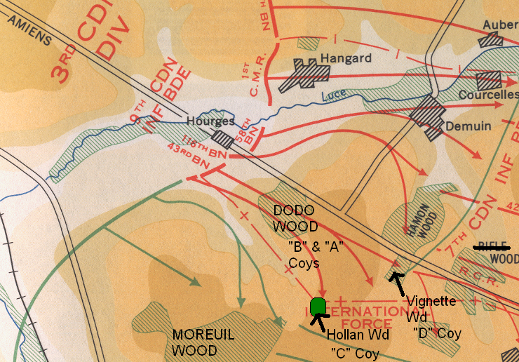

Below are a copy of the 43rd Bn’s War Diary and an aerial photo of the Cameron start line and “Dodu” Wood.
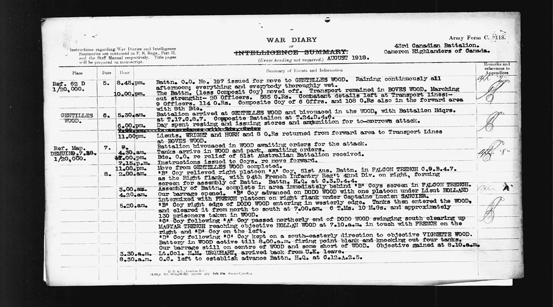

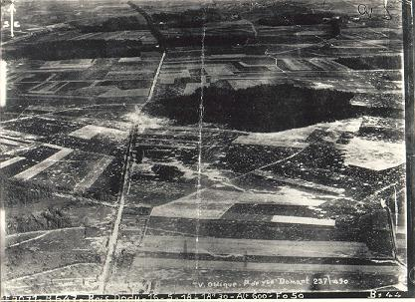

The Sgian Dhu

Canadian Corps Attack Details – usual Cdn Corps thoroughness – phased attack, tight but solid fire plan, inf-tank cooperation, rehearsals where possible, post Somme battle drills & organization, comms by various means, overhead MG fire plan, etc

LEFT OF CDN CORPS = ANZACs
CDN CORPS,
RIGHT OF CDN CORPS = FRENCH 94th Inf Regt, 42nd Div 31st CORPS married up with a PL of the 43rd Bn Camerons of Canada – and going uphill through thick and disorienting mist. and smoke bombs from a fwd ammo dump set of by a German barrage just short of H-Hour.

43rd Bn CEF Plan:
- Relieve 51st ANZAC Bn 070700 Aug 1918
- “B” Coy Frontal Pinning Attack on DODO WOOD
- “A” Coy to support “B” with Left Flanking on axis of Demuin-Moreuil road (enemy trench system oriented to defend that way)
- “C” Coy to bypass left and go for HOLLAN WOOD
- “D” Coy to bypass and go for VIGNETTE WOOD – known battery of German guns there.

43rd Bn CEF Results:

- International (43rd Bn & 94em Regt) PL = Captured 11 MGs and 5 trench mortars,
- 43rd Bn captures: 16 * Trench Mortars, 33 * MG’s, 3 * Bomb Throwers, 4 * 5.9” guns, 1 * 4.1” gun, and 413 PW’s.
- Casualties= 2*Offrs KIA, 3 * Offrs WIA, 19 O.R.s KIA, 170 O.R.s WIA are what is given in the 43rd Bn War Diary, but there are 45 all ranks of the 43rd Bn buried at Hourges Orchard Cemetery who were all killed on 08 Aug 1918. They probably died of wounds.

Damery, 15 August 1918

On the afternoon of 15 August 1918, the 43rd was relieving the 52nd Battalion in the front lines near Damery. Just as C Company arrived, the 52nd was being attacked in force by 4 battalions. This company, in charge of Lt. Geddie, successfully counter-attacked.
That night, a French unit on C Company's flank was attacked and were forced to withdraw some distance. This left one platoon of C Company surrounded. This platoon refused to surrender and put up such a fight that the Germans decided that they would kill them. When this platoon's ammunition had run out, and most of the men wounded, the enemy attacked and captured them.
Instead of taking them prisoner, each Cameron was shot dead and they were all buried in a shell-hole which was filled in.
When the ground was re-taken, there was no sign of this platoon. They were all located a year after the war had ended by Imperial War Graves workers clearing the battlefield. The 22 men were buried in ROYE NEW BRITISH CEMETERY and were in plot I Section “A” 1-22 at one time. I hope to confirm their final resting place sometime in the future.

The Sgian Dhu

The Cameron Association Page

Not too much new to report here. The Association needs the help of any former Cameron as the WW 2 Camerons are fading fast.

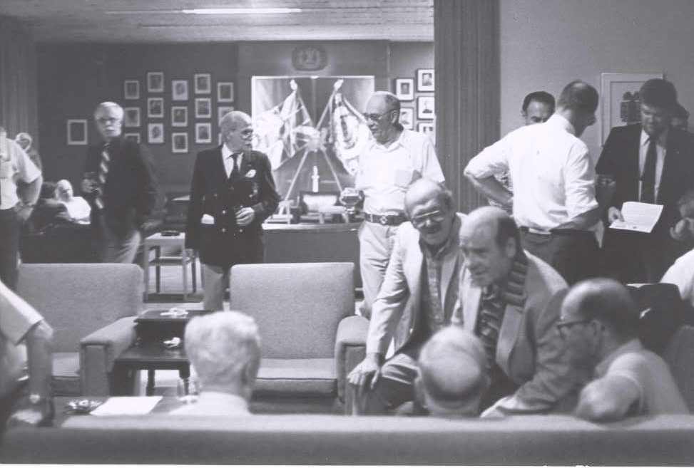

WW 2 Cameron Len DeCosse was present for the Heritage Stone Dedication Ceremony at CFB COMOX, 01 June 2008 by the Governor General. They also placed one for him, which explains the fancy turn out ! Looking sharp Len !
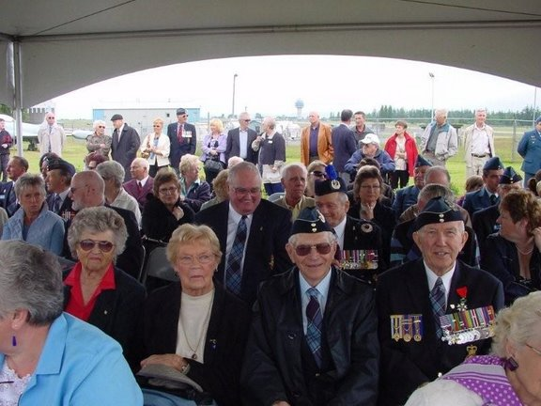

The Sgian Dhu

Here’s another letter from Sgt Dave Gibson:

08/03/2008 08:04 AM
Subject: | AFGHANISTAN

Hi To All
Since my last email I have gone for another trip up north, it was thankfully uneventful. Got to take some more pictures along the way. Was on a Ramp Ceremony for one Canadian lost since I got back from vacation, however have been on several for our American brothers-in-arms, Marines and Special Forces. One was for 5 of 7 guys lost in one battle. Our Canadian Piper plays Amazing Grace and the US Marine Corps anthem on the Bagpipes for them.
Weather has been sunny and 45-50C since I got back. This Saturday, August 2nd, we watched a sandstorm approach the camp. Got some pictures as it advanced and the light turned orange as it passed over top. We then had a 10-minute heavy rainshower with thunder. Our rainshowers are normally only a couple of minutes long. Wind was brisk, but not too bad. However about 3 hours later another sandstorm hit. The wind was so strong that the sand blew over fairly quickly so we didn't get oragne sky again, but it blew a lot of stuff around. It was strong enough to flex and twist our weatherhaven office tent so that the doorframes popped. One of our satellite dishes toppled over, was dented and twisted, and the other satellite dish mount welds broke. So now we can't get Canadian or European news. It was followed by rain for about 2 hours, but I don't think that the drought is over yet.
Finally got to the local Bazaar. Only the second time since I got here and the first time to buy anything. Will try to get back again a few times before I leave. Our platoon still haven't got our departure dates yet, however some are already counting the days as they believe that they will be on the first planes out. We are also looking at activities to do during out "decompression" time in Cyprus. There are lots of interesting things to do after our briefings every day.
Hope everyone is well.

Dave

The Sgian Dhu

Editor’s Closing Notes:

This is the second of what I hope will be many more. It can only survive if you are interested. Let me know what is going on with your piece of the Regiment – all entries will be accepted and vetted. I will use what I can.

Special note – Sorry, but nothing on “A” Coy doings this time out. It’s summer, there isn’t much from Sgt Will Worden at the moment he’s too busy being a daddy, and Sgt Matt Lumsden is making sure that the FGH/Sask D Convoy Escort Troop don’t get into Taliban Trouble.

Cheers to all,

Hugh O’Donnell
Editor

