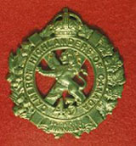 TheSgianDhu 
The Newsletter of The Queen’s Own Cameron Highlanders of Canada
Warrant Officers and Sergeants Club
Edited by CWO HJ O’Donnell #4 April 2009

 | Cameron Club Executive  2007-08  CWO Brian Boyd  Wpg Inf Tac Gp RSM  Sgt James Clark  PMC  Sgt William Worden  VPMC  Sgt Matt Lumsden  Treasurer  Vacant  Secretary  Sgt Dave Gibson  Housing | PMC’s Cameron Club Report:  The Robbie Burn’s 2009 AAR is mostly completed and we are now starting the planning cycle for the 2010 version. Highlights of the AAR in no particular order are:  - 2010 will be the 50th Cameron Robbie Burn’s Dinner since Capt (Ret’d) Russ Miller got them going again after WW 2. Get your ticket orders in early – Sgt Dave Gibson will be only too happy to take your money. He may even give you the ticket !  - Same venue. The Hotel Fort Garry venue is hard to beat, especially for the 50th. We can go downscale later if needs must.  - Ticket price – we will try to not to skin the flock but a certain amount of shearing is in fact necessary. We’ll see how the prices are when the contract comes up and work from there. Start saving $ 8 a month now and you should be Ok or close enough.  - We’ll try to keep the programme short enough to enjoy but get the key events covered.  - Thanks to all for your continued support.
From the Editor’s Desk:  This is issue #4. I have heard back from several of you and thank you for your support and suggestions.  The focus on this issue is once again mainly on articles from the last ROTO 03-08 and some Cameron History stuff as always. “The Low Road” was well received and will continue as long as I continue to get news from our far flung Cameron Clan members.  Sadly, this will be the first appearance of “The Low Road’ counterpart, “The High Road”. Capt. Dave Weldon was a well known fixture for those of us who used to go to the Annual WO’s & Sgt’s Kenora Bonspiel.  The sharp eyed will notice that the “Boots on the Ground” series by Sgt Tim Seeley is being presented in a reverse sequence with this instalment being # 5. This is because I didn’t open all my emails in the correct order and nothing whatsoever to do with Tim having had too many Tim Horton’s servings, or anything else for that matter. My apologies for this. I have not received the # 1 - # 4 issues though so when and if they arrive I’ll get them out to everyone.  My main target audience remains the serving and former mbrs of the Cameron WO’s & Sgt’s Club. My secondary audience is the other former mbrs of the Regiment, and I have received quite a few thoughts but no concerns on this point.  Cheers for now,  CWO Hugh O’Donnell  Former RSM Camerons of Canada  Editor |  |  |  | Upcoming Events:  Known:  Cameron Association:  Annual General Meeting: Bill Worden to info us re DGT, Locn, etc.  Expected dates:  - Limo night: expect it some time in Feb or early March  - Sgt Steve Smith and Erika are expecting another baby boy. Details on Facebook.  - Next ROTO out the door to CFB Shilo and points West – soon.  - Cameron Association Annual General Meeting – TBC.  Useful Links  Reserve Force Pension Buyback Program  http://www.forces.gc.ca/hr/rfpb-rpfr/engraph/home_e.asp  Library & Archives Canada  http://www.collectionscanada.gc.ca/military-peace/index-e.html  Army News web site  www.army.gc.ca  The Maple Leaf newspaper (online)  www.forces.gc.ca/site/home_e.asp  Combat Camera (for images)  www.combatcamera.forces.gc.ca  Land Forces Western Area  www.army.forces.gc.ca/lfwa  38 Brigade  http://www.army.forces.gc.ca/38cbg_hq/
“A” Coy Report

Sgt James Clark has been appointed Platoon 2 i/c of #4 Platoon of the Wpg Infantry Tactical Group.
Sgt William Worden is heavily engaged on the Home Front. 9‘er Domestic overrules 9’er Tac, with of course exceptions.
Sgt Matt Lumsden is keeping the streets safe with the Wpg Police Svc. When not so engaged he does Platoon 2 i/c work.

The next issue should have more details about the March 09 EX.

Pipes & Drums Pages

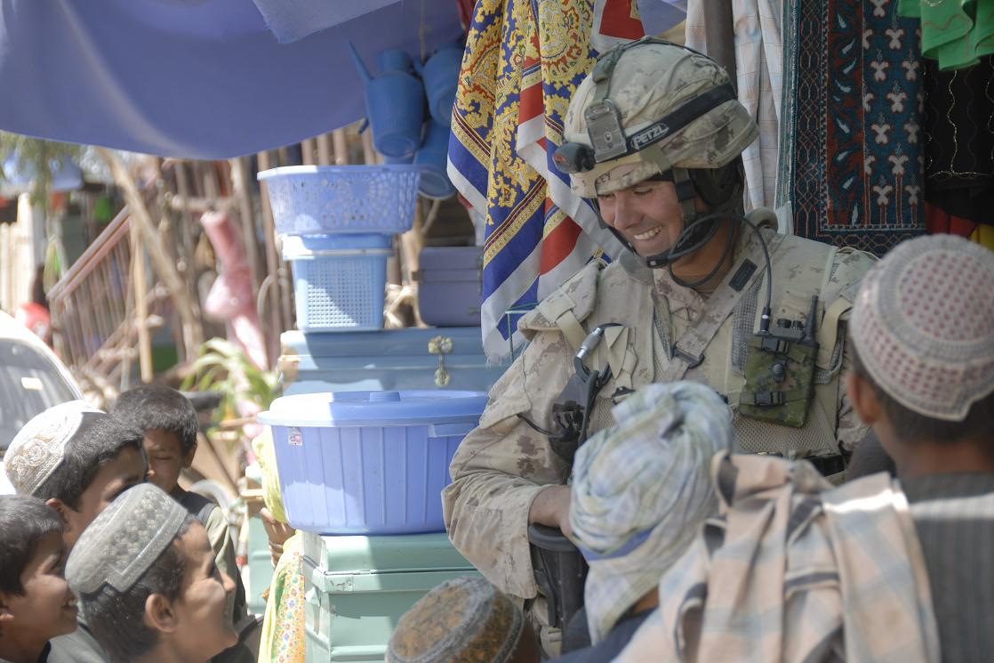

Boots on the Ground 5
Sgt Tim Seeley
Task Force Afghanistan
Panjwayi District, Kandahar Province

Hello again to friends and neighbours throughout the Parkland. It has been awhile since my last dispatch, however everything is going well for me. The lull has been due to the busy workload and operational tempo. Since my last dispatch (almost one month!) I have returned to my area of responsibility in Panjwayi to participate in various activities and operations. The Provincial Reconstruction Team suffered a great loss when our friend Corporal Mike Starker was killed in an insurgent ambush in the Zhari District two weeks ago. Mike, from Calgary, was a great medic and soldier and it was an honour to have known and worked with him. His helpful ways and professionalism will be missed. The accomplishments of the Canadian Forces, and (even though I’m biased) especially our Provincial Reconstruction Team in Kandahar, are what drives us to continue with our mission despite the losses and risks. The positive effects our efforts are having on local Afghans’ everyday lives are very visible now after being here three months. This is the legacy that Mike Starker leaves behind and the challenge that the rest of us will carry on with.

The poppy harvest is wrapping up now, indeed complete in most areas of Kandahar and Helmand provinces, and therefore insurgent activity is expected to increase: “fighting season”. The illicit opium trade is a huge issue in many areas of Kandahar, especially as you get to the fringe areas of our geographic mandate. It is interesting to note that absentee landlords own most of the farmland growing poppies. These landowners live in major cities such as Kandahar City or even locations in Pakistan. These plots are then rented to absentee leaseholders also living elsewhere. The leaseholders oversee the farming operations but hire local villagers and tribesmen to engage in the highly labour-intensive job of growing the poppies and harvesting the opium. These locals are desperate to take any job available that might put food on the table for their families. As well, there are complex arrangements where the insurgents engage local producers to grow poppies by entering involving them in dubious loan schemes. Money is borrowed in the spring to allow for seed purchases and other inputs with a certain amount of opium production as one of the stipulations. The producers don’t have many options; agricultural assistance from the Government of Afghanistan is limited and slow in coming, and non-governmental organizations and charities are very limited when operating in dangerous areas. Furthermore, farming cooperatives are in their infancy and bank loans are non-existent in rural areas, so many farmers see no other choice but to take up the insurgents’ offers of “assistance”. The effects of this are large percentages of total farming output dedicated to poppy and marijuana, and less to wheat and other traditional crops. This has manifested into a serious situation now, especially when coupled with the world shortages of wheat and other commodities, resulting in skyrocketing food prices. Many local tribesmen I speak with are now questioning the decision to support the insurgents and the illicit drug trade as they see the hardship and starvation being faced throughout the province. Afghanistan should be in a position of being a net exporter of agricultural commodities, not forced to rely on international aid and assistance from their central government. The results of thirty years of war and an on-going insurgency are wearing thin on public attitudes and many locals that were “sitting on the fence” are now turning away from the insurgency.

My favourite part of working in Afghanistan is enjoying the rich South Asian culture. One of the many cultural differences involves the set-up of the days of the week. Friday is the Muslim holy day, similar to our Sunday, and is a day off from work for most Afghans. Thursday is like our Saturday, and Thursday nights are for socializing. The workweek resumes on Saturday, which would be like our Monday. So instead of TGIF in Afghanistan it is TAIT: Thank Allah It’s Thursday! Another factor of living in a 99.99% Muslim area is the “call to prayer”. Five times a day the “call to prayer” echoes out from loudspeakers situated on top of the many mosques scattered throughout the villages and cities. The first call to prayer comes just before sunrise, so as I sit for my shifts in the observation post of our little compound out in Panjwayi, the morning calls to prayer begin echoing across the valley starting at about 3:45 am. Due to less-than-stringent time keeping and other factors, the calls to prayer blast from the loudspeakers at slightly different times from each mosque; in our valley they started at 3:45 am and the last one finished around 4:30 am. These calls to prayer are not tape recorded messages or CDs but instead the local priest or “mullah” singing/chanting into a microphone and amplification system. When one first comes to Afghanistan, if he is living amongst the local community as we are, you are awoken everyday at the first call to prayer. As the loudspeakers crackle to life they are soon after followed by the roosters, dogs and donkeys joining in. After a few weeks you get used to it and they don’t wake you up any more. It seems that the first call to prayer is the loudest since the villages are so quiet at that time of the morning. Later in the day they can hardly be heard over the din of everyday life.

I would like to thank those of you sending feedback via email, and I welcome any comments and questions; I will attempt to answer them all via this column. I would also like to thank the Dauphin Herald for this opportunity to share a different point of view of the Canadian Forces’ work in Afghanistan than is normally presented in the media. I have had the opportunity to interact with many reporters from different organizations and countries and although their intent is usually honourable, often they work under constraints which don’t permit them to develop the situational awareness to get to the underlying issues behind the headlines. Some of the best and most informed reporters, however, come from Canadian national media corporations, another thing we can be proud of as Canadians. As usual, I can be reached at my civilian email address: seeley363@gmail.com. Enjoy summer as it hits the Parkland. Yesterday the thermometer in our compound, which goes to 50 degrees Celsius, exploded as it was forced beyond its limits. And I thought it was hot in March!
- Tim

The Low Road

We have recently heard from some of our former Camerons. Here are their respective SITREPs:

Capt. Dan Richter
January 23, 2009

Thanks for the Regimental update. I thought you would all like to know what we have been up to.

I was on TF 1-08 and ran into most if not all of the Camerons in the TF. Sgt. Matt Lumsden was in the company, as I was a part in getting into the NSE to do force protection. He was an outstanding NCO and convoy commander. All the soldiers from the Camerons and 38 CBG that were in the NSE demonstrated excellent professionalism and high dedication to a job that at times was monotonous (ECP3), and at others extremely dangerous (Convoys).

Just ask Matt about the day we rode up to Massum Ghar and FOB Wilson. It was one of those really lucky days with action all around us but nothing touching the convoy. Are you still serving as the RSM to the Garrys? If so, let the guys know that I did prefer to go out with that platoon and as Coy 2IC, I just could not tell them that at the time. But now I can !

Family is good. Rita is on mat/pat leave with the girls. Danica is a wild and crazy 2 year old, and Leah is growing fast at 5 months. I have enjoyed all the time off with the family since coming home. I am working as the Base Adjt here in Edmonton. Not the most glorious job, but these days a job is nice to have.

Former MCpl Eman Turner
We are currently living in Brandon for 9 years now. I was working in Sioux Valley as a Dental Therapist but now I have just retired due to repetitive strain injury while on duty. I am in a process of completing my Bachelor of Health Admin and if things work out, we should be back in Winnipeg working at the Health Canada HQ maybe in 2-3 years.
Maligayang pasko, Merry Christmas, and a Happy Prosperous New Year !
Cheers!

Former Cpl David Desjean
January 22, 2009

I do miss the Regiment and wish I could still be in to enjoy it but unfortunately as you know, life decided to put the stick in my wheels ... sort of.

So that said, I decided to do the next best thing (hopefully) and joined the Legion. To my surprise, many of the members were ex engineers from my time. Once again the stories and memories of days gone by come back to surface. I know this might not be of too much interest but the Honorary Col. of the engineers passed away recently at the ripe old age of 92. Col. Joel Wolfe had quite the story and I will have to forward it to you if you like.
I still try to remain busy and balance family life with other things involving Legion life. The boys are getting bigger and quite the handful. Hopefully they will carry on with family tradition and join up. Of course Bonnie has quite a different outlook on this. I will keep you posted with that one too...lol

F W (Editor’s Note: Name & details withheld for security reasons)
I'm doing alright, work is busy. My dad is in the hospital and he's quite ill. I've applied to go to Afghanistan with the PRT through the RCMP but I'm having a few issues with the City releasing me because of liability issues. I have made headway though, I have a good relationship with the new Chief as I've worked for him prior to his first retirement, so I have now had several meetings with him and he's revisiting the whole thing.
Should that fall through I've been in contact with the Camerons and with the recruiters to see what other way I can make it over to the sandbox. I really don't feel that I should start at square one again being that I'm still in the Supp Holding Reserve, I work in an armed profession, I'm current on all the firearms, and I topped every course I've ever taken with the military. We'll see how that works out, but I'd like to see if I can keep as many quals as possible.
As for the Robbie Burns, and other Cameron events, I'd love to attend but it never seems that I get enough advance notice.
Andrew C Law
01/26/2009
I happened to view the report on Dieppe on the above site and was concerned about the reference to my father’s name as “Tony” Law. His name was Andrew, and Andy was his used name. I would appreciate if you would take it upon the Regiments responsibility to get this corrected.
Thank you for your attention to his matter.
(Editor’s Note: Done. Any other errors or omissions let us know please !)

Former Drum Major Ralph Flom
02/04/2009
Thanks so much for the copy of the Newsletter. It was great to hear news of so many of the regiment. I try to get news of the regiment, but sadly the Cameron website had the Association Executive from 2006.

The letter from Captain Fraser was especially interesting from a personal perspective, as I knew my Lads were over there and it was nice to know they were actually working, not just quaffing ALE at BAND PRACTICE!!! Actually I was worried for them (funny how the mind works, thinking they were only 17 how could they even get deployed ! (MAN AM I OLD!!!)

Just a quick update on Irene and me. We are still in Edmonton in the west end by the Mall (open invitation to get together to whoever gets to town) and the only Flom in the phonebook). I tried to get to Winnipeg for the Dieppe Reunion but couldn’t make it work. I am making sure that I will be in Winnipeg for the 100th! I am still in the car business here in Edmonton and thought about joining a pipe band in town here, but my heart wasn’t in it. It’s not the Camerons so it’s not the same.

Say hello to everyone for me and keep the news coming. I hope not too many were injured at the Burn’s Dinner. I am looking forward to a sit-rep.

Ullamh !

UK Dental Corps Ray Berry
02/05/2009

I am attempting to trace the family history of a man named James Stewart, born Scotland March 3 1872.
He enlisted in the Canadian forces at Ottawa June 22 1915 where he stated that he had three years service in the Cameron Highlanders, I am wondering if he meant the regiment formed in Winnipeg in 1913. Is there in existence a muster roll of enlisted men for this time ? He gives his trade as blacksmith.

This research stems from me finding in a thrift shop a 1914/15 star named to a Sapper J Stewart Army number 664. Canadian Engineers, from which I obtained his Attestation Paper.

I found this medal in Port Alberni B.C. but as yet can not find any local connections. I was hoping to do a write-up in time for Remembrance Day. I look forward to hearing anything that will give me more background on the man I am researching.

As an ex R.S.M. yourself , here is a story you might find interesting, while in the Dental Corps in the U.K. in the 1950's I was attached to the Black Watch at their Depot in Perth, Scotland. I got to be friends with the R.S.M. who asked me to give him a small dental mirror which he fastened on to the end of his swagger stick so he could unobtrusively look up a soldiers kilt to see if he was "incorrectly" dressed.

(Editor’s note: Yes, there is the roll and Sgt Grant Tyler and Sgt (Ret’d Ian McGregor are working on this one)

“Chairman” Galeung Lau
"I am still in Kingston; I will be here until 18 May 09, and then I will be in Halifax, NS. If you can come to my commissioning parade, you are more then welcome to come! It is on 15 May 09 at 1000hrs.

The High Road

Capt Dave Weldon, CD
February 09, 2009 from LCol (Ret’d Ken McQuaig)

Gentlemen

I regret to inform you that I received a call from Donna Durand, Dave Weldon's daughter. Dave, a long time Cameron known to many of you, passed away on Sunday morning in BC after a long illness. He had relocated to Vernon, BC, last May due to his health and to be close to his family. Ms Durand advises that an obituary will appear in next Saturday's Free Press. It is the family's intention to bring his cremated remains to Winnipeg for a service this summer. His daughter requests that we arrange a piper and will contact us later with details.

For those so wishing, cards of sympathy may be sent to:

Ms Donna Durand
4317 Wellington Drive
Vernon, BC V1T 9A6
Res: (250) 260-8091

Cameron Association Page

Former Cameron Mortar Platoon Sgt Len DeCosse’s Christmas list:

The new nail gun, made by Dewalt can drive a 16D nail through a 2 X 4 at 200 yards. This makes construction a breeze, you can sit in your lawn chair and build a fence. Just get the wife and kids to hold the fence boards in place while you sit back and relax with a cold drink. When they have the board in the right place just fire away.. With the hundred round magazine, you can build the fence with a minimum of reloading. After a day of fence building with the new Dewalt Rapid fire nail gun, the wife will not ask you to fix or build anything else.

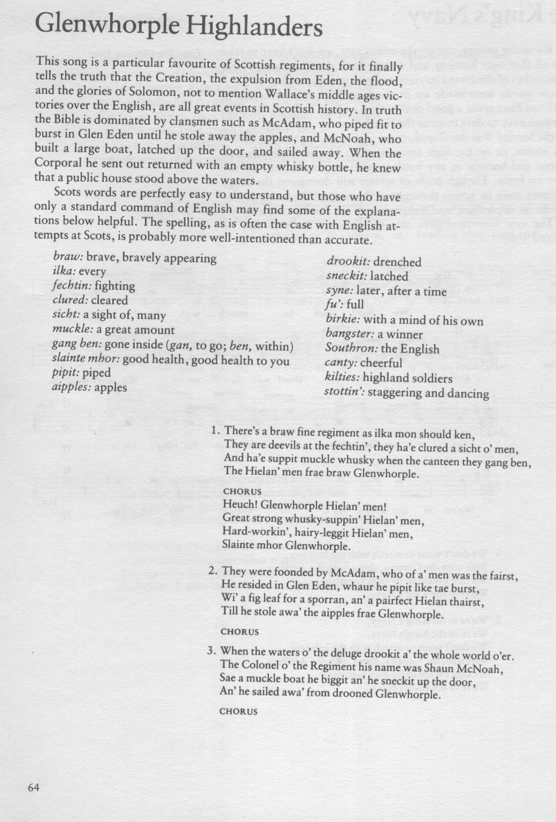
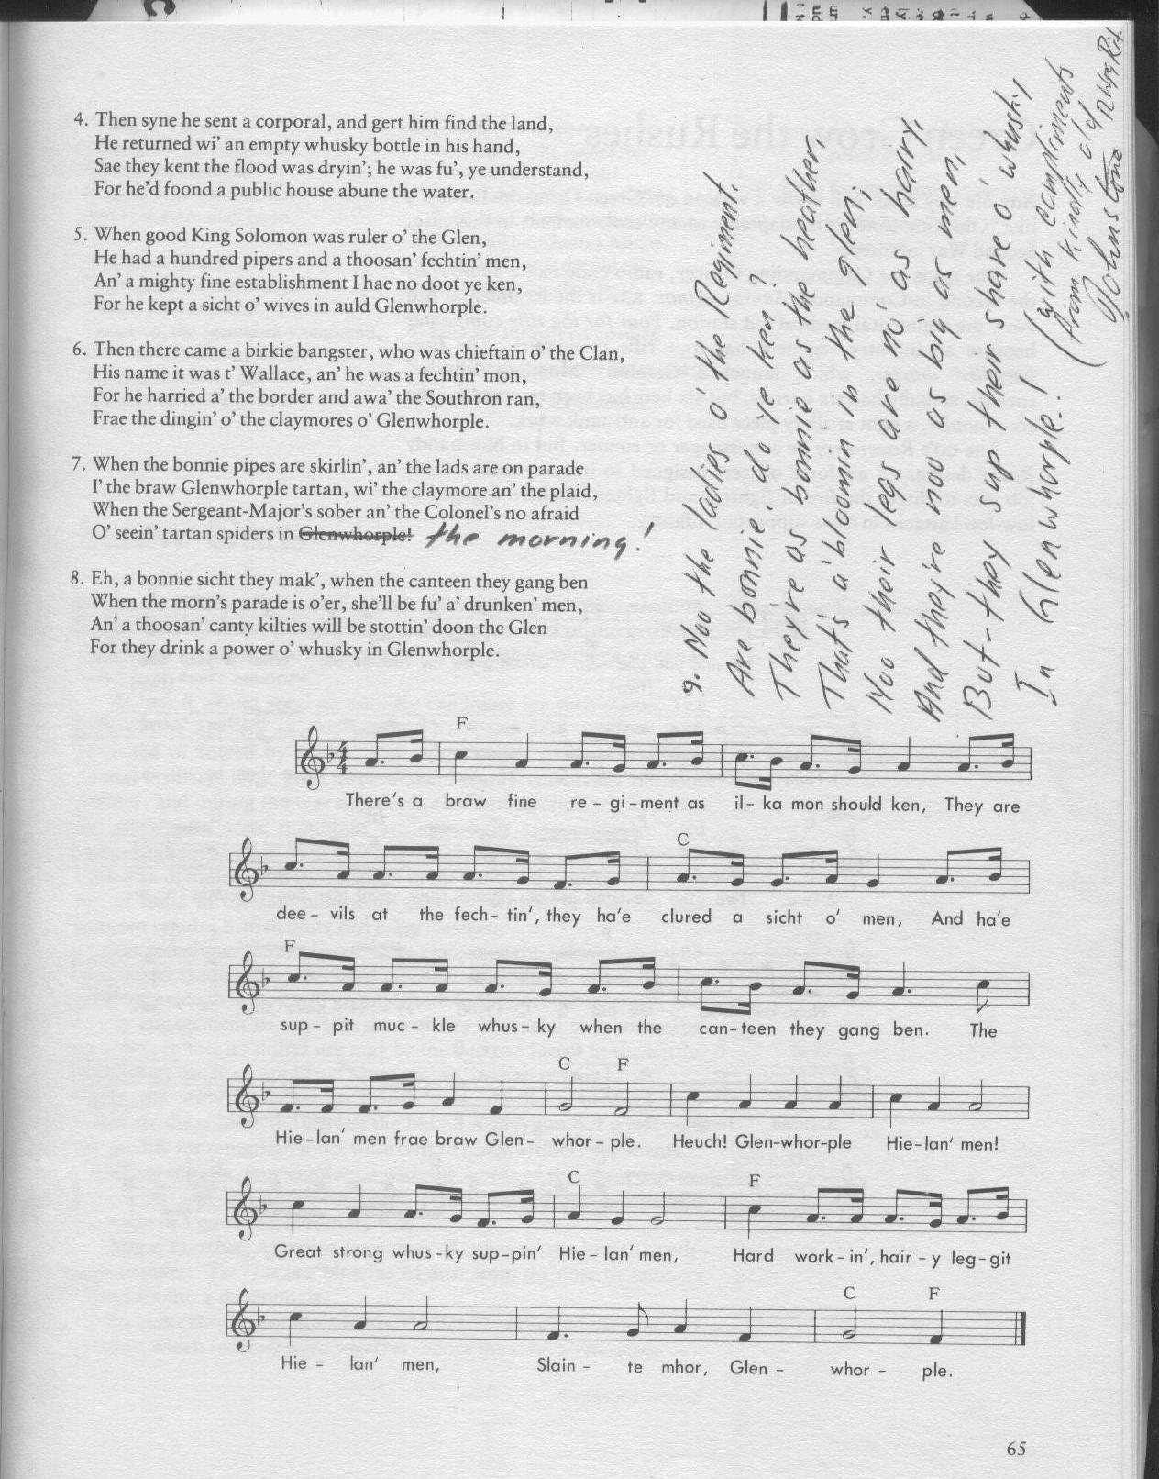

Editor’s Closing Notes:

This is the fourth of what I hope will be many more. It can only survive if you are interested. Let me know what is going on with your piece of the Regiment – all entries will be accepted and vetted. I will use what I can.

Cheers to all,

Hugh O’Donnell
CWO
Editor

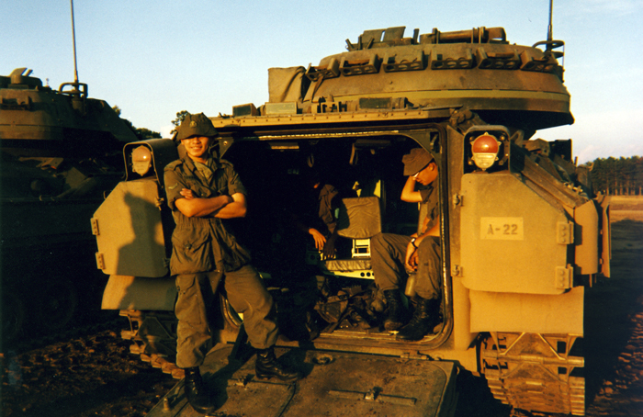

Former Cpl Carlos Fuentaspina

