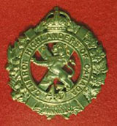 TheSgianDhu 
The Newsletter of The Queen’s Own Cameron Highlanders of Canada
Warrant Officers and Sergeants Club
Edited by CWO HJ O’Donnell #8 March 2010

Cameron Club Executive  2007-09  CWO Brian Boyd  Wpg Inf Tac Gp RSM  Sgt James Clark  PMC  Sgt William Worden  VPMC  Sgt Matt Lumsden  Treasurer  Vacant  Secretary  Sgt Dave Gibson  Housing |  | PMC’s Cameron Club Report:  - Limo Night is delayed but not quite dead yet.  - Sushi Night is TBC.  - Robbie Burns Dinner: 23 Jan 2010.  What a night ! Well done to all involved. 154 seated and that’s a very good turnout given that the room holds 160 comfortably.  - Elections due this year: Sometime soon per the PMC & Club constitution.  - August Reunion: 20-21 August 2010. Usual deal, Officer’s Mess Friday pm and Golf Sat. CWO H O’Donnell is OPI’ing with help from the indefatigable Bill Worden.  - 100th Anniversary Weekend: 22- 24 Oct 2010  We have been asked to ramrod the Friday evening part of the event. It will be the same general format as the August reunion but in a much bigger venue. MTF shortly.  - The Lumsden Highland Games: We’re working on a summer time event. It should feature at least a few of the normal Highland Games events. Sgt Matt Lumsden OPI for now.
 | From the Editor’s Desk:  This is issue #8. I have again heard back from several of you as usual and thank you for your support and suggestions.  Some updates and the usual fare here. Less from Afghanistan this time, but more good historical stuff for your reading pleasure.  Also, work is progressing on the 100th Weekend. I have sat in on several meetings now and I can assure you that LCol Ken McQuaig & the Gang have a really good show planned for us in Oct. Now regarding Robbie Burn’s observation about “best laid plans” there are some “Plan B’s” in place – just in case of course !  Cheers for now,  CWO Hugh O’Donnell  Former RSM Camerons of Canada  Editor |  |  | Upcoming Events:  Cameron Association:  Expected dates:  - August Reunion: 20 & 21 August 2010 at Minto Armouries. The same format as every year as much as possible will be followed.  - 100th Anniversary Weekend: 22- 24 Oct 2010. The budget almost GTG so the prices and mail out packages will be coming shortly – I hope.  - ISAF Return: There are 5 Camerons serving overseas now in the Afghanistan Theatre. They should all be home for the 100th – if only just in a few cases.  Useful Links  Copy & paste these links into your web browser to use them.  Reserve Force Pension Information:  http://www.cmp-cpm.forces.gc.ca/dgcb-dgras/ps/pen/res/welcome-bienvenu-eng.asp  http://www.cmp-cpm.forces.gc.ca/dgcb-dgras/ps/pen/res/ap-ar/bbs-rs-eng.asp  Military News Links:  http://www.wednesday-night.com/military.asp  The Highlander 2009:  http://www.cohortsbydesign.com/fbook/highlander09/flip-book.html
Regimental NCO Plot

Sgt James Clark has been appointed Platoon 2 i/c of #1 Platoon of the Wpg Infantry Tactical Group. This is the designated Arctic response Platoon for the Tactical Group.

Sgt Matt Lumsden is keeping the streets safe with the Wpg Police Svc. When not so engaged he works as 2 Platoon’s 2 i/c.

Sgt William Worden is still heavily engaged on the Home Front. 9‘er Domestic overrules 9’er Tak, and with 2 young ones he’s been tasked for Home Front duties. He is still with the RQ shop.
Sgt Brad Clyde is the Acting Pipe-Major these days while Sgt John Dawson is away. Brad is also heavily engaged on the Home Front with the arrival of Evelyn Faye who was born on September 21 2009 for those who missed it. This will cause quite a bit of impact on the Pipes & Drums but Brad has promised to see the key events don’t go awry. Maybe we can get him to sort out the 11 Nov 2010 Minto parade music program ?

Sgts John Dawson and Tim Seeley are working overseas. It’s a really hot and bagpipe deprived area they’re in so they’re bring a little Cameron culture as best they can to the locals to do their bit for Hearts and Minds. How’s Haggis the goat lads ?

Sgt Dave Gibson is now with the 4th Canadian Ranger Patrol Group.

WO Bruce Breustedt is reputedly working with Area Standards.

WO Reg Corbin is now the CQMS “A” Coy of the WITG. Or somewhere like that.
MWO Lloyd Harris is busy with special tasks for the CO. He’s nae sae lame these days following a good boot to the shins from Sgt Clark. Ok, it WAS surgery but it sure felt like Hamish had given him a good kickin’ !
CWO Hugh O’Donnell is now Extra Regimentally Employed at Domestic Operations which is part of Joint Task Force West. The “current event” is the usual Red River Flood watch in early 2010.

Pipes & Drums Page
Everybody not in the P&D that hasn’t heard the story wants to know why there was none of the usual music programme after the 11 Nov 2009 Parade at Minto. Maybe it was the Medics fault ?

The Low Road
We have recently heard from some of our former Camerons. Here are their respective SITREPs:
Best Wishes 100th
MWO (Ret’d) George G Hamilton
I joined the cadet corps in the late 50s and the Reserves in 1961 and then joined the Regular Force in 1962, and went on to a 28 plus year career retiring in 1990. Throughout my career I never forgot the start I received in the cadet corps. I WANT TO WISH THE MEMBERS OF THE CAMERONS HAPPY 100th ANNIVERSARY !

Cpl (Former Sgt Camerons) Shaun Delamere December 4 at 10:22am
Hi Guys. How's it going? Just a heads up that I won't be at the Burn's Supper and neither will Michelle haha !! Been in Afg for over month now. Time has flown by very quickly. Besides trade work I’ve been doing other stuff during OP HYDRA...brings back memories.
Doing OP duty along with "sheriff" sure gives you an inside impression/awareness on the operational situation. Been out at PBSG but came to Kaf yesterday for about a week before I go out on a travelling circus...would say more but you know opsec. Boy does Kaf suck...the noise, pollution, dust, the nimrods, etc...glad I am not doing my tour here. I saw Kevin Fink in Edm just before I left to go and had a nice chat with him...he hasn't changed that’s for sure he's still the finkster. Anyway can you email me the latest ed. of the Sgian Dhu as the network won't let me on the link that it is on.
Take care and say hi to all.
Shaun

Former 2nd LT Andre Blais
12/05/2009 11:10 AM
I'll be looking forward to the 100th event week-end in Oct. Let me know of any details please.
While I'm at it, Susan and I have purchased and moved into a new abode. We are now in Westbank - not Gaza!
I'll include our new address with the X'mas card we'll be sending your way.
It was a very nice surprise to see Marc this summer and I hope he has things going better for him.
Bye for the moment.

Former Drum-Major Joe Ridout
Date: Wed, 17 Feb 2010 16:59:13 EST
Hey good buddies haven't talked to for a bit. Things are going a bit slow here; the Casino is slowing down, people not gambling as much anymore. Getting ready to go to Disney World this weekend for a week. Will enjoy the R and R. On leave for about 5 big weeks ! I know I can handle that. Anyway give my best to all, will talk to you later.

Ciao

PS: May send you some pics from Florida eh!!!

Sgt Doug Setter
Sent: Friday, December 25, 2009 12:05 AM

"Merry Christmas, Guys. Best in 2010 for you and the Regiment."

Former Cpl David Desjean
Thursday, December 24, 2009 5:03 PM
Subject: accident
"Hi Guys,
Make sure you ask Mike Fejes what a wonderful trip I had coming back from Gatineau the other night. The only thing wrong is that I might have damage to my right rotator cuff."

Major Mike Fejes
Monday, December 21, 2009 9:12 AM
"Kings Head ! I am there ! I think that I still even have my membership card somewhere. Just say when !
Lori and I will be in town from the 26th to the morning of the 30th.... if the weather is not too bad, we might even leave the hotel ;) "
(Ed’s Note: We missed Mike in the end – his family needed him for a very important event – pity, it was a good one !)

Piper Roy Taylor
Just a note to say that Roy is doing well and he and Louise had a great time at the Robbie Burn’s. He did leave early but all things considered he’s in great shape and has just paid his 2010 Cameron Association dues. How about you ?
The High Road
Cpl Bradford Sigurdson’s Father
http://www.legacy.com/canttawa/Obituaries.asp?Page=LifeStory&PersonID=136478307

JAMES WALTER VICK (published on March 13, 2010)
http://www.passagesmb.com/obituary_details.cfm?ObitID=161939
JAMES WALTER VICK April 24, 1925 - March 1, 2010 It is with great sadness that we announce the passing of Jim Vick in Lloydminster, SK on March 1, 2010. He is survived by his loving wife Glenadean, children James, Heather (David), stepchildren Terri (Tim), Toni (Dewey) and Gary, and nine grandchildren. Predeceased by brother Bill, sister Ellen and first wife Christine. Born in Winnipeg he was a Second World War veteran, drove streetcar for Winnipeg Electric, joined Canada Post in 1953 and retired after 30 years. As well as teaching dance skating at the Winnipeg Roller Rink in the 1960s and 1970s, Jim was an accomplished pipe band drummer and teacher. He played lead drum for the Cameron and Henderson Highlanders and the Mass Pipes and Drums of Winnipeg, was Drum Major for the Calgary Highlanders and played with the Lloydminster and Battleford bands before retiring his drum in 2008. Jim returned annually to Winnipeg for the Cameron Highlanders Reunion and was happily anticipating the 2010 gathering. It was Jim's wish that there be no funeral or memorial service. Donations may be made in his name to the Canadian Cancer Society. And so goodbye to one who was, in his own words, genteel, sophisticated, suave, debonair and perfect in every way.

Cameron Association Pages
Things are ticking along much more smoothly these days with the new Executive busy doing things that need to be done.

NDI75 Veteran’s ID Card
Dear fellow Veterans,

Many of you have been asking about the “Veterans Card”. A plastic Record of Service Card NDI75 is available to all retired military service personnel of the Canadian Forces, Regular and Reserve components.

This card is valid to enter all federal government historic sites and is recognized at some historic sites in Europe as well. It is essential to book free passage on VIA Rail in July and for other transportation agencies and companies for passage.

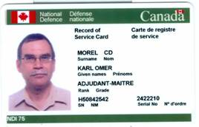

To obtain your NDI75 card write to the address below. They will send you a form to complete which you will have to return with two pictures of yourself. The procedure takes form 6 to 8 weeks. Apply now!

Service Recognition / Commission Scripts and Scrolls
DMCA 4-2-2-4-3-2
National Defence Headquarters
MGen George R. Pearkes Building
101 Colonel By Drive
Ottawa, ON K1A 0K2

Proud to serve, proud to have served, IN THE SERVICE OF PEACE
Fier de servir, fier d’avoir servi, AU SERVICE DE LA PAIX

Karl O. Morel CD BA
CPVA Communications AVMP
archivaire@sympatico.ca
4478, avenue Laval, appartement 6
Montréal, QC Canada H2W 2J8
514-847-0025
As is often the case we have a number of requests for information from families regarding these former Camerons. Anyone able to help the families out please drop me a line or an email.
Hello Mr. O’Donnell:
As you had requested in our previous emails, I am just following up to see if there has been any luck in finding a photograph of my dad, Patrick Michael Sheridan, who served with The Queen’s Own Cameron Highlanders in the 1940’s?
I am hoping that there is a photograph in existence so that I can come to Winnipeg to see it.
Thank you very much for your help with this request.
Marie Scharapenko
Cameron War Stories:
During our first late fall operations in Holland our first front line was about one mile east of the village of MOOK (Ed’s Note: near Nijmegen of Bridge Too far fame). In addition to my regular position as No 1 on the No 1 Mortar of the Platoon, I was also delegated as the platoon PIAT gunner. One day my stock of PIAT bombs were forwarded up to Don Company, who were holding our front line. I helped deliver them wondering as to what in hell was going on as there was no tank action going on what so ever. My surprise was in the manner they were using the PIAT - like a Mortar and absolutely deadly on German dug outs and other positions.
Len DeCosse
Sgt
Cameron 3” Mortar PL

Here is a tribute to a former Cameron by his grandson:
(Sgt. Wilford Ernest Clark, 43rd Bn CEF, 04 Jan 1916- 24 March 1919, RIP 30 Mar 1973)

43rd Cameron Tartan
10/14/2009 04:32 PM
As promised, attached are pictures of the finished product. My apologies in taking so long in getting these to you but it took a while to get it right. The framer had to make some adjustments a couple of times.
These are now proudly hanging in my home office and have become a family heir loom. Friends and family members have commented that it is a wonderful tribute to someone who sacrificed to help make this world a better place to live. I agree, and I am quick to mention the assistance that you, Will, and my grandfather's Regiment gave to make this a very special piece of our family history. My heartfelt thanks. It would have not been the same without the Regimental Tartan.
Again, many thanks to you and Sgt Will Worden for your assistance in this adventure. I've told several people about the help you have given and all are impressed that all I had to do was ask. My next project is to go through my grandfather's service record, which I have, and to encapsulate it into readable synopsis for future generations. It's hard to fathom that it is almost 100 years since this all happened.
Please pass on my best regards to Will if you would be so kind.
Best regards and sincerely,
Vernon Clark
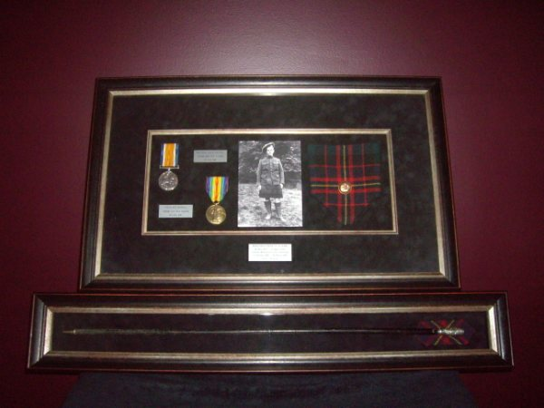

The Allied Regiments:
From the Feb 2010 issue of http://www.cabarfeidh.com/ put out by the Queen’s Own Highlanders Association:

Subject: MPs medals "So wrong"
Can you all take time to read this and add your names please. I didn't know this but MPs get a medal for visiting a war zone. They don't have to do time in country like our service personnel and they don't have to wait months afterwards to get presented with the thing. Medals are all the recognition we as soldiers get for spending long months in staggeringly deprived locations getting shot at and blown up. The most action and flak an MP sees is over their expenses. As we saw with the Wootton Basset petition thousands of signatures in a short space of time did make the government act. They cannot ignore the voters. Especially now with elections looming. Please take the time to sign this petition and please encourage all your family to also do so. Where it asks for your name also add on the same line former military if you were. You will see what others have done. I think this adds just a little more bite to the petition. Once again get everyone with an email address to sign, including neighbours. Let’s do our service personal this small service for all the danger they face and hard work they complete in the name of our country.
http://petitions.number10.gov.uk/notompmedals/
Kind regards
Maurice Gibson
Here are the fine details of the thing:
http://www.telegraph.co.uk/news/newstopics/onthefrontline/7006304/MPs-criticised-for-accepting-Mickey-Mouse-medals.html

Light Reading for You:
AMAZING DRONES
http://en.wikipedia.org/wiki/Creech_Air_Force_Base
Has anyone ever heard of Creech AFB ? All of the Air Force's unmanned drones are now operated from Creech Air Force Base, 45 miles northwest of Las Vegas at Indian Springs. They used to run out of Nellis AFB but now have their own Wing at Creech AFB.
It's the most deadly remote controlled plane in the world. Pilots fly it like a teenager playing a video game. Airmen at Creech AFB can control the Predator drone and the second generation Reaper anywhere in the world. At least since 2001, Predator's have been airborne 24 hours a day, 7 days a week, primarily over Iraq and Afghanistan.
There has never been a time when we haven't. The unmanned program is so successful it's now under the command of the Air Force. "We are going to increase the number of combat air patrols that we fly with it and the number of hours astronomically," Col. Chambliss said. This year the Predator drone will fly 75,000 hours -- up 20-percent from last year. What a different perspective on future combat roles!
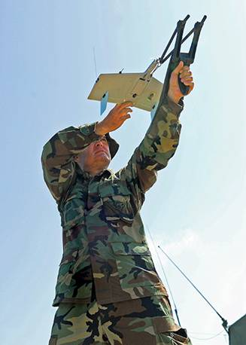
As unmanned aerial vehicles, or UAVs, become a staple of modern military operations, their uses and forms have grown more varied. Today they range from slingshot-launched spybots to global guardians. In fact, the acronym itself may be morphing into UAS (unmanned aerial systems) to indicate that these are not just aircraft, but systems that include ground stations and other elements. It's not just the military that uses them -- police use the same technology for surveillance, while terrorists build flying suicide bombers. Check out the stealthiest, deadliest and highest flying drones in use today, and the UAVs that are most likely to be making tomorrow's headlines. WASP is the smallest UAV in use today, weighing less than 300 grams. The miniaturization is achieved by the use of multifunctional components, like the combined wing/battery. WASP is nearly silent and, when flown at night, it's almost undetectable. The Air Force has just ordered several hundred for reconnaissance and bomb-damage assessment.
Afghanistan Photo Essays:
http://www.boston.com/bigpicture/2010/01/afghanistan_january_2010.html

http://www.boston.com/bigpicture/2010/02/afghanistan_february_2010.html

Chernobyl Nuclear Disaster Scrap Metal:
http://englishrussia.com/?p=2343
Afghanistan De-mining video:

http://video.nytimes.com/video/2009/11/18/opinion/1247465742545/the-minefields-of-afghanistan.html
Editor’s Closing Notes:

Let me know what is going on with your piece of the Regiment – all entries will be accepted and vetted. I will use what I can.

Cheers to all,

Hugh O’Donnell
CWO
Editor
Editor’s Very Special PS:
Perth's World Record Kilt Run
Dear "THE QUEEN’S OWN CAMERON HIGHLANDERS OF CANADA";
I am the race director for an unusual event in Perth, Ontario this summer - June 26, 2010. We have a 5 mile race where everyone registering receives a "real kilt", and is required to wear it in the race. The event has been recognized by Guinness as a world record attempt for most kilts in a race. The current record is 250, and we have 1,146 people registered. The race is in recognition of the 800th anniversary of our sister town of Perth, Scotland, and a fund raiser for MS (Scotland and Canada have the highest incidence of this disease in the world).
The race starts at the historic Perth TOWN HALL / Band Stand. The race is at 6pm on Saturday night, and we are looking to have some additional related events ... perhaps leading into a new annual event featuring the kilt run, but also some athletics and music as a "highland games". We are currently looking to fill our need to have individual pipers at each 1km marker (7 pipers+), and for a couple highland bands.
I note that The Cameron Highlanders are celebrating the 100th anniversary this year. Congratulations! (We certainly have Cameron blood in our community!). We would be honoured to consider some aspect of participation by the "Highlanders" in our event. We are located less than an hour from Ottawa. Thank-you to consider how you might be able to join us ... we would be open to suggestions, and to promote your centennial within our event. (Representative troops with inspection by the Governor General of Canada?, band, piper, runner?)
Please check out our race website for details (not bad for our 1st year)
http://www.perthkiltrun.ca/
Here is a link to the town fyi
http://www.beautifulperth.com/
Thanks!
Terry Stewart
Director - Perth's WORLD RECORD KILT RUN
email: therunninggoat@cogeco.net
email alt: terry.stewart@omya.com
ph days race headquarters: 613-264-8904
ph days alt: 613-267-5367
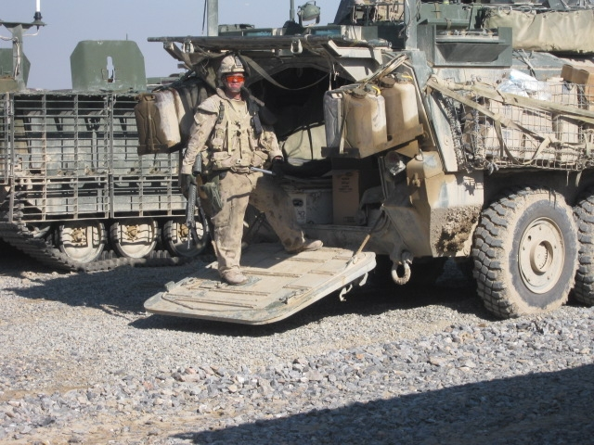
Former Cameron Sgt S. Delamere, now Combat plumber extraordinaire !

