***Project Proposal***

*Subject details*

| - Employment Agency

| - Three months

*Project members*

| - Chung Minh Nhật

| - Nguyễn Trần Chí Hiếu

| - Chiêm Quốc Hùng

**I – Background**

Since the job market today is becoming more competitive, it poses a challenge for employees to find suitable jobs and for employers to recruit workers with expected capability. As an attempt to mitigate the related troubles and to facilitate profits, we decided to create an application for an employment agency, building a necessary database in the process.

**II – Project Description**

1 – Goals

The team aims to build a working employment agency application. This ‘agency’ software will consist of a well-structured database of information provided by clients and two functional systems.

(Students’ goal: By simultaneously working on the database and the application system, we expect to thoroughly understand, master database management system and the procedure of building a complete application.)

2 – Specifications

a/ Functions:

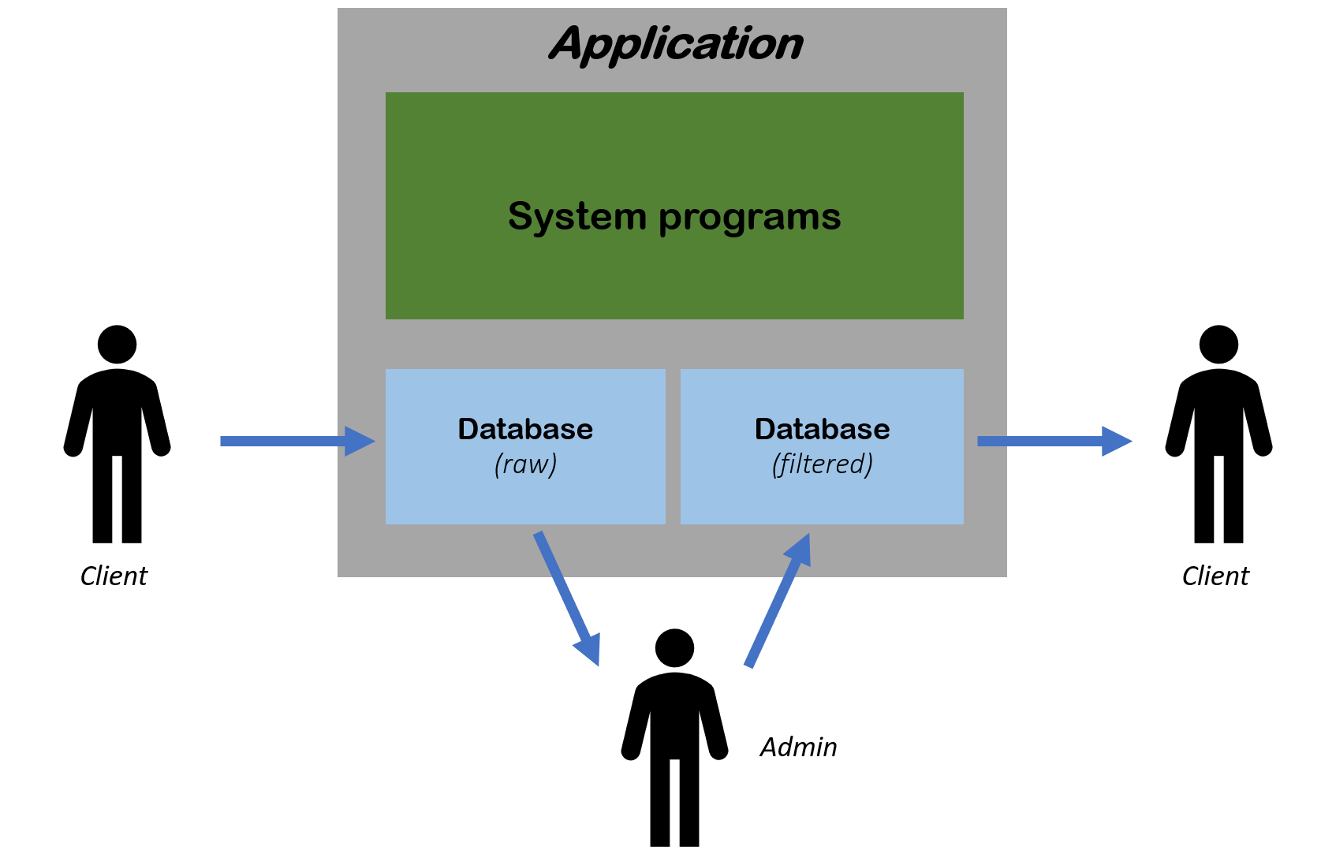

*(pictorial description)*

* Job-seekers can upload their curriculum vitaes onto our database (raw).
* Recruiters can upload the vacancies of their companies onto our database (raw).
* Clients can view available information on job candidates or vacancies of various posts from database (filtered).
* A data-processing system for admins.
* A monthly-charge system for clients (depending on their activities).

b/ Tasks assignment:

* Database modeling
  + *Nguyen T. Chi Hieu & Chiêm Quốc Hùng*
* Systems modeling
  + *Chung Minh Nhat*
* Database implementation
  + *joint effort*
* Application implementation
  + *joint effort*
* Writing report
  + *Main writer: Chung Minh Nhat*
  + *Editor: Nguyen T. Chi Hieu*
  + *Proof-reader: Chiem Quoc Hung*

3 – Outcomes

* An easy-to-navigate application that allows for efficient interactions for people in the job market; one that is also highly maintainable and manageable.
* A database that once established can be used for various extensions.
* Profits are made as the application plays the role of an intermediary.