

Employment Agency

database-based application

Principles Of Database Management | April 1st 2019

Table of Contents

Introduction 2

Project overview 2

System and design specification 2

Human resources 4

Project implementation 4

Conclusion 5

Reference 5

# Introduction

# Project overview

* Name of project:
  + Employment Agency application
* Members of the team:
  + Chung Minh Nhat
  + Nguyen Tran Chi Hieu
  + Chiem Quoc Hung
* Tools in use:
  + MySQL
  + Qt Creator C++
  + Microsoft Word (report)

# System and design specification

1. Database

Entity Relationship Diagram:

We decided to use an ERD, since it can illustrate the view of the entire system in a way that facilitates the understanding of such system and therefore ease the implementation of our database. Moreover, ERD can be easily drawn, using tools that support making flowcharts.

Relationship diagram

We provide the notation as follow:

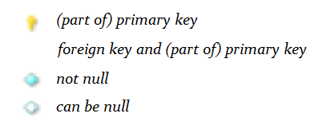

1. Application

# Project management

# Project implementation

# Conclusion

# Reference