
ADDIS ABABA SCIENCE AND TECHNOLOGY UNIVERSITY
DEPARTMENT OF SOFTWARE ENGINEERING
SECTION C

GROUP MEMBERS……………………………….…. ID
- NATNAEL ASFAW …………………….. 1071/15
- NATNAEL KEBEDE …………………… 1067/15
- NATNAEL SAMSON ……………………1065/15
- NATNAEL YONAS ……………………...1049/15
- NIKODIMOS HUNEGN………………..1094/15
- MESUD MELAKU………………..0916/15

COFFEE QUALITY INTELLIGENCE
Machine Learning Models — Technical Documentation

Project Overview & Model Reference

Version  1.0 | Date  2025
Domain  Coffee Quality & Grading | Status  Released

Table of Contents
1. Executive Summary 1
2. Project Overview 2
2.1 Background & Motivation 2
2.2 Dataset Summary 2
2.3 Score Distribution 2
2.4 Quality by Country and Processing Method 3
3. Model 1 — Coffee Quality Scorer 5
3.1 Objective 5
3.2 Feature Engineering & Correlation Analysis 5
3.3 Model Architecture 5
3.3.1 Model 1a — Linear Regression (Baseline) 5
3.3.2 Model 1b — XGBoost Regressor (Tuned) 6
3.4 Results & Model Comparison 6
3.5 SHAP Feature Importance 6
4. Model 2 — Roast Level Classifier 8
4.1 Objective 8
4.2 Dataset 8
4.3 Architecture — MobileNetV2 Transfer Learning 8
4.4 Training Performance 8
4.5 Classification Results 9
5. Model 3 — Defect Detector 10
5.1 Objective 10
5.2 Defect Classes 10
5.3 Dataset 10
5.4 Architecture — MobileNetV2 with Dropout 10
5.5 Training Performance 11
5.6 Classification Results 11
6. Supplementary — K-Means Flavor Clustering 13
6.1 Objective 13
6.2 Methodology 13
6.3 Elbow Method — Optimal Cluster Count 13
6.4 Cluster Profiles 13
6.5 Cluster Visualization 14
7. Ethiopian Coffee Deep Dive 15
7.1 Scope 15
7.2 Regional Sample Distribution 15
7.3 Predicted Quality by Region 15
7.4 Predicted vs. Actual Scores 16
8. Limitations & Known Issues 18
8.1 Dataset Constraints 18
8.2 Model Limitations 18
8.3 Data Quality 18
9. Recommendations & Future Work 19
9.1 Short-Term 19
9.2 Medium-Term 19
9.3 Long-Term 19
10. Technical Appendix 20
10.1 Model Summary Table 20
10.2 Technology Stack 20
10.3 Glossary 20
11. References 21

1. Executive Summary
This document provides comprehensive technical documentation for a suite of machine learning models developed to assess, classify, and segment Ethiopian and global specialty coffee. The project combines classical statistical learning, deep learning with transfer learning, and unsupervised clustering to deliver an end-to-end intelligent grading pipeline.

Project at a Glance
• Model 1 — Coffee Quality Scorer: Linear Regression & XGBoost on cupping sensory data
• Model 2 — Roast Level Classifier: MobileNetV2 CNN trained on bean imagery (4 classes)
• Model 3 — Defect Detector: MobileNetV2 CNN for granular defect detection (9 classes)
• Supplementary — K-Means Flavor Clustering: Unsupervised segmentation of flavor profiles
• Ethiopian Focus Analysis: Regional quality benchmarking for Guji, OROMIA, and Sidama

2. Project Overview

2.1 Background & Motivation
Ethiopia is the birthplace of Arabica coffee and remains one of the world's most significant specialty coffee-producing nations. Despite its rich heritage, quality assessment in the supply chain relies heavily on manual cupping and subjective grading. This project applies machine learning to automate and standardize quality prediction, roast classification, and defect detection, supporting both producers and buyers across the value chain.

2.2 Dataset Summary
The primary dataset for quality regression and clustering is sourced from CQI (Coffee Quality Institute) cupping records. The image datasets for roast and defect classification were obtained from Kaggle (gpiosenka/coffee-bean-dataset).

Dataset | Size | Usage
CQI Cupping Records (Ethiopia) | 207 rows, 13 features | Quality scoring & clustering
Coffee Bean Imagery | 1,600 images (224×224) | Roast level classification
Coffee Defect Imagery | 1,260 images (224×224) | Defect detection (9 classes)

2.3 Score Distribution
The overall cupping score distribution is approximately bell-shaped, centered around 83–84 points, consistent with the specialty coffee range (80+). The target variable spans from 78.0 to 89.3 with a mean of 83.71.
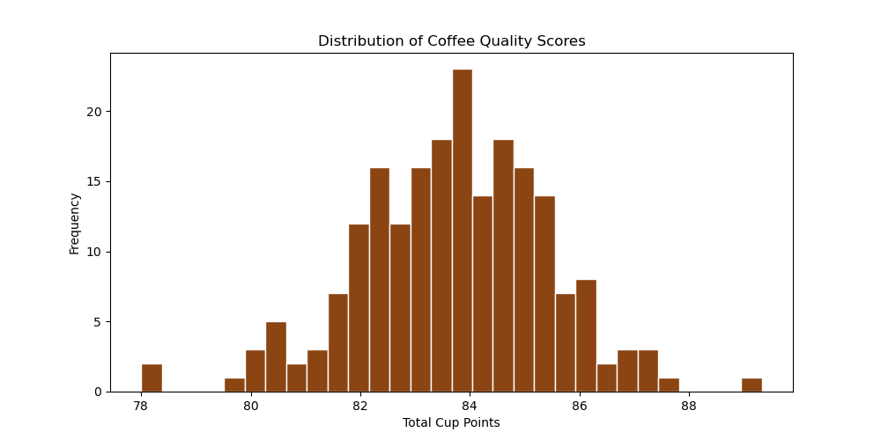
Figure 1: Distribution of Total Cup Points across the dataset

2.4 Quality by Country and Processing Method
Taiwan, Ethiopia, and Guatemala rank among the top-performing origins. Anaerobic and Semi-Washed processing methods tend to yield higher median scores, though with greater variability than Washed/Wet methods.
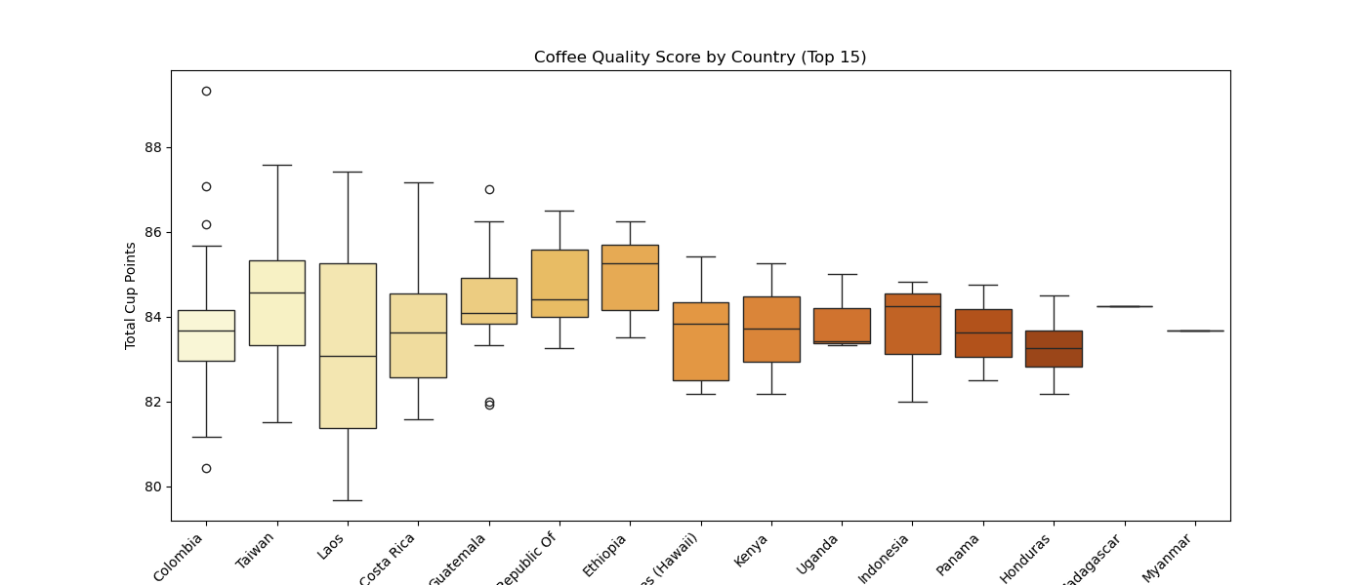
Figure 2: Coffee Quality Score by Country of Origin (Top 15)
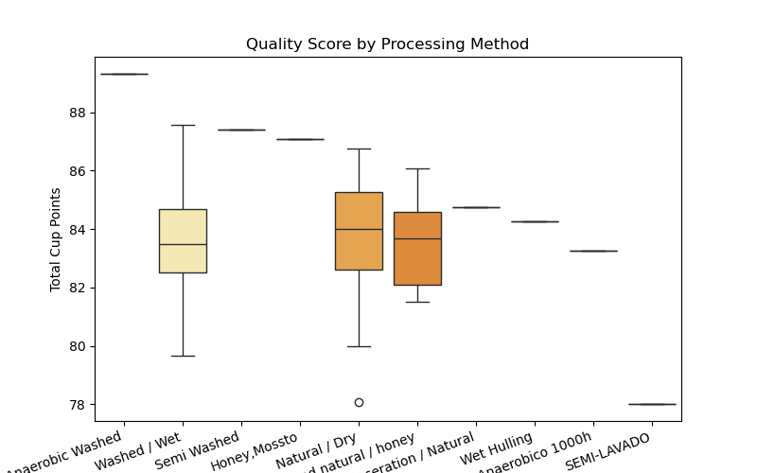
Figure 3: Quality Score by Processing Method

3. Model 1 — Coffee Quality Scorer

3.1 Objective
Predict the Total Cup Points (TCP) of a coffee sample from cupping sensory sub-scores and physical attributes. TCP is the primary SCA specialty coffee quality metric, aggregating scores across aroma, flavor, aftertaste, acidity, body, balance, uniformity, clean cup, and sweetness.

3.2 Feature Engineering & Correlation Analysis
Thirteen features were used for training. A correlation analysis reveals that Flavor (r = 0.94), Aftertaste (r = 0.93), Balance (r = 0.93), and Aroma (r = 0.87) are the strongest predictors of Total Cup Points. Uniformity, Sweetness, and Clean Cup exhibit near-zero variance in this dataset and contribute minimally.
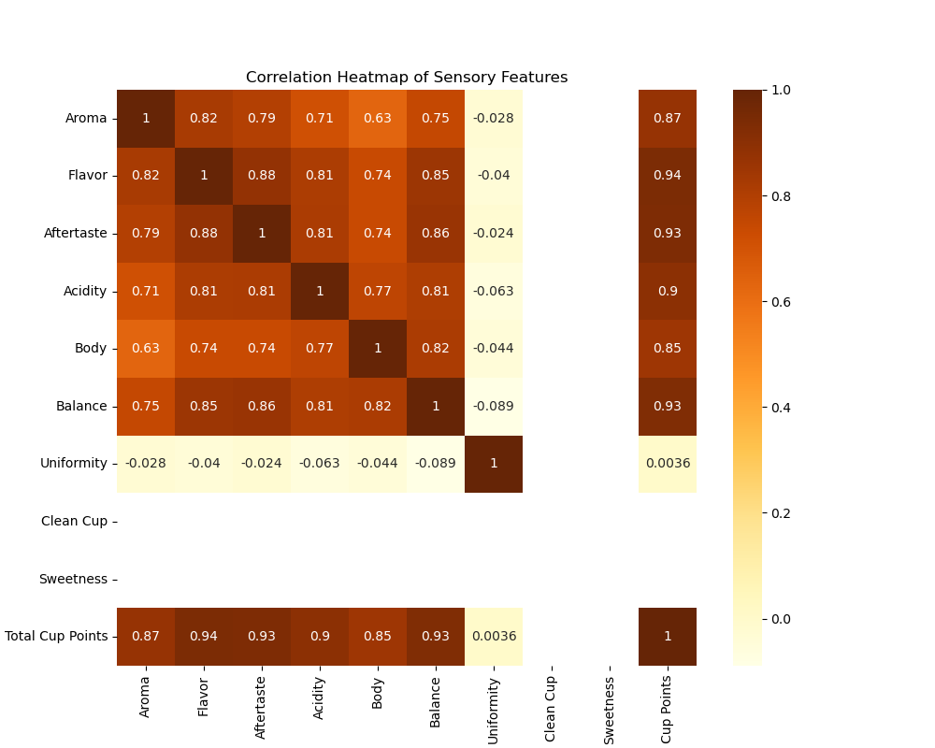
Figure 4: Correlation Heatmap of Sensory Features vs. Total Cup Points

3.3 Model Architecture

3.3.1 Model 1a — Linear Regression (Baseline)
- Algorithm: Ordinary Least Squares (OLS) Linear Regression
- Preprocessing: Standard feature scaling
- Validation: 5-fold cross-validation
- Purpose: Establish a high-interpretability baseline

3.3.2 Model 1b — XGBoost Regressor (Tuned)
- Algorithm: eXtreme Gradient Boosting (XGBRegressor)
- Hyperparameter tuning: Grid search over learning_rate, max_depth, n_estimators
- Best hyperparameters: learning_rate = 0.05, max_depth = 3, n_estimators = 300
- Validation: 5-fold cross-validation with early stopping

3.4 Results & Model Comparison
Linear Regression outperforms XGBoost on this dataset. This is expected given the near-linear additive structure of cupping sub-scores. The XGBoost model shows mild overfitting (Train R² = 0.999 vs. Test R² = 0.960).

Metric | Linear Regression | XGBoost
Test RMSE | 0.128 | 0.341
Test R² | 0.994 | 0.960
CV R² Mean | 0.992 ± 0.007 | 0.958 ± 0.015
Train R² | 0.996 | 0.999
Train RMSE | 0.109 | 0.065

Recommendation: Linear Regression is the preferred production model for quality scoring due to its superior generalization (Test R² = 0.994), lower variance, and full interpretability. XGBoost may be revisited with larger training data.

3.5 SHAP Feature Importance
SHAP (SHapley Additive exPlanations) analysis confirms that Aftertaste and Flavor drive the most impact on model output, followed by Acidity, Balance, Aroma, and Body. Physical attributes such as Altitude and Moisture Percentage show smaller but positive contributions.
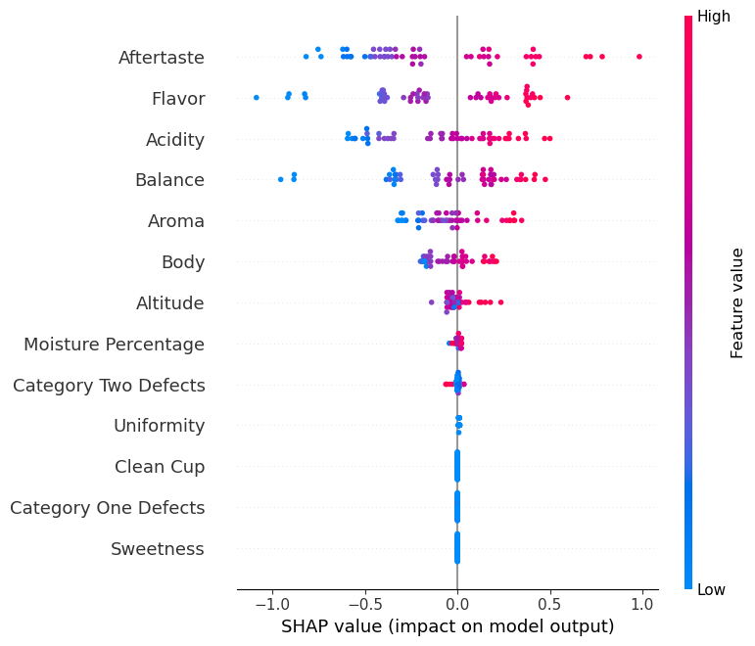
Figure 5: SHAP Summary Plot — Feature Impact on Quality Score Prediction

4. Model 2 — Roast Level Classifier

4.1 Objective
Classify coffee bean images into one of four roast levels: Dark, Green (unroasted), Light, and Medium. This model enables automated visual quality control at intake or post-roasting stages.

4.2 Dataset
- Source: Kaggle — gpiosenka/coffee-bean-dataset-resized-224-x-224
- Classes: Dark, Green, Light, Medium
- Training images: 1,200 | Validation/Test images: 400
- Image dimensions: 224 × 224 × 3 (RGB)
- Batch size: 32 | Epochs: 10

4.3 Architecture — MobileNetV2 Transfer Learning
The model leverages MobileNetV2 pre-trained on ImageNet as a frozen feature extractor. A lightweight classification head is appended and trained on the coffee imagery.

Layer | Configuration
Base Model | MobileNetV2 (ImageNet pretrained, all layers frozen)
Feature Extraction | GlobalAveragePooling2D
Dense Layer | Dense(128, activation='relu')
Output Layer | Dense(4, activation='softmax')
Optimizer | Adam (default learning rate)
Loss Function | Categorical Cross-Entropy

4.4 Training Performance
The model converged rapidly, achieving 97.75% validation accuracy by Epoch 1 due to the powerful ImageNet features. Peak validation accuracy of 100% was achieved at Epoch 8.
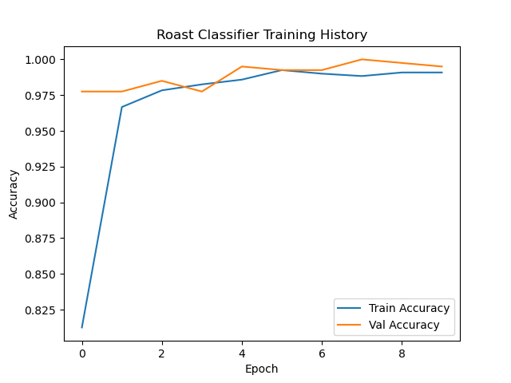
Figure 6: Roast Classifier Training History (Accuracy per Epoch)

4.5 Classification Results
The model achieves near-perfect classification across all four roast levels. Only 2 out of 400 test images were misclassified (1 Dark predicted as Medium, 1 Light predicted as Medium).

Class | Precision | Recall | F1-Score | Support | Notes
Dark | 1.00 | 0.99 | 0.99 | 100
Green | 1.00 | 1.00 | 1.00 | 100 | Perfect
Light | 1.00 | 0.99 | 0.99 | 100
Medium | 0.98 | 1.00 | 0.99 | 100
Accuracy / Avg | — | — | 0.99 | 400 | Overall

Key Takeaway — Roast Classifier
Final Test Accuracy: 99.5% | Best Val Accuracy: 100% (Epoch 8)
All four roast classes achieved F1-score ≥ 0.99. The model is production-ready for automated visual roast grading.

5. Model 3 — Defect Detector

5.1 Objective
Identify and classify 9 distinct types of coffee bean defects from images. Accurate defect detection is critical for grading lots according to SCA standards, where primary and secondary defect counts directly determine cup quality eligibility.

5.2 Defect Classes
The model classifies the following nine defect categories:
- black — Fully black/dead beans indicating fermentation or drying failure
- broken — Physically fractured or chipped beans
- foreign — Non-coffee material in the lot
- fraghusk — Parchment fragments or husk remnants
- green — Underdeveloped/unripe beans passed into the lot
- husk — Dried fruit skin attached to the bean
- immature — Pale, underdeveloped beans
- infested — Beans showing insect damage (CBB)
- sour — Fermented/discolored beans

5.3 Dataset
- Training images: 1,005 | Validation images: 123 | Test images: 132
- Image dimensions: 224 × 224 × 3 (RGB)
- Batch size: 32 | Max Epochs: 16 (with early stopping, patience = 5)
- Note: Class imbalance present — sour (3 test), immature (4), husk (5) have very low support

5.4 Architecture — MobileNetV2 with Dropout
The defect detector uses a similar MobileNetV2 backbone with an added Dropout(0.3) layer for regularization, essential given the higher number of classes and class imbalance.

Layer | Configuration
Base Model | MobileNetV2 (ImageNet pretrained, all layers frozen)
Feature Extraction | GlobalAveragePooling2D
Dense Layer | Dense(128, activation='relu')
Regularization | Dropout(0.3)
Output Layer | Dense(9, activation='softmax')
Optimizer | Adam
Loss Function | Categorical Cross-Entropy
Callbacks | ModelCheckpoint (best val_accuracy) + EarlyStopping (patience=5)

5.5 Training Performance
Training showed gradual convergence over 16 epochs. The best validation accuracy of 85.37% was achieved at Epoch 11. Validation accuracy fluctuates due to the small validation set (123 images) and class imbalance.
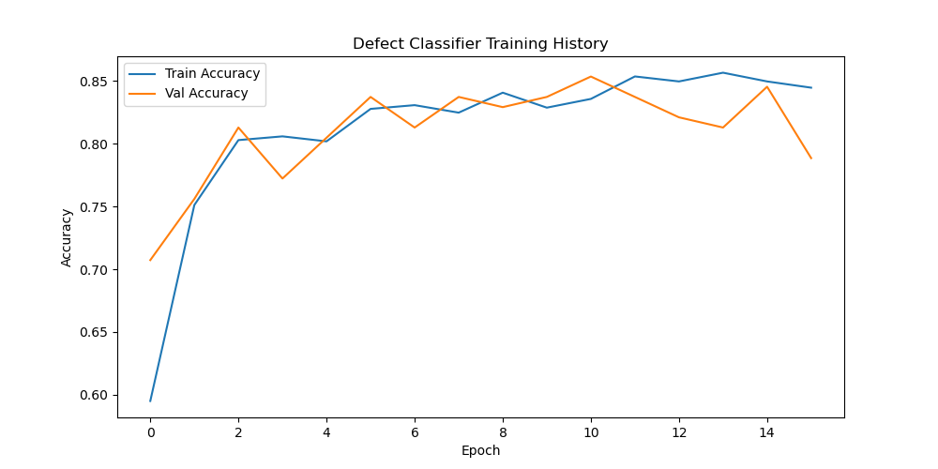
Figure 7: Defect Classifier Training History (Accuracy per Epoch)

5.6 Classification Results
Overall test accuracy is 87% (weighted average F1 = 0.86). High-support classes (black, broken, foreign, infested) achieve strong F1-scores above 0.85. Low-support classes (sour, immature, green) show degraded performance due to insufficient training examples.

Class | Precision | Recall | F1-Score | Support | Observation
black | 0.81 | 0.90 | 0.85 | 29
broken | 0.91 | 1.00 | 0.95 | 21 | Strong recall
foreign | 0.97 | 0.94 | 0.95 | 31
fraghusk | 0.92 | 1.00 | 0.96 | 12
green | 0.38 | 0.43 | 0.40 | 7 | Low sample count
husk | 1.00 | 0.80 | 0.89 | 5 | Very low support
immature | 1.00 | 0.25 | 0.40 | 4 | Low support
infested | 0.90 | 0.95 | 0.93 | 20
sour | 0.00 | 0.00 | 0.00 | 3 | Needs more data
Overall Accuracy | — | — | 0.87 | 132 | Weighted avg 0.86

Key Takeaway — Defect Detector
Best Val Accuracy: 85.37% (Epoch 11) | Test Accuracy: 87%
Classes with low training support (sour, immature, green, husk) require additional data collection.
Recommended next step: Augmented data collection for underrepresented defect types + fine-tuning MobileNetV2 top layers.

6. Supplementary — K-Means Flavor Clustering

6.1 Objective
Unsupervised clustering groups coffees by sensory profile without predefined labels, enabling market segmentation, blending recommendations, and targeted quality improvement.

6.2 Methodology
- Algorithm: K-Means clustering
- Features: Aroma, Flavor, Acidity, Body, Balance (5 normalized sensory dimensions)
- Optimal k: 4 (determined via elbow method)
- Final inertia: 20.88

6.3 Elbow Method — Optimal Cluster Count
The elbow plot shows a pronounced inflection at k = 4, confirming this as the optimal number of clusters. Beyond k = 5, the marginal reduction in inertia becomes minimal.
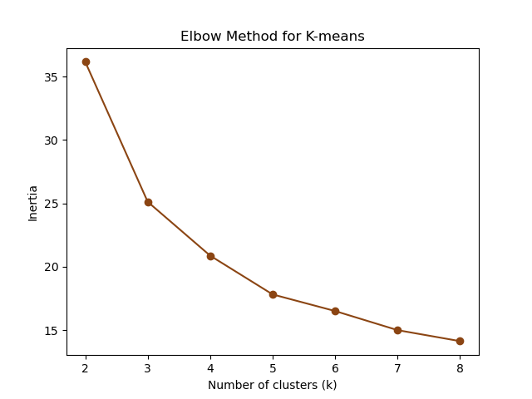
Figure 8: Elbow Method for K-Means Cluster Selection

6.4 Cluster Profiles

Cluster Name | Aroma | Flavor | Acidity | Body | Balance
Bright & Floral (0) | 8.17 | 8.19 | 8.07 | 7.98 | 8.05
Earthy & Full-bodied (1) | 7.64 | 7.67 | 7.63 | 7.60 | 7.59
Balanced & Sweet (2) | 7.89 | 7.92 | 7.85 | 7.77 | 7.79
Mild & Neutral (3) | 7.35 | 7.35 | 7.33 | 7.32 | 7.28

6.5 Cluster Visualization
The scatter plot of Aroma vs. Acidity reveals well-separated clusters with clear sensory differentiation. Cluster 0 (Bright & Floral) occupies the high-quality upper-right quadrant, while Cluster 3 (Mild & Neutral) clusters in the lower-left.
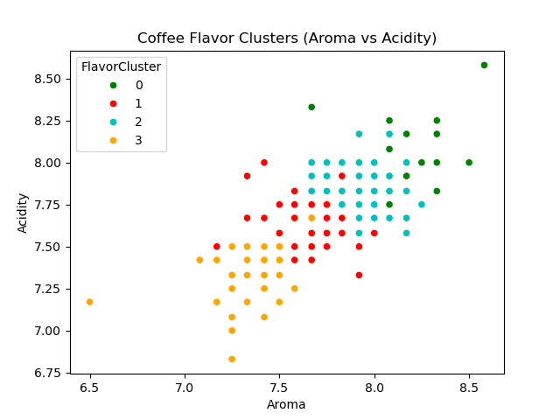
Figure 9: Coffee Flavor Clusters — Aroma vs. Acidity

7. Ethiopian Coffee Deep Dive

7.1 Scope
A focused analysis was performed on Ethiopian coffee samples in the dataset. Ethiopia contributed samples from eight distinct regions/designations. This analysis applies the trained Linear Regression quality model to predict and compare scores by region.

7.2 Regional Sample Distribution
Sample coverage spans Addis Ababa, Guji, OROMIA, Oromia, Sidama, Southern Ethiopia Guji, Gedeb-Yirgacheffe-Sidamo, and generic Ethiopia designations. Guji, OROMIA, and Sidama each contribute two samples.
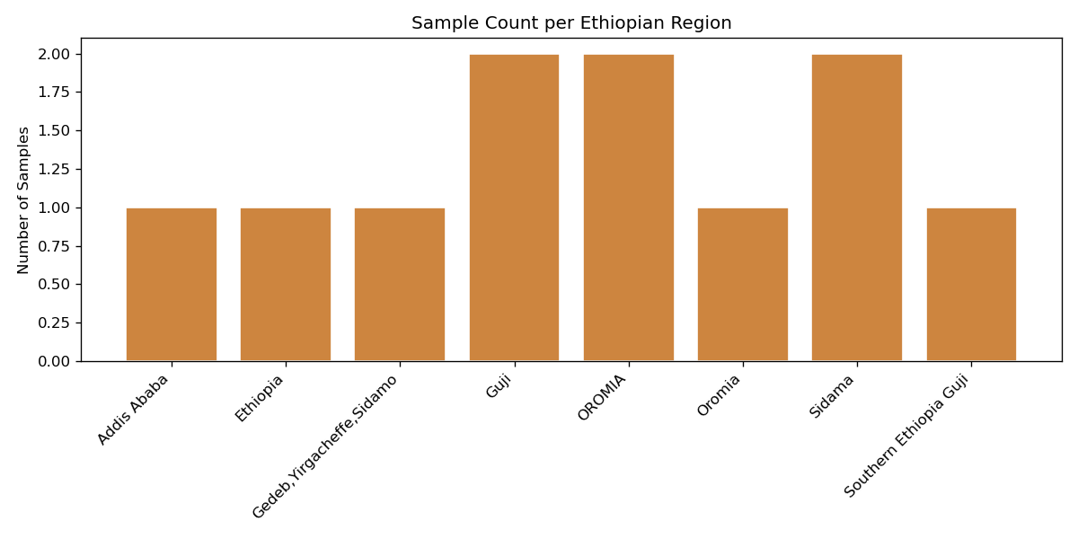
Figure 10: Sample Count per Ethiopian Region

7.3 Predicted Quality by Region
All Ethiopian samples in the dataset exceed the 80-point specialty threshold. Guji leads with the highest average predicted score (~86 points), followed closely by OROMIA and Sidama (both ~84.5). All regions comfortably qualify as specialty grade.
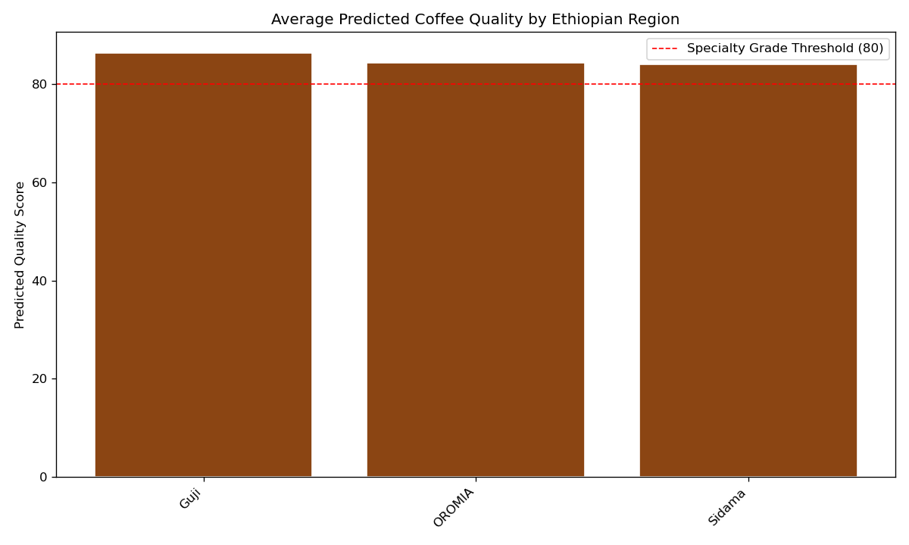
Figure 11: Average Predicted Quality Score by Ethiopian Region

7.4 Predicted vs. Actual Scores
The predicted vs. actual scatter for Ethiopian coffees shows excellent alignment with the perfect-prediction line (R² close to 1.0). Minor deviations are observed at the upper score range (86+), where sample density is lower.
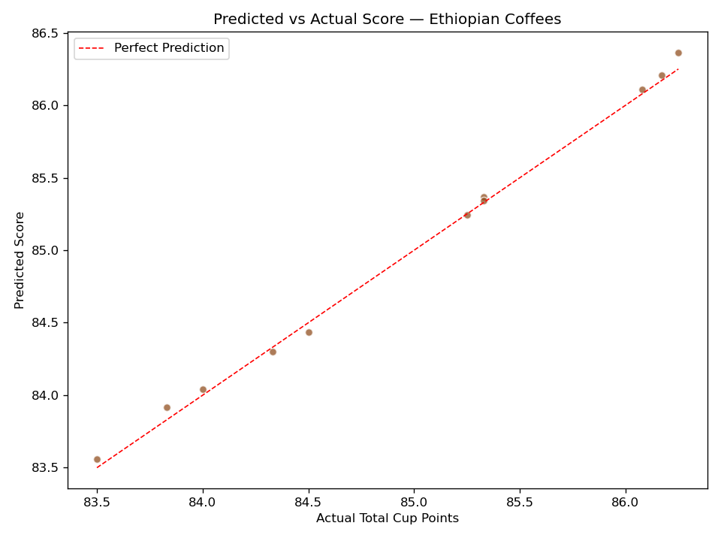
Figure 12: Predicted vs. Actual Score — Ethiopian Coffees

Ethiopian Coffee Insight
All regions tested score above the SCA Specialty Grade threshold of 80 points.
Guji region coffees achieve the highest predicted quality, consistent with its reputation for complex fruit-forward profiles.
Model predictions track actual scores closely (see Figure 12), validating generalizability to Ethiopian origins.

8. Limitations & Known Issues

8.1 Dataset Constraints
- Sample size for cupping regression (207 rows) is relatively small for tree-based methods — explains XGBoost overfitting
- Defect classes with very low support (sour: 3, immature: 4, husk: 5) produce unreliable F1 scores
- Ethiopian regional analysis is based on small per-region sample counts (1–2 samples per region)

8.2 Model Limitations
- Linear Regression assumes additive feature contributions — may not generalize to highly unusual flavor profiles
- MobileNetV2 backbone is frozen — fine-tuning could improve performance for both image classifiers
- Defect detector macro F1 (0.70) is dragged down by minority classes; weighted F1 (0.86) is more representative

8.3 Data Quality
- Minor label inconsistencies in Ethiopian region names (OROMIA vs. Oromia) exist in the source data
- Uniformity, Clean Cup, and Sweetness show near-constant values, limiting their predictive value in regression

9. Recommendations & Future Work

9.1 Short-Term
- Collect additional defect images for sour, immature, husk, and green classes (target 100+ per class): Data Collection
- Unfreeze and fine-tune the top MobileNetV2 layers for both image models: Fine-tuning
- Combine Linear Regression and XGBoost predictions via stacking to improve robustness: Ensemble

9.2 Medium-Term
- Expand Ethiopian dataset to 20+ samples per region for statistically valid regional benchmarking: Regional Expansion
- Encode processing method (Washed, Natural, Honey) as a model feature in regression: Processing Method Features
- Build an interactive SHAP dashboard for quality score interpretation: Explainability Dashboard

9.3 Long-Term
- Combine sensory scores + bean imagery into a unified quality prediction pipeline: Multi-Modal Pipeline
- Deploy models via REST API for integration with cupping lab software: Real-Time API
- Implement retraining triggers as new cupping data accumulates: Continuous Learning

10. Technical Appendix

10.1 Model Summary Table

Model | Type | Task | Key Metric | Score
Quality Scorer (LR) | Regression | Predict TCP Score | Test R² | 0.994
Quality Scorer (XGB) | Regression | Predict TCP Score | Test R² | 0.960
Roast Classifier | CNN Classification | 4-class Roast Level | Test Accuracy | 99.5%
Defect Detector | CNN Classification | 9-class Defect Type | Test Accuracy | 87.0%
Flavor Clustering | Unsupervised | Market Segmentation | Clusters (k) | 4

10.2 Technology Stack
- Python 3.10+
- scikit-learn — Linear Regression, XGBoost, K-Means, cross-validation
- TensorFlow / Keras — MobileNetV2 transfer learning, image augmentation
- SHAP — Model explainability for regression models
- pandas, numpy, matplotlib, seaborn — Data processing and visualization
- kagglehub — Dataset acquisition for image models

10.3 Glossary
- TCP (Total Cup Points): SCA's aggregate cupping score (max 100)
- SCA: Specialty Coffee Association — sets the 80-point specialty grade threshold
- MobileNetV2: Lightweight CNN architecture optimized for efficient image classification
- SHAP: Game-theoretic approach to explain machine learning model outputs
- K-Means: Partition-based clustering algorithm minimizing within-cluster variance
- Transfer Learning: Re-using pretrained model weights (ImageNet) for a new task
- Early Stopping: Training termination when validation metric stops improving

11. References
The following works, datasets, and resources informed the design, methodology, and implementation of this project.

[1] Mitchell, M., Wu, S., Zaldivar, A., et al. (2019). Model Cards for Model Reporting. Proceedings of the Conference on Fairness, Accountability, and Transparency (FAT*'19).
[2] Gebru, T., Morgenstern, J., Vecchione, B., et al. (2018). Datasheets for Datasets. arXiv:1803.09010.
[3] fatihb. Coffee Quality Data (CQI). Kaggle. https://www.kaggle.com/datasets/fatihb/coffee-quality-data-cqi
[4] gpiosenka. Coffee Bean Dataset (Resized 224 x 224). Kaggle. https://www.kaggle.com/datasets/gpiosenka/coffee-bean-dataset-resized-224-x-224
[5] vishwesh-pbvmh. coffee-bean-defect Dataset, v1 (2024-03-10). Roboflow Universe. https://universe.roboflow.com/vishwesh-pbvmh/coffee-bean-defect-smvw1. License: CC BY 4.0.
[6] Lundberg, S. M., & Lee, S. I. (2017). A Unified Approach to Interpreting Model Predictions. Advances in Neural Information Processing Systems (NeurIPS).
[7] Sandler, M., Howard, A., Zhu, M., et al. (2018). MobileNetV2: Inverted Residuals and Linear Bottlenecks. Proceedings of the IEEE Conference on Computer Vision and Pattern Recognition (CVPR).
[8] Chen, T., & Guestrin, C. (2016). XGBoost: A Scalable Tree Boosting System. Proceedings of the 22nd ACM SIGKDD International Conference on Knowledge Discovery and Data Mining.

