**CCT College Dublin**

**Assessment Cover Page**

*To be provided separately as a word doc for students to include with every submission.*

|  |  |
| --- | --- |
| **Module Title:** | *Programming for DA*  *Statistics for Data Analytics*  *Machine Learning for Data Analysis*  *Data Preparation & Visualisation* |
| **Assessment Title:** |  |
| **Lecturer Name:** | *David Gonzalez*  *Marina Iantorno*  *Muhammad Iqbal*  *David McQuaid* |
| **Student Full Name:** | *Natalia Iolchin* |
| **Student Number:** | *sba23303* |
| **Assessment Due Date:** | *10/11/2023* |
| **Date of Submission:** |  |

**Declaration**

|  |
| --- |
| By submitting this assessment, I confirm that I have read the CCT policy on Academic Misconduct and understand the implications of submitting work that is not my own or does not appropriately reference material taken from a third party or other source. I declare it to be my own work and that all material from third parties has been appropriately referenced. I further confirm that this work has not previously been submitted for assessment by myself or someone else in CCT College Dublin or any other higher education institution. |

# Group ID - MSc in Data Analytics

Author: N. Iolchin

e-mail: [sba23303@student.cct.ie](mailto:sba23303@student.cct.ie)

Student ID: sba23303

1. **Introduction**

<https://www.gov.ie/en/publication/c1b0c9-national-broadband-plan/>

<https://nbi.ie/>

<https://esb.ie/media-centre-news/press-releases/article/2023/05/19/esb-networks-completes-process-for-development-of-private-mobile-network>

Industry development and Service on demand

Households? Enterprise?

Euro stats? Ireland stats?

From [Department of the Environment, Climate and Communications](https://www.gov.ie/en/organisation/department-of-the-environment-climate-and-communications/)

Published on 17 June 2020

Last updated on 22 February 2023

The National Broadband Plan (NBP) is the government’s initiative to deliver high speed broadband services to all premises in Ireland. This will be delivered through investment by commercial enterprises coupled with intervention by the State in those parts of the country where private companies have no plans to invest.

The State Intervention area includes:

* **over 560,000 premises**
* **1.1 million people**
* **Over 65,000 farms**
* **44,000 non-farm businesses**
* **679 schools**

The NBP is a key aspect of government strategy across areas including climate, agriculture, education, transport, tourism, sustainable growth, jobs and health.

Since the publication of the NBP in 2012, the commercial telecommunications sector has invested over €3.3 billion. At the time, 30% of Irish premises had access to high-speed broadband.

Investment was spent primarily on upgrading and modernising networks which support the provision of Gigabit broadband and mobile telecommunications services. Significant additional investment is expected over the coming years. Now, of the 2.4 million premises in Ireland, 77% can access commercially available high-speed broadband services of more than 30 Mbps.

Strategic Community Points (SCPs) are a key element of the NBP providing high-speed broadband in every county in advance of the roll out of the fibre to the home network. To support connected communities, approximately 284 publicly accessible SCPs known as Broadband Connections Points (BCPs) will be connected to high-speed broadband this year. BCPs assist communities gain access to high-speed broadband in advance of the main NBP deployment.

The NBP will contribute significantly to removing the existing digital divide between urban and rural communities in Ireland.

Taking on the challenge of delivering the National Broadband Plan, our team will be deploying fibre on approximately 1.5 million poles, many of them new, over 15,000km of underground ducts. We will use up to 142,000km of new fibre cable, and will run along almost 100,000km of the road network. We said it was big!

The network will be designed, built and operated by us, using a combination of State subsidy and commercial investment. It will make its services available to all of the rollout area, which accounts for 23% of the population in about approximately 569,000 homes, farms, schools and businesses. This project will radically change the broadband landscape across the country to ensure that every farm, business and home has access to high-speed broadband, no matter where they are located.

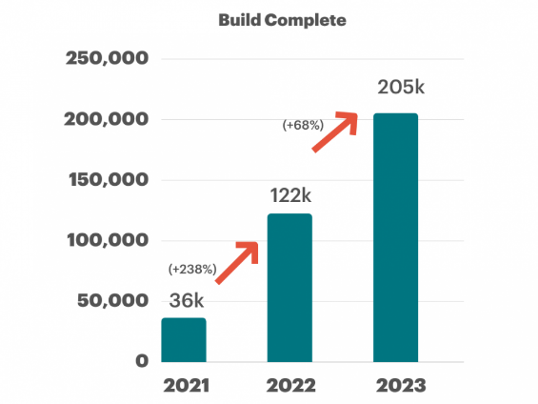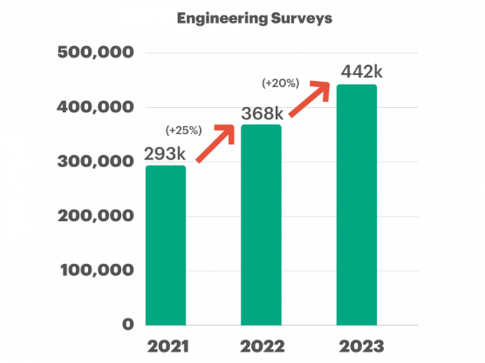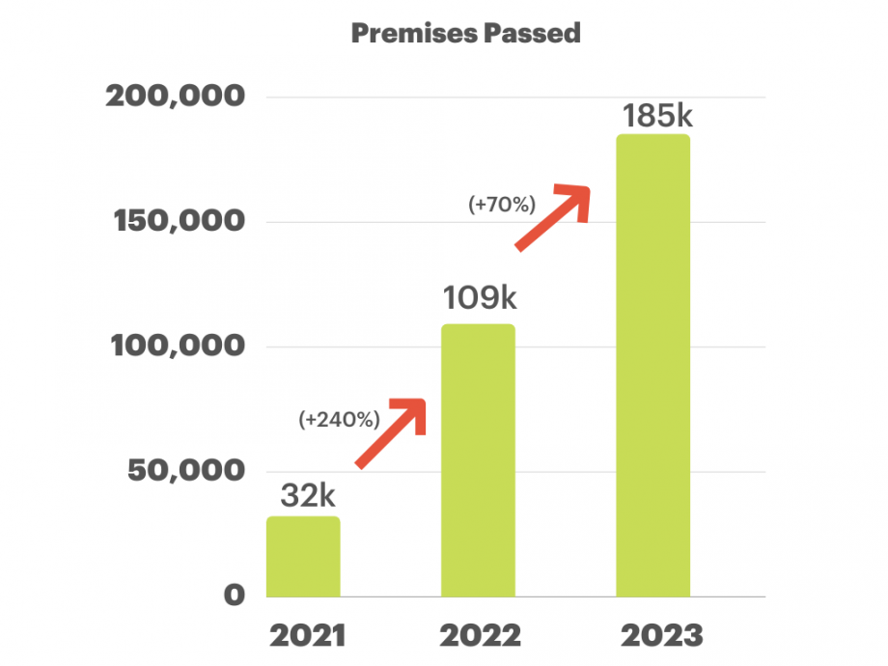

*Issued: 19 May 2023*

* **Company to work with Sigma Wireless Communications and Nokia to supply and install LTE core network and radio access network**
* **The 4G-equivilent mobile network will be an important infrastructural development to enable the delivery of ESB Networks’ “Networks for Net Zero” Strategy and the Government’s Climate Action Plan.**

ESB Networks announces that it has completed a process to award a contract for the development of a private mobile network. Sigma Wireless Communications will work with Nokia to supply and install the new LTE Core Network and Radio Access Network over a three-year period, with the network expected to be live from Q4 2023.

This follows from a 2019 decision by ComReg to award a 15-year licence for radio spectrum to ESB Networks. In its recently published *Networks for Net Zero* strategy, ESB Networks set out ambitious plans to develop the electricity network of the future which will be supported by a dedicated smart-grid telecommunication system.

* 1. **Objective**

Focus: Develop new products and services

* **Total amount of data used:** to predict the total amount of data that users will use based on their type of internet connection, frequency of usage, and demographic data.
* **Identification of trends in internet usage:** For example, information that certain demographics are using more data than others, can be used to develop new products and services, or to target marketing and advertising campaigns more effectively.
  1. **Scope**

Problems based on data about internet usage of households and enterprise, including:

* **Predicting future internet usage:** Machine learning algorithms can be used to predict future internet usage based on historical data. This can be useful for businesses to plan for future capacity needs, and for governments to plan for future infrastructure investments.
* **Identifying trends in internet usage:** Machine learning algorithms can be used to identify trends in internet usage, such as the increasing popularity of streaming video or the growing use of social media. This information can be used by businesses to develop new products and services, and by governments to develop new policies and regulations.
* **Segmenting customers:** Machine learning algorithms can be used to segment customers based on their internet usage patterns. This information can be used by businesses to target their marketing and advertising campaigns more effectively.
* **Developing new products and services:** Machine learning algorithms can be used to develop new products and services that are tailored to the needs of internet users.

1. Check if population is using internet with positive trend. (ICA77 2020)
2. Check if frequency of usage increases. ICA79 2017-2022
3. Check if estimated population will increase. PEA04 2011-2023
4. Check age of people with max% of internet usage, that use internet more often. ICA108 2020.2021.2022
5. Correlate this age with estimated population. (FORMULAS)
6. Check most disposable devices/recycling. SUST02 2022
7. Correlate mob and desktop/laptop devices (FORMULAS)
8. Correlate device usage (ages) with internet usage ages. (FORMULAS)
9. Check usage per region (ICA172 2020.2021.2022)
10. Check internet devices per region (ICA174 2021.2022)
11. Correlate development of mob and fixed infrastructure

**FUTURE RESEARCH**

Correlate Ireland trends with European?

Educational sector?

Educate population on how to use?

Develop TV streaming instead of current TV licence system?

Economic trend for Tech industry development?

Logistic vs e-commers?

1. **Materials and Methods**

Examples of machine learning algorithms that can be used to solve these problems:

* **Linear regression:** Linear regression can be used to predict future internet usage based on historical data.
* **Clustering:** Clustering can be used to identify trends in internet usage, such as the increasing popularity of streaming video or the growing use of social media.
* **Decision trees:** Decision trees can be used to segment customers based on their internet usage patterns.

1. **Results** 
   1. Programming for DA
   2. Statistics for Data Analytics
   3. Machine Learning for Data Analysis
   4. Data Preparation & Visualisation
2. **Discussion/Conclusions**

Identification of trends in internet usage. For example, information that certain demographics are using more data than others, can be used to develop new products and services, or to target marketing and advertising campaigns more effectively.

Overall, having data about type of internet connection, frequency of usage, and demographic data can be very useful for predicting internet usage and identifying trends. This information can be used to make better decisions about how to allocate resources and develop new products and services.