NOVA ML Demo walk-through.

This demo focuses on the functionality of the ML search optimisation algorithms and how they have been incorporated into the current geojson datasets we are using for NOVA and not on frontend which is for visual display of algorithm information.

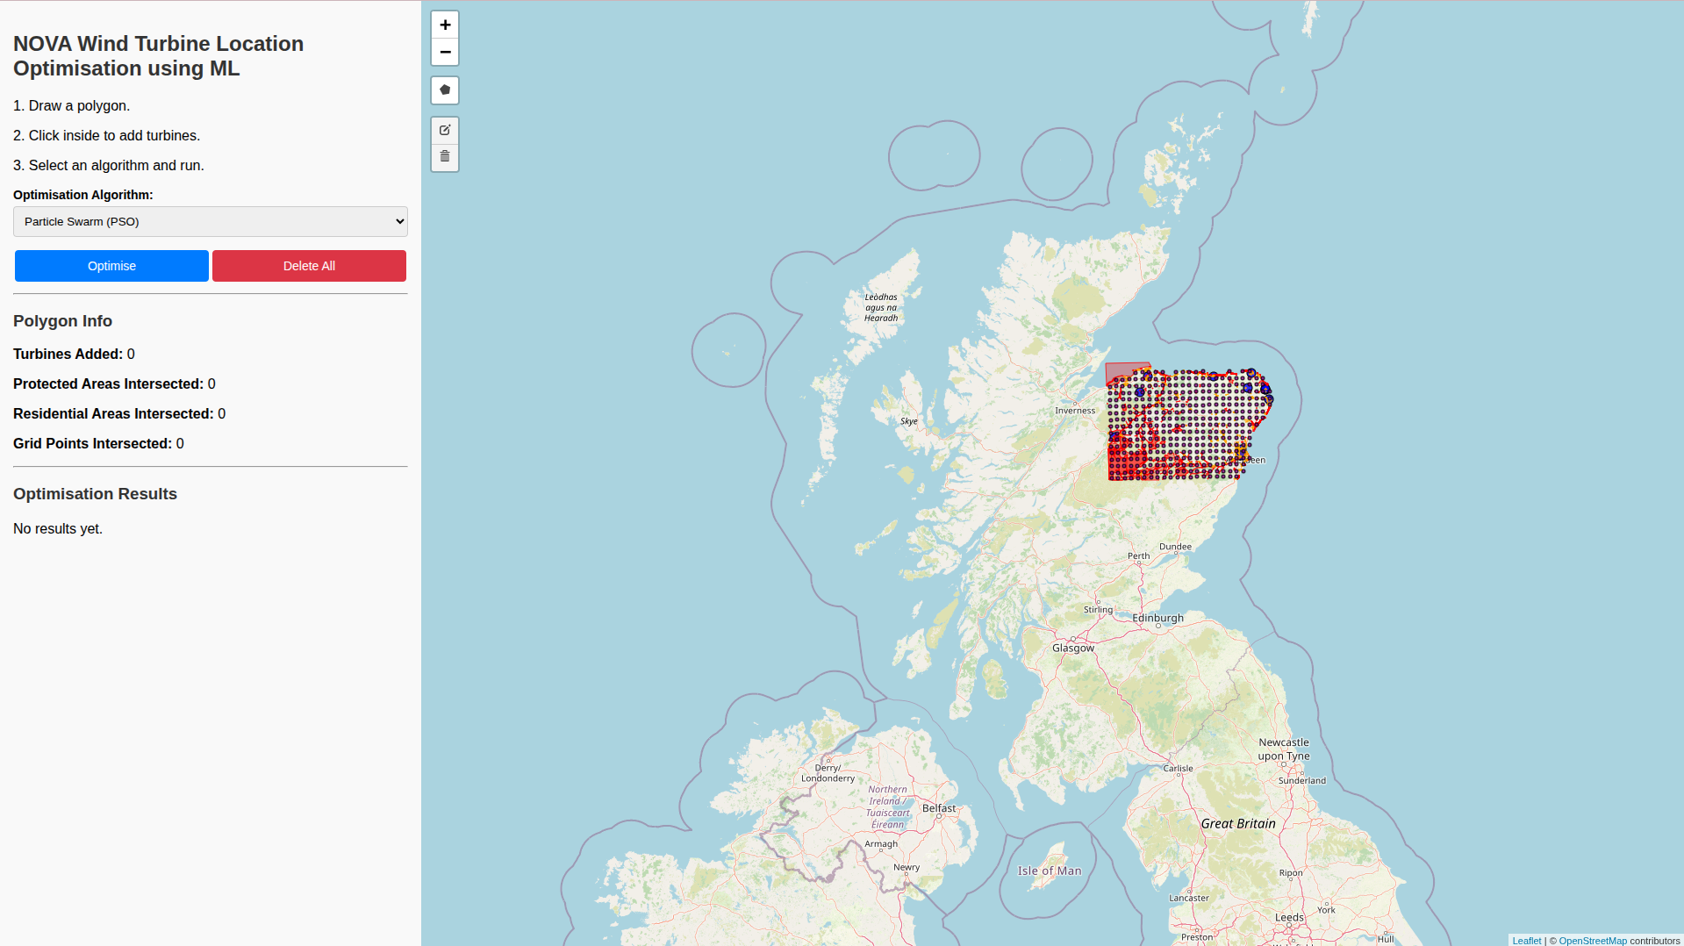
Landing page with data layers loaded for some parts of Scotland

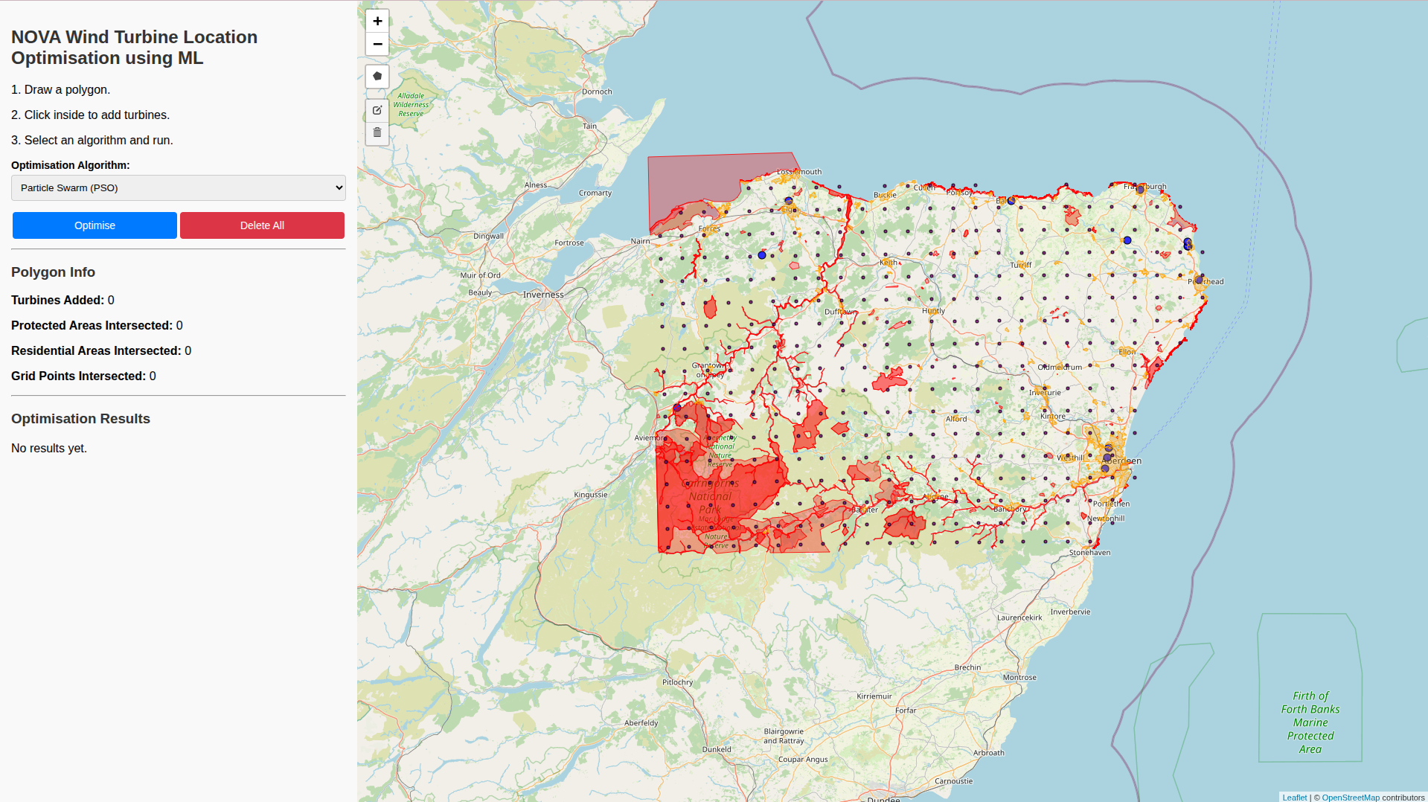
Zoomed in view showing protected areas in red, built-up areas in orange, grid supply points as blue circles and wind speeds as grey dots.

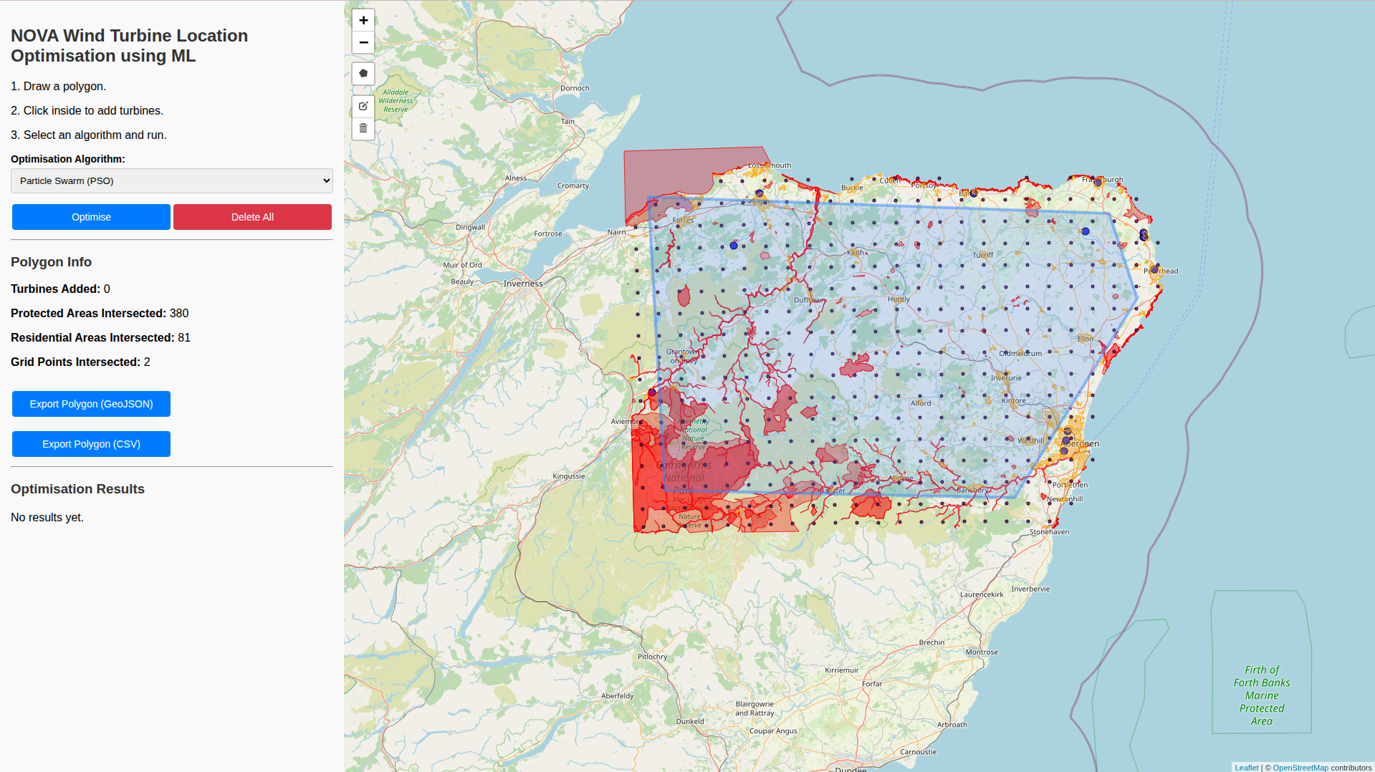
Polygon drawn using the draw polygon tool. Once drawn, a turbine (blue marker) can be added. Intersected layers are shown.

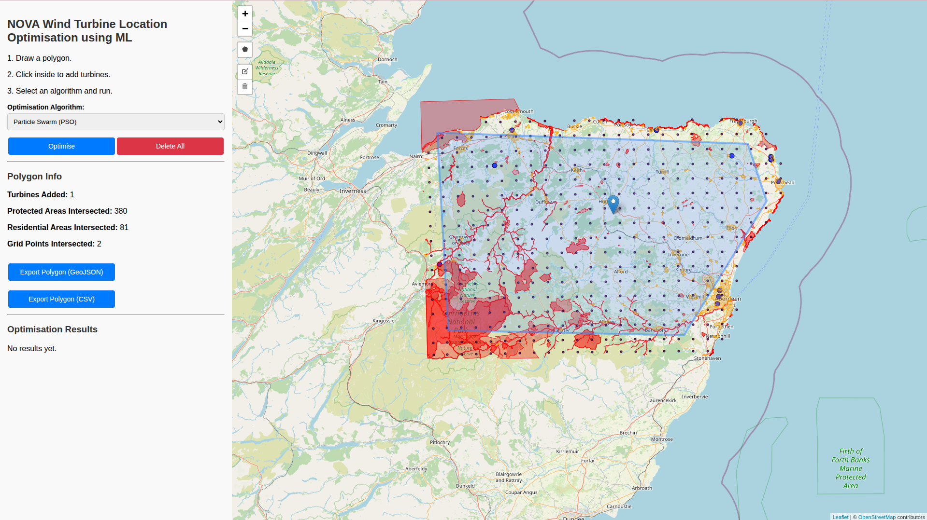
Once a turbine has been added anywhere in the polygon, the user can click on ‘optimise’ to run the any of the ML algorithms. Six algorithms have been developed and can be selected from the dropdown. Details and descriptions of these are documented on Confluence https://ndtp.atlassian.net/wiki/spaces/DPAAV/pages/106528805/NOVA+Machine+Learning+for+Optimal+Location

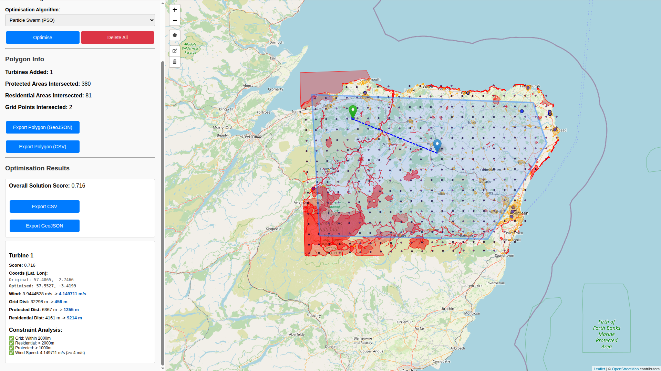
The algorithm completes within some seconds depending on size of drawn polygon and shows the optimal location using a green marker and a dotted line from the original location to the new optimised location. The result details and reasons are shown including previous and current coordinates and before and after wind speeds and distances from grid supply points, residential areas and protected areas.

The algorithms and further analysis of power generated, integration into grid, energy demand of the areas etc. will be further scoped and incorporated into the NOVA build.

