Predictive Analytics
Week 3 Assignment: Build Non-Linear Models Part 1
Todd DeLozier, MBA, Data+
3/1/2026

Abstract
This paper documents completion of Assignment 3, which required a conceptual analysis of subset and stepwise selection, an applied simulation exercise using forward and backward stepwise selection and the lasso, and continued participation in the Regression with Abalone Dataset Kaggle competition using a regularized regression model and a principal components regression model. The report emphasizes interpretability, cross-validated model selection, and diagnostic evaluation consistent with standard regression assumptions. Exactly eight charts are included, two from the applied simulation and six from the Kaggle modeling workflow. A separate space is reserved for Kaggle submission evidence and the GitHub repository link.

Conceptual Question 1 (ISLR Python, p. 283)
For a fixed number of predictors, best subset selection yields the smallest training residual sum of squares because it evaluates all candidate models of that size and selects the one that minimizes training error. Forward and backward stepwise selection constrain the search to a nested path and therefore can miss the globally optimal subset for a given size. In contrast, no approach is guaranteed to yield the smallest test residual sum of squares for a fixed number of predictors, because test performance depends on generalization under finite samples and on the bias variance tradeoff.
Forward stepwise selection is nested by construction, so the predictors selected in the model with k predictors are a subset of those selected in the model with k plus one predictors. Backward stepwise selection is also nested because it removes predictors sequentially from a larger model. However, there is no guaranteed subset relationship across solutions produced by forward and backward stepwise selection at adjacent model sizes, because the procedures traverse different search paths. Best subset selection is not constrained to be nested, so the best model of size k is not guaranteed to be a subset of the best model of size k plus one.

Applied Question 8 (ISLR Python, p. 286)

Simulation design and selection objectives
The applied exercise generates simulated data and fits polynomial candidate predictors from X through X to the tenth power. Model selection is performed using forward stepwise selection, backward stepwise selection, and the lasso. The lasso is used to demonstrate penalized estimation with cross-validation for penalty selection and to illustrate how correlated polynomial basis functions influence sparsity and coefficient allocation. Because the lasso is a shrinkage method that supports variable selection while stabilizing estimates, it is appropriate when predictors are correlated and when the goal includes interpretability through sparsity (Zou & Hastie, 2005).

Lasso cross-validation for the cubic signal
Figure A1 presents the cross-validation curve for the cubic signal simulation. The selected penalty corresponds to the minimum cross-validated error, reflecting a compromise between goodness of fit and coefficient shrinkage. In polynomial expansions, correlated basis terms can share explanatory variance, and the chosen penalty influences whether the fitted model concentrates weight on a small subset of terms or distributes weight across correlated predictors (Zou & Hastie, 2005).
Figure A1. Lasso cross-validation error versus alpha for the cubic signal.
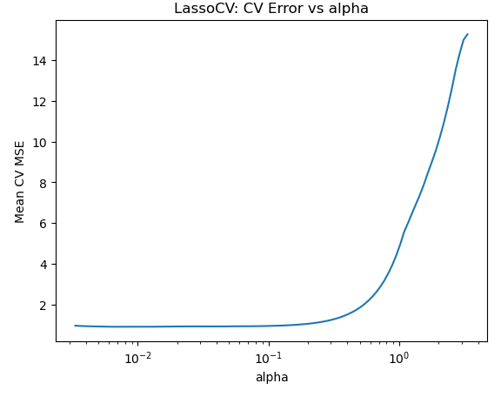

Lasso cross-validation for the seventh order signal
Figure A2 presents the cross-validation curve for the seventh order signal scenario. Cross-validation provides an empirical basis for selecting a penalty that stabilizes estimation while preserving the dominant signal component. Under strong correlation among polynomial bases, penalization can yield sparse or partially distributed representations depending on the sample realization and penalty strength, which is consistent with the elastic net and lasso literature on correlated predictors (Zou & Hastie, 2005).
Figure A2. Lasso cross-validation error versus alpha for the seventh order signal.
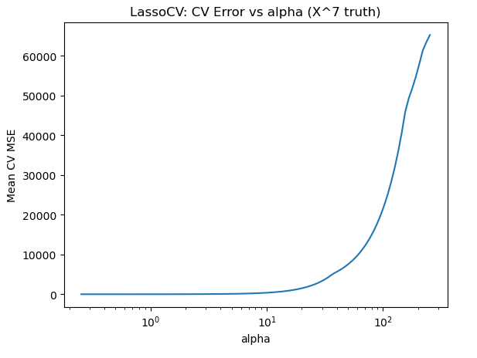

Kaggle Regression with Abalone Dataset

Data, preprocessing, and evaluation framework
The Kaggle Abalone dataset was provided as train.csv and test.csv. Predictors include numeric measurements and may include categorical attributes. Preprocessing used median imputation for numeric fields, mode imputation for categorical fields, one hot encoding for categorical predictors, and standardization for numeric predictors. Standardization is critical for both regularization and PCA-based methods because coefficient penalties and component directions depend on feature scale (Li & Li, 2026). Model evaluation used cross-validation on the training data, with root mean squared error used as the primary metric for model comparison.

Regularization model and subset-style selection logic
A regularization model was fit using elastic net. Elastic net combines L1 and L2 penalties and is designed to improve prediction and stability when predictors are correlated, while also supporting variable selection and grouped selection behavior under correlated feature sets (Zou & Hastie, 2005). The regularization model also provides a principled basis for ranking features by coefficient magnitude, which can be used to inform a compact subset-style refit when the transformed feature space becomes high dimensional after one hot encoding. This approach is consistent with practical recommendations to use shrinkage methods and cross-validation to guide model selection in multivariable settings (Li & Li, 2026).
Figure K1. Elastic net model selection evidence.
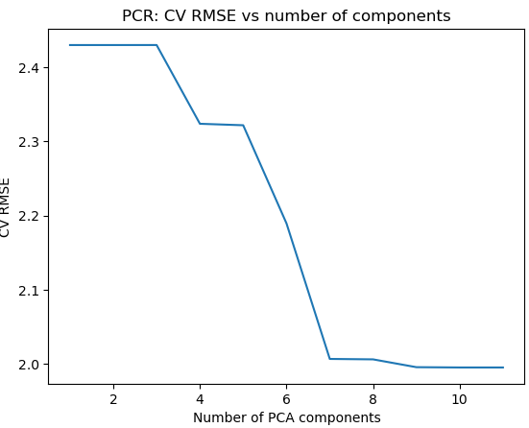
Figure K2. Subset-style refit model selection evidence as a function of top-k features.
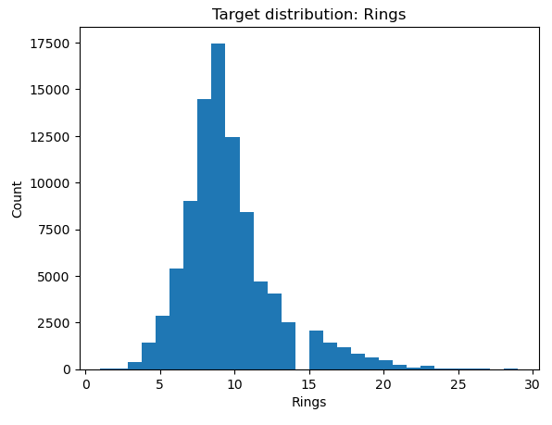

Principal components regression model
PCR was implemented by applying PCA to the preprocessed design matrix followed by ordinary least squares regression on the selected components. PCR mitigates multicollinearity by projecting correlated predictors into an orthogonal component basis, improving stability at the cost of interpretability in the original feature space (Li & Li, 2026). PCA and PCR-style approaches remain common in high-dimensional prediction contexts, and recent work continues to develop PCR variants for correlated-feature settings (Ding et al., 2022).
Figure K3. Cross-validated error versus number of PCA components for PCR.
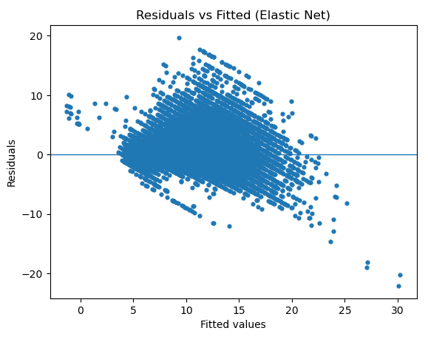

Regression assumptions and diagnostics
Diagnostic evaluation addresses regression assumptions. Residuals versus fitted plots provide evidence about linearity in the mean function and constant variance. Q-Q plots provide evidence about residual distributional shape. These checks support interpretability when conclusions depend on the adequacy of error structure assumptions, while cross-validation remains the primary guardrail for predictive overfitting in applied settings (Li & Li, 2026).
Figure K4. Residuals versus fitted for the elastic net model.
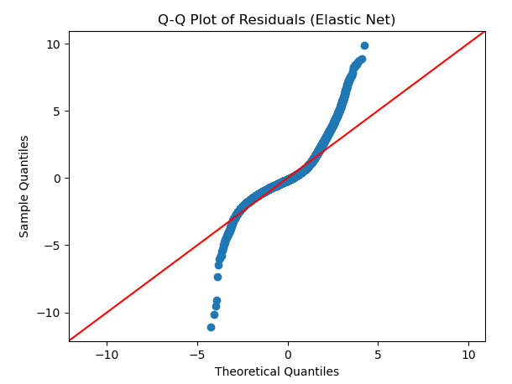
Figure K5. Q-Q plot for elastic net residuals.
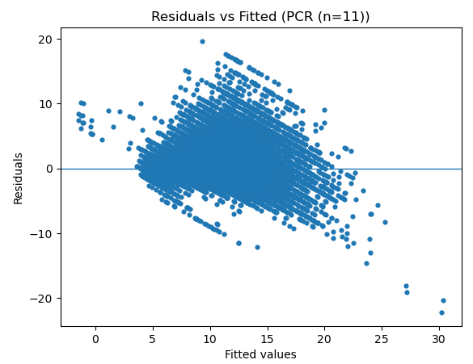
Figure K6. PCR residual diagnostic plot.
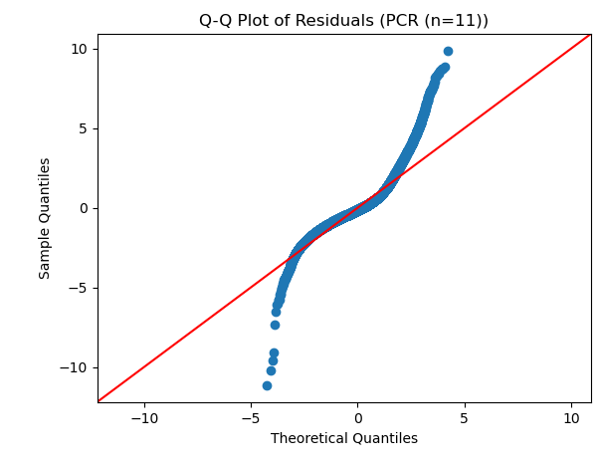

Kaggle submission evidence and reproducibility
Kaggle submission evidence.
[KAGGLE SUBMISSION SCREENSHOT INSERTED HERE]
GitHub repository link: [GITHUB LINK INSERTED HERE]

Conclusion
Assignment 3 integrated conceptual reasoning about subset and stepwise selection with simulation-based validation and applied predictive modeling in a Kaggle regression competition. The lasso cross-validation curves illustrate how penalty selection balances fit and stability under correlated polynomial features, consistent with the role of shrinkage methods in improving reliability and interpretability under correlation (Zou & Hastie, 2005). In the Kaggle Abalone task, elastic net regularization provides a principled approach to stable prediction and feature selection under correlated predictors, while PCR provides a complementary approach that reduces multicollinearity by projecting predictors into an orthogonal component space (Ding et al., 2022; Li & Li, 2026). Together, the results support a coherent modeling workflow grounded in cross-validation and diagnostic evaluation, aligned with best practices for multivariable linear modeling (Li & Li, 2026).

References
Ding, L., Zentner, G. E., & McDonald, D. J. (2022). Sufficient principal component regression for pattern discovery in transcriptomic data. Bioinformatics Advances, 2(1), vbac033. https://doi.org/10.1093/bioadv/vbac033
Li, B., & Li, X. (2026). Best practices for developing linear models with multiple explanatory variables. Advanced Genetics, 7, e00024. https://doi.org/10.1002/ggn2.202500024
Zou, H., & Hastie, T. (2005). Regularization and variable selection via the elastic net. Journal of the Royal Statistical Society: Series B (Statistical Methodology), 67*(2), 301-320. https://doi.org/10.1111/j.1467-9868.2005.00503.x

