

Meteor 4 Shibboleth Configuration Guide

Version 1.0

Contributors:
Richard Allen
John Lazos

Revision History
Version | Revision Description | Author | Date
1.0 | Initial document. | John Lazos | 11/21/2011
1.0 | Added Meteor Shibboleth diagram | John Lazos | 11/23/2011

Contents
Revision History 2
Contents 3
1. Purpose 4
2. Shibboleth Overview 4
3. Installing Shibboleth 4
4. Meteor 4.0 Shibboleth Configuration 5
4.1 Meteor Configuration 5
4.2 Shibboleth Configuration 5

Purpose
This document describes how to configure the Meteor 4.0 UI provider software to handle authentication using Shibboleth.

Shibboleth Overview
Meteor 4.0 supports Shibboleth authentication. Shibboleth is an open source Web Single Sign-On solution that is part of the Internet2 Middleware Initiative. You may read more about Shibboleth and the Internet2 Middleware Initiative at the following web sites:

- http://shibboleth.internet2.edu
- http://www.internet2.edu

Installing Shibboleth
Shibboleth is available for download at the following web site:

- http://shibboleth.internet2.edu/downloads.html

A Shibboleth Service Provider must be set up to authenticate all user requests and forward authenticated requests to the Meteor UI provider. Users will be faced with an “Access Denied” page if they hit the UI provider directly. If the service provider is running on an Apache HTTP Server, the ProxyPass directive can be used to forward requests to the UI provider. In httpd.conf:

ProxyPass /uiprovider ajp://localhost:8009/uiprovider

The AJP URL should point to the UI provider through an AJP port on the server hosting the UI provider, e.g. in Tomcat server.xml:

<Connector port="8009" protocol="AJP/1.3" redirectPort="8443"/>

The core Shibboleth installation is beyond the scope of this document. Installation instructions can be found in the Shibboleth documentation:

- https://wiki.shibboleth.net/confluence/display/SHIB2/Installation

Meteor 4.0 Shibboleth Configuration
The Meteor 4.0 UI provider must be configured to use the Shibboleth TokenProvider implementation to handle Shibboleth authentication. In addition, Shibboleth must be configured to pass custom Meteor attributes to the Meteor UI provider.

The following diagram illustrates the resulting Meteor-Shibboleth environment:
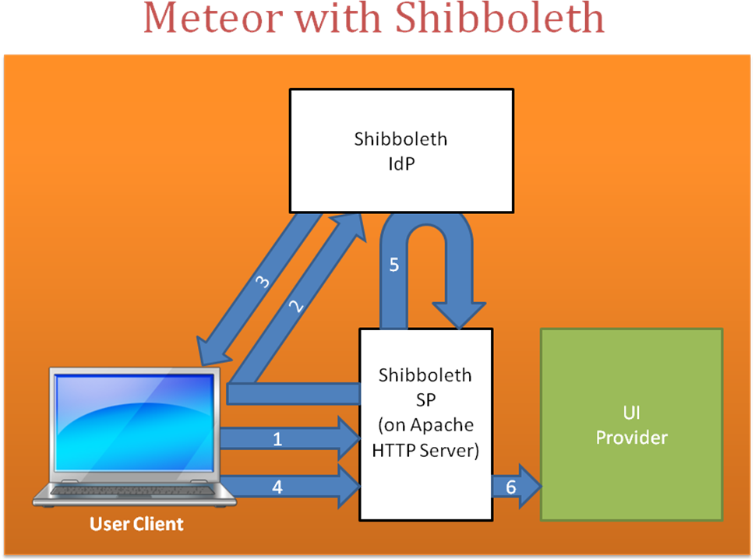

- User attempts to access UI provider.
- Shibboleth Service Provider determines User is not logged in, so it redirects the user to a Shibboleth Identity Provider (or an IdP Discovery Service).
- User authenticates with Identity Provider. Identity provider creates a Shibboleth assertion with Meteor custom attributes and returns an Artifact ID to the User referring to that assertion.
- User attempts to access UI provider using the Artifact ID from the Identity Provider.
- Shibboleth Service Provider obtains the Shibboleth assertion from the Identity Provider by resolving the Artifact ID.
- User’s request is forwarded to the UI provider. The Shibboleth TokenProvider implementation obtains the Shibboleth assertion’s Meteor attributes. The UI provider forwards these attributes to the Access Provider, which creates SAML 2.0 assertions when connecting to other providers on the network.

Meteor Configuration

- In the deployed UI provider web application, edit the file WEB-INF/classes/uiprovider.properties.

- In uiprovider.properties, set the property uiprovider.tokenproviderclass to:

org.meteornetwork.meteor.provider.ui.token.ShibbolethTokenProvider

This tells the UI provider to expect Shibboleth authentication.

Shibboleth Configuration
Shibboleth must be configured to deliver the following Meteor attributes. Shibboleth Identity Providers and Service Providers must both be configured to use these attributes. More detailed descriptions of these attributes can be found in the Meteor 4.0 Implementation Guide.

Attribute ID | Description | Required?
UserHandle | The name of the user | Yes
AuthenticationProcessId | The authentication process identifier. (Integer) | Yes
Level | The level of authentication used to authenticate the user. (Integer) | Yes
Role | The user’s role. May be the following values (UPPER CASE required):  FAA  BORROWER  APCSR  LENDER | Yes
OrganizationId | (FAA only) The ID of the organization the user represents. | No
OrganizationIdType | (FAA only) The type of ID specified in OrganizationId (e.g. OPEID) | No
OrganizationType | (FAA only) The type of organization specified in OrganizationId (e.g. School) | No
SSN | (BORROWER only) The SSN of the user | No
Lender | (LENDER only) The OPEID of the Lender | No

To return Meteor attributes from a Shibboleth Identity Provider: https://wiki.shibboleth.net/confluence/display/SHIB2/IdPAddAttribute

To configure the Shibboleth Service Provider to pass Meteor attributes it receives from an Identity provider to the UI provider:
https://wiki.shibboleth.net/confluence/display/SHIB2/NativeSPAddAttribute

Important Notes:

- When specifying attributes, the attributes are labeled with a fully qualified name (URI) and a shorter, friendly name. The following is recommended for the qualified name:

uri:meteornetwork.org/meteor40/saml2attributes/[Attribute ID]

The Attribute ID refers to the above table of Meteor attributes. The Attribute ID is also the recommended value for the friendly names and the ID values in mapping files.

- When configuring the attributes in the attribute-map.xml configuration file, the ID must match the Attribute ID according to the above table of Meteor attributes, e.g.:

<Attribute name="uri:meteornetwork.org/meteor40/saml2attributes/UserHandle" id="UserHandle"/>

If the ID specified does not match the Attribute ID in the above table, the Meteor UI provider will not recognize the attribute.

- Attributes are received by the UI provider as environment variables, not as request headers. Therefore, the Shibboleth Service Provider must be configured to pass the custom Meteor attributes as environment variables. (This is the default for most service provider instances.)

