Kathambam - Rule Based Tagger for Tamil

Introduction

Tamil being a morphologically rich language needs complex rules to tag the words in the Tamil documents. For example, verbs and auxiliaries join together to form a single compound verb unit, and case markers are part of compound noun in Tamil. In order to lookup the root verb/root noun in dictionary or WordNet it is necessary to do a heuristically directed morphological analysis of the verb unit/noun unit. The POS tagger for Tamil uses heuristically dictated rules to find the nouns, verbs, adjectives, adverb and postpositions. In Tamil it is necessary to check for appropriate morphemes in the words to classify them. Tamil is a free word order language, with the only constraint being that normally sentences are verb terminating. In some cases a one step lookahead with sensing of verbs is necessary to help the tagging. The steps in tagging include the deduction of some classes of words, removal of clitic, which form parts of words, deduction of nouns and verbs without look ahead and with lookahead and, finally deduction of adjective and adverbs.
Look and Feel 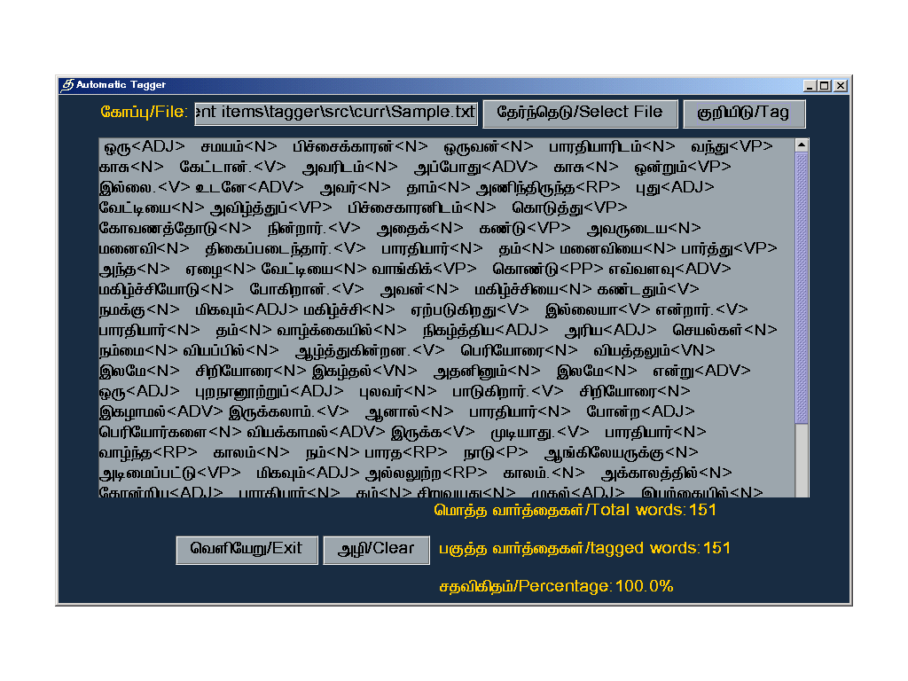

How to Identify the Noun, Verb, Adverb..Etc

Deduction of Stand alone words

In Tamil Standalone words are only a few for example, numbers, names of objects, pronouns, few atomic adjectives and postposition

Noun

In numbers category some standalone numbers like oru, eru, onru, eraNdu, muunru… and etc these are adjectives

In noun category, the standalone Adverbs like adikadi, enimel, ennum, marupadium, meendum, meele, udane,nettru, enggu, endru and endru .

In name of object category some standalone nouns like

In noun category, the standalone personal pronouns like avan, evan, avar, athu, avai, ethu, nee, un, nan, en, than, tham, nam, naaam, em, avargal, avaigal, evargal, evargal, neeveer, neenggal, naanggal, thanggal, enggal, unggal are tagged as nouns.

In Demonstrative pronoun category very few pronouns like antha, intha and entha are stand alone pronouns.

Verb
In verb category very few stand alone atomic verbs like Kuudum, Kuudathu, vEndaam, ellai, thoonrum, thoonrathu and vEndum are tagged as verbs

Postposition
In postposition category there exists a total number of 42 standalone postpositions like meel, keel, natu, piraku, thavira, poola, poonra, appaal, pin, mun, vadakku, therkku, kizakku, mErkku, mAthiri, churri, vida, idaiyee, veLiyee, thaandi, nookki, oliye, kitta, kiza, mulam which can be tagged directly as postpositions.

Syntactic categories based on morphemes

Noun
Nouns, adverbs and adjectives are easily grouped by detecting certain end patterns like kku, edam, aal, aaka, aana, ending words
The peculiar properties of nouns is that it is usually terminated with case markers so when a case marker is detected as a pattern at the end of word it can be treated as a noun Kku is a case marker which comes with a root marathukku which end with kku. Around 15 case markers like ai, aal, kku, ukku, ukkaka, idam, udan, udaya,athu, illiruthu, edamiruthu, oodu, odu, ana, aar have been identified so for dealing with noun. Sometimes noun comes along with only plural markers; these markers can also be sometimes used as a basis for detecting nouns.

Adjective
Morphological rules can be used to identify the adjective. In the word ending aana has come that word tagged as Adjective
Adverb
Similarly, the word ending aaka has come that word tagged as Adverb

Relative Participle
Identify the Relative participle in using some set of tense marker i.e. (tt,th,rr) and also using ‘a’ end pattern
Here using looking ahead methodology, in a particular sentence where second token takes the form as a noun and then check the first token, the first token end pattern finish ‘a’ and also checking tense marker. This word is tagged as Relative particle.

Verbal Participle
Identify the Verbal participle in using some set of tense marker i.e. (tt,th,rr,kk,tr) and also using ‘u’ or ‘e’ end pattern
Here using looking ahead methodology, in a particular sentence where second token takes the form as a verb and then check the first token, the first token end pattern finish ‘u’ or ‘e’ and also checking tense marker. This word is tagged as Relative particle.

Verb
Like case markers for noun, the PNG markers along with the tense marker can be used to classify a verb. The PNG marker contain the information about person, number and gender and the tense marker classify the time information of the verb
so the combination of PNG and tense markers is used for tagging a verb
Tense marker: (th, n, y, p, v, thth, r,rr, t,tt, nth,kiru, kindru)
PNG Marker: ( een,oom,iir,aar,aarkal,iirkal,aana,athu,aan)

Look aheads

The process by which the type of a word is determined by the tag of the word next to it is termed as lookahead tagging. At times word is marked by a particular tag due to the morpheme detected but however on seeing the next word the tagging is found to be incorrect.In these cases a one step lookahead is used to tag the current word based on the tag of the next word.

Verb terminating

When a word is found untagged at end of a sentence, by the rule that sentences are generally verb terminating we classify the last word as verb. If an analysed sentence contains words such that not a single word is that sentence could be tagged as verb then we can treat the last word in the sentence as a verb. There are exceptions here since Tamil allows verb-less sentences also. Normal Tamil sentence takes the form SOV (Subject Object Verb) and with this property, we will be able to tag a verb if it is untagged by the previous rules.

Class Diagram
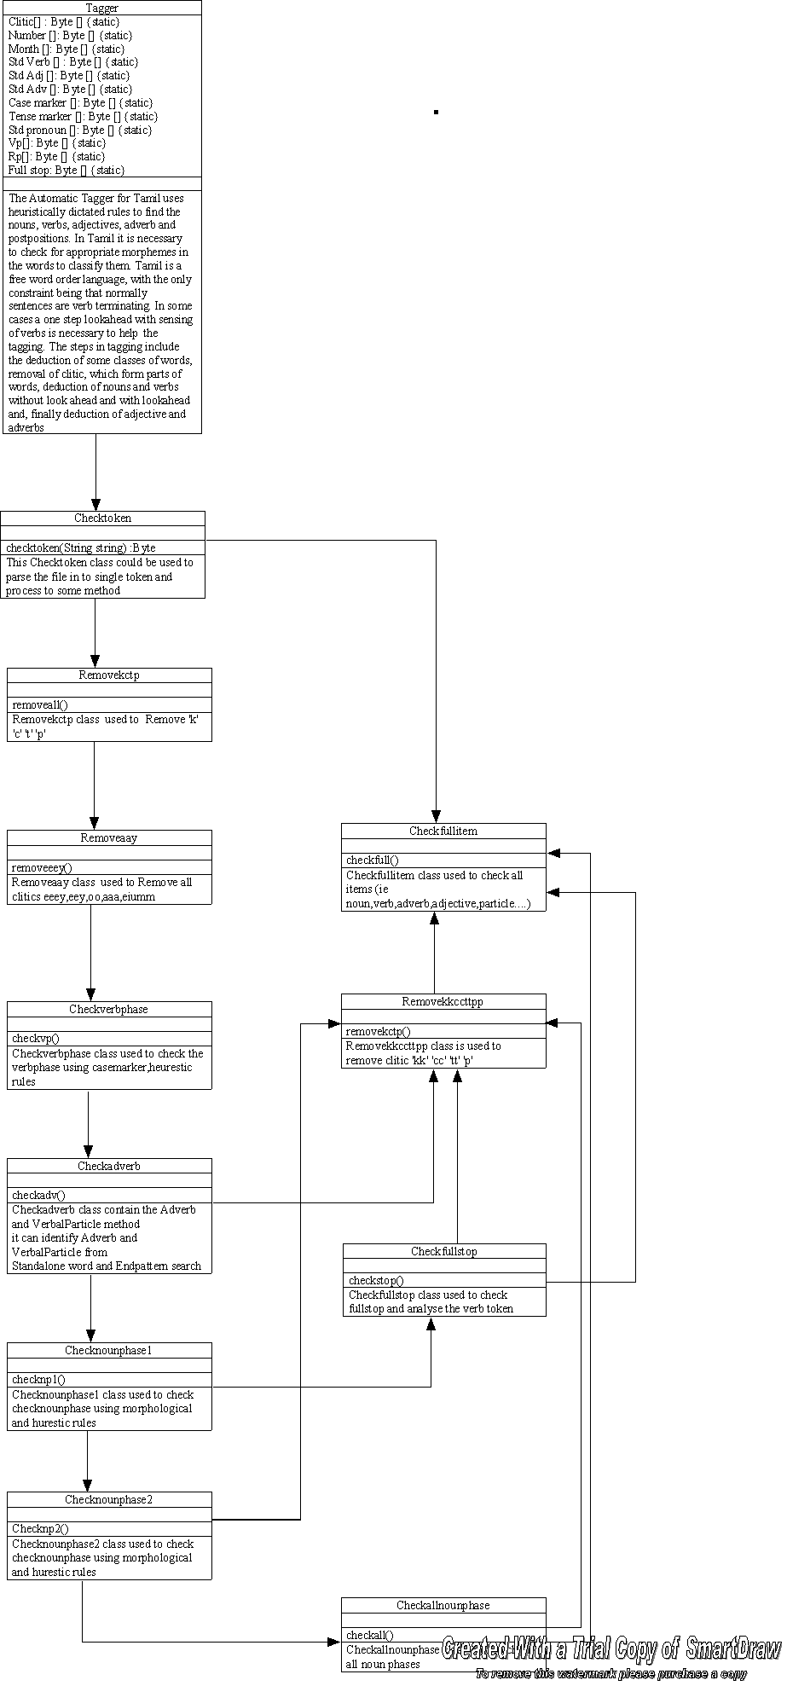

Algorithm of Automatic Tagger
Begin

If Get token (key) in SAADJ [] or End pattern search (key) in MARADJ [] or look ahead search (key)
Tag [key] =Adjective.

If Get token (key) in SAADV [] or End pattern search (key) in MARADV [] or look ahead search (key)
Tag [key] =Adverb.

If Get token (key) in SANOUN [] or End pattern search (key) in CASEMAR [] or End pattern search (key) in PULURAL [] or End pattern search (key) in HURISTIC []
Tag [key] =Noun.

If Get token (key) in SADEMPRON []
Tag [key] = Demonstrative pronoun.

If Get token (key) in SAPOST []
Tag [key] =Postposition.

If Get token (key) in SAVERB [] or End pattern search (key) concatenate with TENMAR [] and PNGMAR []
Tag [key] =Verb.

If Get token (key) is untagged
Then If Get token (key) is concatenate with “.”
Tag [key] =Verb.

If Get first token (key) in MARADV [] and Get second token End pattern search (key) MARVN []
Tag [key]=Adjective

If Get first token (key) in MARADV [] and Get second token End pattern search (key) concatenate PNGMAR [] and TENMAR [] or SAVERB []
Tag [key]=Adverb + Verb

If Get first token End pattern search (key) in concatenate with HURISTICRPTENSE[] and HURISTICRP [] Get second token (key) in SANOUN or End pattern search (key) in CASEMAR [] or End pattern search (key) in PULURAL [] or End pattern search (key) in HURISTIC []
Tag [key]=Adjective + Noun

If Get first token (key) in SANOUN or End pattern search (key) in CASEMAR [] or End pattern search (key) in PULURAL [] or End pattern search (key) in HURISTIC []
Get second token (key) in untagged
Then
While (Get next Token=Noun token)
{
Next token =next token + another token;
}
NOUNPH []={Next token};

Tag [Noun token+ NOUNPH [] + first token] =Noun phrase

If Get Right token End pattern search (key) concatenate PNGMAR [] and TENMAR [] or SAVERB []
Then
While (Get next Token=SAAUX [])
{
Next token =next token + another token;
}
VERBPH []={Next token};
Tag[VERBPH [] +right token] =Verb phrase.

End.

Future Enhancement

By studying typical corpora it is possible to identify more heuristic and statistically based rules to improve the efficiency of the tagger. By considering enough documents of the same domain it is possible to statistically extract all typical patterns, which can then be incorporated as heuristic rules to further improve the efficiency of the tagger.

