BugBuddy Survey Paper

Natalie Lopez
Human Computer Interaction
Full Sail University
Winter Park, FL, USA
Nlopez5@student.fullsail.edu

Abstract— This paper presents an updated analysis of a user survey for BugBuddy, a human-centered bug detection and code-risk analysis application developed as part of a Human–Computer Interaction (HCI) course project. BugBuddy is designed to help users identify bug-prone functions, view ranked risk results, and receive plain-language explanations of code risk, aligning with current work on workflow-integrated software visualization and interpretable analysis tools [1], [2]. The original survey was used to collect early feedback on usability, trust, explanation clarity, feature usefulness, and interface expectations so that the prototype could be revised according to participant needs rather than only technical assumptions [5], [6]. In response to those survey findings, BugBuddy was improved into a live browser-based website with stronger visuals, an animated Buddy guide, and OpenRouter-based explanation support configured through the OPENROUTER_MODEL environment variable set to openrouter/free. These updates extend the original prototype into a more accessible and interactive system while preserving its core function-level risk analysis workflow [3], [4].
Keywords— human-computer interaction, usability, user survey, code visualization, bug prediction, BugBuddy

Introduction
BugBuddy is a code-risk analysis project developed to act as a bug detector while remaining understandable to students and other non-expert users. Its design goal is consistent with recent software-visualization and explainable analysis systems that emphasize integrating risk information into the user workflow rather than presenting opaque technical output [1], [2]. The earlier BugBuddy prototype already supported code upload, ranked function output, and explanation text, but the HCI component of the project required evaluating whether users found the interface clear, trustworthy, and genuinely helpful [5], [6].
A major goal of BugBuddy is not only to score potentially risky functions but also to explain those results in a way that users can understand and act on. Recent research on AI-enhanced code review and defect prediction shows that developer-facing tools are more useful when they combine technical findings with interpretable presentation and practical guidance [3], [4]. These ideas motivated BugBuddy’s emphasis on plain-language explanations, risk ranking, fix-oriented guidance, and a user-facing interface that supports learning as well as analysis.
The purpose of this paper is to document how the BugBuddy survey informed actual design changes in the next version of the system. The survey did not function only as a class requirement; it directly influenced the redesign of the application into a more polished website with better visual presentation, animated interface guidance, and live LLM-powered explanations. In that sense, the BugBuddy project reflects a standard HCI pattern in which early user feedback shapes later design iterations [5], [6].

Survey Design
The BugBuddy survey was created in Google Forms as a structured, multi-section questionnaire. Google Forms supports sections and answer-based branching, which allow the survey to route participants to later sections based on their answers to earlier questions, a pattern commonly used in modern online survey tools [7]. This structure was used to separate general background questions from tool-experience questions and broader user-needs questions, making the survey easier to complete for both experienced and inexperienced users in line with HCI survey-design guidelines [5], [6].
The survey included five sections: a title and overview section, a consent section, a background and coding experience section, an experience-with-tools section, and a user-needs-and-preferences section. The form used multiple question types, including multiple choice, dropdown, checkbox, linear scale, paragraph, and grid items, which are recommended for capturing both quantitative and qualitative perspectives in HCI surveys [5]. Branching logic was applied to the consent question and to the question asking whether respondents currently use tools to help find bugs or code problems; participants who declined consent were routed directly to submission, while consenting participants continued to later sections [7].
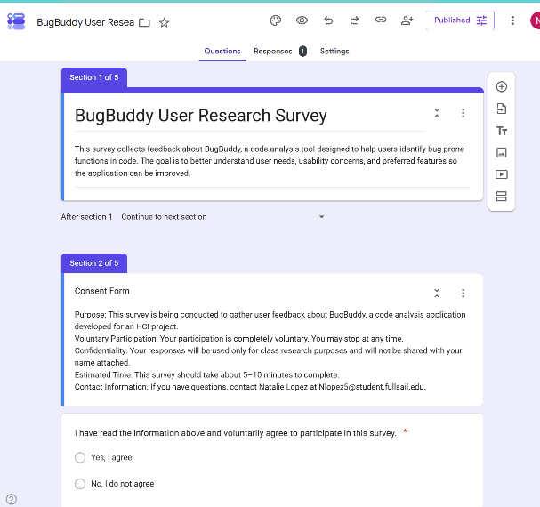
Fig. 1. Consent section logic in Google Forms using answer-based branching.
The background section asked users whether they had used BugBuddy before, how often they write code, which programming language they use most often, and whether they currently use tools to help detect bugs or code issues. This part of the form provided context for interpreting later responses and helped distinguish between respondents with more technical familiarity and those with limited tool experience, a distinction that can influence how users interpret code-analysis visualizations [3], [6]. If respondents indicated that they already use bug-finding tools, the survey routed them to a section focused on experience with BugBuddy or similar tools; otherwise, they were directed to a needs-and-preferences section.
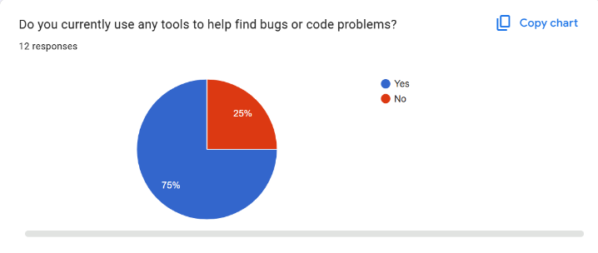Fig. 2. Section routing for respondents based on prior use of debugging tools.
The experience section focused on usability and trust. It asked respondents to rate how easy it was to understand results shown by BugBuddy or a similar tool, how much they trust bug-risk suggestions, and which features they considered most useful—dimensions that closely match recent studies on developer perception of AI-assisted review and static analysis [3], [4]. It also included a feature-importance grid and an open-ended question about confusion or frustration. The final section focused on prospective needs, asking whether users would use a tool like BugBuddy, how important simple language explanations are, which improvements matter most, and what changes they would make to the system, which mirrors standard HCI practice of linking feedback to future design directions [5], [6].

Survey Purpose in HCI Context
Within an HCI framework, the survey supports iterative design by gathering evidence about user expectations, explanation clarity, and perceived system usefulness. Many recent visualization systems for code review and program understanding emphasize integrating visual representations into real workflows and validating them with user studies or surveys, rather than relying only on technical performance metrics [1], [2], [8]. The BugBuddy survey adopts this perspective by focusing explicitly on comprehension, trust, and feature priorities instead of only detection accuracy.
The survey also helps identify whether the current BugBuddy concept is suitable for users who are not already experts with debugging tools. This matters because introductory programming students and less-experienced developers may interact differently with code-visualization systems than professional reviewers, as seen in program-visualization and educational visualization research [8]. In HCI terms, a system that works only for technically advanced users may still need design changes before it can be considered accessible and effective for a broader audience [5].
Another HCI benefit of the survey is that it creates a structured bridge between design assumptions and observed user priorities. BugBuddy has emphasized features such as multilingual support, plain-English explanations, and risk-ranked functions, which are typical goals for explainable code-analysis tools [3], [4]. Survey questions about trust, explanation quality, and feature usefulness enable testing whether these planned features are meaningful to users rather than simply assumed valuable by the developer.
The survey process also highlighted the importance of precise wording in question design. For example, the item asking whether participants had used BugBuddy before appeared to be interpreted by some respondents as asking whether they had used BugBuddy before that day rather than before the study overall. This ambiguity matters because small wording differences can change how participants understand a question and can reduce the reliability of the responses. In future revisions, the item should be rewritten more explicitly, such as asking whether the participant had used BugBuddy before the current session or before taking the survey.

Initial Testing and Survey Readiness
Before distributing the survey to outside participants, the form was piloted with a complete response to verify that the logic, sections, and submission flow worked correctly, which is standard practice in HCI survey design [5], [6]. The test response confirmed that the consent logic routed a participant to the survey when “Yes, I agree” was selected and that the survey recorded responses across all subsequent sections. The Google Forms Responses summary page also showed that answers were captured for multiple-choice, checkbox, scale, grid, and paragraph items, demonstrating that the overall form structure was functioning as intended [7].
The test response also served as a usability check for the survey itself. It confirmed that the final section submitted correctly, that the form accepted responses after the response toggle was enabled, and that summary charts were automatically generated in the Responses tab for later analysis [7]. This kind of pilot check is valuable because it reduces the chance that real participants encounter broken logic, missing submission behavior, or confusing navigation during data collection [5], [6].
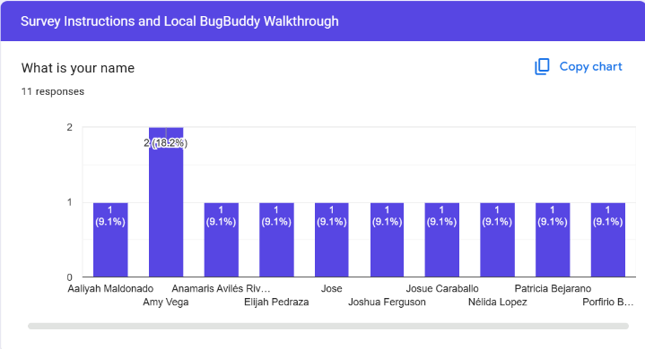
Fig. 3. Initial response summary was used to verify that the survey was recording data correctly.
Although a single test response does not yield meaningful research findings on its own, it confirms that the instrument is operational and ready for distribution. The next step is to collect additional responses from real participants, such as classmates, coworkers, friends, or family members, so that the project can analyze broader patterns in user priorities and concerns, which is common in early-stage HCI evaluation work [5], [6]. In this project context, these responses are intended to inform design improvements rather than claim large-scale generalizable results.

Expected Use of Survey Results
The survey results are intended to guide future revisions to BugBuddy. If respondents consistently prioritize clearer explanations, faster results, easier navigation, or greater trust in predictions, those findings can translate into direct interface improvements and feature refinements [3], [4]. For example, feedback favoring plain-English explanations would support continued emphasis on simplified explanation text, while strong interest in snippet previews or fix suggestions would justify expanding those interface elements [3], [4].
The results can also strengthen the project report by showing that design decisions are informed by user feedback rather than only technical implementation goals. In HCI work, connecting interface changes to observed user needs improves the credibility of the design process and demonstrates iterative refinement [5], [6]. This is especially relevant for BugBuddy because the application must satisfy both technical project goals and human-centered usability expectations as it moves toward a more complete implementation.
Finally, the survey can help identify the limits of the current prototype. If users report confusion, low trust, or difficulty understanding the risk output, these findings indicate that the app still needs stronger explanatory support or interface simplification [3], [5]. In that sense, negative or mixed feedback would still be useful because it would reveal where the next design cycle should focus.
Several participants also suggested that BugBuddy would be more practical and accessible if it were available as a live website rather than only as a locally run prototype. In response to that feedback, the system was revised into a browser-based website with improved visual design, a more engaging interface, and an animated version of Buddy that helps guide users through the analysis process. The updated version also included OpenRouter support for explanation features, allowing BugBuddy to provide clearer and more interactive responses during code review. These changes were made directly in response to survey feedback and demonstrate how participant suggestions influenced the transition from an early prototype to a more refined, user-centered implementation.
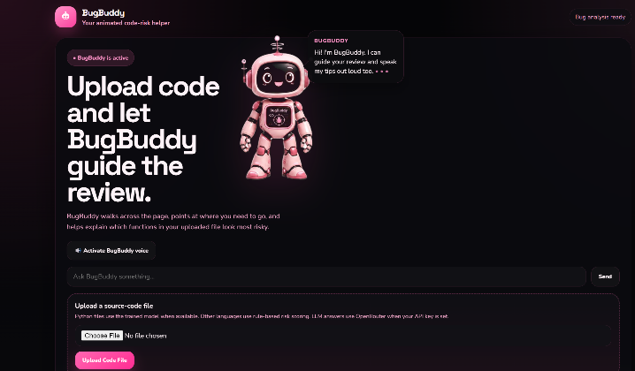Fig. 4. Updated BugBuddy website interface at launch, showing the redesigned browser-based layout, improved visuals, and guided workflow.
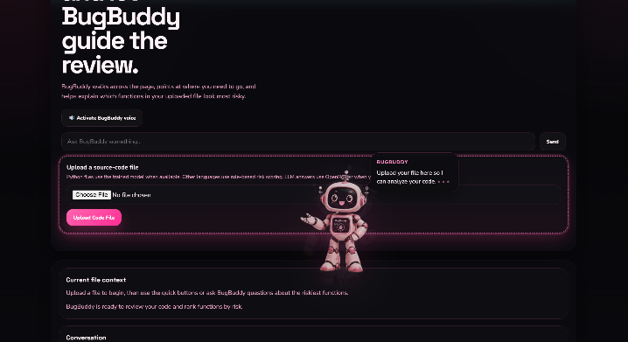Fig. 5. BugBuddy in explanation mode, showing the animated assistant providing guidance and code-risk support within the interface.

Example Survey Charts and Formula Support
Although this paper emphasizes survey design more than formal statistical testing, it is still useful to show how the collected responses can be summarized visually. For example, a bar chart can display how often respondents write code. In contrast, a pie chart can summarize prior BugBuddy use or prior use of debugging tools, depending on which survey item is being discussed [7]. A Likert-style bar chart can also be used to present how strongly respondents agreed that plain-language explanations are important in a tool like BugBuddy, a topic closely connected to explainability in developer tools [3], [4].
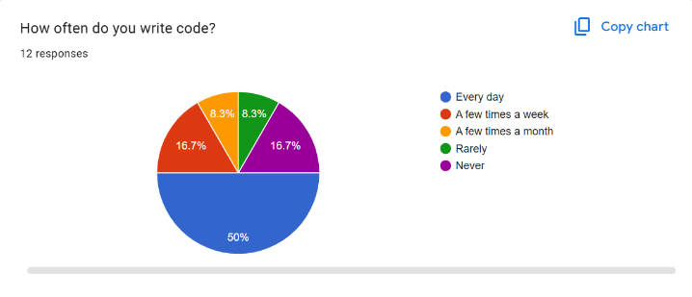Fig.6. Example chart summarizing the frequency of respondent coding.
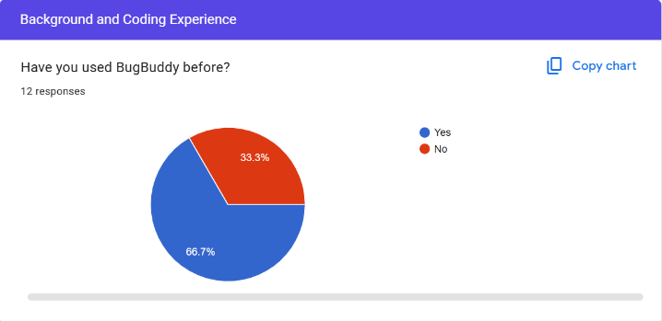Fig. 7. Chart summarizing prior BugBuddy use.
If the survey responses are analyzed numerically, a simple percentage formula can be used to report the proportion of respondents selecting each option. The percentage of respondents in each category can be expressed as:
$$P=\frac{n}{N}×100$$

where n is the number of responses in one category, and N is the total number of responses. This formula can be used to convert raw counts into percentages for charts and tables in the final report.
A simple mean score can also be calculated for linear-scale survey questions. The average rating can be expressed as:
$$\overset{‾}{x}=\frac{1}{N}\sum_{i=1}^{N}{ }x_{i}$$
where x_i represents an individual response, and N is the total number of responses. This value can be used to summarize overall perceptions of usefulness, trust, or clarity for BugBuddy survey items [5].

Limitations
The main limitation of this survey approach is the likely use of a small convenience sample, such as classmates, friends, family members, or coworkers. This is practical for a course project, but it means the results will reflect early exploratory feedback rather than broad or statistically representative conclusions, which is a common limitation in formative HCI studies [5], [6]. Participants may also vary widely in their coding experience, which can affect how they interpret questions about bug-risk tools and code analysis [8].
Another limitation is that not all respondents will have direct experience using BugBuddy itself. Some participants may answer based solely on the tool’s concept rather than on hands-on use, especially if they do not have access to the application or do not regularly code. However, this limitation is acceptable in an early HCI evaluation because perceived usefulness, explanation clarity, and feature expectations are still valuable inputs for design planning [5], [6].
A final limitation is that the survey captures self-reported perceptions rather than direct observation of in-app behavior. This means it can indicate what users say they want or find helpful, but it cannot fully replace future usability testing sessions in which participants interact with BugBuddy while completing realistic tasks [5]. For that reason, the survey should be treated as one component of a broader user-centered evaluation strategy rather than the sole source of evidence for design decisions.

Conclusion
The BugBuddy user survey provides an organized way to collect early feedback about usability, trust, explanation quality, and desired features in a bug analysis application [3], [5]. The form’s multi-section structure, use of varied question types, and branching logic make it suitable for both users with coding-tool experience and those new to this type of system [7]. As a result, the survey serves as a practical HCI instrument for gathering evidence to guide future interface improvements and feature refinement [5], [6].
In the context of the BugBuddy project, the survey is not an end but a step in an iterative design process. It supports the project’s human-centered goals by focusing attention on what users understand, what they trust, and what they still need from the system [5]. With additional responses and follow-up analysis, the survey can help move BugBuddy closer to a prototype that is both technically useful and easier for real users to understand and apply [2], [3].

References
- A. Krause-Glau, B. Scharf, and W. Hasselbring, “Visual Integration of Static and Dynamic Software Analysis in Code Reviews: Challenges and Code Review Workflow Design,” in Proc. IEEE Working Conf. on Software Visualization (VISSOFT), 2024, pp. 1–11.
- P. Demeter and A. Gyén, “Visualization of Code Metrics for Code Quality and Standard Compliance,” in Proc. IEEE Working Conf. on Software Visualization (VISSOFT), 2024, pp. 1–10.
- Y. Almeida, T. M. Usluer, and A. B. M. Sultan, “AICodeReview: Advancing Code Quality with AI-Enhanced Reviews,” SoftwareX, vol. 27, art. no. 101804, 2024.
- X. Xie, W. Xu, X. Liu, Q. Wang, S. Ding, and C. Liu, “Research on Software Defect Prediction Models Based on the Combination of Static Analysis Warnings and Deep Learning,” Int. J. Softw. Eng. Knowl. Eng., 2025.
- G. Desolda, D. De Greco, M. Matera, and F. M. Donini, “Designing and Evaluating Human-Centred AI Systems: Best Practices and Multidisciplinary Methodologies,” in Proc. BEHAVE-AI 2025 Workshop on Human-Centred AI, 2025.
- A. M. K. Law et al., “Using Human-Centered Design and Development to Create a Prototype for Personalized Sick Day Medication Guidance: Iterative Heuristic Evaluation and Formative Usability Testing,” JMIR Formative Research, vol. 9, e77240, 2025.
- Google, “Show Questions Based on Answers,” Google Docs Editors Help, accessed Jul. 13, 2026. [Online]. Available: https://support.google.com/docs/answer/141062
D. Spadini, T. van der Storm, M. Bruntink, and A. Bacchelli, “Graph-Based Visualization of Merge Requests for Code Review,” J. Syst. Softw., vol. 204, art. no. 111796, 2023.

