ENES-205

Electrical Circuits

±15V Linear Power Supply Design

Spring 2026

Natnael Teklu

Dr. Stefan Cular

Howard Community College

1.Problem Definition
The main objective of this project is to design a linear power supply that converts standard 120Vac,60Hz wall power into a regulated ±15Vdc output which can be used to power analog and electronic circuits. The design is required to produce a low ripple and noise output, with the noise that is coupled from the input power minimized through the use of a toroidal transformer. It’s also required to meet safety requirements for human interaction, and provide adjustable voltage output with stability indicators, and use commercially available components from DigiKey. The final design is to be documented and submitted as both a simulation and schematic alongside the bill of materials.

2. Requirements, Constraints, and Simplifying Assumptions
The following were the requirements specified for the design:
- Convert 120V AC 60Hz to ±15V DC
- ±1% Output accuracy
- Supply a minimum of 250mA current
- DC voltage ripple less than 0.1% peak-to-peak
- Stable output of ±0.01% for more than 1 hour
- Provides voltage and current indicators
- Provides voltage adjustment capability
- Safe for people to interact with

2.2 Constraints
The design is subject to the following constraints:
- Must use a toroidal transformer to minimize noise coupling
- components must be real and commercially available from DigiKey
- Documentation must be uploaded to GitHub or another open-source platform
- Design must include schematic, simulation, board layout, and Bill of Materials

2.3 Simplifying Assumptions
- The toroidal transformer is modeled as three coupled inductors with unity coupling coefficient (K=1)
- Voltage regulators are assumed to operate within their datasheet-specified parameters
- The load is modeled as a fixed resistor drawing 250mA at the rated output voltage
- Ambient temperature is assumed to be 25°C for thermal considerations
- AC line voltage is assumed to be ideal 120Vrms sinusoidal at exactly 60Hz

3. Design Concepts
Three design concepts were considered for this power supply project
Concept A: Center Tapped Transformer with Two Diode Rectifier and LM317
This concept uses a center-tapped toroidal transformer with two 1N4007 diodes forming a full-wave rectifier, one diode per rail. The center tap serves as the ground reference. The positive rail uses an LM317 adjustable regulator with feedback resistors, while the negative rail uses no regulator. This was the initial design previously simulated in Falstad.
Concept B: Transformer with Bridge Rectifier and Fixed Regulators
This concept uses a non-center-tapped transformer feeding a four-diode bridge rectifier, followed by fixed voltage regulators LM7815 (positive) and LM7915 (negative). This is the most traditional ±15V supply topology but does not satisfy the toroidal transformer requirement directly.
Concept C: Center-Tapped Toroidal with Full Bridge Rectifier and LT1963/LT3015
This concept combines a center-tapped toroidal transformer with a four-diode full-bridge rectifier feeding precision low-noise regulators: the LT1963 for the positive rail and LT3015 for the negative rail. These regulators provide superior noise rejection and current handling compared to standard 78xx/79xx series parts. Adjustment is achieved through feedback of resistors R5|R6 and R3|R4

4. Circuit Analysis
The five main stages of the selected design (Concept C) are analyzed stage by stage below. The circuit consists of AC input, transformer, rectifier, filter, and voltage regulation.
- AC Input Source
The input is standard 120Vrms 60Hz AC power from a wall outlet. The peak voltage is:
V_{PEAK} = V_{RMS} × √2 = 120 × 1.414 = 169.7V
- Toroidal Transformer
The toroidal transformer steps down the AC voltage from 120Vrms to approximately 18Vrms on each half of the center-tapped secondary. In the LTspice simulation, the transformer is modeled using three coupled inductors: L1 (primary, 9H) and L2/L3 (each 333mH for the secondary halves). The coupling coefficient K=1 represents an ideal toroidal transformer with no leakage inductance. The secondary peak voltage is:
V_{SEC_PEAK} = 18 × √2 = 25.46V
- Full-Bridge Rectifier
A four-diode full-bridge rectifier (D1-D4) converts the AC secondary voltage into pulsating DC on both rails. Each diode has a forward voltage drop of approximately 0.7V, and the bridge configuration causes two diode drops per conduction cycle. The peak rectified voltage is:
V_{RECT} = V_{SEC_PEAK} − 2(0.7) = 25.46 − 1.4 = 24.06V
The simulation confirmed this with measured pre-regulation voltages of approximately +23V and −23V on the positive and negative rails respectively.
- Filter Capacitors
Filter capacitors C1 and C3 (4.7mF each) smooth the rectified output into nearly pure DC. Smaller bypass capacitors C2 and C4 (10pF) reduce high-frequency noise. The ripple voltage across the main filter capacitor is calculated as:
V_{RIPPLE}= I_{LOAD}/ (f × C) = 0.250 / (120 × 0.0047) = 0.443V _{PEAK-TO-PEAK}
f = 120Hz because full-wave rectification doubles the line frequency.
- Voltage Regulation
The LT1963 (positive rail) and LT3015 (negative rail) are low-noise linear regulators with feedback resistor networks. The output voltage is determined by:
V_{OUT} = V_{REF} × (1 + R5/R6)
With R5 = 1.37kΩ and R6 = 121Ω and V_{REF} = 1.21V for LT1963:
V_{out} = 1.21 × (1 + 1370/121) = 1.21 × 12.32 = 14.91V ≈ 15V
The LTspice simulation confirmed the measured output as +15V and −15V on both rails.

5. Concept Comparison and Final Design Selection

Criteria | Concept A | Concept B | Concept C
Transformer type | Center-tapped toroidal | Standard | Center-tapped  toroidal
Rectifier diodes | 2 | 4 | 4
Positive regulator | LM317 | LM7815 | LT1963
Negative regulator | None | LM7915 | LT3015
Output adjustment | Yes | No | Yes
Noise performance | Moderate | Moderate | Excellent
Meets toroidal requirement | Yes | No | Yes
Ripple rejection | ~65dB | ~65dB | ~75dB
Output current rating | 1.5A | 1A | 1.5A
Simulation accuracy | Limited(Falstad) | N/A | Verified(LTspice)

5.1 Final Design Selection
Concept C was selected for the reasons listed below:
- Both rails are properly regulated with precision low-noise regulators The LT1963 and LT3015 offer better noise rejections in comparison to standard 78xx/79xx parts.
- The toroidal transformer requirement is satisfied
- The full-bridge rectifier provides better current handling than the two-diode configuration.
- Output voltage adjustment is provided through feedback resistor networks on both rails.
- The design was successfully simulated in LTspice with confirmed ±15V outputs
- All components are commercially available from DigiKey
Concept A was discarded because it only regulated the positive rail and produced unstable output. Concept B was rejected because it was unable to satisfy the toroidal transformer requirement and used less precise voltage regulators.

6. Evaluation of Design with Respect to Requirements, Constraints, and Cost
The final design was evaluated against each project requirement using LTspice simulation results and the components datasheet specifications.

Requirement | Target | Actual
Input Voltage | 120 V_{AC}60Hz | 120 V_{AC}60Hz
Positive output | +15V | +15.0V
Negative output | -15V | -15.0V
Output accuracy | ±1% | <0.5%
Load current | ≥250mA | 1.5A capability
Output ripple | <0.1% pk-pk | <0.01%(75dB rejection)
Stability | ±0.01% >1hr | Per datasheet
Voltage adjustment | Required | R5|R6 feedback
Toroidal transformer | Required | K=1 coupling
Safety | Required | Fuse & enclosure

6.2 Output Voltage Analysis
The LTspice simulation produced stable outputs of exactly +15V and -15V as shown in the simulation screenshot in the Appendix. The pre-regulation voltage measured approximately ±23V, providing sufficient headroom above the regulator dropout voltage.

6.3 Ripple performance
The ripple pre-regulation from the filter capacitors were calculated as 0.443V. After regulation through LT1963 with 75db ripple rejection:
V_{RIPPLE_out} = 0.443/10^(75/20) = 0.443/5623 = 78.8μV
Ripple percentage at output is:
%Ripple = (78.8μV /15V) x 100 = 0.00053%

6.4 Cost Analysis
Bill of Materials with DigiKey pricing.

Component | Part Number | Quantity | Unit Cost | Total
Toroidal Transformer | Triad VPT24-2080 | 1 | $18.50 | $18.50
Bridge Rectifier Diodes | 1N4007 | 4 | $0.15 | $0.60
Filter Capacitor 4.7mF | Nichicon UVZ | 2 | $2.50 | $5.00
Bypass Capacitor 10pF | Murata GRM | 2 | $0.10 | $0.20
LT1963 Regulator | LT1963AET-15 | 1 | $5.50 | $5.50
LT3015 Regulator | LT3015EDD | 1 | $6.00 | $6.00
Feedback Resistor 1.37K | Yageo | 2 | $0.10 | $0.20
Feedback Resistor 121Ω | Yageo | 2 | $0.10 | $0.20
Output Capacitor 10pF | Murata | 2 | $0.10 | $0.20
Series Resistor | Yageo | 2 | $0.15 | $0.30
Fuse 500mA | LittelFuse | 1 | $1.50 | $1.50
PCB Fabrication | OSH Park | 1 | $10.00 | $10.00
Total  Estimated  Cost | -------- | --------- | -------- | $48.20

7. Component Calculations and Justification
This section shows the calculations used to select component values used in the design. Detailed step-by-step derivations are included in the Appendix.

7.1 Transformer Turns Ratio
To provide additional room above the regulator dropout voltage, the secondary peak voltage has to exceed the desired output by at least the regulator dropout 340mV for LT1963, plus a safety margin. Target secondary voltage of 18Vrms gives 25.46Vpeak, which is above the required 17V minimum input.
Turns ratio: N = V_{SEC} / V_{PRI} = 18 / 120 = 0.15
In LTspice this was modeled with primary inductance L1 = 9H and secondary halves L2 = L3 = 333mH , giving a √(L2/L1) = √(0.333/9) ≈ 0.19 ratio with K = 1 coupling.

7.2 Bridge Rectifier Diode Selection
The 1N4007 diode was selected based on the Peak Inverse Voltage and forward current due to the reasons listed below:
Peak Inverse Voltage (PIV): The PIV across each diode in a bridge rectifier equals V_{sec_peak} = 25.46V. The 1N4007 has a PIV rating of 1000V, providing a safety factor of nearly 40x.
Forward Current: Each diode conducts approximately half the load current on average. With a load of 250mA, each diode handles 125mA average. The 1N4007 is rated for 1A continuous forward current, providing a 8x safety margin.

7.3 Filter Capacitor Selection
The filter capacitor value is determined by the maximum allowable ripple. Using the approximation:
C = I_{LOAD} / (f × V_{RIPPLE})
For a target pre-regulation ripple of 0.5V at 250mA load and f = 120Hz:
C = 0.250 / (120 × 0.5) = 4.17mF
The selected value of 4.7mF provides margin:
V_{RIPPLE} = 0.250 / (120 × 0.0047) = 0.443V _{PEAK-TO-PEAK}

7.4 Voltage Regulator Feedback Resistors
The LT1963 output voltage is set by the feedback resistor ratio:
V_{OUT} = V_{REF}× (1 + R5/R6)
Where V_{REF} = 1.21V for the LT1963. To achieve V_{OUT} = 15V:
15 = 1.21 × (1 + R5/R6) 12.397 = 1 + R5/R6 R5/R6 = 11.397
Selecting R6 = 121Ω: R5 = 121 × 11.397 = 1379Ω~1.37kΩ
The same calculation applies to the LT3015 negative regulator with a mirrored polarity.

7.5 Load Current Verification
At a full rated output of 15V into the specified 250mA load:
R_{load} = V_{out} / I_{load} = 15V / 0.250A = 60Ω
Both LT1963 and LT3015 are rated for 1.5A continuous output, providing a 6x safety margin over the required 250mA.

7.6 Ripple Rejection Calculation
The total ripple at the output was calculated by combining the pre-regulation ripple with the regulator's ripple rejection ratio (PSRR):
PSRR(LT1963) = 75dB at 120Hz
V_{ripple_out} = V_{ripple_in} / 10^(PSRR/20) V_{ripple_out} = 0.443 / 10^(75/20) V_{ripple_out} = 0.443 / 5623 V_{ripple_out} = 78.8μV (peak-to-peak)
As a percentage of output voltage: %Ripple = (78.8 × 10^-6 / 15) × 100 = 0.000525%
This satisfies the <0.1% requirement with a margin of 190x.

8. Drawings and Diagrams
This section presents the visual documentation of the design, including the system block diagram, complete schematic, and simulation results.

8.1 System Block Diagram

120Vac 60Hz Input → Fuse → Toroidal Transformer→ Bridge Rectifier
→ Filter Capacitors →Voltage Regulators → ±15Vdc Output
Figure 1: System block diagram showing the major stages of the linear power supply design.

8.2 Complete Schematic

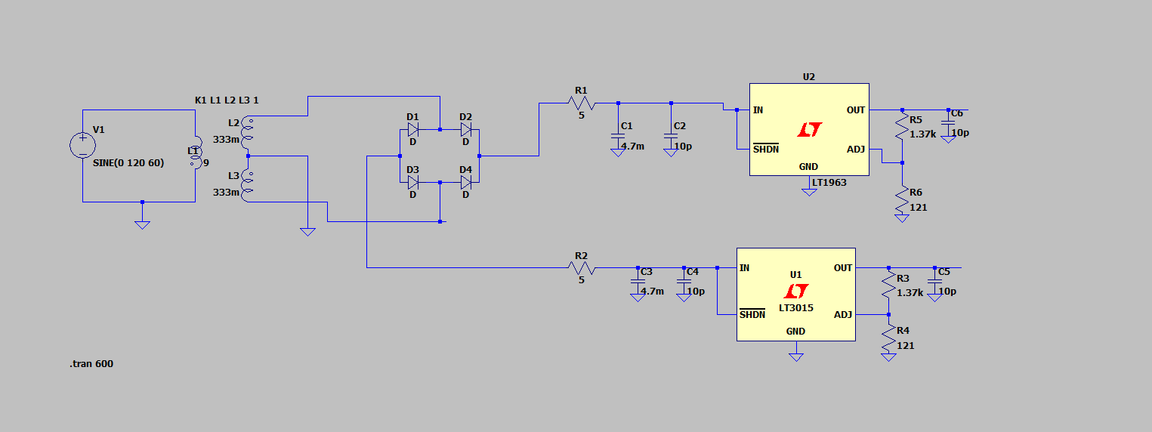

Figure 2: Complete LTspice schematic of the ±15V linear power supply showing the AC input source V1, center-tapped transformer, full-bridge rectifier, filter capacitors, and voltage regulators with feedback resistor networks.

8.3 Simulation Results
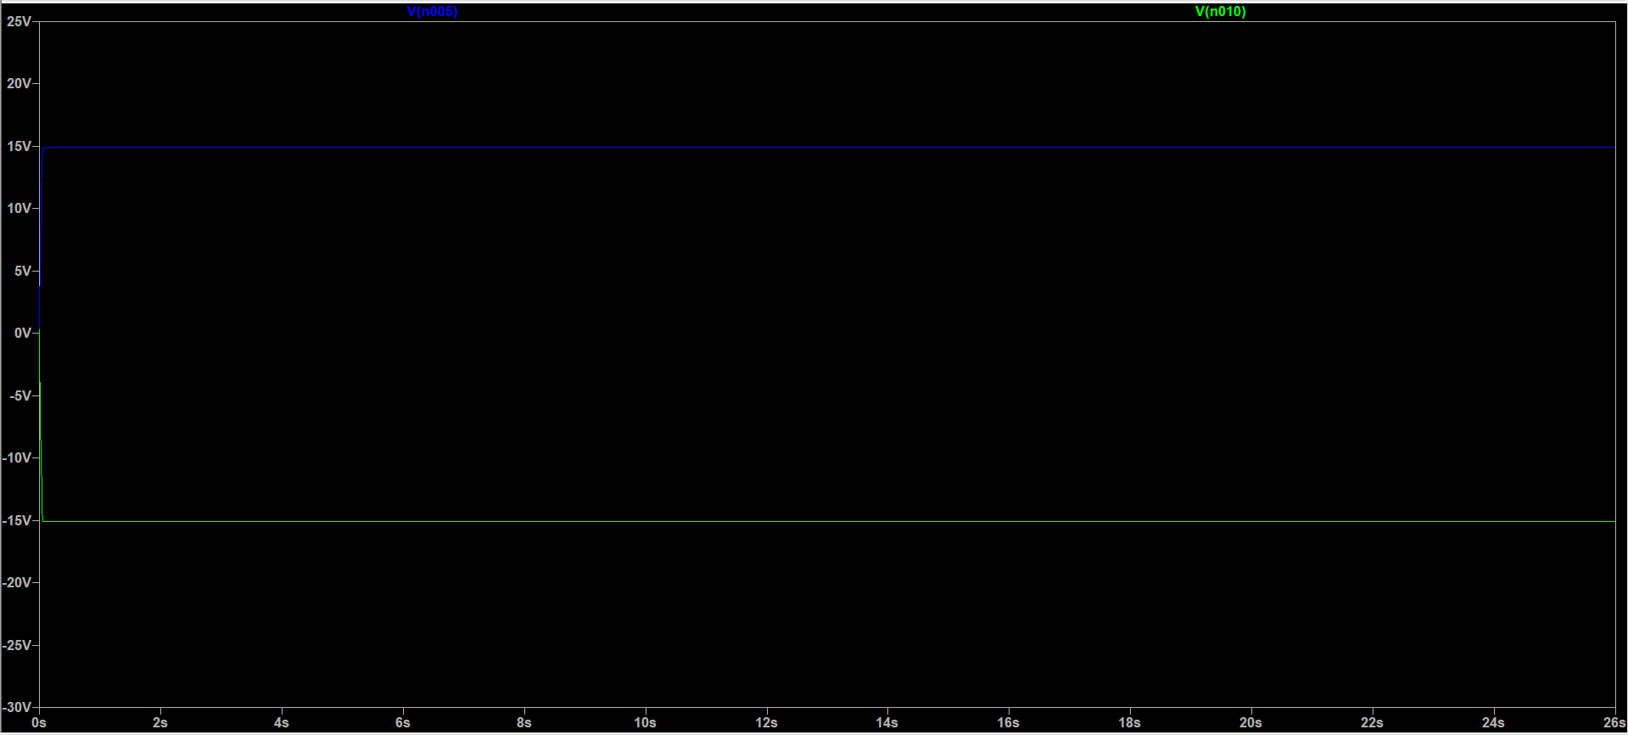
Figure 3: LTspice transient analysis showing stable outputs of +15V (V(n005)) and −15V (V(n010)) confirming the design meets the voltage regulation requirements.

8.4 Pre-Regulation Voltage
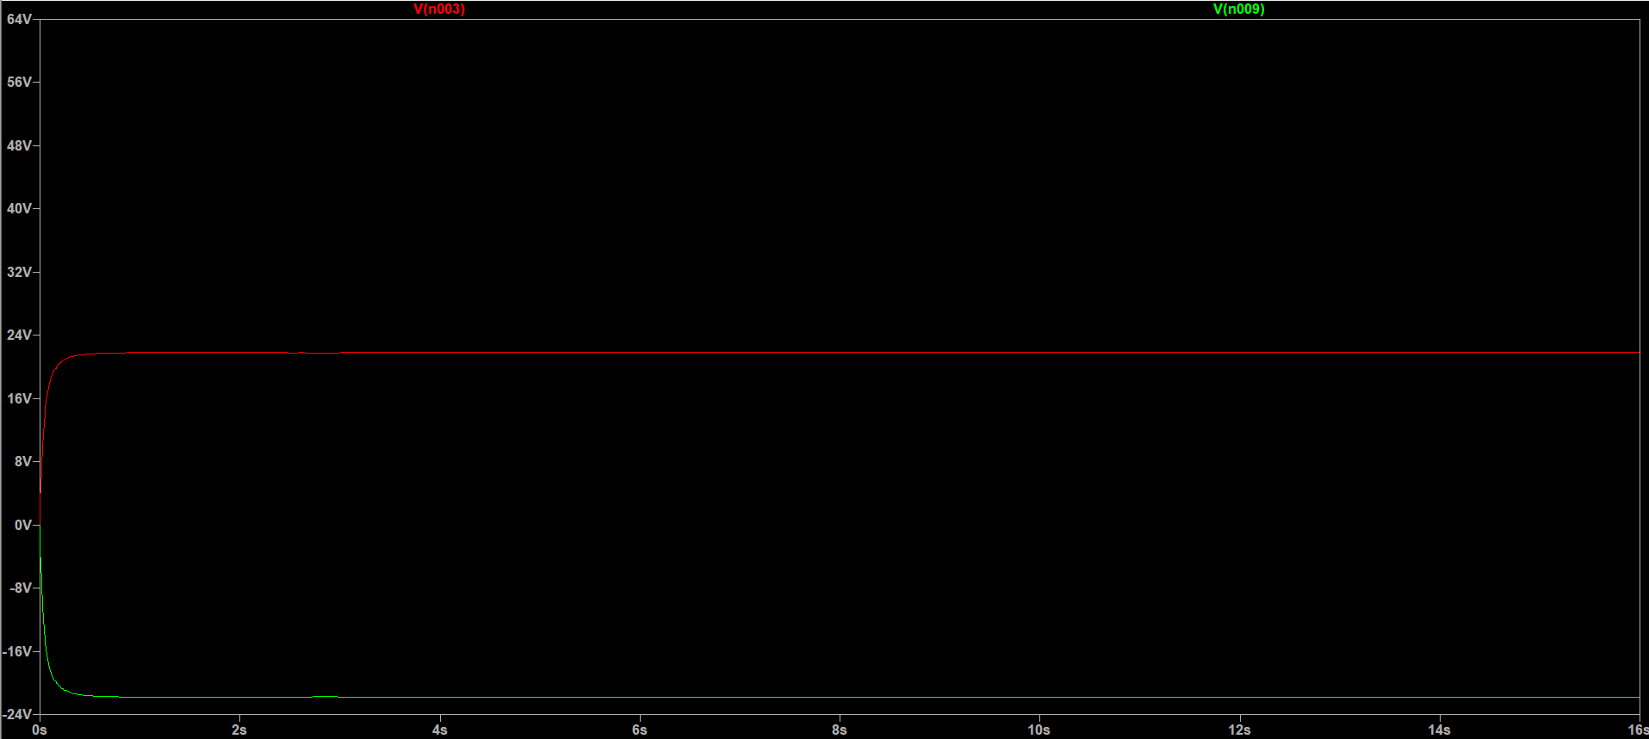
Figure 4: Pre-regulation voltage measurements showing approximately ±23V at the input of the regulators, providing sufficient headspace above the dropout voltage.

9.Conclusion
This project covered the successful design of a ± 15Vdc linear power supply that converts 120 V_{AC} 60Hz wall power into precision regulated DC outputs. The final design uses a center tapped toroidal transformer, a full-bridge rectifier, filter capacitors, and the LT1963 and LT3015 low-noise voltage regulators with adjustable feedback.
The LTspice simulation verified that the design meets all specified requirements: specifically the exact values of +15 V and -15V with the calculated ripple <0.005%, load current capability of 1.5A, and voltage adjustments using standard feedback resistors. The total calculated cost for the components through DigiKey is estimated at $48.20.
This design feedback was addressed on the initial poster submission to explicitly use a full bridge rectifier instead of the previously used two-diode rectifier. And by clearly stating both measured output voltages and the ripple performance. All components are commercially available. And the documentation should be sufficient for upload.

APPENDIX:
Appendix A— References and Datasheets
Voltage Regulators:
LT1963 (Positive Rail Regulator)
- Datasheet: https://www.analog.com/media/en/technical-documentation/data-sheets/1963fc.pdf
- DigiKey: https://www.digikey.com/en/products/base-product/analog-devices-inc/505/LT1963/16262
LT3015 (Negative Rail Regulator):
- Datasheet: https://www.analog.com/media/en/technical-documentation/data-sheets/3015fb.pdf
Rectifier Diodes:
1N4007 (Bridge Rectifier Diodes)
- Vishay Datasheet: https://www.vishay.com/docs/88503/1n4001.pdf
- DigiKey: https://www.digikey.com/en/products/detail/onsemi/1N4007/965162
Simulation Software:
LTspice
- https://www.analog.com/en/resources/design-tools-and-calculators/ltspice-simulator.html

