CSS Basics  **1**

**CSS Basics**

**Exercises**

1. Create a table as shown below. Use pseudo-class selectors to highlight the odd rows.

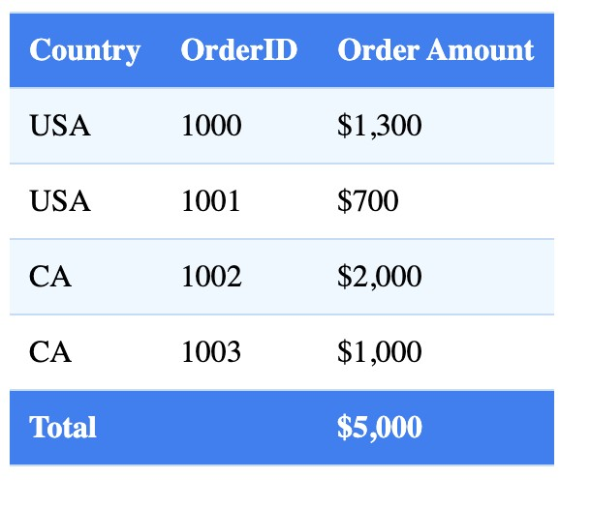

* Background color of the heading cells: **#427fef**
* Background color of odd rows: **#eef7ff**
* Border color: **#c4dcf3**

CSS Basics  **2**

2. Create a box as shown below.



* Dimension: 300px x 300px
* Background color: **tomato**
* Shadow color: **lightgrey**