**Everyone has to be tech literate first, then tech fluent: Accenture's Rekha Menon**

**Jhinuk Sen  11 hours ago**

Microsoft kicked off the Future Ready program on January 11 with a host of sessions helmed by some of the biggest names in the industry. One of the sessions, titled ‘Tech multiplier to build India’s talent reservoir’, saw **Rekha Menon, Chairperson and Senior Managing Director, Accenture India,** and Ronnie Screwvala, Chairperson and co-founder of UpGrad, chatting with Vikram Chandra, founder of Editorji Technologies, about the human skills needed to succeed in a digital economy.

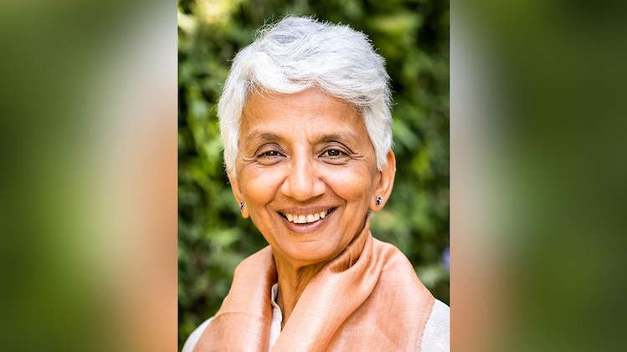© Provided by Business Today Everyone has to be tech literate first, then tech fluent: Accenture's Rekha Menon

While tech skills are of utmost importance, Menon pointed out that while working remotely, people need a very different set of leadership skills and human skills like critical thinking and reasoning. Screwala added that job security, in today’s world, has been redefined based on people’s ability to upgrade and upskill themselves.

Speaking about how hiring is at a decade-long high in the tech industry, Menon said that there is a huge demand for right talent since everyone is getting back from dealing with COVID-19, and India is fulfilling the demand for digital roles and requirements.

“The skill gap itself is not a new thing for the tech industry, because there are always emerging technologies that keep developing rapidly. We have to keep looking for new skills or skilling our people. And beyond the tech industry, digital skills are needed for every industry right now. It's no longer just for technology industry. Every company is a digital company. Therefore, the same talent now has opportunities elsewhere,” she said, adding that the demand in tech industry is about eight times higher than the available talent.

“And there's a third segment, which we don't talk about too much. It's more than the tech skills. There are also other skills now needed. As we work remote remotely, you need very different leadership skills. As we work with machines, you need very different human skills, which is critical thinking, reasoning. So all of those are adding to this huge demand for talent,” Menon explained.

Screwvala reiterated Menon’s point about different skill sets needed in the industry right now and said that the skill to upgrade oneself is necessary across a spectrum of professional roles, not only in IT sector.

“Marketing is not the same, consumer behaviour is not the same, product is not the same, technology is not the same, sales approach needs a lot more data, the entire ecosystem of doing business and high growth has actually been redefined,” Screwvala pointed out while explaining why it is necessary to expand skill sets, especially at a time like this.

“I just caution everybody that when we use the word ‘skilling’, it's always in the form of a low common denominator. I entered what I call the lifelong learning approach because it's going to be something that you will have to keep doing to get a step up. Skilling sounds like a little bit of a top up, a little bit about being job ready. And there is much more today that is needed for people to be in the top 50 per cent of a company otherwise. And I think job security today has been redefined completely based on just the ability of people to upgrade themselves, upskill themselves and be specialists, generalists in whichever form they want to be,” he added.

Speaking of the skills that people need to pick up immediately, Menon mentioned that ‘tech literacy’ is right on top.

“Everybody has to be tech literate because in all aspects of your life we are dealing with technology, whether it's shopping, doing a transaction at the bank, and more. If you are not tech literate, (it) creates a divide between the tech literate and those who are not, not just in terms of jobs but being able to participate in the economy,” she explained and added that the second skill to pick up is tech fluency.

“What the pandemic did was it redefined everything. Whether it is how consumers interact with each other or how consumers interact with the company, the supply chain, what services and offerings have to be made available, etc., and new industries have also opened up. Therefore, there's a bunch of new skills that are needed beyond, a long list of tech skills whether it's blockchain or AR, VR or cloud security, data analytics, all of which are going to be needed,” Menon said.

However, there is one another requirement beyond all these, which is the need for human skills. According to a research, Accenture conducted along with the World Economic Forum (WEF), out of the top 15 skills that will be important in 2025, just five are tech skills. The rest are skills focused on social influence, active learning emotional intelligence, complex problem solving, etc, Menon pointed out.

“If we want to move the needle, it is much more about soft skills because we are not grounded and that's why we are not job ready. I deal with alumni. I deal with learners and students and people and working professionals by the thousands every week. I do a class every Saturday and Sunday on just soft skills. There's no point in being a data scientist if you can't get through your interview. We are missing that balance that everyone's looking for and that's adding a lot of stress to people in their work lives,” Screwvala said.

“The lowest hanging tool for everyone would be that if you're a good communicator and if you're a good storyteller, half of your work is done. But that's actually not the one because at the core of it is self-confidence, self-conviction, which can only be built up as a reservoir, which is not easy to do,” he added.

Screwvala explained that there are about 20 to 30 soft skills with the most obvious ones being focused on communication since it is the most visible one.” But overall, the ability to be able to present yourself, your idea, to participate in a group meeting, to have a point of view, which requires self-confidence. Those are the elements today that I think it's not known about and can be taught,” he said, adding that this is a problem not just in India but globally as well since industries have been redefined but how people think, operate, communicate and execute have not been redefined yet.

Menon added to Scewvala’s point and said that in the past Accenture was just hiring people who could code, but over the last few years the company has moved on to hiring people from liberal arts, anthropology background, design skills and creative thinking.

“You now need people who are thinking creatively, solving complex problems, but also doing multidisciplinary things so there is no point just having one single approach. Also with remote working, what's needed is the ability to remotely empathise, collaborate to build, and to become a good leader. All of these are soft skills,” she said.

Menon also talked about the need for companies, organisations, and governments to partner to fill in the gaps in the tech ecosystem.

“No one organisation can do it alone and you're going to need a close ecosystem collaboration between academia, government, industry, research, to make things work. We also need to take a relook at our entire education system and revamp it to create the right kind of learning modules right from the beginning,” she added.

“If you want an actual contribution to the economy, you’re going to need thinkers, you’re going to need innovators. You’re going to need a lot more than just people with a conveyor belt approach, which worked very well for us when we were in the multiple outsourcing businesses that we were in, but it won’t any longer,” Screwvala said.