Project Progress Report 2

## Title of the project. (5%)

MUST Graduate Application Forum

## Team Members (Name and ID in English). (5%)

* + - Workload Distribution/Contribution.
      * Mark down the contribution by checklist numbers and short notes beside each member.

Information of Team Members:

Cao Yulong, Student ID: 19090853C-I011-0017

Chen Rui, Student ID: 19098533-I011-0171

Lu Jie, Student ID: 19098533-I011-0085

He Xinyi, Student ID: 1909853G-I011-0070

Work Distribution:

Cao Yulong: MGAF-8, MGAF-9, MGAF-14, point 6, 7 in report, JIRA management

Chen Rui: MGAF-7, point 4, 5, 6, 7 in report, JIRA management

Lu Jie: MGAF-10, point 3, 6, 7, 8 in report, JIRA management

He Xinyi: MGAF-19, point 3, 4, 6, 7 in report, JIRA management

## Derive/Discover/Refine Product Backlog and list them in JIRA+Scrum. (30%)

* + - List & prioritize the task-level details to execute your project. (20%)
      * List/Refine the User Stories with Acceptance Criteria. (15%)

In sprint 2, we plan to complete 6 issues. which mainly involve a series of operations that users can perform on posts; administrator and user permissions and the setting of operations that can be performed respectively. The issues to be executed and related information are described below：

Issues MGAF-14 and MGAF-19 are larger pages with more functions, so we set them as issues with Priority: High. At the same time, we have divided sub-tasks for MGAF-14 to make the steps clearer when we start to do it; and for each sub-task, we also set the priority order according to the coding steps.

|  |  |  |  |
| --- | --- | --- | --- |
| Issue key | Content | Priority | Acceptance Criteria |
| MGAF-19 | As an admin, I want to have several permissions so that I can better manage the forum. | High | 1. The admin can be logged in with an admin account and have multiple admin permissions |
| 2. Some illegal or inappropriate information in the forum can be deleted permanently by pressing the “Delete” button |
| 3. The users who have posted lots of inappropriate information can be blocked by the admin temporally or permanently by setting the time duration. |

|  |  |  |  |  |  |
| --- | --- | --- | --- | --- | --- |
| Issue key | Content | Priority | Acceptance Criteria | Sub-task | |
| MGAF-14 | As a registered user, I want to upload my offer related information so that it can be provided to other users in need. | High | 1.Page contains a form with: (1)Offer picture upload button; (2)Fill in all information boxes of offer, such as country, University, GPA, etc; (3)Save button | MGAF-25: Create HTML template | Priority: Highest |
|  |
| MGAF-28: Implement JS code for UI logic | Priority: High |  |
| MGAF-26: Design and implement page layout in css | Priority: High |  |
| After clicking the Save button, the offer display page can display the relevant information of this offer | MGAF-27: Design and create SQL database for MGAF-14 | Priority: Medium |  |
| MGAF-30: Implement backend logic for data fetch to frontend | Priority: Low |  |
| MGAF-29: Implement backend logic for database update | Priority: Low |  |

Issue MGAF-10 MGAFf-7 and MGAFf-10 need to complete some important functions, so we set their priority second only to the above-mentioned page, namely, medium.

|  |  |  |  |
| --- | --- | --- | --- |
| Issue key | Content | Priority | Acceptance Criteria |
| MGAF-7 | As a registered user, I want to post my experience with pictures so that help others understand the information of applying. | Medium | 1.The page should contain elements: (1)A place where pictures can be selected and uploaded from the system photo library; (2)Post button |
| 2. Users can post the pictures after pressing the post button |
| 3. Posts sent by users can be seen by others |

|  |  |  |  |
| --- | --- | --- | --- |
| Issue key | Content | Priority | Acceptance Criteria |
| MGAF-10 | As a registered user, I want to comment on other people's posts so that I can learn more relevant information from the sender. | Medium | 1. The page should have a form to write the comment with a submit button and a delete button |
| 2. Users can comment on other people's posts by pressing the submit button |
| 3. Users can delete their comments by pressing the delete button |

Issue MGAF-8 and MGAF-9 belong to smaller functions and are relatively simple. Therefore, we set their priority lower and allocate fewer story points than the previous functions.

|  |  |  |  |
| --- | --- | --- | --- |
| Issue key | Content | Priority | Acceptance Criteria |
| MGAF-9 | As a registered user, I want to give a like to other people's posts so that I can express that this post is very helpful to me | Low | 1. The page should have a like button |
| 2. Users can give a like to other people's posts by pressing the like button |
| 3. Users can cancel the like by pressing the like button again |

|  |  |  |  |
| --- | --- | --- | --- |
| Issue key | Content | Priority | Acceptance Criteria |
| MGAF-8 | As a registered user, I can reset my password so that if I forget my password, I still have a chance to reset the password and have access to the forum. | Lowest | 1.The users can choose an authentication question with their answer when registering or in the Account Management. |
| 2.The Login page provides user with an option of “Forgot my password”, which is a hyperlink to the password resetting page. |
| 3.Password resetting page includes a form with fields of username, corresponding authentication question, answer, and the new password the user wants to be set. |
| 4.An incorrect answer will cause an alert message which reminds that the authentication failed |
| 5.A right answer will l lead to a new page with new password information |

* + - * Refine the 3 sprints (if necessary). (5%)

1. In sprint 1, we have completed the registration and login functions, but they exist in the same page. Considering that they are inconsistent with the actual application, we optimize them in sprint 2. We separate the functions of login and registration. Users can click the corresponding operation as required (Registered users click the button 'Login to MGAF' and unregistered users click 'Register New Account' to present different forms respectively), as shown in the figure below.

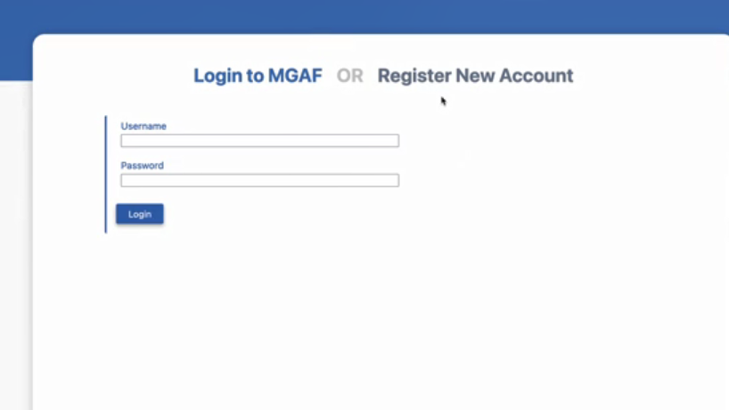

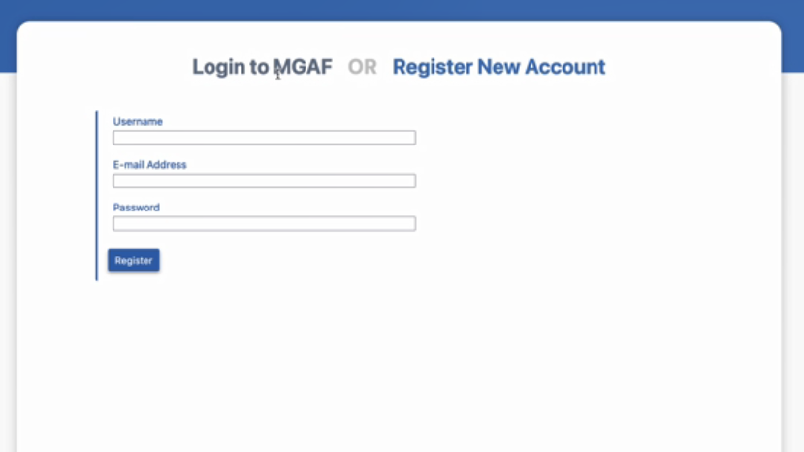

* + - Export the issues as a **CSV** file (**Export Excel CSV (all fields)**) from JIRA and include it with the submission. (10%)

The CSV files will be attached with this report named as ‘*MGAF Sprint2 Issues.csv*’.

## Rework on Sprint1 (if necessary). Implement Sprint2 and Release it as version 2 of your project. (10%)

* + - Show the workflow/progress as a Software Development project in JIRA Scrum. (5%)
      * Attach print screens of the workflow (**Active sprints**) in the report.

The following figure shows the workflow when our project is in progress:

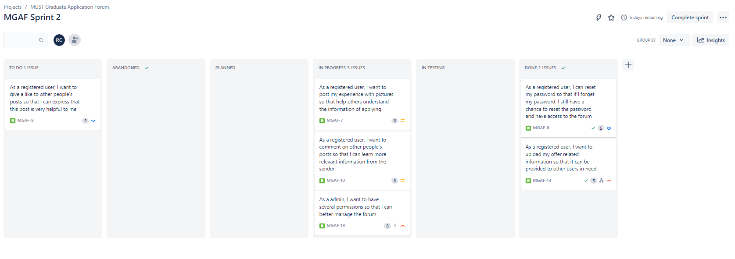

The following figure shows the workflow after sprint2 is completed：

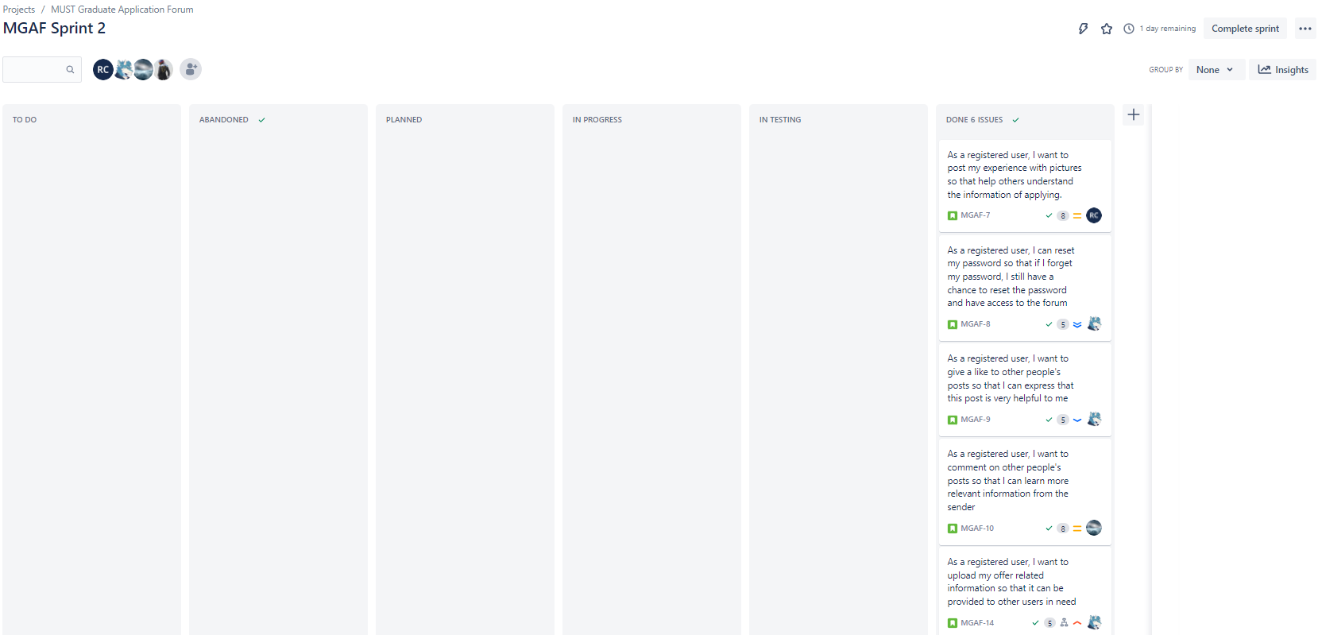

In addition, as shown below, we draw the workflow diagram we should follow in JIRA according to the execution process of our project.

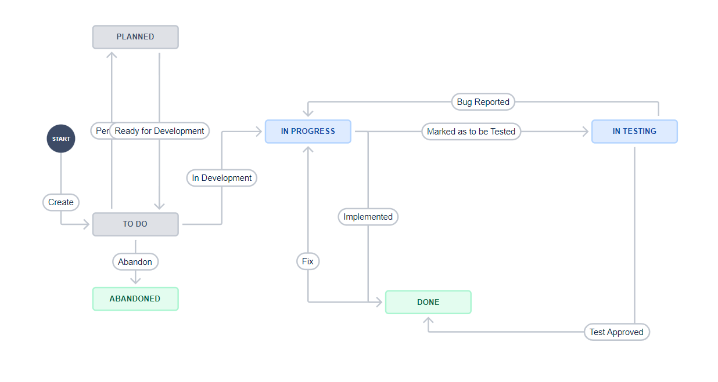

* + - Show the steps of creating a version and releasing the version in JIRA+Scrum. (5%)
      * Attach print screens of the steps in the report.

Create a version

Step1: Click on the Releases link, the screen appears as below.[1]

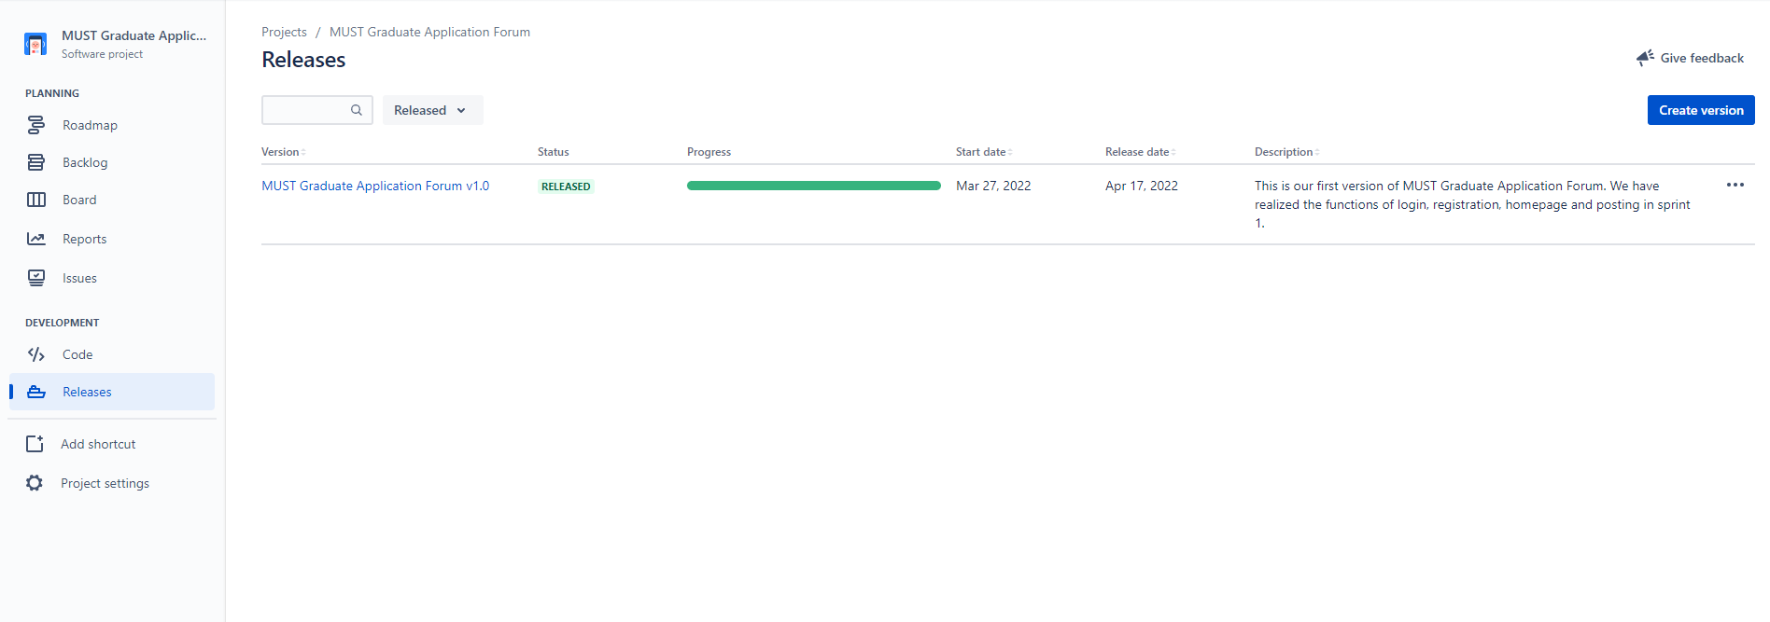

Step 2: Click on the Create version button.

We implement Sprint 2 as MVP and release it as version 2.0 so it has the same start and end time of sprint 2. The creation information of Version 2.0 is as follows:

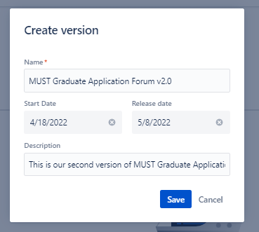

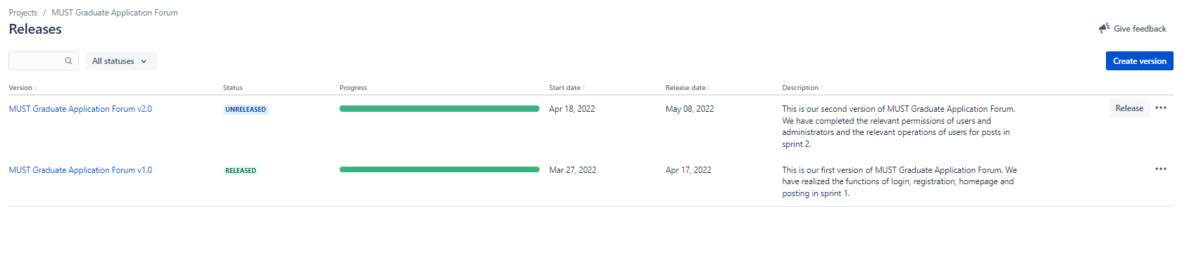

Release the version

We add issues in sprint 2 to version 2 of our project, as shown in the figure, version 2 is expected to be released on May 8th, so it is not yet due. [1]

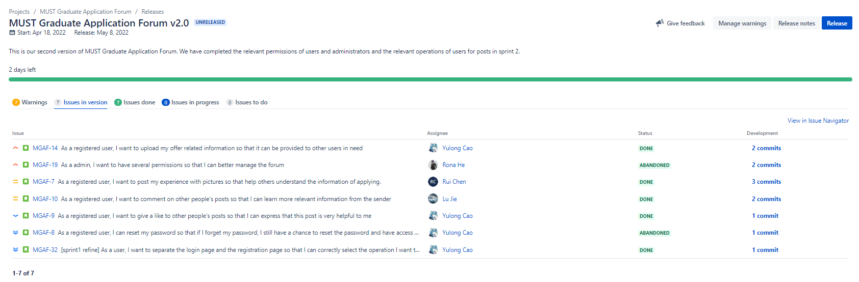

* + - You are also asked to present your work (**source code**) during the presentation.

Here is the Github link of our source code:

<https://github.com/NatsumeRyuhane/CS360-GroupProj>

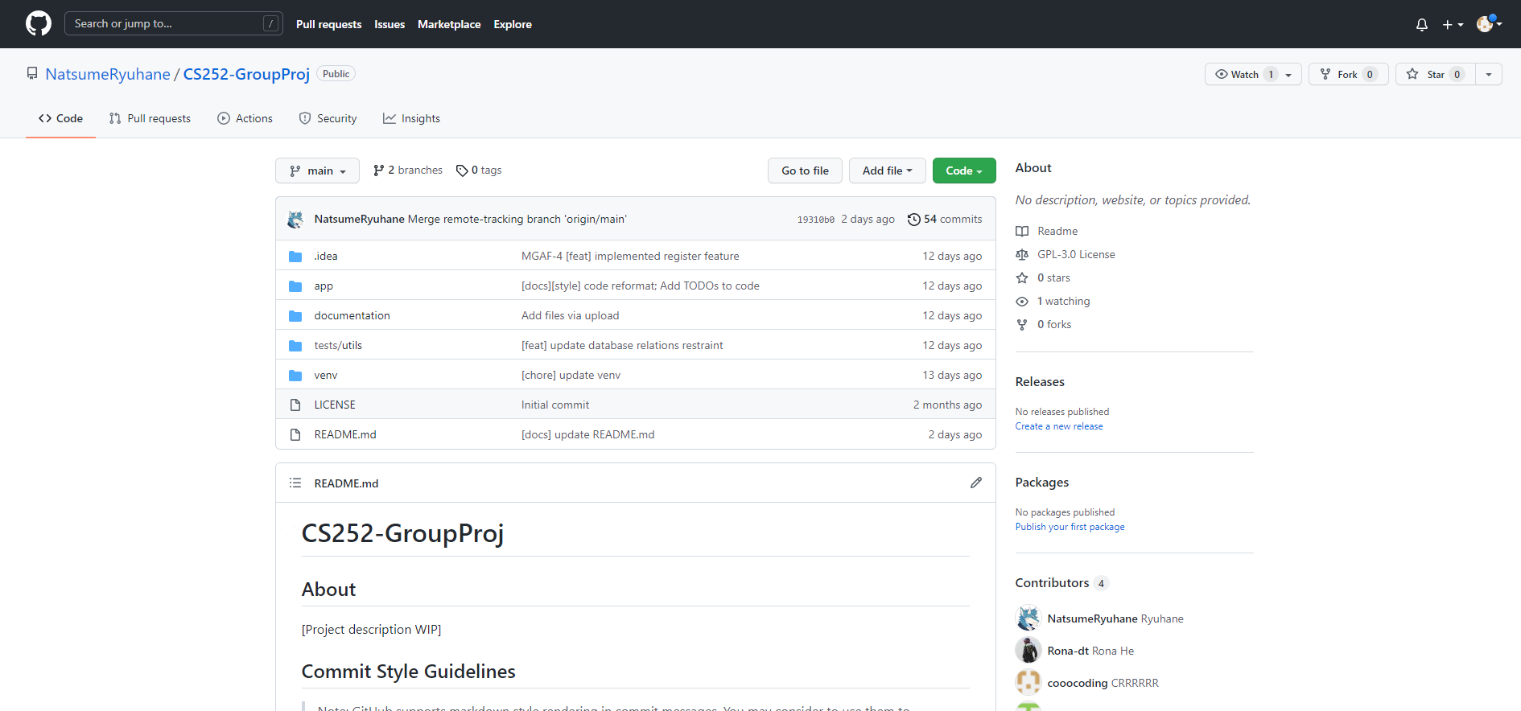

## Show the workflow/status/progress of your project using Burndown Chart, Burnup Chart, Sprint Report, Velocity Report. (15%)

* + - Export (print screen) the Burndown Chart, Burnup Chart, Sprint Report, Velocity Report from JIRA+Scrum and attach them to your report. Finally, explain them and identify the loopholes/impediments in your project (if any).
      * You are also asked to present the project-related Burndown Chart, Burnup Chart, Sprint Report, Velocity Report directly from your JIRA+Scrum during the presentation.

**Burnup chart**

It displays the Burndown chart of the sprint2 like how our team is progressing towards the committed task. The red line displays how much work we remaining in the form of story points. As can be seen from the figure, we have set a total of 40 story points and issue count 7 in sprint 2. The green line shows the completed tasks as a form of story points, which reaches the same point with the red one. Finally, from April 18 to May 6, we completed all the tasks of sprint 2. Our completion speed is slightly slower than expected in the early stage; In the later stage, the speed of our project accelerated, and the curve trend gradually approached the expected completion speed. Finally, all issues in this stage were completed at a slightly ahead speed on May 6. In the later position, we can see that our curve fluctuates, because we didn't create the issue that needs to be modified for sprint 1 at the beginning on time, also due to the fact that we want to shelve some issues that do not belong to the main content of the project, such as the administrator modifying user permissions. [2]

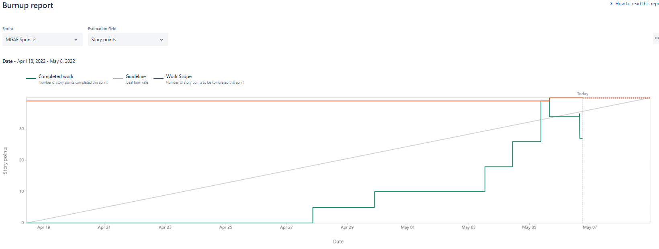

Note: The report will be attached named as ‘*Burnup report.pdf*’.

**Burndown Chart**

Sprint burndown chart uses red line to indicate the number of story points left to complete in sprint 2. Our task has been completed on May 5. Similar to the burnup chart, our completion speed is slightly slower in the early stage, significantly faster in the later stage, and the completion time is slightly earlier than the expected date. The fluctuation of lines is also due to the fact that we created the issue that needs to be modified in sprint1 later and the suspension of tasks. [3]

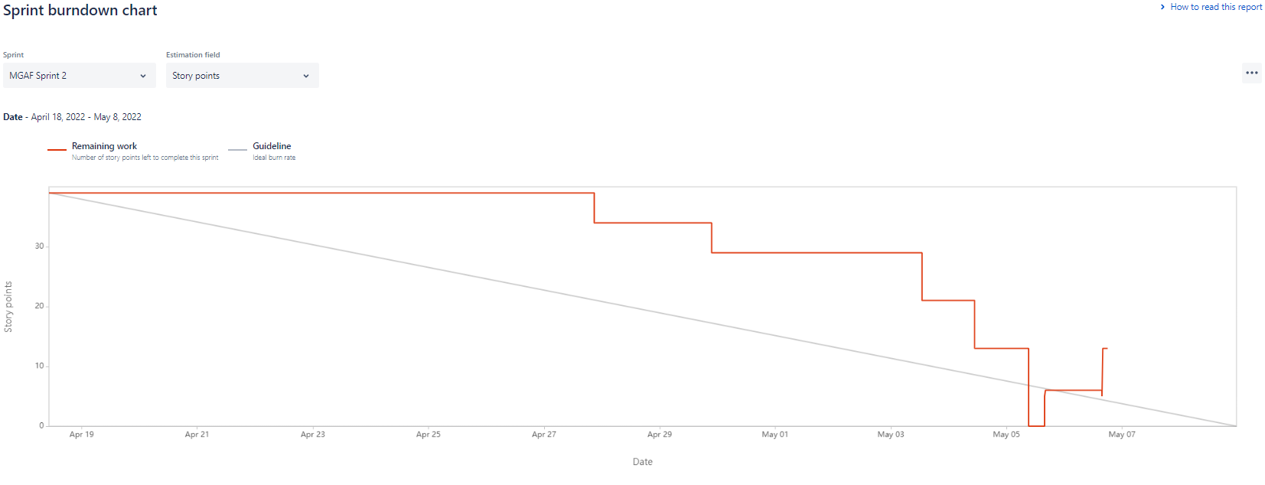

Note: The report will be attached named as ‘*Sprint burndown report.pdf*’.

**Sprint Report**

This report shows all the issues completed in this stage and the relevant issue information (issue type, completion status, assignee, etc.), all of which are in sprint 2. At the same time, it also shows the changes we have made to the issue at this stage. Similar to the figures shown in the previous two reports, we can see that we have made a few changes in this sprint.[4]

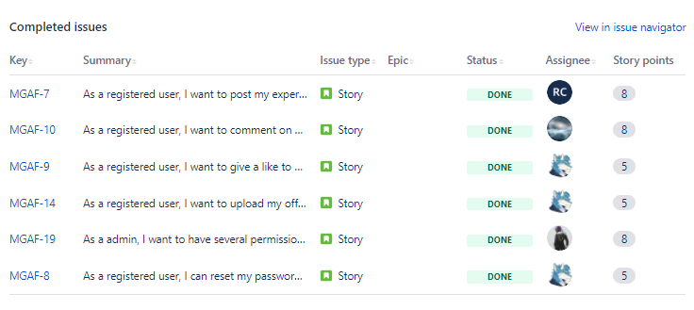

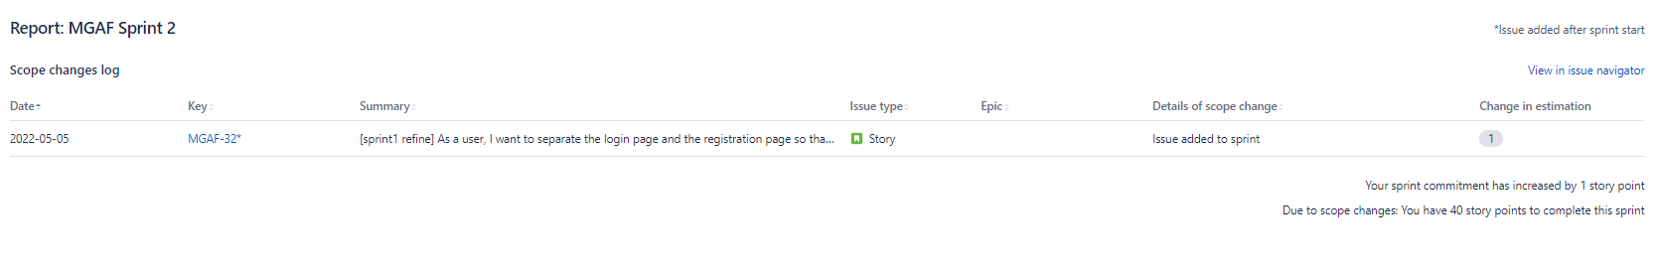

Note: The report will be attached named as ‘*Sprint* *burndown report.pdf*’.

**Velocity Report**

In this report, we can see that y-axis displays the statistic used for story points while x-axis shows the sprint we have completed. The grey columns show the work we need to commit, which is 39. At the same time the green column shows the completed work, whose number is equal to 27. The reason why our actual completed quantity is less than the promised quantity in the early stage is that we have a tight schedule in the later stage of completing the project. For example, the modification of user permissions by the administrator is not the main content of the project, so we choose to suspend the completion of this issue.

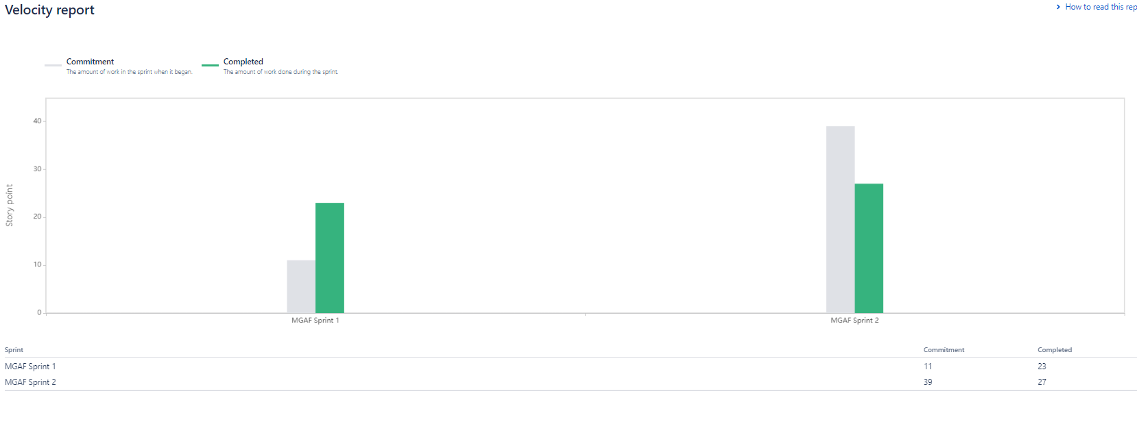

Note: The report will be attached named as ‘*Velocity Report.pdf*’.

In sprint 2, we correct the shortcomings in sprint 1: Divide the issue into sprint accurately; Frequent adjustments to the issue are reduced through early meetings, which can be seen in sprint report. However, it can be seen that we still lack the time and schedule management of the project. In the early stage of sprint 2, our progress is slow, and the speed has been greatly improved in the later stage. This also shows that there is a risk of work stacking and failure in our later stage. Therefore, we have indeed shelved some issues that have little impact on the main functions of the project. In addition, we didn't make a decision on what needs to be improved in sprint 1 before the start of sprint 2, which also led to a small amount of ups and downs in our diagram.

## Summary of Sprint2 Daily Scrums (summary of 5+ discussion points with name). (20%)

* + - Discussion Point #:
      * **Name of the group member**:
      * **Status**: What did I do yesterday?
      * **Issues**: What will I do today?
      * **Action** **items**: Any difficulties or impediments stopping me from the Sprint goal?

Because there are cases where the content of the meeting is similar and the meeting maybe not held everyday, we summarize the most representative items of the meeting discussion in the table below. In general, we focused on roughly 8 items in the daily scrums of sprint 2, mainly involves the improvement of sprint 1, the completion of issue in sprint 2 and the completion of progress report.

|  |  |  |  |  |
| --- | --- | --- | --- | --- |
| DAILY SCRUM | | | | |
| ID | Group members | Date | Discussion Content | Key points |
| 1 | Cao Yulong;  He Xinyi;  Chen Rui;  Lu Jie | 2022.4.20 | **Status**: What did I do yesterday? | Review what needs to improve in sprint 1; Conceive the layout changes of login and register pages |
|  |
|  |
|  |
| **Issues**: What will I do today? | Change and improve the login and register pages in sprint 1 |  |
|  |
|  |
|  |
| **Action items:** Any difficulties or impediments stopping me from the Sprint goal? | —— |  |
|  |
|  |
|  |

|  |  |  |  |  |
| --- | --- | --- | --- | --- |
| DAILY SCRUM | | | | |
| ID | Group members | Date | Discussion Content | Key points |
| 2 | Cao Yulong;  He Xinyi;  Chen Rui;  Lu Jie | 2022.4.23 | **Status**: What did I do yesterday? | Summarize sprint 1;  Sort out the issues to be completed by sprint 2 |
|  |
|  |
|  |
| **Issues**: What will I do today? | Plan to start sprint2;  Confirm the content of sprint 2 again and discuss the priority of issues and other related information. |  |
|  |
|  |
|  |
| **Action items:** Any difficulties or impediments stopping me from the Sprint goal? | —— |  |
|  |
|  |
|  |

|  |  |  |  |  |
| --- | --- | --- | --- | --- |
| DAILY SCRUM | | | | |
| ID | Group members | Date | Discussion Content | Key points |
| 3 | Cao Yulong;  He Xinyi;  Chen Rui;  Lu Jie | 2022.4.25 | **Status**: What did I do yesterday? | Assign tasks that everyone needs to complete in sprint2 |
|  |
|  |
|  |
| **Issues**: What will I do today? | Plan to start making offer upload page. |  |
|  |
|  |
|  |
| **Action items:** Any difficulties or impediments stopping me from the Sprint goal? | The image upload function is relatively difficult |  |
|  |
|  |
|  |

|  |  |  |  |  |
| --- | --- | --- | --- | --- |
| DAILY SCRUM | | | | |
| ID | Group members | Date | Discussion Content | Key points |
| 4 | Cao Yulong;  He Xinyi;  Chen Rui;  Lu Jie | 2022.4.27 | **Status**: What did I do yesterday? | Jira management;  Plan to do the reset password permission. |
|  |
|  |
|  |
| **Issues**: What will I do today? | Do user reset password permission and offer upload page |  |
|  |
|  |
|  |
| **Action items:** Any difficulties or impediments stopping me from the Sprint goal? | The front end needs to consider the cooperation of JS, CSS and DOM |  |
|  |
|  |
|  |

|  |  |  |  |  |
| --- | --- | --- | --- | --- |
| DAILY SCRUM | | | | |
| ID | Group members | Date | Discussion Content | Key points |
| 5 | Cao Yulong; He Xinyi;  Chen Rui;  Lu Jie | 2022.4.29 | **Status**: What did I do yesterday? | Jira management;  Complete the functions of reset password. |
|  |
|  |
|  |
| **Issues**: What will I do today? | Jira management;  Complete the offer page uploaded by user and summarize;  Adjust project schedule time; |  |
|  |
|  |
|  |
| **Action items:** Any difficulties or impediments stopping me from the Sprint goal? | There are many other learning tasks in the near future, and the original task completion plan may lag behind |  |
|  |
|  |
|  |

|  |  |  |  |  |
| --- | --- | --- | --- | --- |
| DAILY SCRUM | | | | |
| ID | Group members | Date | Discussion Content | Key points |
| 6 | Cao Yulong;  He Xinyi;  Chen Rui;  Lu Jie | 2022.5.1 | **Status**: What did I do yesterday? | Plan to do the function of users publishing posts containing pictures. |
|  |
|  |
|  |
| **Issues**: What will I do today? | Do the function of posts containing pictures;  Adjust project schedule time |  |
|  |
|  |
|  |
| **Action items:** Any difficulties or impediments stopping me from the Sprint goal? | There are many other learning tasks in the near future, and the original task completion plan may lag behind |  |
|  |
|  |
|  |

|  |  |  |  |  |
| --- | --- | --- | --- | --- |
| DAILY SCRUM | | | | |
| ID | Group members | Date | Discussion Content | Key points |
| 7 | Cao Yulong;  He Xinyi;  Chen Rui;  Lu Jie | 2022.5.3 | **Status**: What did I do yesterday? | Jira management;  Plan to start the likes function;  Complete progress report |
|  |
|  |
|  |
| **Issues**: What will I do today? | Complete the administrator authority page and summarize, do the page of resetting the password authority for the user |  |
|  |
|  |
|  |
| **Action items:** Any difficulties or impediments stopping me from the Sprint goal? | —— |  |
|  |
|  |
|  |

|  |  |  |  |  |
| --- | --- | --- | --- | --- |
| DAILY SCRUM | | | | |
| ID | Group members | Date | Discussion Content | Key points |
| 8 | Cao Yulong;  He Xinyi;  Chen Rui;  Lu Jie | 2022.5.5 | **Status**: What did I do yesterday? | Jira management;  Complete all sprint2 content |
|  |
|  |
|  |
| **Issues**: What will I do today? | Check and improve sprint 2;  Release the second version;  Complete progress report |  |
|  |
|  |
|  |
| **Action items:** Any difficulties or impediments stopping me from the Sprint goal? | —— |  |
|  |
|  |
|  |

## What are the challenges you encountered while working on Sprint2? How did you address the challenges? (10%)

**(1) Challenge**: Each issue we divided in sprint 2 contains multiple small functions, which makes it impossible for us to track the implementation of each small function when carrying out tasks, and each issue takes a relatively long time.

**The way to solve**: We plan to divide each issue more carefully in the subsequent sprint to better control the progress of the project.

**(2) Challenge**: For the issue that needs to be improved and modified in sprint 1, We forgot to create this issue in the early stage and added it later in sprint2, so we lack JIRA related management on this part.

**The way to solve**: We plan to create issues that needs to be changed before starting the subsequent sprint, so as to facilitate better project management.

**(3) Challenge:** When we plan the completion date of each task in sprint2, we lack to consider the impact of other factors in this time period. As there are many other schoolwork tasks in this time period recently, many of our tasks are concentrated in the late stage. The reports generated in JIRA show the characteristics of slow before fast, loose before tight, and we lack consideration of the control of the project speed.

**The way to solve**: In the subsequent sprint, we plan to take external factors into account and give more detailed and thoughtful consideration to the completion of the issue plan, so as to avoid the stacking of work.

(4) **Challenge:** When we want to complete the Sprint 2, Jira reminds us that the sprint cannot be completed because of some incomplete subtasks on “MGAF-14” issue:

However, when we check the “MGAF-14” issue, we find that the whole issues, including the child issues have been 100% done, as following picture shows：

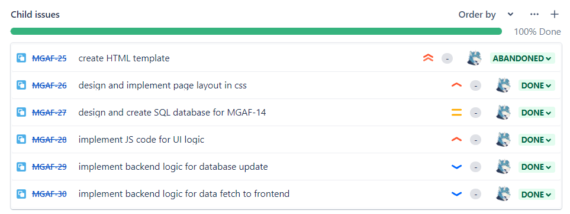

**The way to solve**: We analysed the problem and thought that maybe the abandoned issue caused the problem, so we changed the state of “abandoned” into “done”, and then we can complete the sprint successfully. We guessed this might be a small bug of Jira.

## References (5%)

* + - Relevant references and cite the referred papers/articles/portals in your writing as in the academic papers.

[1] Caitlin Mackie. (2020, December 15). What is the difference between sprints and versions in Jira, from What is the difference between sprints and versions in Jira: https://www.easyagile.com/blog/sprints-versions-jira/

[2] Erica Chappell. (2020, February 21). What’s A Burn Up Chart & How Do You Use It, from What’s A Burn Up Chart & How Do You Use It: <https://clickup.com/blog/burn-up-chart/>

[3] Team Asana. (2021, October 11). Burndown chart: What it is and how to use it, from Burndown chart: What it is and how to use it: https://asana.com/resources/burndown-chart

[4] David Lowe. (2017, May 15). Sprint Reports, from Sprint Reports: <https://scrumandkanban.co.uk/sprint-reports/>

[5] David Lowe. (2022, Feburary 4). Velocity report, from Velocity report: https://docs.microsoft.com/en-us/previous-versions/azure/devops/report/sqlreports/velocity?view=tfs-2017