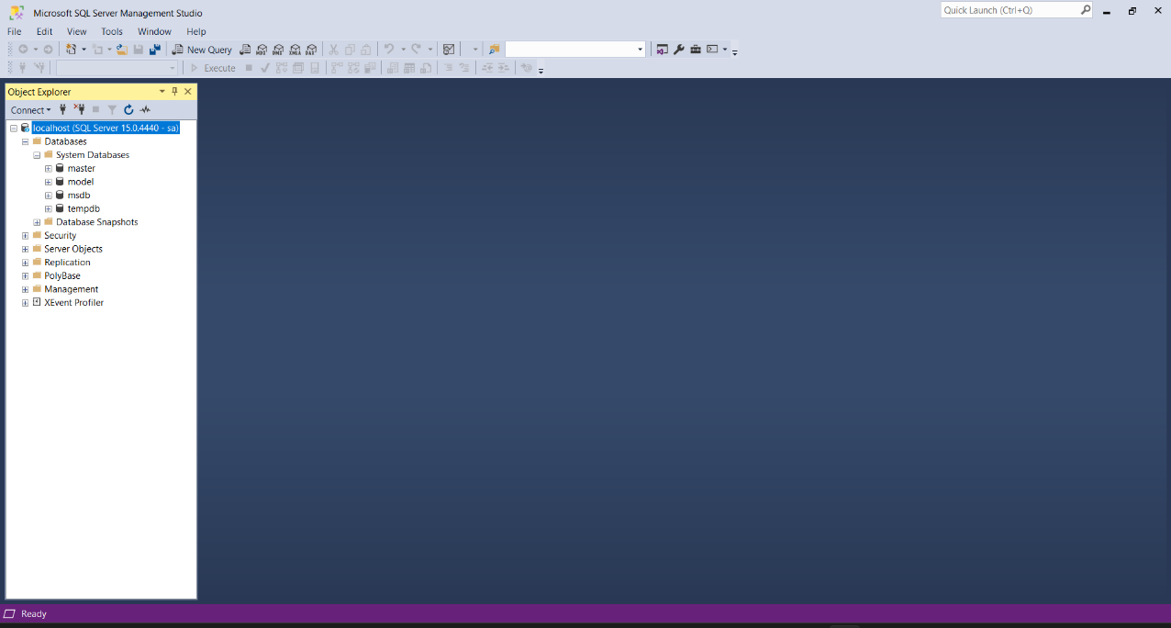

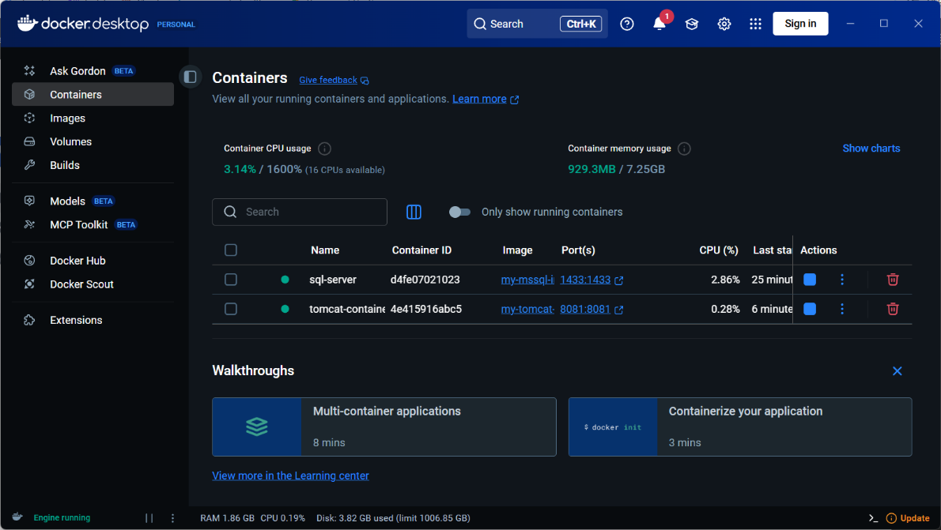

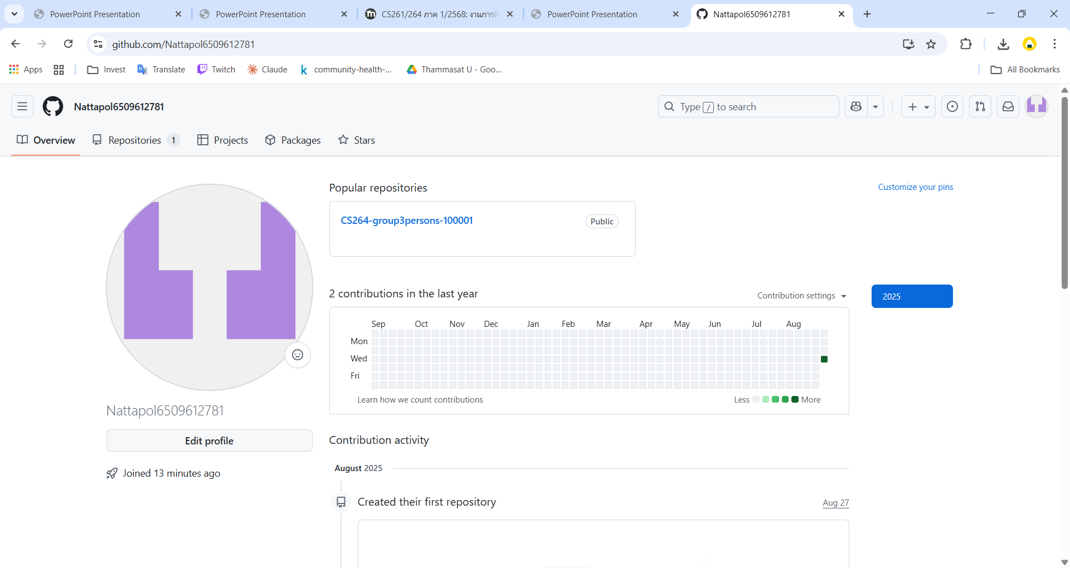

Nattapol6509612781

https://github.com/Nattapol6509612781/CS264-group3persons-100001.git

nattapolsnap@gmai.com

