Business Requirements Document

<<rapidreg automation

(คลินิกหมอบูม จ. สุราษฎร์ธานี) >>

**VERSION: 1.0**

DATE <<2025-02-25 >>

# Version and Approvals

**UTORS**

|  |  |
| --- | --- |
| **Version History** | |
| **Version #** | **Date** | | **Revised By** | **Reason for change** |
|  |  | |  |  |
|  |  | |  |  |
|  |  | |  |  |
|  |  | |  |  |

This document has been approved as the official Business Requirements Document for RapidReg Automation, and accurately reflects the current understanding of business requirements. Following approval of this document, requirement changes will be governed by the project’s change management process, including impact analysis, appropriate reviews and approvals.

|  |  |
| --- | --- |
| **Document Approvals** | |
| **Approver Name** | **Project Role** | | **Signature/Electronic Approval** | **Date** |
|  |  | |  |  |
|  |  | |  |  |
|  |  | |  |  |
|  |  | |  |  |

**Table of Contents**

Version and Approvals 2

Project Details 2

Document Resources 3

Glossary of Terms 4

Project Overview 4

4.1 Project Overview and Background 4

4.2 Project Dependencies 4

4.3 Stakeholders 4

Key Assumptions and Constraints 5

5.1 Key Assumptions and Constraints 5

Business Requirements 7

Appendixes 10

Appendix A – Business Process Flows 10

Project Details

|  |  |
| --- | --- |
| **Project Name** | **RapidReg Automation** |
| **Project Type** | **New Initiative** |
| **Project Start Date** | **02/15/2025** |
| **Project End Date** | **12/31/2025** |
| **Project Sponsor** | **Chuntid Dedruktip** |
| **Primary Driver** | **Nattapol Dedruktip** |
| **Secondary Driver** | **Praphan Dedruktip** |
| **Division** | **-** |
| **Project Manager** | **Praphan Dedruktip** |

Document Resources

| **Name** | **Business Unit** | **Role** |
| --- | --- | --- |
| **Chuntid Dedruktip** | **Medical Unit** | **End-User** |
| **Praphan Dedruktip** | **IT & Development Unit** | **IT developer Tech lead** |
| **Nattapol Dedruktip** | **Business & IT Unit** | **Business Analyst & Developer** |

Glossary of Terms

| **Term/Acronym** | **Definition** |
| --- | --- |
| ProMed | A software used by this clinic as a database for client records, medicine storage, and appointment scheduling. |
| A-Med Care | A digital healthcare service platform developed by National Science and Technology Development Agency (NSTDA) of Thailand to support primary care units in recording, managing patient data, and integrating with National Health Security Office (NHSO) systems for eligibility verification and claims processing. |
| n8n | An open-source workflow automation tool that enables users to connect various apps, services, and APIs with a visual, node-based interface. It allows for complex automations, data processing, and integrations without requiring extensive coding. |

Project Overview

## 4.1 Project Overview and Background

This project is being developed in collaboration with Dr. Boom Clinic, a General Internal Medicine Clinic located in Surat Thani, Thailand. The primary goal of the project is to improve the efficiency of the registration and medical history documentation process, which is currently repetitive and time-consuming. By optimizing these processes, the clinic can enhance workflow efficiency, reduce administrative burdens, and improve overall patient experience.

The main issue of this project revolves around the "One ID Card Smart Hospital" initiative, also known as the "30 บาทรักษาทุกที่" program. When clients use this medical welfare service (which most clients do), the clinic must complete the registration and medical history documentation process for reimbursement in the NSTDA platform.

Currently, the clinic uses a separate program as a database for client records, medicine storage, and appointment scheduling. This means that for each client using the medical welfare service, clinic staff must manually enter data into two systems, one in the clinic's database and another in the NSTDA platform.

This duplication significantly increases workload and takes up valuable time, leading to repetitive tasks that divert medical personnel from their primary responsibilities. The inefficiency not only affects staff productivity but also impacts on the overall patient experience.

## 4.2 Project Dependencies

This project relies on several key dependencies to ensure its successful implementation. The dependencies include:

1. Software & System Dependencies:

* ProMed System - The clinic’s database system for client records and appointments.
* Amed (NSTDA Platform) - The government system required for medical reimbursement.

1. Regulatory & Compliance Dependencies:

* “30 บาทรักษาทุกที่” Healthcare Policy: Government regulation affecting service eligibility.
* PDPA (Personal Data Protection Act - Thailand): Ensuring data privacy compliance.

1. Hardware & Infrastructure Dependencies:

* Clinic IT Infrastructure: Computers and networks required to run the system.

## 4.3 Stakeholders

The following comprises the internal and external stakeholders whose requirements are represented by this document:

|  | **Stakeholders** |
| --- | --- |
| **1.** | **Chuntid Dedrultip** |
| **2.** | **Praphan Dedruktip** |
| **3.** | **Nattpol Dedruktip** |

Key Assumptions and Constraints

## 5.1 Key Assumptions and Constraints

|  |  |
| --- | --- |
| **#** | **Assumptions** |
| 1. | Doctors and staff will adopt the new system |
| 2. | The clinic will continue to use ProMed (clinic’s database) as its primary system |
| 3. | The Amed (NSTDA platform) remains operational and accessible |
| 4. | Internet and network stability are sufficient for the system to function properly |
| 5. | Government regulations regarding "30 บาทรักษาทุกที่" remain unchanged during implementation |
| **#** | **Constraints** |
| 1. | Patient information must not be transmitted or stored on any online platform except for the NSTDA platform. |
| 2. | The project must be completed by December 2025 without delays |
| 3. | The ongoing maintenance cost must not exceed the current system's cost, which includes one additional hour per day for medical personnel to input data into the NSTDA platform after clinic hours. |

Business Requirements

|  |  |
| --- | --- |
| Requirement ID | FR-01 |
| Type | Functional Requirement |
| Business objective | Reduce repetitive data entry workload in medical documentation in **Amed software**. |
| Description | Implement a macro or hotkey function for commonly used general symptoms or medicine in medical documentation. |
| Business values | Reduce workload for medical personnel, allowing them to treat more patients or focus on other essential tasks. |
| Acceptance Criteria | -The hotkey must be operable with one hand.  -The process using the hotkey must be completed within 90 seconds. |
| Priority | High |
| Complexity | Low – Can be completed with 3rd party software within one week with sufficient information. |
| Status | Pending for data |
| Source | Chuntid Dedruktip |

|  |  |
| --- | --- |
| Requirement ID | FR-02 |
| Type | Functional Requirement |
| Business objective | Reduce repetitive data entry workload and minimize the time doctors spend on documentation during diagnosis in the **ProMed software**. |
| Description | Implement a text expansion function, allowing doctors to use abbreviations (e.g., "MFPS" expands to "Myofascial Pain Syndrome") to reduce time spent on medical documentation when diagnosing patients. |
| Business values | Reduce workload for medical personnel, allowing them to treat more patients or focus on other essential tasks. |
| Acceptance Criteria | -The text expansion must work automatically when the doctor types a predefined abbreviation.  -The expanded text must be correct and match predefined medical terms.  -The expansion process must not cause delays (should complete within 1 seconds).  -Users must have the ability to add or modify predefined abbreviations. |
| Priority | High |
| Complexity | Medium – Can be completed within two weeks with sufficient information. |
| Status | Pending for data |
| Source | Chuntid Dedruktip |

|  |  |
| --- | --- |
| Requirement ID | FR-03 |
| Type | Functional Requirement |
| Business objective | **Automate the registration process** by ensuring that patient data registered in the clinic database (ProMed) is also registered in Amed software (NSTDA platform) automatically or semi-automatically. |
| Description | The process does not need to be fully automated but should provide a semi-automated solution that reduces the time medical personnel spend on the registration process. The system should allow medical personnel to use only one software (ProMed or Amed) while automatically filling in the required information in the other one without manual data entry. |
| Business values | Reduce workload for medical personnel, allowing them to treat more patients or focus on other essential tasks. |
| Acceptance Criteria | -The system must allow patient data from Amed to be transferred to Promed software without requiring manual data entry.  -The automation process must maintain data integrity, ensuring no missing or incorrect data is transferred.  -The process must comply with data security regulations and prevent unauthorized data exposure.  -The semi-automated process should reduce the registration time by at least 50% compared to the manual process. |
| Priority | Medium |
| Complexity | High – Data security is a major concern, and direct API integration with NSTDA is not possible. |
| Status | Start doing proof-of-concept prototype |
| Source | Chuntid Dedruktip |

|  |  |
| --- | --- |
| Requirement ID | FR-04 |
| Type | Functional Requirement |
| Business objective | **Automate the process of filling medical history documentation**. Ensure that patient data registered in the clinic database (ProMed) is also registered in the Amed software (NSTDA platform) with minimal manual entry. |
| Description | The process does not need to be fully automated but should provide a semi-automated solution that reduces the time medical personnel spend on the registration process. The system should allow medical personnel to use only one software (ProMed) while automatically filling in the required information in the Amed software (NSTDA platform) without manual data entry. **There is a concern regarding discrepancies in data fields between the two databases (e.g., differences in medicine names and formats).** |
| Business values | Reduce workload for medical personnel, allowing them to treat more patients or focus on other essential tasks. |
| Acceptance Criteria | - Data integrity must be maintained, and any discrepancies (e.g., different medicine names) must be handled with a mapping or verification process.  - The system must comply with data security regulations and prevent unauthorized data access.  - Since direct API integration is not possible, a secure and efficient alternative method for data transfer must be implemented.  - The process should reduce the time spent on medical history documentation by at least 50% compared to the manual process. |
| Priority | Medium |
| Complexity | High – Data security is a major concern, and direct API integration with NSTDA is not possible. |
| Status | Not started |
| Source | Chuntid Dedruktip |

Appendixes

## Appendix A – Business Process Flows

### *Registration Process (As Is Diagrams)*

*Prof-of-Concept Prototype 1 (To Be Diagrams)*

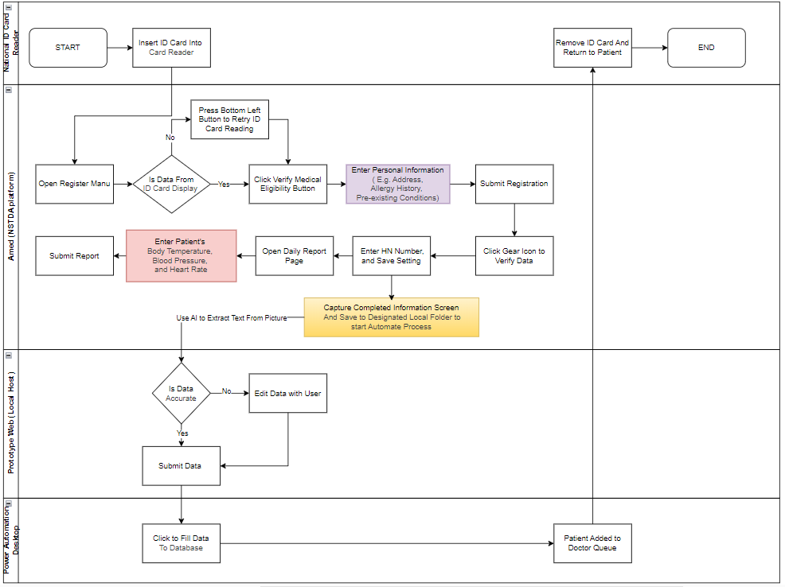

**Prof-Of-Concept Prototype 1 (POC1) in Detail**

POC1 utilizes an AI tool built using the n8n platform to extract text from images captured from the Amed system. The extracted text is sent to a webhook UI (localhost) for data verification. Once verified, the confirmed data is saved as a CSV file in designed folder. Finally, Power Automate Desktop is used to input the verified data into ProMed, reducing redundant data entry and improving efficiency.

As you can see, POC1 reduces repetitive tasks and transforms the process into a semi-automated workflow. It requires only 3-4 user interactions (highlighted in green) where users need to click and edit data if it is inaccurate. This improvement reduces the overall processing time by approximately 40%, making the workflow more efficient.

POC1 raises concerns regarding data security and compliance with Thailand’s PDPA policy, as it currently uses the OpenAI API to extract data. Therefore, in the next version of the prototype, the development team aims to implement a local ML model for data extraction to enhance security and ensure compliance with data protection regulations.