**Homework 5 Due Nov 23, 2020**

1. Write a program to enhance a given image below in order to obtain an enhanced image as shown on the bottom using any method(s) of your choice. Write down the comment for each step in your program.

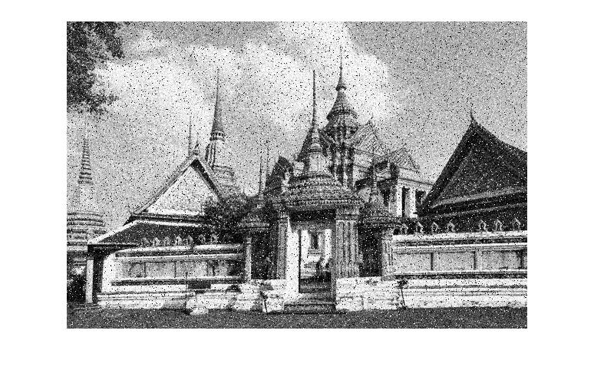

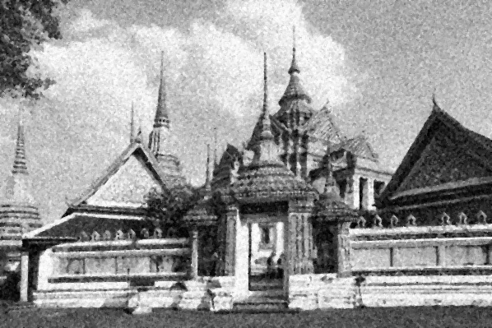

I put the picture through Adative Median Filter with kernel size is 3*3 and sMax equal to 7. I have also try Contra Hamonic Mean filter but No as efficient as Adaptive Mean Filter.

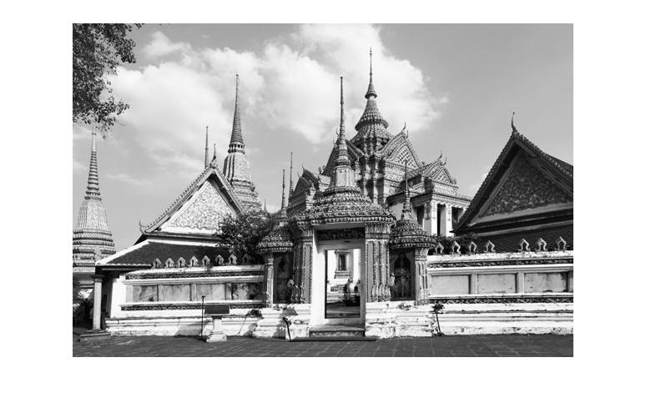

2. Write a program to sharpen an image using any method(s) of your choice. Write down the comment for each step in your program.

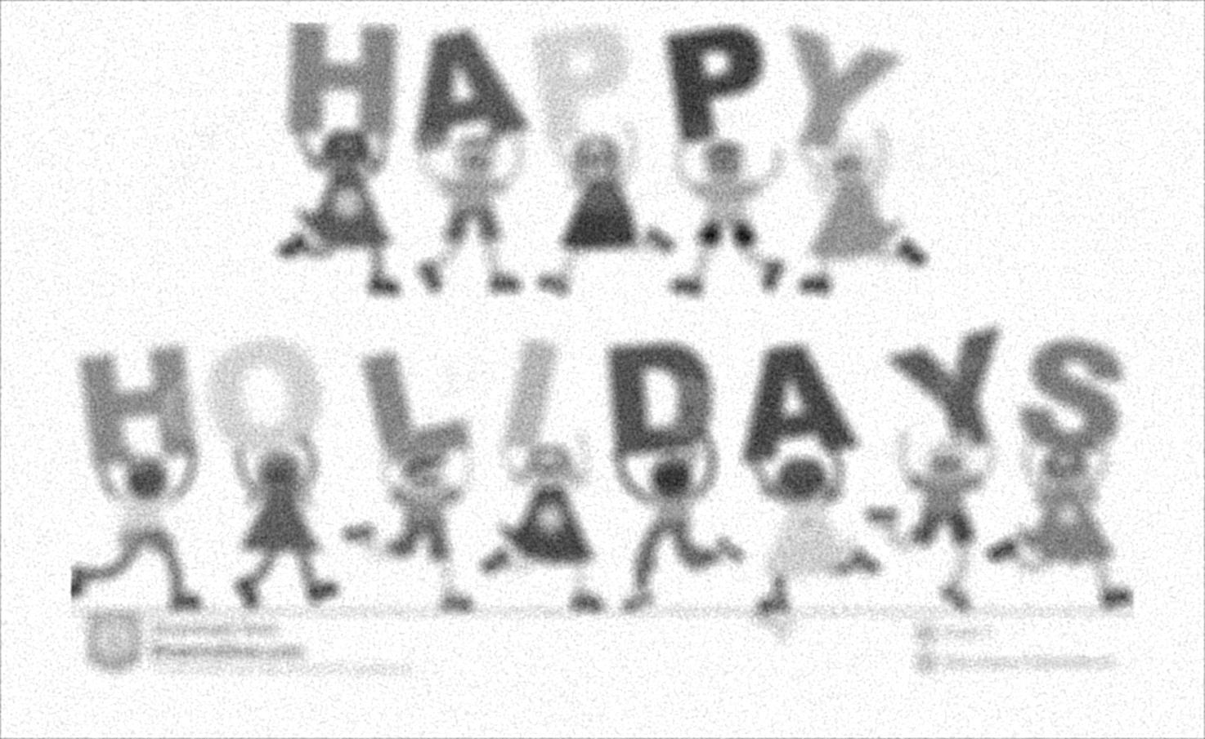

I use Weiner Filter to adjust the image note that I try a lot of variation after apply Weiner Filter but none seem to improve the result.

3. Write a program to remove noise from these 2 images using any filter(s) of your choice. Write down the comment for each step in your program.

I adjust both picture in Frequency Domain with Butterworth Low pass Filter because I can’t program to find the less frequency spot to use notch filter. Anyway after apply the filter and inverse to Normal Domain the Image is too bright so I apply the Histogram Equivalization to the result.

