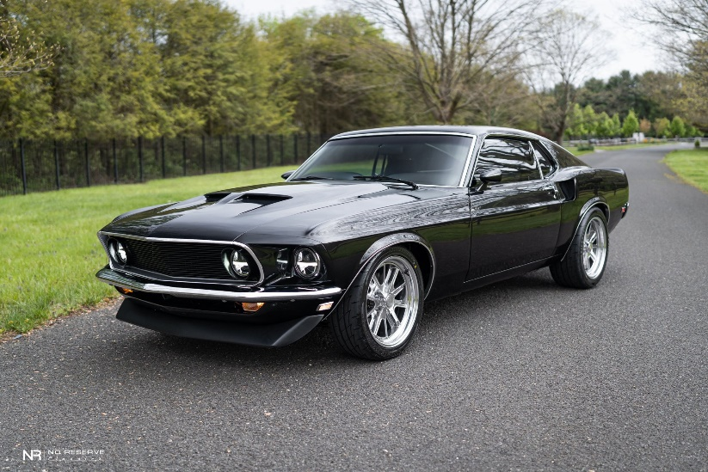

Ford Mustang 1969

The 1969 model was the first model to use quad headlamps placed both inside and outside the grille opening. The corralled grille pony was replaced with the pony and tribars logo, set off-center to the driver's side.The car was longer than previous models and sported convex rather than concave side panels. The fastback body version was named SportsRoof in Ford's literature.

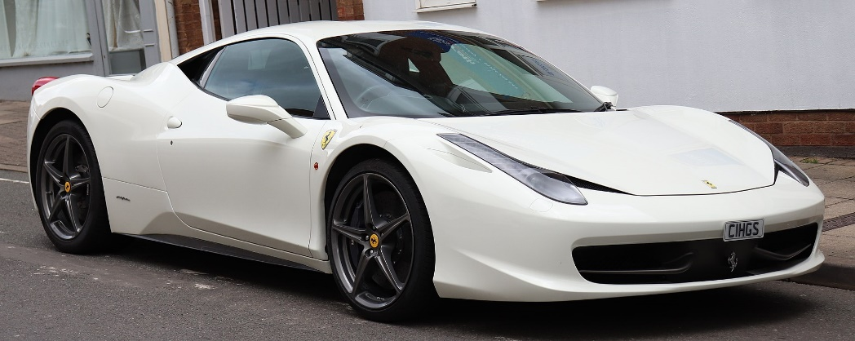

Ferrari 458

The Ferrari 458 Italia (Type F142) is an Italian mid-engine sports car produced by Ferrari. The 458 is the successor of the F430, and was first officially unveiled at the 2009 Frankfurt Motor Show.It was succeeded by the 488 GTB (Gran Turismo Berlinetta) in 2015.