Sprite1 - opening

C:\Users\ALIENWARE\Desktop\1.gif

tank

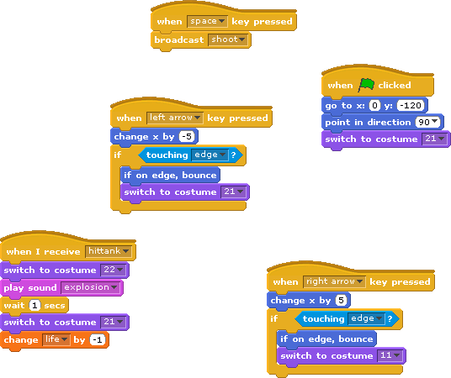

Sprite2 – green bullet

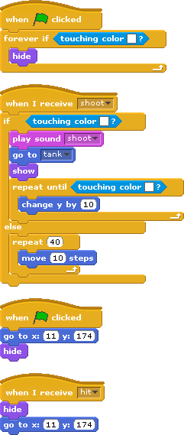

Sprite76 – white bullet

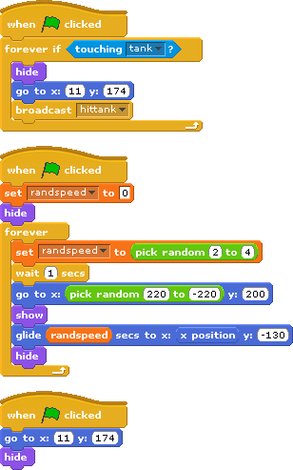

left

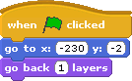

right

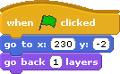

bottom

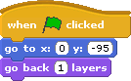

Sprite11

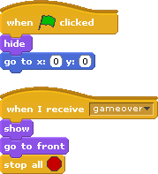

Alien, sprite13, sprite 18 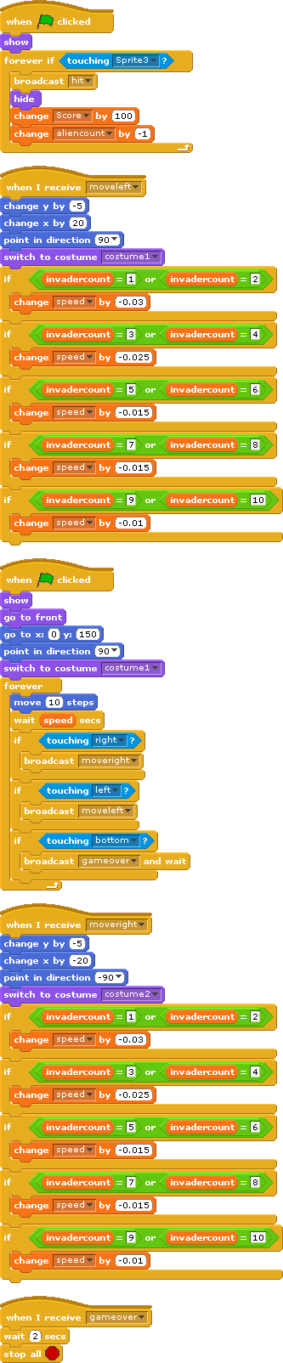

Sprite14-sprite17, sprite 19-22 (only difference between each are positions)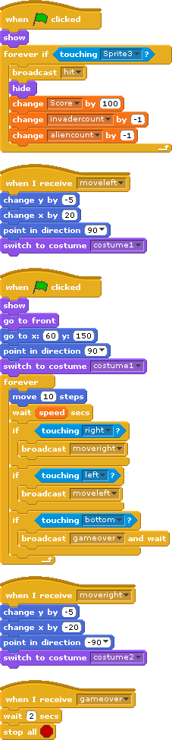

Sprite32-sprite42 (only difference is the location that they start with)

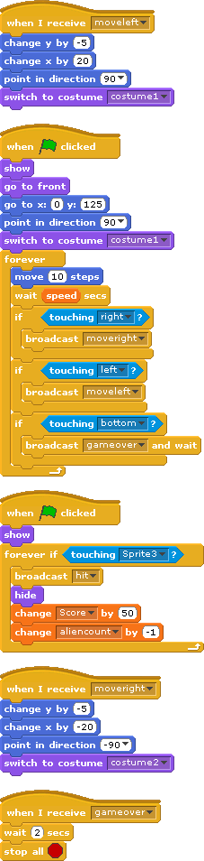

Sprite43-sprite53 (only difference is the location that they start with)

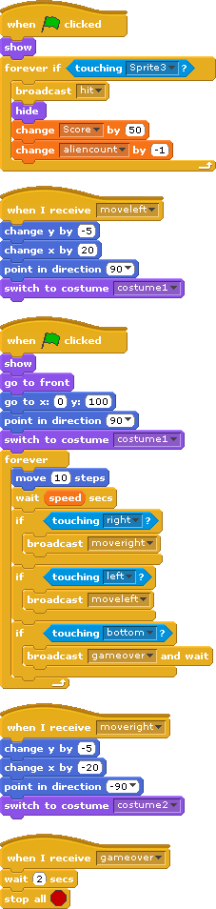

Sprite54-sprite64 (only difference is the location that they start with)



Sprite65-sprite75 (only difference is the location that they start with)

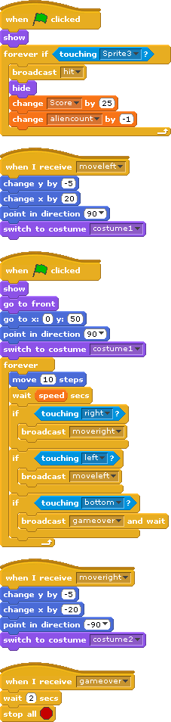

Sprite77

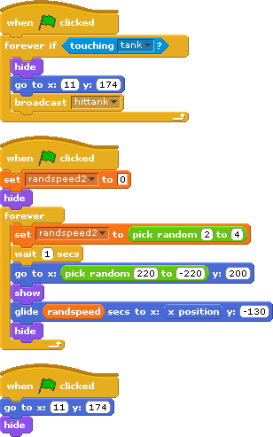

Sprite78

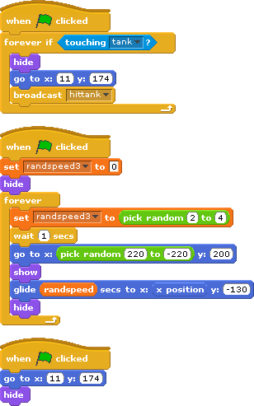

Sprite79

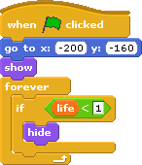

Sprite80

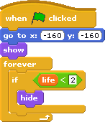

Sprite81

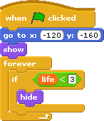

Sprite82

