
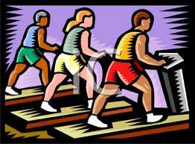

Combining these great features has created the ultimate Fitness Companion. The easiness to operate the web and app will let any athlete become a master of training. Being able to connect to friends will create a competitive environment that will keep any person motivated. While friends can be supportive, expertise is needed to bring your physique to the next level. Communicating with doctors, trainers, and diet consultants as you are exercising will be a great asset to anyone training seriously. All of these functions separately would be an extensive amount of money, however, using the web, you are able to get all these features at a much lower cost.
Friendly Fitness
Founded by: Kyle Raucci, Jie Huang, Cody Goodman, Florian Pranta Hidayat.

se1.engr.rutgers/~13group12/index.php
Revolutionize Your Workout!

Now you can:

Easily access various graphs of recorded data including:
Heart Pressure
Hours Slept
Hours Exercised
Calorie Intake

Connect with friends to challenge yourself

Connect with professionals to get expert advice

Make fitness fun

Keep fitness inexpensive

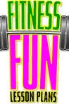
Two people can encourage each other without having to be on the same track!

Working out with a buddy can keep you motivated. Join your friends to make fitness fun!
You can get help from a trained professional or your own doctor!

A doctor at your side can be very beneficial, especially if you’re new to fitness training or have a heart condition.
Connect with friends to compete and encourage good physical fitness.
Connect with doctors and physicians that can view your information and give you advice.
Viewing your workout sessions will be “no-sweat” with our easily accessible website and app.

All of your workout results will be seamlessly transferred from the device to the Web/App and conveniently organized in easy to read graphs.

With all important information stored, you can track your progress and adjust your workouts accordingly.

(not actually graph)
Get trainer quality assistance without having to run to the bank.

By cutting out the middle man, you are able to get trainer assistance for a lower price than at the gym.

