# 3. Functional Requirements

## 3.1 Stakeholders

* Athletes
* Professional Sports Leagues
* Dietitians and Nutritionists
* Fitness Trainers
* Medical Practitioners
* Medical Device Companies

## 3.2 Actors and Goals

|  |  |
| --- | --- |
| Actor | Goals |
| Administrator – User with special permissions | To retrieve a client’s username and/or password from database  To ban, restrict, or delete other users |
| Client –Typical Registered User | To improve their own fitness and health  To input data about their diet, workouts, and health information  To access previously stored and analyzed data |
| Database – Non-human | To store user input data  To retrieve user input data  To facilitate comparison and analysis of user data |
| Monitoring Device | To track and record various aspects of a user’s health  To allow easy efficient uploading of user’s health data |
| Professional ­– User with special access to client data | To provide client with expert analysis of data  To provide client with professional services |
| Social Network | To provide client with a platform to share data with friends |
| Visitor – Unregistered User | To explore system capabilities  To view software product information |

## 3.3 Use Cases UC - 1: Visitor Registration (Derived From REQ – 5, REQ – 7)

* Allows a visitor to create a client account
* **Initiating Actor:** Visitor
* **Actor’s Goal:** To create a client account
* **Participating Actors:** Database
* **Precondition:** Visitor provides a currently unused username/password combination
* **Post-condition:** A new client account with the given username/password is created

**UC – 2: User Login** (Derived From REQ – 5)

* A user is able to login to their account by providing a valid username and password combination
* A user that provides an invalid username and password combination more than 5 times will be temporarily locked out of the system (Derived From REQ – 16)

**UC - 3:** **User Views Health/Fitness Data** (Derived From REQ – 2a, REQ – 2b)

* User is able to view previously entered data
* User is able to view analysis of previously entered data

**UC - 4:  Client Request for Professional Review** (Derived From REQ – 11a, REQ – 11b)

* Client is able to grant access of their data to Professional user accounts
* Client is able to request that a Health/Fitness Professional review their data/progress
* Client is able to allow their doctor or physician to access their data
* **Initiating Actor:** Client
* **Participating Actors:** Database, Professional
* **Precondition:** Client is logged in, client provides username of a valid professional account
* **Post-condition:** Client provided professional account can now access client’s data

**UC - 5: Client Password Change or Reset** (Derived From REQ – 7, REQ – 8)

* Client can change their password by providing the current password and the new password
* Client can request that their password be reset in the case that they have forgotten their password.

**UC - 6: Account Access for Administrators** (Derived From REQ – 8)

* An administrator such as an IT professional can access a user’s account in order to address any technical issues that the user may be experiencing.
* An administrator can put a temporary or permanent restriction on client access to their account or on a Professional’s account in the case that they misuse their account privileges.

**UC - 7: Client Input/Upload Data** (Derived From REQ – 2d, REQ - 6)

* Client can input new data to their account to be stored on the database by either inputting information manually or by directly uploading data from supported health monitoring devices.

**UC - 8: Linking Client Accounts to Social Networks** (Derived From REQ – 10)

* Allow a client to permanently link their account with a supported social network account

**UC – 9: Sharing Client Data/Graphs/Tables to Social Networks** (Derived From REQ – 10)

* Allow a client to share fitness data to a linked social networking site
* Allow a client to share generated graphs/tables to a linked social networking site

**UC – 10: Deletion of Client Account** (Derived From REQ – 9)

* An Administrator can delete an account from the database

**UC – 11: Restoration of User Account/Data** (Derived From REQ – 8, REQ – 13)

* An Administrator can restore a user’s account/data from a backup copy if there is a problem with the client’s account

**UC – 12: Generate/Refresh Graphs and Tables** (Derived From REQ – 3, REQ – 6)

* Client can generate analysis graphs and/or tables based on new input data
* Client can refresh existing graphs and/or tables to include new input data
* **Initiating Actor:** Client
* **Participating Actor:** Database
* **Preconditions:** Client is logged in, and Client has previously entered data
* **Post-conditions:** Graphs and tables are generated from Client’s data

## 3.4 Use Case Diagram

## C:\Users\Cody\Desktop\UseCaseDiagram1.png

Figure 3.4: Use Case Diagram

|  |  |  |  |  |  |  |  |  |  |  |  |  |  |  |  |  |  |
| --- | --- | --- | --- | --- | --- | --- | --- | --- | --- | --- | --- | --- | --- | --- | --- | --- | --- |
| 3.5 Use Case Traceability Matrix | | | | | | | | | | | | | | | | | |
| **REQ#** | **1** | **2** | **3** | **4** | **5** | **6** | **7** | **8** | **9** | **10** | **11** | **12** | **13** | **14** | **15** | **16** | **17** |
| **UC-1** |  |  |  |  | **X** |  | **X** |  |  |  |  |  |  |  |  |  |  |
| **UC-2** |  |  |  |  | **X** |  |  |  |  |  |  |  |  |  |  |  |  |
| **UC-3** |  | **X** |  |  |  |  |  |  |  |  |  |  |  |  |  |  |  |
| **UC-4** |  |  |  |  |  |  |  |  |  |  | **X** |  |  |  |  |  |  |
| **UC-5** |  |  |  |  |  |  | **X** | **X** |  |  |  |  |  |  |  |  |  |
| **UC-6** |  |  |  |  |  |  |  | **X** |  |  |  |  |  |  |  |  |  |
| **UC-7** |  |  | **X** |  |  | **X** |  |  |  |  |  |  |  |  |  |  |  |
| **UC-8** |  |  |  |  |  |  |  |  |  | **X** |  |  |  |  |  |  |  |
| **UC-9** |  |  |  |  |  |  |  |  |  | **X** |  |  |  |  |  |  |  |
| **UC-10** |  |  |  |  |  |  |  |  | **X** |  |  |  |  |  |  |  |  |
| **UC-11** |  |  |  |  |  |  |  | **X** |  |  |  |  | **X** |  |  |  |  |
| **UC-12** |  |  | **X** |  |  | **X** |  |  |  |  |  |  |  |  |  |  |  |

**3.6 System Sequence Diagrams**

**UC – 2: User Login**

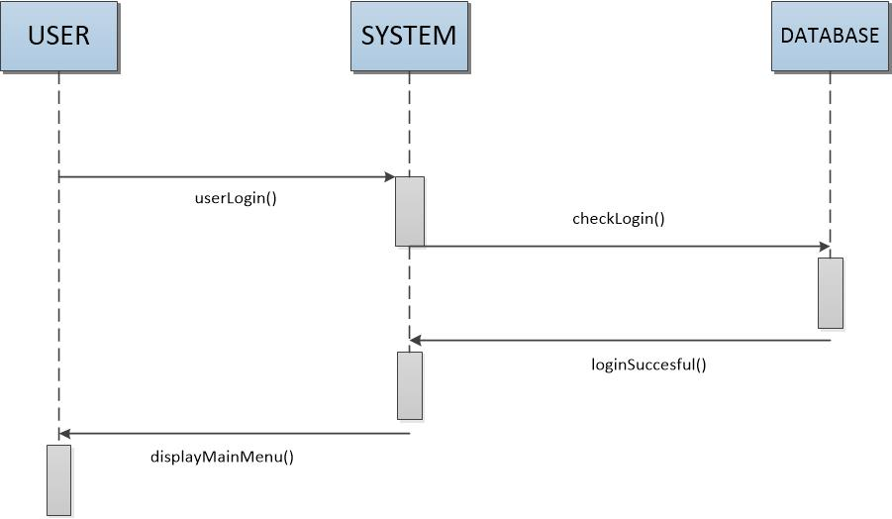

**Alternate Case**

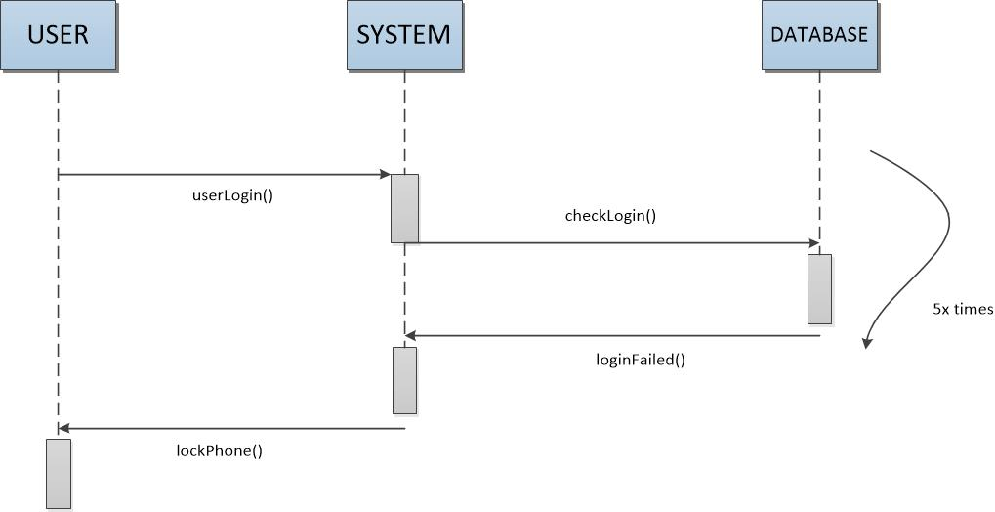

**UC - 3: Client Views Health/Fitness Data**

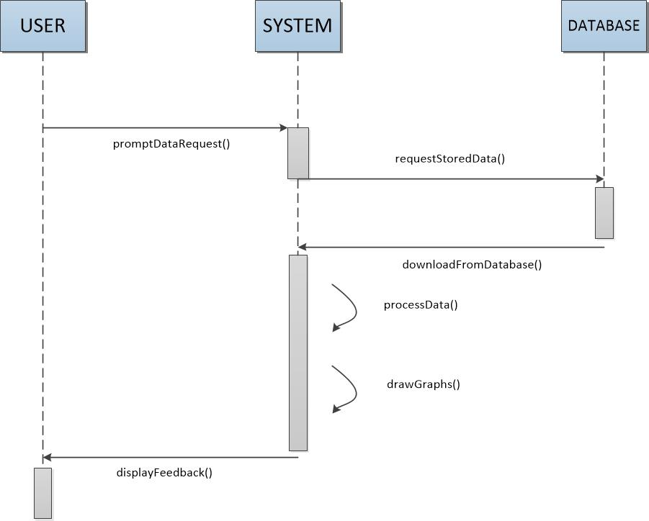

**UC - 4: Client Request for Professional Review**

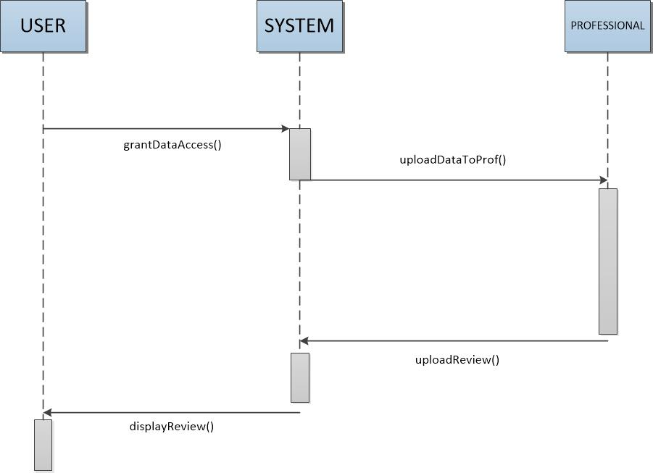

**UC - 7: Client Input/Upload Data**

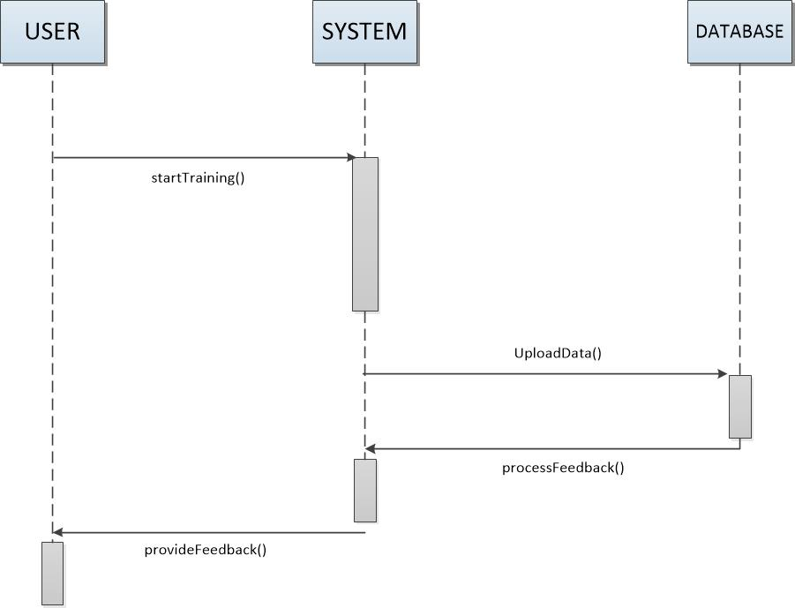

**UC – 9: Sharing Client Data/Graphs/Tables to Social Networks**

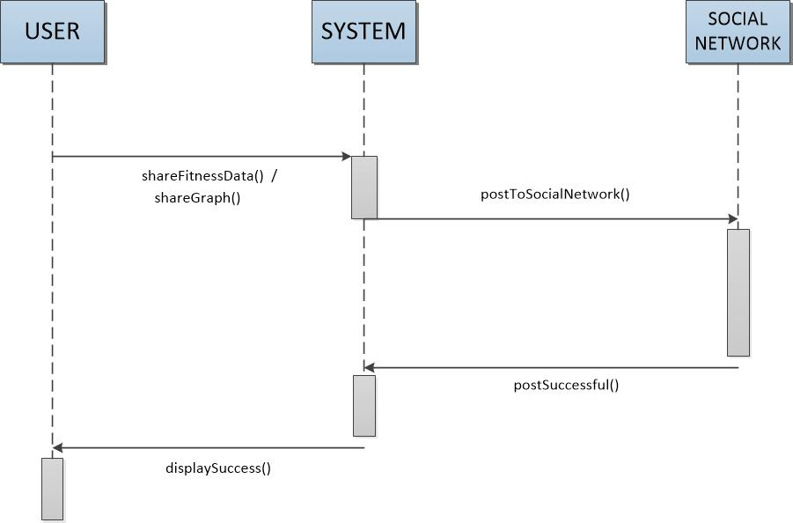

**UC – 12: Generate/Refresh Graphs and Tables**

