**1. Introduction**

Fitness Friends is a health improving program that will help improve or better the lives of the individual user. With Fitness Friends, the user can compare, share, and compete with friends on their daily exercise or routine. Users can view their "fitness points" vs. their friends and see who has a better score.

**2. Disclaimer**

Fitness Friends will not make you feel better or promises to make you fit. Our program is to allow users to compare data with friends and analyze the data user uploads/inputs. This program will not make you skinnier, healthier or stronger. This program is for data collection and comparison only.

**3. Table of Contents**

1. [Introduction](http://magazine.joomla.org/topics/item/107-create-docs#1)
2. [Disclaimer, Versioning and License Agreement](http://magazine.joomla.org/topics/item/107-create-docs#2)
3. [Table of Contents](http://magazine.joomla.org/topics/item/107-create-docs#3)
4. [Body of the Guide](http://magazine.joomla.org/topics/item/107-create-docs#4)
   * Installation
   * Uninstall
   * Step by Step
5. [Reference Materials, Glossary and Additional Requirements](http://magazine.joomla.org/topics/item/107-create-docs#5)
6. [Contact and Support Information](http://magazine.joomla.org/topics/item/107-create-docs#6)
7. [Copyright and Affiliation](http://magazine.joomla.org/topics/item/107-create-docs#7)

**4. Body of the Guide**

This will differ for each project but here are a few points to cover

* Installation (both automated and manual)
  + Upload all files onto a php server
  + Correct connect.php to specific database password, username and database name
  + Create database, follow instructions on database on readme1.txt on how to create the database
  + Run program
* Uninstallation (both automated and manual)
  + Delete all files from php server
  + Delete all information from database
* Step by step guides   
  1. 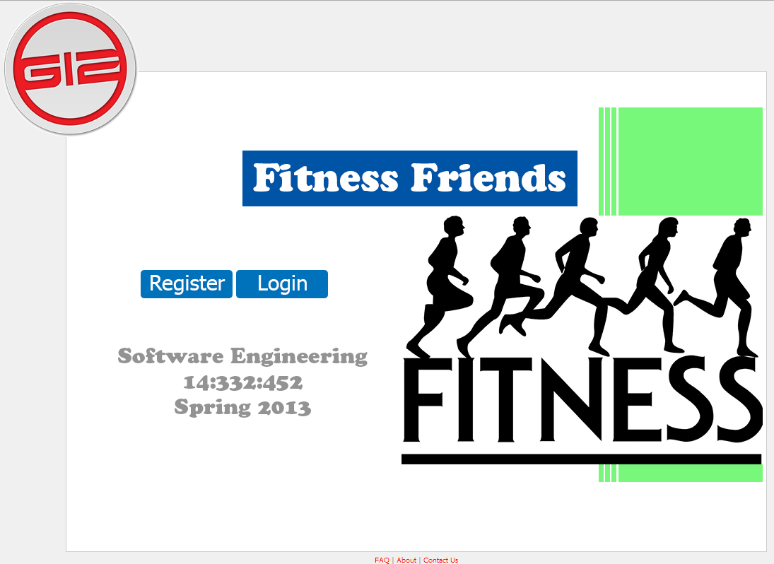

Go to home page

2. 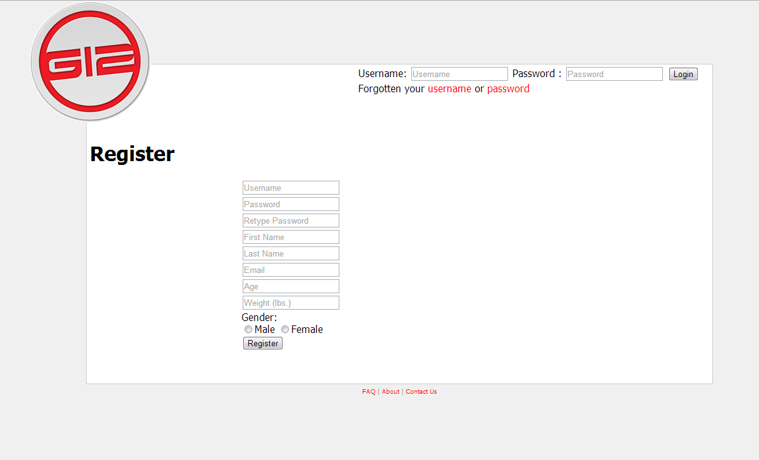

Register account

3. 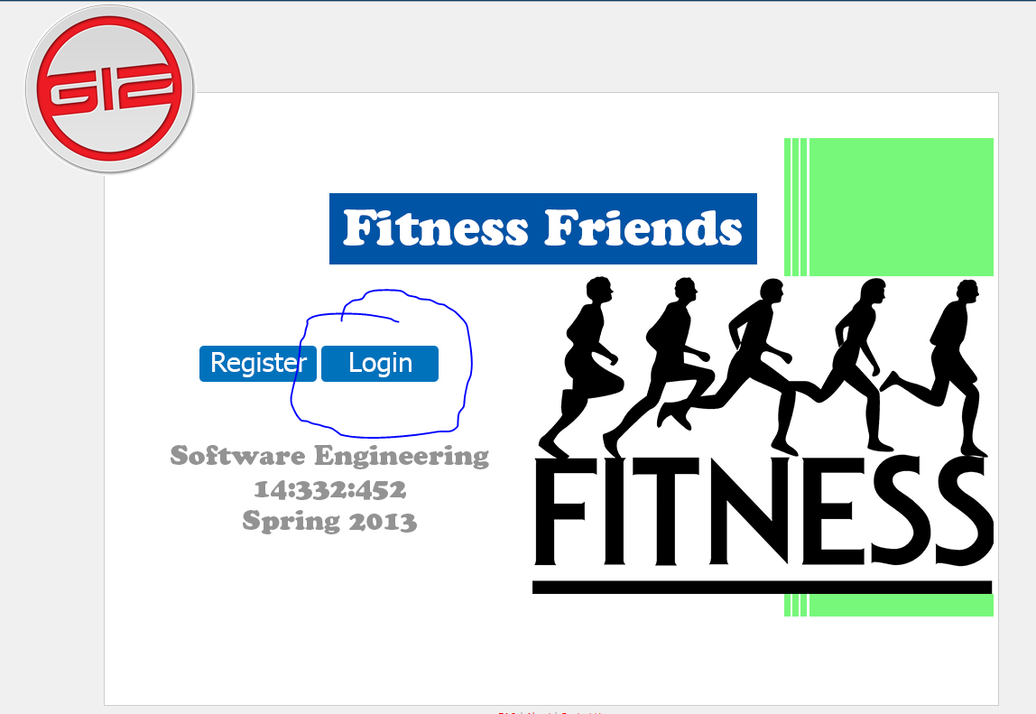

Go back to home page and click on login

4. 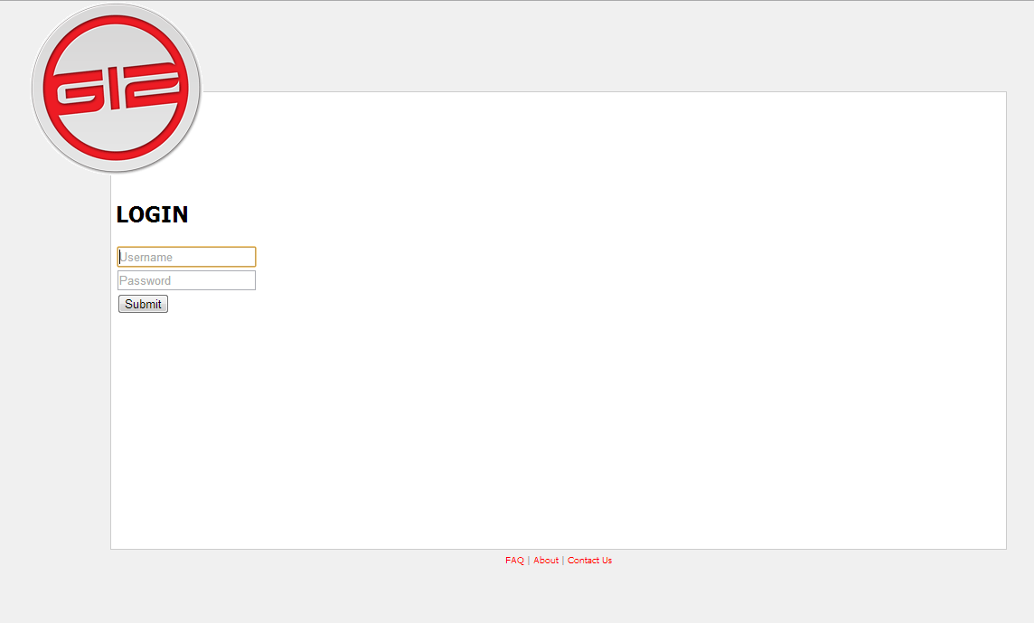

Login with username and password

5. 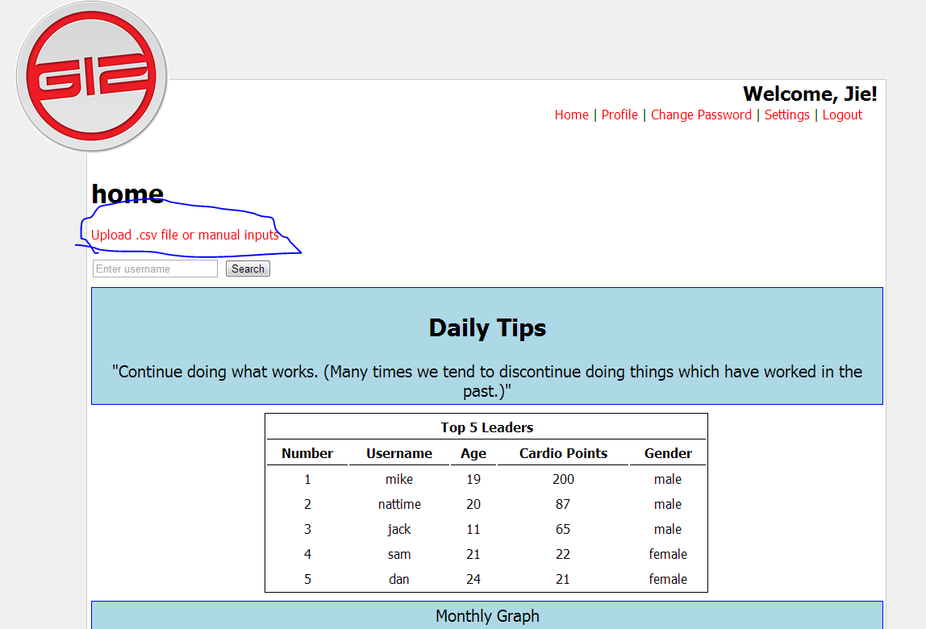

Click on upload csv file

6. 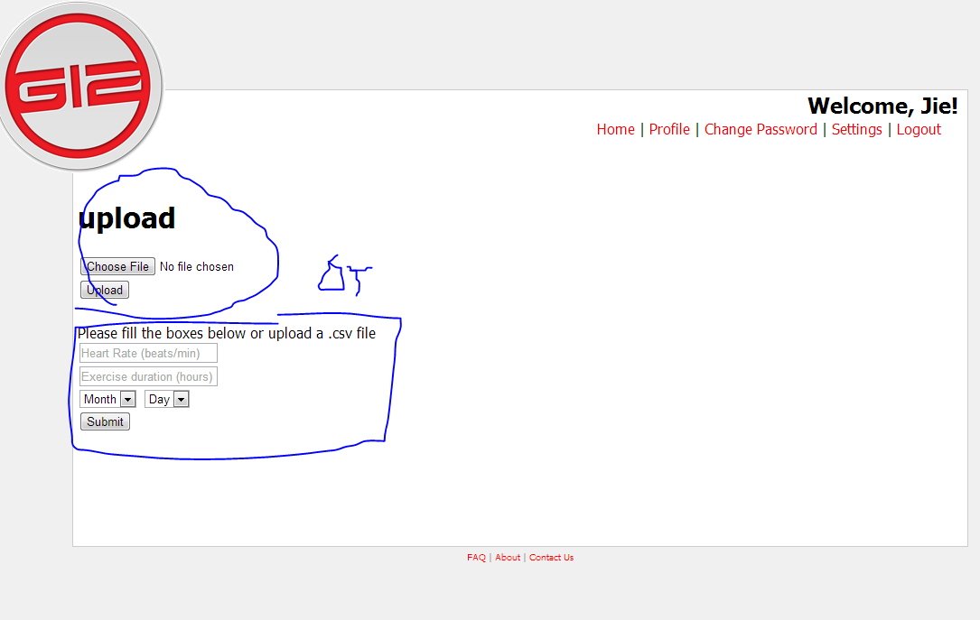

Upload or manually input data of workout

7. 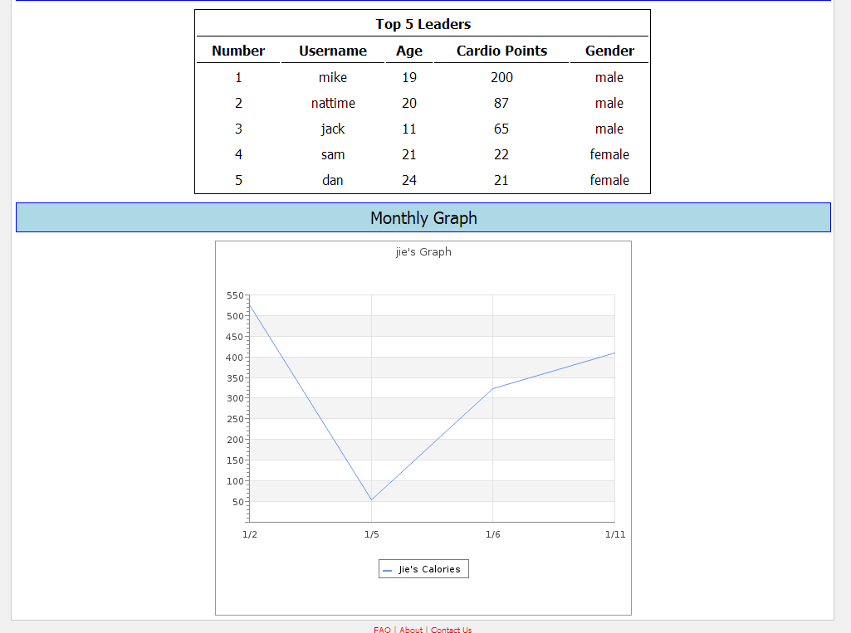

Click home and view your data

**5. Reference Materials**

1)**"Adult Obesity Facts."** *Cdc.gov*. Centers for Disease Control and Prevention, 13 Aug. 2012. Web. 08 Oct. 2012. <http://www.cdc.gov/obesity/data/adult.html>.

2) **"Wearable Wireless Medical Devices to Top 100 Million Units Annually by 2016, ABI Research."** *Wearable Wireless Medical Devices to Top 100 Million Units Annually by 2016, ABI Research*. Business Wire, 17 Aug. 2011. Web. 08 Oct. 2012. <http://www.businesswire.com/news/home/

3) **"Google Code University: Android."** *Code.google.com*. Google, n.d. Web. 23 February 2013. <http://code.google.com/edu/android/index.html>.

4) **"Heart Diseases & Disorders."** *Hrsonline.org*. Heart Rhythm Society, n.d. Web. 23 Feb. 2013. <http://www.hrsonline.org/Patient‐Resources/Heart‐Diseases‐Disorders>.

5) **"Heart Rate."** *Wikipedia*. Wikimedia Foundation, 10 Aug. 2012. Web. 23 Feb. 2013. <http://en.wikipedia.org/wiki/Heart_rate>.

6) McGee, Marianne Kolbasuk. **"11 Telemedicine Tools Transforming Healthcare."** *Informationweek*. InformationWeek, 23 Mar. 2012. Web. 23 Feb. 2013. <http://www.informationweek.com/healthcare/mobile‐wireless/11‐telemedicine‐tools‐transforminghealt/232602982>.

**6. Contact and Additional Support Information**

Visit us at http://se1.engr.rutgers.edu/~13group12/ for any questions or problems. Also contact Group 12

**7. Copyright and Affiliation**

Copyright Group 12