|  |  |  |  |  |  |  |
| --- | --- | --- | --- | --- | --- | --- |
| **Practicum Final Exam – Even Semester Year 2021/2022** | | | | | | |
| **Subject** | | | **COMP7084001 - Multimedia Systems** | | |  |
| **Class** | **:** | **BR01** | | **Start Date** | **: 17 June 2022** |
| **Lecturer** | **:** | **D5381 - Aisha Gemala Jondya, S.Kom., M.TI** | | **Start Time** | **: 15:20** |
| **End Date** | **: 17 June 2022** |
| **End Time** | **: 17:20** |

**PERATURAN UJIAN:**

*Exam Regulations:*

* Mahasiswa tidak diperbolehkan berdiskusi dan/atau bekerja sama dengan peserta ujian lainnya

*Student is not allowed to discuss and/or work together with other exam participants*

* Mahasiswa tidak diperbolehkan untuk membuka dan menyalin dari **BUKU** atau **CATATAN**, **VIDEO** dari pengajar (recording kelas, VBL, Youtube, dsb) dan **REFERENSI** lainnya

*Student isn't allowed to open and copy from any resources such as notes, videos (class recording, VBL, Youtube, etc) and other references*

* Mahasiswa tidak diperbolehkan membuka dan menyalin jawaban dari internet (google, stackoverflow, dsb)

*Student isn't allowed to open and copy answer from the internet (google, stackoverflow, etc)*

* Asisten **BERHAK** memberi nilai 0 **(NOL)** bagi peserta ujian yang melakukan segala bentuk kecurangan

*Assistant is able to give 0 (ZERO) score for exam participant who does any cheating actions*

* Kumpulkan jawaban tepat pada waktunya, apabila terlambat mengumpulkan maka jawaban tidak akan dikoreksi dan nilai mahasiswa adalah 0

*Submit the answer on time, if not, then the answer will not be checked, and the students will receive 0 (ZERO)*

* Bila Anda tidak membaca peraturan ini, maka Anda dianggap telah membaca dan menyetujuinya

*If you have missed to read these regulations, so you are considered to have read and agreed on it*

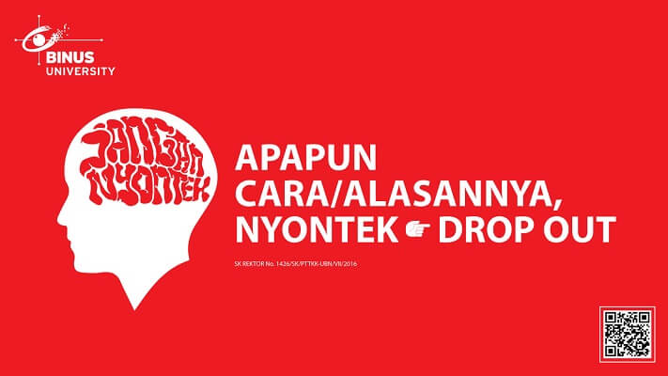

**SOFTWARE YANG DIGUNAKAN:**

*Software will be used:*

Adobe Animate CC 2021  
Chrome / Firefox / Microsoft Edge

**FILE YANG DIKUMPULKAN:**

*File must be collected:*

FLA  
Image Files (JPG / PNG)  
Audio Files (MP3 / WAV)  
Video Files (AVI / MP4)

**PERHATIAN!**

*Attention!*

* Bagi yang mengerjakan tidak sesuai dengan soal, maka akan diberikan nilai **NOL (0)**

*For those who do not work in accordance with the exam case will be marked as* ***ZERO (0)***

* Bagi yang mengerjakan tidak sesuai dengan software dan versi yang telah ditetapkan, maka akan tetap dikoreksi dengan software dan versi yang telah ditetapkan

*For those who do not work in accordance with the software and specific version will be corrected by the predefined software and version*

* Kompres semua jawaban yang akan diunggah. Pastikan format pengumpulan nama file dan ekstensi sesuai dengan format berikut: **[NIM]-[NAMA].zip**

*Compress all file that will be uploaded. Make sure the format for collecting file name and extension according to the following format:* ***[NIM]-[NAME].zip***

**Soal**

*Case*

**Zunder Zifflin**

The Scranton-based paper company, **Zunder Zifflin** is making a resurgence in the industry. To announce their new company profile, you are asked to create an animation to promote the company to more people. Because more people, more money for the company! You can see an example application at the [**following link.**](https://mega.nz/file/RjY3kKSC#ekJZlTPePA8i_NpnJTrcWQxNu75H02sKUeWKWtJ7dxs)

The application has these pages and features in it:

1. **Intro Part**

* When the user opens the application, the **background will fade from white to black**. Create a **Shape Tween** to **change the color of the background**. And then, create a **Classic Tween** to **change the logo alpha from 0% to 100%.**
* When the logo is already on screen, show a **paper plane swirling around the logo** using the **Motion Guide.**
* After that, use the **Classic Tween/Motion Tween** to **show the start button** from the bottom of the screen.
* Create **a start button** with the following criteria:
  + **Over state:** make the background color grey
  + **Click event:** Proceed to the main part
* To proceed to the main part, use the **Virtual Camera** to **zoom in to the white part** of the logo.

**Figure 1. Intro Part**

1. **Main Part**

* Upon starting the **Main Part,** show the “**paper.png**” and the buttons using the **Classic Tween**. Other than that, **a mission statement** will be placed on top of the paper using **Shape Tween** (from white box to text). After that, the “**theme-song.mp3**” audio file will play.
* The mission statement will be as follows:

**ZUNDER ZIFFLIN, Inc. is committed to providing its customers quality office and information technology products, furniture, printing values and the experience required for making informed buyer decisions.**

* At the top of the **Main Part,** there will be **a movie clip**, which is:
  + **Bundle Text:** Change the text in the movie clip from showing prices and products to showing the discount text.
* Create **a buttons “Watch Commercial”** with the following criteria :
  + **Click Event:** Proceed to the **Ending Part**
  + **Over State:** Change the color to white background and black text

**Figure *2*. Main Part**

1. **Ending Part**

* In the **Ending Part,** show the **video component** **and two** **buttons.**
* The **video component** will play the “**Commercial.mp4**” video.
* There are animation worker doing walking with **Masking** Technique using **Movie Clip**.
* There are two buttons you need to create will have the following specifications:
  + **Back Button**
    - **Click Event:** Go back to **Main Part.**
    - **Over State:** Change color from gray to white.
  + **View Company Profile Button**
    - **Click Event:** Opens your web browser and go to the link **“https://theoffice.fandom.com/wiki/Dunder_Mifflin_Paper_Company”.**
    - **Over State:** Change the color to white background and black text

**Figure *3*. Closing Part**

**Notes:**

* The font used for the alphabet characters is the **“Impact”**.

**References:**

* https://media.istockphoto.com/vectors/cartoon-blank-piece-of-paper-vector-id1190524331?k=20&m=1190524331&s=170667a&w=0&h=1lGBZ4V1sywxiqWQ3M-PqjdEkvjVwMnJF9GB_f1iGcQ=
* https://www.deviantart.com/0rdinarystrawberry/art/Office-Worker-Sprite-733836592
* https://upload.wikimedia.org/wikipedia/commons/thumb/9/9c/Dunder_Mifflin%2C_Inc.svg/1200px-Dunder_Mifflin%2C_Inc.svg.png
* https://theoffice.fandom.com/wiki/Dunder_Mifflin_Paper_Company
* https://www.youtube.com/watch?v=Sn3yhB49RSM&ab_channel=Soporial