Recorded by Haoyang Wu(z5177881)

Date | Task

5/3/19 Regular lab meeting: our group decided to assigned "Milestone 1". Every group. member should finish one part of the User-Story this week. Minh will write epic stories and user stories for "Customer - Online Orders". Haoyang will write epic stories and user stories for "Staff - Service Orders". Peiwen will write epic and user stories for "Staff - Maintain Inventory". Then combine the each

epic stories into one main.

26/3/19 Regular lab meeting: group members shared their ideas about class diagram. for "Milestone 2". Some significant classes with clear objects and methods were defined, including order system, customer and so on. The next thing our group did was to determine and show the relationship between classes. As shown below, CRC cards was done. Focusing on the implementation of the restaurant order system and making detailed plan of how to accomplish each part would be the task of this week.

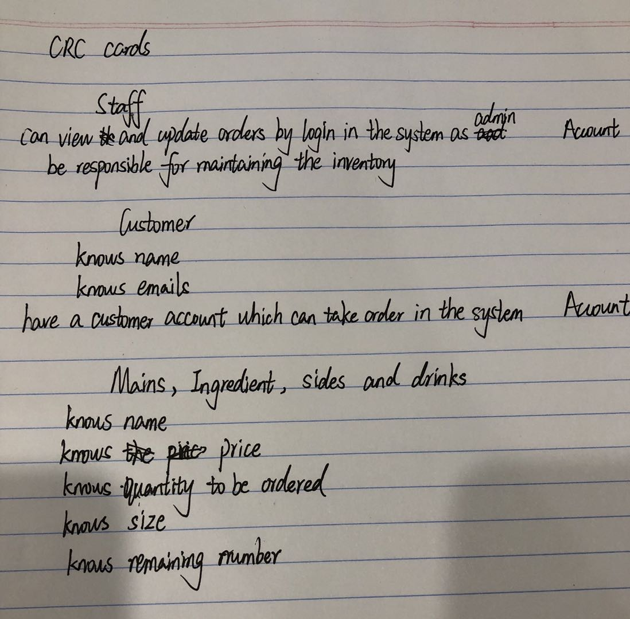

2/4/19 Regular lab meeting: the feedback of class diagram was given by tutor this week. We missed the relationship between order and food which should be aggregation. Customers should be also added the burger list so that they can choose different ingredient that satisfies their favor. The most important task is that the software system needs to be built and the test cases should be accomplished. We are required to make sure that customers are able to place their order and staff can process the order. The implementation of different classes which includes customer, staff, order, order system, food, ingredient, sides and drinks assigned to each member separately.