**Part 1**

I took a screenshot of the desktop showing the output of the ls command on the Raspberry Pi. I saved it to the desktop, then used SCP over SSH to copy it to my computer using the following command:

C:\Windows\System32\OpenSSH\scp.exe -r RPI@192.168.1.12:/home/RPI/Desktop/Proof C:\Users\Study\Desktop

**Part 2**

SSH into Raspberrypi

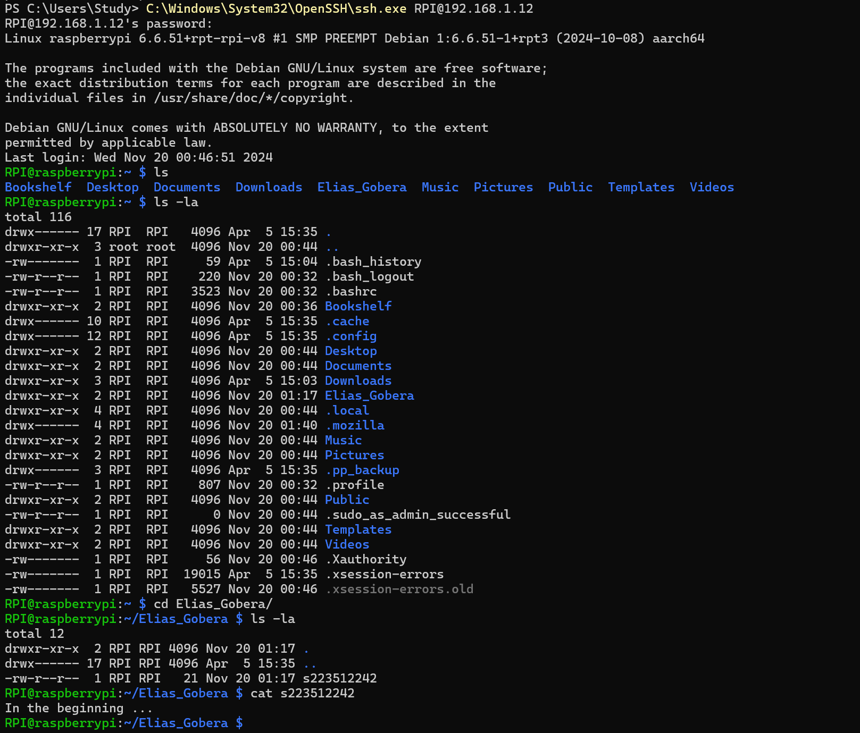

**Part 3**

Python Code Explanation Video Link – <https://deakin.au.panopto.com/Panopto/Pages/Viewer.aspx?id=1b1e4741-a2d4-4ac4-88f2-b2b6006bd1ae>

Hardware setup and demonstration of LED blinking - <https://deakin.au.panopto.com/Panopto/Pages/Viewer.aspx?id=501f23ad-d6a9-4c40-a86b-b2b600686a4b>

Code –

import RPi.GPIO as GPIO

import time

GPIO.setmode(GPIO.BOARD)       # Use physical pin numbering

GPIO.setup(19, GPIO.OUT)       # Set pin 19 (GPIO10) as output

print("Blinking LED 10 times...")

for i in range(10):            # Blink 10 times

    GPIO.output(19, GPIO.HIGH)

    time.sleep(0.3)

    GPIO.output(19, GPIO.LOW)

    time.sleep(0.3)

print("Done.")

GPIO.cleanup()                 # Clean up GPIO pin state