Nikita Avdeev
undergraduate student, faculty of information technology
Iryna Yurchuk
associate professor, faculty of information systems
Taras Shevchenko National University of Kyiv

USING HYBRID NEURAL–NOISE METHODS TO DETECT ARTIFICIALLY GENERATED AND MANIPULATED IMAGES

Introduction. Rapid advances in generative AI have made it trivial to produce realistic images and subtle local manipulations (e.g., face swaps, mouth/eye edits). In parallel, the EU has adopted a risk-based regulatory approach that tightens verification requirements for higher-risk AI systems, which elevates the practical need for trustworthy detectors of synthetic and manipulated content [1–2].
This work presents a web-based detection system that combines statistical, noise-oriented analysis with neural network verification to deliver both an end-user verdict (real/fake/uncertain) and auditor-friendly evidence (heatmaps, masks, metrics) [1–2].
Background. Convolutional neural networks provide strong classification performance but often act as “black boxes,” motivating complementary explainable forensics signals [1].
We therefore pair neural models with noise-based modules: ELA (Error Level Analysis) for JPEG inconsistency, PRNU (sensor “fingerprint”) for camera-noise integrity, and a Noisesniffer-style ROI analyzer that detects statistically unlikely noise deficits in homogeneous blocks using an a-contrario Number of False Alarms (NFA) test (regions are accepted only if NFA < ε) [2].
These signals guide neural verification, reducing false positives and helping capture subtle local edits [4].
System design (methods). Consistent with established practices for monitoring global media dynamics, we emphasize tracking the most popular news resources—such as Reuters, Xinhua, and major social platforms—to analyze emotional coloring and derive conclusions on evolving public sentiments and framing trends [2]. In practice, this involves large-scale data collection from high-impact outlets, preprocessing for multilingual NLP (e.g., tokenization, lemmatization), application of models like transformers for joint sentiment-emotion detection, and temporal analysis to uncover shifts in attitudes, such as dominant fear/anger in early 2022 phases transitioning to hope/resilience over time [1].
Some data analysis and machine learning problems can be formulated as
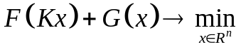, (1)
where 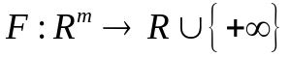, 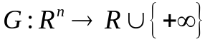 are proper closed and convex functions, 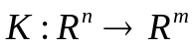 is a linear operator [1]. Problem (1) and its dual
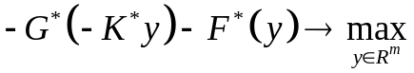
can be formulated as the following saddle-point problem (primal-dual formulation)
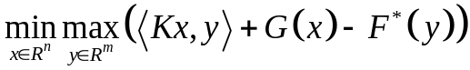. (2)
Here
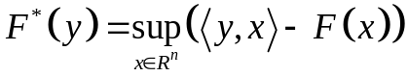
is the conjugate function for . Details can be found in [1].
Visual example. Figure 1 — Example output. The UI shows: original image; DIRE residual heatmap; ELA inconsistency map; PRNU correlation visualization; and the ROI/NFA mask with the fused verdict (Real/Fake/Uncertain). This illustrates how statistical noise cues and neural residuals co-localize on manipulated regions.
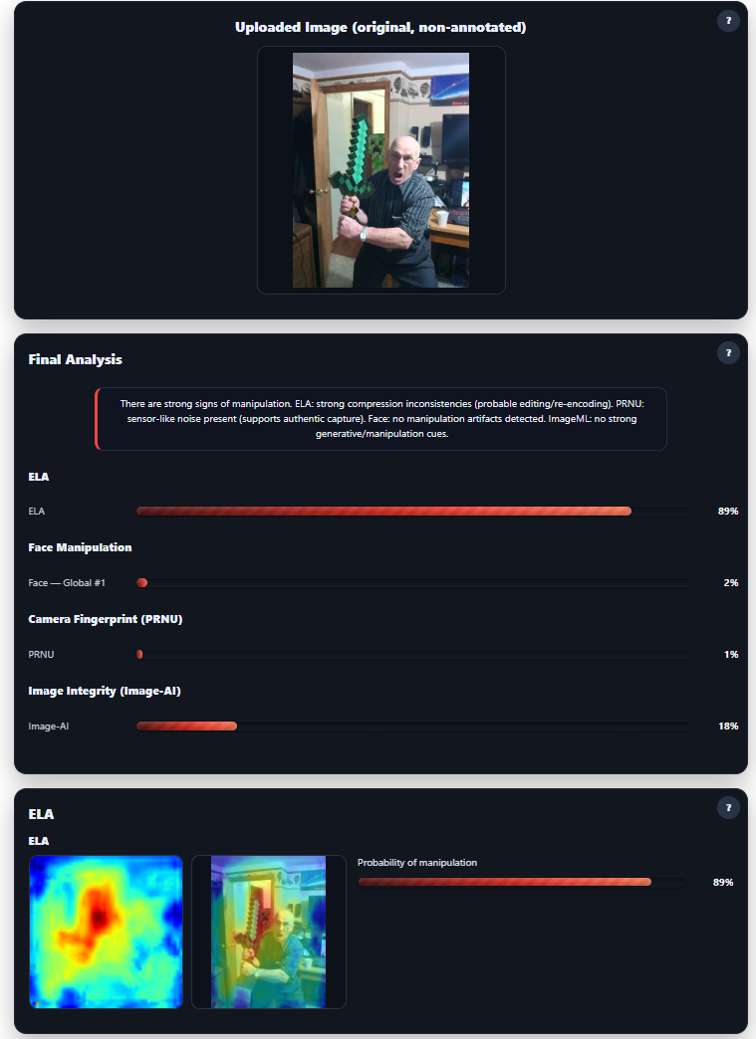
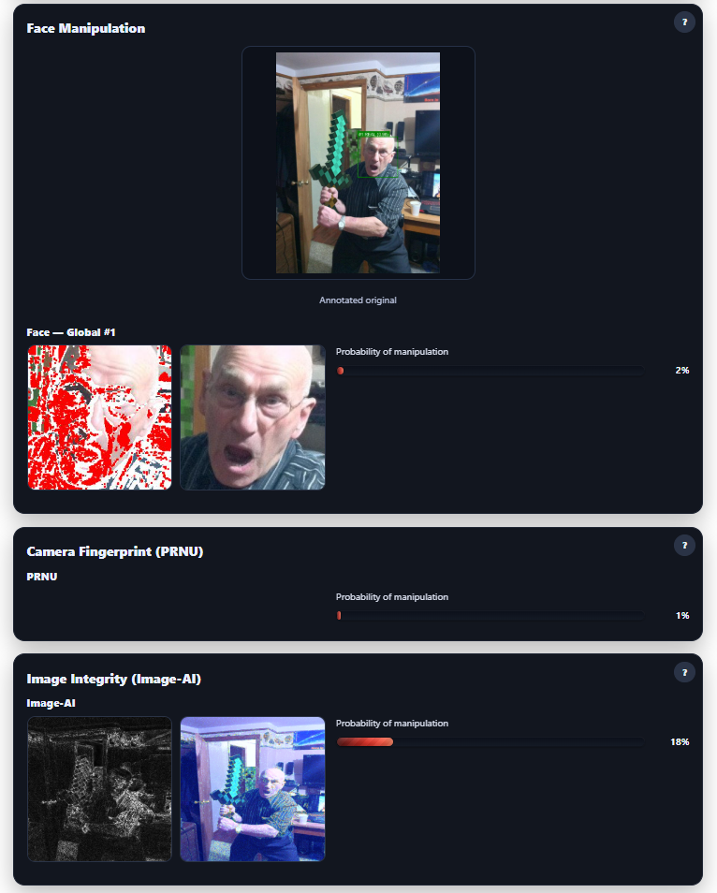
Figure 1. Example output program process

Conclusion. By integrating statistical noise forensics (ELA, PRNU, ROI/NFA) with neural verification (global + local, illustrated via a DIRE residual example), the system detects both fully generated images and localized manipulations while producing auditable, reproducible evidence (overlays, parameters, logs) appropriate for risk-aware environments [1–2].

References:
- Goodfellow, I., Bengio, Y., & Courville, A. (2016). Deep Learning. MIT Press.
- Kingma, D. P., & Ba, J. L. (2015). Adam: A method for stochastic optimization. International Conference on Learning Representations (ICLR). URL: https://arxiv.org/abs/1412.6980

