UDC 004.93'1:004.932:004.032.26
Mykyta Lapin
National Technical University "Kharkiv Polytechnic Institute", Kharkiv, Ukraine
ERROR ANATOMY AND STABILITY OF STRUCTURAL CONCEPT FORMATION IN A GRAPH-BASED CLASSIFIER WITHOUT BACKPROPAGATION
Abstract. Relevance. Structural classifiers that form explicit graph concepts promise interpretable decisions, but their failure modes and the stability of their concept formation receive little of the scrutiny given to accuracy benchmarks. Both questions matter more for structural classifiers than for weight-based ones precisely because the internal representation claims semantic meaning. The object of research is a non-backpropagation classifier that converts images into attributed bipartite skeleton graphs, forms per-class concept attractors by iterative critical-point reduction, and decides by winner-take-all competition over graph-similarity scores, reaching 91.13% accuracy on classified images of the complete-contour MNIST test subset (90.90% counting pipeline failures). The subject of the research is the origin of the classifier's dominant confusion and the stability of its concept-formation process with respect to sample presentation order, sample count, and reduction depth. The purpose of this paper is to localize the cause of the dominant error stage by stage in the processing pipeline, to test by ablation whether any downstream parameter can repair it, and to characterize how reproducible, how compact, and how quickly converging the learned concepts are. Research Results. The dominant confusion, digit 2 predicted as 7, traces to the representation front end: at the run's binarization threshold, the topological hole of the digit's lower-left loop is already missing from the binarized image in 110 of 111 cases — the loop is drawn open in the handwriting, or its small interior is flooded by a thick stroke. Ablations exclude the complexity pre-filter and the ranking prior as remedies; whether the similarity function itself should still separate the impoverished graphs remains an open design question. Five exploratory stability studies then characterize formation: node counts are invariant to sample-presentation order for three probed concepts, node and edge counts freeze within tens of samples for all thirteen concepts while the parameter envelope keeps widening, the concepts generalize to uncurated MNIST splits at reduced accuracy, and concepts store 91.9× fewer nodes than the training graphs they consume. Conclusions. For this dominant confusion the bottleneck sits in the image-to-graph front end, upstream of concept formation, and the concepts the system learns are compact and largely reproducible.
Keywords: structural pattern recognition; graph edit distance; concept formation; few-shot learning; skeletonization; explainable AI; MNIST.

Introduction
Most modern image classifiers optimize millions of weights by backpropagation and explain their decisions only post hoc. An alternative line of work encodes images as attributed graphs and learns explicit structural concepts whose nodes, edges, and parameter ranges remain human-readable [1–3]. In our system, an image is skeletonized into a bipartite graph of critical points and connecting segments, per-class concepts are formed by iterative graph reduction without gradient descent, and classification is a winner-take-all (WTA) competition in which concepts are scored by an attribute-weighted graph-similarity measure derived from graph edit distance (GED) [4, 5] and ranked by that score plus a prior favoring the more complex concept. The approach was introduced in [3], which reports ≈82% accuracy from five to six samples per class; in the configuration studied here it reaches 91.13% accuracy on the complete-contour subset of the MNIST test set [6] with only 13 concepts formed from 869 training samples, which derive from 85 unique source images, and every concept parameter inspectable.
Accuracy alone, however, says little about why such a system fails when it fails, and whether the concepts it forms are stable artifacts or accidents of training order and sample choice. Both questions matter more for structural classifiers than for weight-based ones precisely because the internal representation claims semantic meaning: a concept that changes with presentation order, or an error whose cause cannot be located in the pipeline, would undermine the interpretability argument itself.
This paper answers both questions empirically. Our contributions are the following.
An anatomy of the dominant error. The most frequent confusion of the baseline (true digit 2 predicted as 7; 111 of 792 failures, 14.0% of the error mass) superficially contradicts the WTA design: the concept for class 2 is more complex than the one for class 7, so it should win when it matches. We trace all 111 cases through the production scoring code, localize the anchor-point loss stage by stage (binarized mask: 110 of 111; vectorization: 1 of 111; reduction and inference: 0), exclude the complexity pre-filter and the ranking prior by direct ablation, and verify the cost implementation by replay; the suitability of the similarity projection itself remains open.
Five exploratory stability studies of concept formation, covering generalization to other MNIST splits, sample-order dependence (three concepts, ten orders), sample-count dependence (three draws per condition), reduction convergence, and storage compression, each with its scope stated.
A diagnosis with design consequences: the dominant error cluster originates in the representation front end and resists every parameter-level downstream repair we tested, while the formation process itself is largely order-invariant, freezes node and edge counts after few samples in all thirteen concepts, and compresses input structure by 91.9× in nodes and 50.6× in stored values under the counting convention of the compression study.
All analyses run on the production code paths, with no re-implemented scoring.
Analysis of Recent Research and Publications
Graph matching and GED. Pattern recognition has used graphs as a structural representation since the late 1970s [7], with graph edit distance providing the standard error-tolerant similarity measure since Bunke and Allermann [4]. Because exact GED is NP-hard, practical systems rely on approximations such as bipartite matching [8] and its journal refinement [5]. Our classifier uses an attribute-weighted, GED-derived similarity as its scorer; this paper contributes a measured account of how a complete GED-based classifier fails and how stable its learned structures are — an analysis the graph-matching literature rarely applies to end-to-end systems.
Learning without backpropagation. Interest in alternatives to end-to-end gradient descent ranges from topology-learning networks such as Growing Neural Gas [9] to Hinton's forward-forward algorithm [10]. The system studied here descends from the modal-vector theory of formal intelligence systems [1, 2] and its energy formulation [11]: concepts are formed by deterministic graph reduction rather than weight updates. The classifier itself was introduced in [3], which reports an earlier, smaller-scale result; the present paper analyzes the full baseline and supplies the missing error anatomy and stability evidence.
Few-shot and prototype-based learning. Learning a class from tens of examples is the goal of few-shot methods such as prototypical networks [12] and model-agnostic meta-learning [13], which position class prototypes in a learned embedding space. Lake et al. [14] showed that compositional, generative structure enables human-level one-shot character learning. Our concepts play the prototype role but remain explicit attributed graphs whose every node and range is inspectable — closer in spirit to [14] than to embedding-based prototypes.
Interpretability and error accountability. Rudin's argument for inherently interpretable models over post-hoc explanations [15] motivates our evaluation standard: a model whose internal representation claims semantic meaning must also support locating the cause of each error and showing that its learned structures survive changes in training order. The present work operationalizes that standard for a structural classifier.
System Overview
We summarize the pipeline only to the depth needed for the analyses; the representation and formation method are described in [3, 11].
Image-to-graph construction
An input image is binarized (intensity threshold 110–180, adaptively retried on disconnection), thinned to a one-pixel skeleton [16], and approximated by a Growing Neural Gas network [9] whose output polyline is simplified with the Ramer–Douglas–Peucker algorithm [17]. The result is an attributed bipartite graph: Point nodes (endpoints, corners, junctions, a start point) alternate with Vector nodes (line segments carrying length, direction, and quadrant attributes). Node coordinates are normalized to a centered [−1, 1] system for scale and translation invariance. We define the complexity of a graph as its total number of nodes plus edges.
Concept formation
For each class, training graphs are merged one at a time into a concept by critical-point reduction: shared topology is retained, instance-specific branches are reduced, and each surviving node accumulates per-feature ranges (envelopes) instead of point values. The first sample seeds the concept; formation is incremental and uses no gradient signal. A class may yield more than one concept (e.g. two stylistic variants of the digit); the baseline uses 13 concepts for 10 classes, formed from 869 pre-augmented training samples. Those 869 samples come from 85 unique source images; the other 784 are geometric variants generated offline from them, five to ten variants per source.
Classification
Classification runs three stages before a winner is picked. A complexity pre-filter first discards every concept whose complexity exceeds the image complexity, before any comparison runs, on the rationale that a simple image cannot instantiate a more complex concept. Each surviving concept is then prepared against its own isolated copy of the image graph: the concept's learned centroid direction and expected start degree anchor a concept-specific start point in the image, and the image graph is reduced by endpoint, intersection, and corner-point operations until its critical-point structure is isomorphic to the concept's. Every concept therefore scores against a differently anchored and differently reduced version of the image. Preparation also enforces structural compatibility gates for pairings the representation cannot support, such as a concept containing intersection points matched against an image that has none, or a concept with more corner points than the image. A concept that hits a gate, or that cannot be reduced to isomorphism within the iteration budget, receives no similarity score at all and ranks below every scored concept; that outcome differs from scoring low.
The prepared pair is then scored by a GED-derived similarity over 13 node features. Substitution costs are attribute-weighted, each feature weighted inversely to the width of the concept's learned interval (ε = 0.1), so a narrow diagnostic range counts for more than a wide one. Edit costs are asymmetric: inserting a concept node the image lacks costs 6.0, deleting an image node the concept does not account for costs 0.25, and edge insertion is free, which biases the measure toward subgraph containment — whether the image contains the concept. The total edit cost c becomes a similarity
s = 1 − c / (c + max(n₁, n₂)) (1)
normalized by the larger graph, with n_{i} counting nodes plus edges. The winner-take-all step finally ranks the scored concepts by the adjusted score
ŝ = s + λ log₂ C (2)
with λ = 0.10, where C is the concept's complexity. This prior states the design intent that among concepts which match adequately, the more complex one should win: a small concept matches an arbitrary graph more easily, so its similarity carries less evidence. The concept at the top of this ranking is the winner and its class is the prediction.
Baseline
The reference run (run_20260630_235356; artifacts — configuration, metrics, confusion matrix, per-image errors, concept graphs — are archived with the code) evaluates the full complete-only MNIST test subset: 8,704 of the 10,000 test images whose contours are complete (unbroken strokes), a restriction discussed in the dataset-variant study below. The run log records 8,707 submissions over these 8,704 images; 22 submissions failed in skeletonization (dead-letter queue) and 8,685 were classified, with accuracy 91.13%, precision 91.92%, recall 91.13%, and F1 91.34% over the classified set. Counting every submission in the denominator yields the end-to-end accuracy 7,915/8,707 = 90.90%. Throughout the paper we keep both readings apart: conditional accuracy is measured over classified images, end-to-end accuracy over everything submitted. Fig. 1 shows the confusion structure. The largest confusion pairs are 2→7 (111), 4→7 (62), 2→6 (57), 4→1 (52), and 9→4 (46); classes 2 (215 errors) and 4 (155 errors) dominate the error mass.
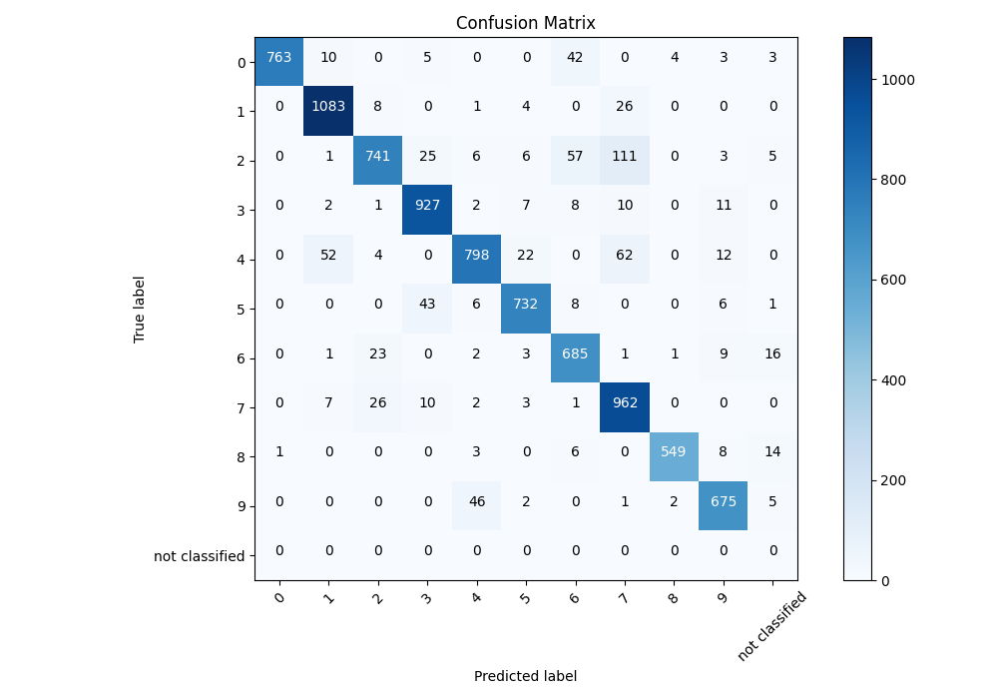
Fig. 1. Confusion matrix of the 91.13% baseline on the complete-only MNIST test subset (8,685 classified images, 13 concepts)
Anatomy of the Dominant Error: Why 2s Fall into 7s
The 2→7 confusion seems to contradict the WTA design. The rich concept for class 2 (2_2, complexity 24) is far more complex than the concept for class 7 (7_1, complexity 9, the smallest in the system). Under WTA with a complexity prior, the rich concept should win whenever it genuinely matches. The working hypothesis was that 2_2 never gets to compete: the image graph loses critical anchor points during construction — before reduction — so the "2" arrives at the classifier already impoverished.
We verified this hypothesis on all 111 misclassified images using the production classification orchestrator and cost functions; the offline tool reproduced the live prediction for 111/111 images. This replay runs the current code tree, not a frozen copy of the June baseline: predicted labels agree in all 111 cases, but raw similarity values drifted slightly as the scoring code evolved (the primary exemplar's 2_1 similarity reads 0.7300 in the run log and 0.7469 in the replay), so the similarity values reported below are replay values. The mechanism is two-staged, and both stages share one root cause. Beyond verifying the hypothesis, we localize the loss stage by stage with a topological measurement and ablate the two adjustable downstream mechanisms — the complexity pre-filter and the ranking prior — individually, testing whether either repair short of fixing the input could flip the outcome.
Stage 1: the complexity pre-filter excludes the rich concept
The median complexity of the 111 misclassified "2" graphs is 21 (range 13–29), below the complexity 24 of 2_2. Consequently the pre-filter removes 2_2 from the competition in 86 of 111 cases (77.5%). The rich concept does not lose the WTA competition — it never enters it.
The obvious repair — remove or soften the pre-filter — was tested by direct ablation: we disabled the pre-filter and scored 2_2 against all 111 images with the production scoring code. It wins zero of 111 cases, and its raw similarity is 0.0 in all of them. The reason is structural: 2_2 contains the crossing point where the descending stroke curls back across the base stroke, while no image graph retains a crossing after degree normalization. The constructed graphs do contain a degree-3 T-junction node where the descending stroke meets the base stroke (visible in the second panel of Fig. 3), but endpoint reduction removes its short branch and demotes it to a corner point before the gates apply, so the compatibility gate ("concept has intersection points but the image does not") rejects the pairing before GED optimization runs. The reported 0.0 is this gate outcome, not a computed GED score. Impoverished graphs are small, so the pre-filter is a symptom of the same degradation, not a cause of the error. Removing it changes nothing.
Stage 2: the simplified concept loses on raw similarity
The simplified concept 2_1 (complexity 13) is never pre-filtered — it competes in all 111 cases — and loses to 7_1 on raw similarity in all 111: mean raw similarity 0.673 against 0.813, a mean gap of 0.140 and a minimum gap of 0.053. In 5 of 111 cases 2_1 is additionally zeroed by a second compatibility gate ("concept has more corner points than the image"). Bucket analysis over all 111 cases (Table 1) shows that all 111 errors are raw-similarity losses (bucket B); there are no cases where no 2-concept competed at all (bucket A) and no cases where a 2-concept won on raw similarity but lost the final λ-ranking (bucket C). The ranking prior is innocent. In the 25 cases where 2_2 nominally competed, its similarity was 0.0 for the same structural reason as in the ablation above, so it never outscored 2_1.
Table 1. Anatomy of all 111 2→7 errors: buckets, stage localization of the anchor-point loss, and ablation
Indicator | Value
A: no 2-concept in competition | 0
B: 2-concept competes, loses on raw similarity | 111 (100%)
C: wins raw similarity, loses λ-ranking | 0
Lower-loop hole absent already in binarized mask | 110 (99.1%)
Hole survives to skeleton, lost at vectorization | 1
Anchor points lost at reduction or inference | 0
Final graphs with zero cycles, no crossing point | 111 (100%)
2_2 excluded by complexity pre-filter | 86 (77.5%)
Ablation — pre-filter removed, 2_2 wins | 0 of 111
Ablation — 2_2 raw similarity | 0.0 in all 111
2_2 competed and outscored 2_1 | 0 of 25
Mean raw similarity, 2_1 / 7_1 | 0.673 / 0.813
Raw-similarity gap (mean / min) | 0.140 / 0.053
Image complexity (min / median / max) | 13 / 21 / 29

Root cause: the lower-loop hole never reaches the graph
For each of the 111 images we measured, stage by stage, where the topological hole of the lower-left loop disappears: holes of the binarized mask (via its Euler characteristic), cycles of the one-pixel skeleton, and cycles of the final graph. Stage measurements use the production skeletonization code at the run's threshold (110) without the live pipeline's adaptive threshold retries; final graphs are taken from the database exactly as the live run produced them. The outcome (Table 1): in 110 of 111 cases the binarized mask already contains no hole. Two handwriting mechanisms produce this. Either the loop is drawn open — the descending stroke never crosses the base stroke — or the loop is filled with ink: its interior encloses only a few background pixels, so a stroke of ordinary thickness floods it into a solid blob, the eye "reads" a loop into the pixel pattern, but no topological hole exists, and skeletonizing a solid blob yields a line, not a cycle (the exemplars of Fig. 2 and Fig. 4). In the single remaining case (mnist_test_2_00412) the mask carries two measured holes that survive into the skeleton and are lost during GNG+RDP vectorization; an offline rerun with a different GNG initialization preserved them, so loss at that stage is stochastic rather than systematic. No case loses anchor points at reduction or inference: after graph construction there is nothing left to lose.
All 111 final graphs share the measured invariants of the zigzag concept 7_1: zero cycles and, after degree normalization, no crossing point. A human judges the pixel image and reads a loop into the ink; the classifier sees only the graph, which never contained one.
Fig. 2 traces one canonical exemplar through the construction stages, and Fig. 3 shows the resulting graph next to the competing concepts.

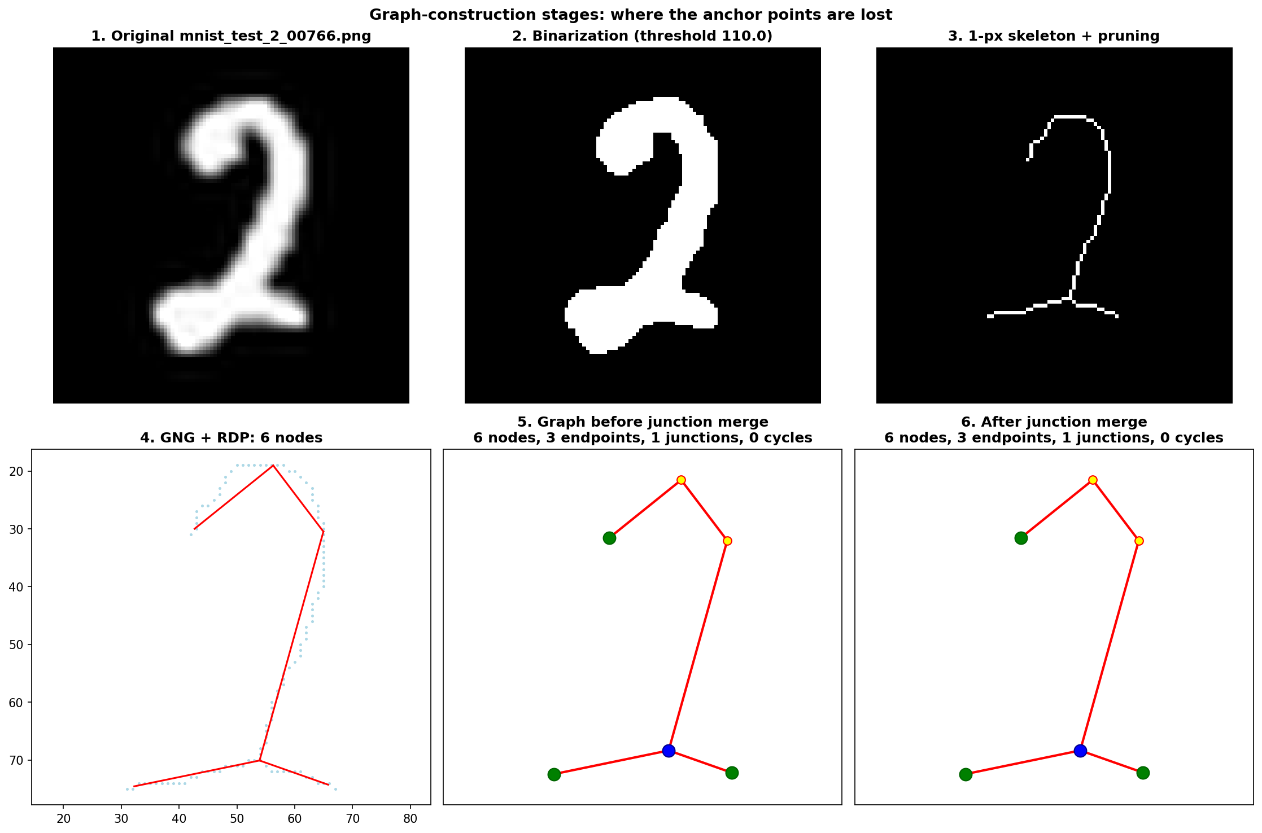
Fig. 2. Construction stages for exemplar mnist_test_2_00766. The lower-left curl reads as a loop in the grayscale image (panel 1), but its small interior is flooded into a solid blob in the binarized mask (threshold 110, panel 2) — the mask contains zero topological holes — so the one-pixel skeleton is an open hook with zero cycles (panel 3). GNG approximation with RDP simplification (ε = 4.55) then flattens the hook arc into two straight segments (panel 4). The intersection anchor point is never created; the defect precedes any learning step
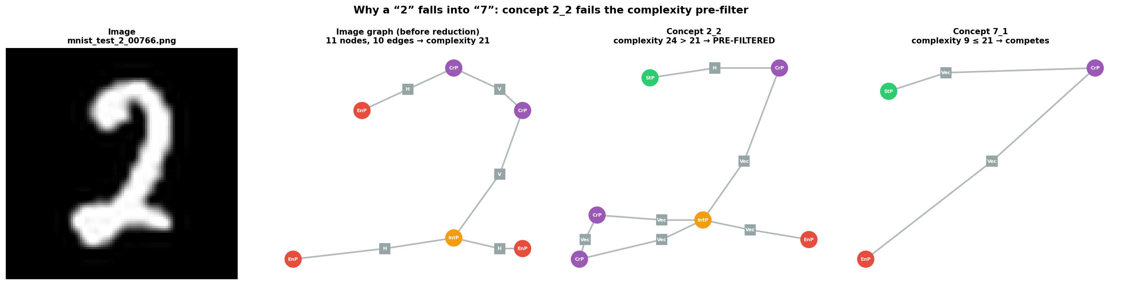
Fig. 3. Exemplar mnist_test_2_00766, four panels: original image, constructed image graph before reduction, and the two competing concepts 2_2 and 7_1. The image graph has 11 nodes and 10 edges (complexity 21), so concept 2_2 (complexity 24) is excluded by the pre-filter; the simplified 2_1 then loses to 7_1 on raw similarity. The T-junction node shown in the second panel is demoted to a corner point during degree normalization, before the compatibility gates apply

The GNG approximation for this exemplar uses ≈35 neurons and leaves a zigzag-like graph of 6 structural points (3 endpoints, 1 junction, 0 cycles), whose complexity of 21 falls below the 24 of 2_2. Table 2 gives the production ranking.
Table 2. Replay ranking for exemplar mnist_test_2_00766 (current code tree, prediction identical to the live run); the 2_2 similarity is from the pre-filter-removed ablation
Concept | Raw sim. | Adjusted | Complexity | In competition
7_1 (winner) | 0.8317 | 1.1487 | 9 | yes
2_1 | 0.7469 | 1.1169 | 13 | yes
2_2 | 0.0 | 0.0 | 24 | no (pre-filter)

The per-feature breakdown of the 2_1 comparison shows where the loss occurs: surviving points sit outside the ranges the concept learned to expect, with full penalties on three features — e.g. distance_to_centroid = 0.558 ∉ [0.69, 1.00] on the start point, normalized_x = 0.200 ∉ [−0.70, 0.10] on a corner point, and length_ratio_to_max on a segment — while every node of 7_1 substitutes within its intervals. The geometry of the graph is distorted by the loss of the loop, so the degraded zigzag is parametrically closer to the tolerances of 7_1 than to the intervals of 2_1.
The contrast exemplar (mnist_test_2_00984, Fig. 4) shows the second mechanism: a flat cursive "2" whose lower loop is filled with ink, so the flooded blob skeletonizes into a zigzag visually close to a "7". The median image complexity of 21 against 2_2's 24 identifies graph impoverishment as the dominant factor across the 111 cases.

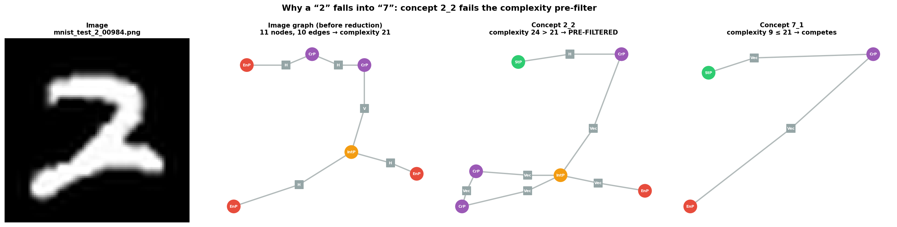
Fig. 4. Contrast exemplar mnist_test_2_00984 (same four-panel layout as Fig. 3): a flat cursive "2" whose lower loop is filled with ink — the second handwriting mechanism; the flooded loop leaves no topological hole, so the graph is an open zigzag

What the ablations exclude, and what they do not
Since every downstream mechanism was suspect, we also checked the scoring implementation. Decomposing each substitution cost by feature in the replay reproduces the total cost with a residual of approximately zero. A self-recognition test scores each concept against its own typical feature values: all 13 concepts respond with similarity 1.00, and the parametric layer separates even structurally isomorphic concept pairs (2_1/5_1 and 4_1/9_2). These checks establish that the implementation computes the specified similarity function consistently; they do not establish that the specified function is the right projection of graph evidence onto a scalar. The error graphs retain a short lower-left branch that genuine 7s lack, and whether a similarity function should exploit it to separate the classes on the impoverished input is an open question these experiments do not answer.
Consequences
Three design consequences follow, none of which requires hard-coding concept identities. (i) Graph construction is the only lever established by measurement: hole-preserving binarization and skeletonization, and topology-aware vectorization that controls cycles through GNG, RDP, and junction merging, would let the lower loop reach the graph, raise image complexity, return 2_2 to the competition, and let its intersection point and cycle-count features discriminate against 7_1. One limit remains: loops filled with ink are not recoverable from the binary mask alone and would require intensity analysis inside the stroke. (ii) The two parameter-level repairs are excluded by experiment: removing the complexity pre-filter changes nothing (2_2 wins 0 of 111 with similarity 0.0), and the λ-ranking prior contributes zero errors. (iii) The similarity function itself is the remaining downstream suspect: its implementation is verified consistent above, but no experiment here tests whether a different projection could exploit the surviving lower-left branch, so a scoring redesign stays open as future work.
Stability Studies of Concept Formation
The second question concerns the trustworthiness of the formation process itself: does the classifier generalize beyond the curated test subset, and are the concepts it forms stable with respect to presentation order, sample count, and reduction depth? Five studies address this. All formation studies run the production formation code through a seedable offline probe; all evaluation studies run the full live pipeline.
Generalization across MNIST dataset variants
The system is contour-based: a digit drawn with broken strokes yields an incomplete skeleton that no concept formed from complete contours can cover. The baseline therefore evaluates the complete-contour subset. To quantify the cost of this restriction, we evaluated the untouched baseline concepts on the full MNIST test set (10,000 images, no exclusions) and on the 60,000-image training split, whose completeness labels come from a heuristic classifier. The 60k split is labeled by a completeness heuristic, not manual review; 85 of its images are the unique source images of the system's training corpus (leakage 0.14%; the offline-generated variants are not MNIST members). Table 3 reports the results with the pipeline status made explicit: a submitted image either receives a prediction, fails into the dead-letter queue (DLQ), or returns no result at all (the run export records no cause for the last group). End-to-end accuracy counts every submission in the denominator; conditional accuracy counts classified images only.

Table 3. Accuracy across MNIST dataset variants (baseline concepts, no retraining), decomposed by pipeline status
Run / split | Submitted | Classified | Completion | Correct | Conditional | End-to-end | DLQ | Other uncl.
10k test, all | 10,000 | 9,942 | 99.42% | 8,221 | 82.69% | 82.21% | 58 | 0
60k train, all | 60,000 | 51,045 | 85.08% | 43,172 | 84.58% | 71.95% | 293 | 8,662
70k aggregate | 70,000 | 60,987 | 87.12% | 51,393 | 84.27% | 73.42% | 351 | 8,662
60k train, complete-only rerun | 45,501 | 44,812 | 98.49% | 38,469 | 85.85% | 84.55% | 14 | 675
Completion is classified/submitted; end-to-end is correct/submitted, so every unclassified case lowers it.

Three observations. First, the completeness restriction is load-bearing: within the 10k run, the complete slice scores 7,911/8,704 = 90.89% end-to-end while the incomplete slice scores 310/1,295 = 23.94%, dragging the no-exclusions figure to 82.21%. Second, per-slice accuracy from the 60k all-split run conflates classifier error with pipeline completion: that run left 8,662 submissions without any result (completion 85.08%), and its complete slice reads 76.12% end-to-end, whereas the dedicated rerun over the same 45,501 "complete" images completed 98.49% and reached 85.85% conditional / 84.55% end-to-end. Both are valid measurements of their executions; the disagreement means the 76.12% figure must not be read as model generalization. The residual gap between 90.89% (test, manual review) and 84.55% (train, heuristic labels) is consistent with heuristic label noise, though we did not isolate that factor. Third, end-to-end accuracy over all 70,000 MNIST images with 13 concepts and no per-split tuning is 73.42%, which bounds the current representation's coverage from below.
Dependence on sample-presentation order
Formation is incremental and the first sample seeds the concept, so order dependence is a structural risk. (Historically, the production order from the graph store was nondeterministic; it is now fixed to a deterministic ordering.) We re-formed three representative concepts — 2_2 (rich, 12 nodes), 7_1 (minimal, 5 nodes), 8_1 (cyclic, 11 nodes) — under 10 random presentation orders each (Table 4). Formed concepts are compared by pairwise GED over node and edge labels only; parameter attributes are compared separately through envelope widths.

Table 4. Order-dependence study: 10 random presentation orders per concept, compared by label-only pairwise GED (45 pairs per concept)
Concept | Seeds | Node counts observed | Zero-GED share | Mean pairwise GED | Max pairwise GED
2_2 | 10 | {12} | 0.64 | 0.36 | 1.0
7_1 | 10 | {5} | 1.00 | 0.00 | 0.0
8_1 | 10 | {11} | 1.00 | 0.00 | 0.0

No formation failures occurred. Node counts are identical across all orders for all three concepts. 7_1 and 8_1 show zero label-only GED in all 45 order pairs; 2_2 in 29 of 45 pairs (share 0.64) with a mean pairwise GED of 0.36 — small residual variation concentrated in the richest concept. The attributed concepts are not identical across orders: parameter-envelope widths vary mildly (e.g. 2_2: 0.438–0.492), and no two stored concept files coincide byte for byte. For these three concepts, formation is thus largely, though not perfectly, order-invariant in structure; the deterministic-ordering fix makes production retrains reproducible by construction.
Dependence on sample count
We formed each of the 13 concepts from n ∈ {2, 5, 10, 20} samples, three random draws per condition. Two monotone trends emerge: node counts decrease or stay constant as n grows (structure is pruned toward the shared core, then freezes — e.g. 2_2: 16 → 12.7 → 12 → 12 nodes), while mean range widths increase monotonically (the envelope absorbs instance variation — e.g. 7_1: 0.33 → 0.48 → 0.68 → 0.80). Larger sample sets widen the parameter envelopes while node counts stay fixed; whether the wider envelopes improve downstream accuracy was not measured.
Measuring downstream classification accuracy per sample-count condition requires retraining the production concept store and is left for future work.
Reduction convergence: when does a concept become stable?
For every concept we recorded two markers over one formation pass (Table 5). The structural marker m_{topo} is the index of the last training sample that changed the concept's node or edge count; it compares counts, not full attributed graphs, so structural rearrangements that preserve counts would escape it. The envelope marker m_{env} is the first sample that opens a run of five consecutive samples whose mean envelope-width growth stays below 0.02 per sample — an onset-of-slow-growth marker, not the last envelope change: envelopes keep widening slowly afterwards, consistent with the monotone widening of the sample-count study.
Table 5. Convergence markers of concept formation: last node/edge-count change (m_{topo}) and onset of slow envelope growth (m_{env})
Concept | m_{topo} | m_{env} | Total samples
0_1 | 11 | 13 | 33
1_1 | 1 | 10 | 33
1_3 | 2 | 5 | 55
2_1 | 23 | 12 | 121
2_2 | 5 | 12 | 55
3_1 | 4 | 13 | 77
4_1 | 2 | 10 | 36
4_2 | 2 | 12 | 65
5_1 | 28 | 11 | 88
6_1 | 12 | 18 | 77
7_1 | 2 | 15 | 99
8_1 | 37 | 5 | 42
9_2 | 16 | 10 | 88

Simple concepts freeze almost immediately (1_1 after 1 sample, 7_1, 1_3, and 4_1 after 2), while structurally rich or heterogeneous classes need tens of samples (8_1: 37 of 42; 5_1: 28; 2_1: 23). In most cases the envelope keeps adjusting after the node counts freeze — consistent with the sample-count study: late samples tune tolerances, not structure.
Concept parameters and compression
Finally, we quantify what a concept actually stores relative to what it consumed (Table 6). Across all 13 concepts, 869 training graphs contribute 9,738 nodes and 9,242 edges carrying 336,637 attribute values; the resulting concepts retain 106 nodes and 100 edges carrying 6,647 values (of which 3,053 are range-valued parameters). Node compression is 9,738/106 = 91.9× overall (up to 176.7× for 2_1; counting nodes plus edges gives 92.1×), and stored-value compression is 50.6×. Values are counted by one fixed convention on both sides: a learned range counts as two numbers (its endpoints; the center is derived), a scalar or string as one, and a list element-wise. Both ratios are internal storage-count ratios between what formation consumed and what it retained; they are not comparable to parameter counts of neural models, and we make no such comparison.

Table 6. Parameter compression from training samples to concepts (input = all training graphs consumed by the concept)
Concept | Samples | Input nodes | Input edges | Input values | Concept nodes | Concept edges | Concept values | Node compr. (×) | Value compr. (×)
0_1 | 33 | 418 | 418 | 14,550 | 10 | 10 | 628 | 41.8 | 23.2
1_1 | 33 | 235 | 202 | 7,912 | 7 | 6 | 433 | 33.6 | 18.3
1_3 | 55 | 187 | 132 | 6,187 | 3 | 2 | 179 | 62.3 | 34.6
2_1 | 121 | 1,237 | 1,116 | 42,093 | 7 | 6 | 435 | 176.7 | 96.8
2_2 | 55 | 902 | 902 | 31,536 | 12 | 12 | 759 | 75.2 | 41.5
3_1 | 77 | 1,093 | 1,016 | 37,710 | 9 | 8 | 556 | 121.4 | 67.8
4_1 | 36 | 400 | 400 | 13,858 | 8 | 8 | 506 | 50.0 | 27.4
4_2 | 65 | 631 | 566 | 21,502 | 9 | 8 | 562 | 70.1 | 38.3
5_1 | 88 | 1,192 | 1,104 | 40,641 | 7 | 6 | 435 | 170.3 | 93.4
6_1 | 77 | 1,050 | 1,050 | 37,005 | 10 | 10 | 632 | 105.0 | 58.6
7_1 | 99 | 669 | 570 | 22,615 | 5 | 4 | 310 | 133.8 | 73.0
8_1 | 42 | 646 | 688 | 23,011 | 11 | 12 | 702 | 58.7 | 32.8
9_2 | 88 | 1,078 | 1,078 | 38,017 | 8 | 8 | 510 | 134.8 | 74.5
Total | 869 | 9,738 | 9,242 | 336,637 | 106 | 100 | 6,647 | 91.9 | 50.6

Property-survival analysis shows that of the ≈60 node properties present on image graphs, only bookkeeping metadata (the source image path) is dropped entirely; every structural and geometric property survives into concepts at approximately its natural rate of occurrence. Conversely, concepts gain aggregate properties that exist on no single image node (e.g. direction-sequence indices, expected start degree, centroid summaries) — evidence that reduction abstracts rather than truncates.
Discussion
The dominant confusion points at the representation front end
The error anatomy and the stability studies point at the same conclusion from two directions. The dominant confusion is traced to anchor-point loss at the representation front end — absent from the binarized mask in 110 of 111 cases, lost during stochastic vectorization in the remaining one — upstream of concept formation, matching, and ranking. Direct experiment excluded the adjustable downstream mechanisms: the pre-filter ablation (0 of 111), the replay-verified cost decomposition, and the empty ranking bucket. Meanwhile the formation process itself is largely reproducible (order study), freezes node and edge counts after few samples in all thirteen concepts (convergence study), and compresses 869 training graphs into 106 concept nodes while preserving the property inventory (compression study). No downstream parameter — pre-filter tolerance, cost ladder, ranking prior — can recover a hole that never existed in the binarized image; whether a different similarity function could separate the classes without it is not settled by these experiments. Two scope limits apply: this cluster is 111 of 792 baseline failures (14.0%), so it cannot alone carry a system-wide bottleneck claim, and the stage localization was measured at a fixed binarization threshold. The most direct repair is the front-end change set out under Consequences above, which would restore image complexity and re-admit rich concepts into the WTA competition.
Concepts show attractor-like signatures
The studies are consistent with the term concept attractor used in prior work [3]: identical node counts under all presentation orders, node/edge-count freeze after a class-dependent but small number of samples, and monotone envelope widening thereafter are the signature one would expect of a fixed point of the reduction process approached from different initial conditions. A proof would need more: our markers track node and edge counts, not full attributed graphs, and the order study still finds structural differences in 2_2 across presentation orders.
Limitations
The 60k-split completeness labels are heuristic, so its "complete" figures conflate model error with label noise and pipeline completion; 85 of its images (0.14%) are the system's own training sources. The order and convergence studies probe three and thirteen concepts of one dataset, respectively, and the sample-count study uses three draws per condition; we report no confidence intervals or significance tests at these sample sizes, so the stability studies are exploratory evidence. The paper also lacks a matched baseline: no neural or conventional classifier was evaluated under the same complete-contour protocol, so the accuracy figures place the system on MNIST but do not rank it against alternatives. The curated complete-only subset excludes ≈13% of the test set, and the exclusions are class-skewed. Two planned extensions require destructive retraining of the production concept store and remain future work: isolating the contribution of training-set augmentation (the corpus is pre-augmented with ≈10 geometric variants per source image, permitting a subtractive design) and measuring downstream accuracy per sample-count condition. Finally, the complete-contour restriction is itself a limitation of the contour-based representation, and Table 3 quantifies it.
Conclusions
We dissected the dominant error of a graph-based non-backpropagation classifier and measured the stability of its concept-formation process. The 2→7 confusion originates in the representation front end. In 110 of 111 cases the binarized image already contains no topological hole at the lower loop, because the descending stroke either fails to cross the base stroke or floods the loop's small interior into a solid blob; the one remaining case loses the hole during stochastic vectorization. Every error graph therefore reaches the classifier with zero cycles and no crossing point. Direct experiment then excluded the adjustable downstream mechanisms. Removing the complexity pre-filter changes nothing, since the rich concept scores zero similarity on loop-free graphs. The substitution-cost implementation decomposes exactly and passes self-recognition, and the ranking prior contributes zero errors. The functional form of the similarity score itself was not tested and remains the open downstream question.
Formation proved order-invariant in node counts for the three probed concepts; node and edge counts froze after 1–37 samples across the thirteen concepts, with node compression of 91.9× and stored-value compression of 50.6×. On the complete-contour test subset — the input domain the contour representation is built for — the system reaches 91.13% on classified images, which supports the structural-concept design in its current scope. Generalization tests bound uncurated-MNIST end-to-end accuracy at 82.21% on the test split and 73.42% over all 70,000 images; the drop is carried by the incomplete-contour slice (23.94%), which no concept formed from complete contours can cover. Recovering broken contours is a separate line of our research, associative recognition, in which a concept acts as a template that predicts the missing contour element and the completed input graph is reduced again, leaving the concept itself unchanged.
The front-end change set out under Consequences is the most direct accuracy lever for future work, and a redesign of the similarity projection is the open downstream alternative.
Reproducibility
All studies run against production code paths: the post-mortem scores images with the live classification orchestrator and cost functions (111/111 prediction agreement with the deployed pipeline, on the current code tree), and the formation studies use a seedable offline probe over the production reduction code. The baseline run artifacts (configuration, metrics, confusion matrix, per-image errors, and concept snapshots), the analysis notebooks, the offline probe caches, and the dataset-variant run exports are available in the main branch of the project repository at https://github.com/kbokh/NaturalAGI.
Conflict of interest. The author declares no conflict of interest.
Funding. This research received no external funding.

REFERENCES
1. Parzhyn, Y. (2013), "Principles of modal and vector theory of formal intelligence systems", arXiv, arXiv:1302.1334, available at: https://arxiv.org/abs/1302.1334
2. Parzhyn, Y. (2025), "Architecture of Information", arXiv, arXiv:2503.21794, doi: https://doi.org/10.48550/arXiv.2503.21794
3. Lapin, M. and Bokhan, K. (2025), "Few-shot learning of a graph-based neural network model without backpropagation", Management Information System and Devices, no. 187, pp. 103–122, doi: https://doi.org/10.30837/0135-1710.2025.187.103
4. Bunke, H. and Allermann, G. (1983), "Inexact graph matching for structural pattern recognition", Pattern Recognition Letters, vol. 1, no. 4, pp. 245–253, doi: https://doi.org/10.1016/0167-8655(83)90033-8
5. Riesen, K. and Bunke, H. (2009), "Approximate graph edit distance computation by means of bipartite graph matching", Image and Vision Computing, vol. 27, no. 7, pp. 950–959, doi: https://doi.org/10.1016/j.imavis.2008.04.004
6. LeCun, Y., Bottou, L., Bengio, Y. and Haffner, P. (1998), "Gradient-based learning applied to document recognition", Proceedings of the IEEE, vol. 86, no. 11, pp. 2278–2324, doi: https://doi.org/10.1109/5.726791
7. Conte, D., Foggia, P., Sansone, C. and Vento, M. (2004), "Thirty years of graph matching in pattern recognition", International Journal of Pattern Recognition and Artificial Intelligence, vol. 18, no. 3, pp. 265–298, doi: https://doi.org/10.1142/S0218001404003228
8. Riesen, K., Neuhaus, M. and Bunke, H. (2007), "Bipartite graph matching for computing the edit distance of graphs", Graph-Based Representations in Pattern Recognition, Lecture Notes in Computer Science, vol. 4538, Springer, Berlin, Heidelberg, pp. 1–12, doi: https://doi.org/10.1007/978-3-540-72903-7_1
9. Fritzke, B. (1995), "A growing neural gas network learns topologies", Advances in Neural Information Processing Systems 7, MIT Press, Cambridge, MA, pp. 625–632, available at: https://proceedings.neurips.cc/paper/1994/hash/d56b9fc4b0f1be8871f5e1c40c0067e7-Abstract.html
10. Hinton, G. (2022), "The Forward-Forward Algorithm: Some Preliminary Investigations", arXiv, arXiv:2212.13345, doi: https://doi.org/10.48550/arXiv.2212.13345
11. Parzhyn, Y., Lapin, M. and Bokhan, K. (2025), "A new approach to building energy models of neural networks", Advanced Information Systems, vol. 9, no. 4, pp. 100–119, doi: https://doi.org/10.20998/2522-9052.2025.4.13
12. Snell, J., Swersky, K. and Zemel, R. (2017), "Prototypical Networks for Few-shot Learning", arXiv, arXiv:1703.05175, doi: https://doi.org/10.48550/arXiv.1703.05175
13. Finn, C., Abbeel, P. and Levine, S. (2017), "Model-agnostic meta-learning for fast adaptation of deep networks", Proceedings of the 34th International Conference on Machine Learning, PMLR, vol. 70, pp. 1126–1135, available at: https://proceedings.mlr.press/v70/finn17a.html
14. Lake, B., Salakhutdinov, R. and Tenenbaum, J. (2015), "Human-level concept learning through probabilistic program induction", Science, vol. 350, no. 6266, pp. 1332–1338, doi: https://doi.org/10.1126/science.aab3050
15. Rudin, C. (2019), "Stop explaining black box machine learning models for high stakes decisions and use interpretable models instead", Nature Machine Intelligence, vol. 1, no. 5, pp. 206–215, doi: https://doi.org/10.1038/s42256-019-0048-x
16. Zhang, T. and Suen, C. (1984), "A fast parallel algorithm for thinning digital patterns", Communications of the ACM, vol. 27, no. 3, pp. 236–239, doi: https://doi.org/10.1145/357994.358023
17. Douglas, D. and Peucker, T. (1973), "Algorithms for the reduction of the number of points required to represent a digitized line or its caricature", Cartographica, vol. 10, no. 2, pp. 112–122, doi: https://doi.org/10.3138/FM57-6770-U75U-7727
Received (Надійшла) __.__.2026
Accepted for publication (Прийнято до друку) __.__.2026
ВІДОМОСТІ ПРО АВТОРІВ / ABOUT THE AUTHORS
Лапін Микита Олексійович – аспірант кафедри системного аналізу та інформаційно-аналітичних технологій, Національний технічний університет "Харківський політехнічний інститут", Харків, Україна;
Mykyta Lapin – Postgraduate Student of the Department of System Analysis and Information and Analytical Technologies, National Technical University "Kharkiv Polytechnic Institute", Kharkiv, Ukraine.
e-mail: Mykyta.Lapin@cit.khpi.edu.ua; ORCID Author ID: https://orcid.org/0009-0003-6307-1172;
Scopus ID: https://www.scopus.com/authid/detail.uri?authorId=60171161300.
Анатомія помилок і стабільність формування структурних концептів у графовому класифікаторі без зворотного поширення помилки
М. О. Лапін
Анотація. Актуальність. Структурні класифікатори, які формують явні графові концепти, обіцяють інтерпретовні рішення, проте види їхніх відмов і стабільність формування концептів досліджено значно менше, ніж показники точності. Обидва питання важать для структурних класифікаторів більше, ніж для вагових моделей, саме тому, що внутрішнє подання претендує на семантичний зміст. Об’єкт дослідження — класифікатор без зворотного поширення помилки, який перетворює зображення на атрибутовані дводольні скелетні графи, формує для кожного класу концепти-атрактори ітераційною редукцією критичних точок і ухвалює рішення конкуренцією за принципом «переможець отримує все» на основі оцінок графової подібності; він досягає точності 91,13 % на класифікованих зображеннях підмножини тестового набору MNIST із повними контурами (90,90 %, якщо враховувати й ті зображення, які не вдалося опрацювати). Предмет дослідження — походження домінантного сплутування класів у класифікаторі та стабільність процесу формування концептів щодо порядку подання прикладів, їхньої кількості та глибини редукції. Метою даної статті є постадійна локалізація причини домінантної помилки в конвеєрі обробки, перевірка почерговим вимкненням того, чи здатен хоч один із механізмів подальших стадій її виправити, а також з’ясування, наскільки відтворюваними, компактними та швидко збіжними є сформовані концепти. Результати дослідження. Домінантне сплутування — цифра 2, розпізнана як 7, — походить із вхідної ланки формування подання: за порога бінаризації, застосованого в цьому запуску, топологічна діра нижньої лівої петлі відсутня вже на бінаризованому зображенні у 110 зі 111 випадків — петля або написана розімкненою, або її малий внутрішній простір залито товстим штрихом. Почергове вимкнення префільтра складності та пріору ранжування показує, що жоден із них помилки не усуває; чи має сама функція подібності розрізняти такі збіднені графи, лишається відкритим питанням проєктування. П’ять пошукових досліджень стабільності характеризують формування: кількість вузлів інваріантна до порядку подання прикладів для трьох перевірених концептів; кількості вузлів і ребер перестають змінюватися вже після кількох десятків прикладів для всіх тринадцяти концептів, тоді як параметрична оболонка продовжує розширюватися; концепти узагальнюються на нефільтровані розбиття MNIST зі зниженою точністю; а самі концепти зберігають у 91,9 раза менше вузлів, ніж навчальні графи, з яких їх сформовано. Висновки. Для цього домінантного сплутування вузьке місце перебуває у вхідній ланці перетворення зображення на граф, ще до формування концептів, а концепти, які формує система, є компактними та здебільшого відтворюваними.
Ключові слова: структурне розпізнавання образів; редакційна відстань між графами; формування концептів; навчання на малій вибірці; скелетизація; пояснюваний штучний інтелект; MNIST.

