**HOW TO INSTALL CERTIFICATE**

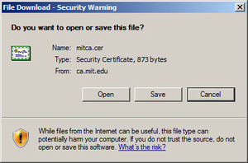**Step 1**: Click "Open".

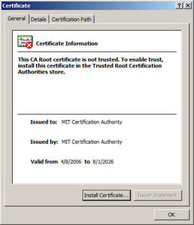**Step 2**: Click "Install Certificate ...".

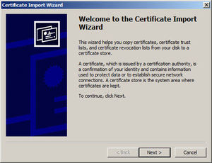**Step 3**: Click "Next >".

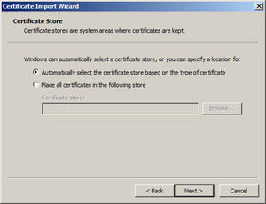**Step 4**: Click "Next >".

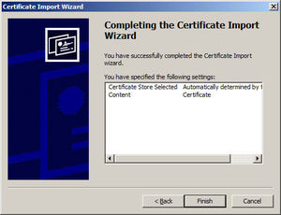

**Step 6**: Click "Finish".

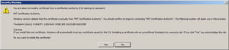**Step 7**: Click "Yes".

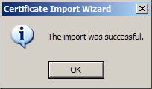

**Step 8**: Click "OK", and exit all the other windows.