The following guide is intended for the sponsor as well as any future development team.

Setting up a new EmailJS account
In case of testing or loss of account, follow these steps
- Sign up for a free account through emailjs.com
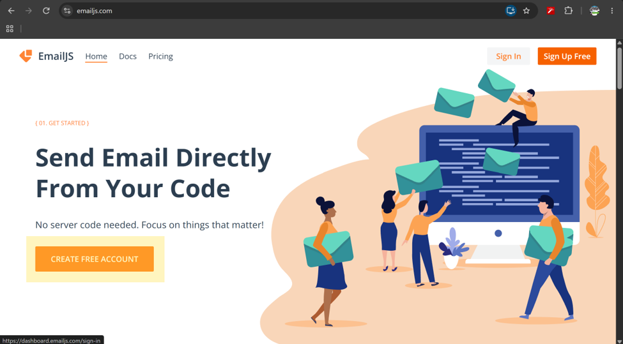
- Sign in to your new account
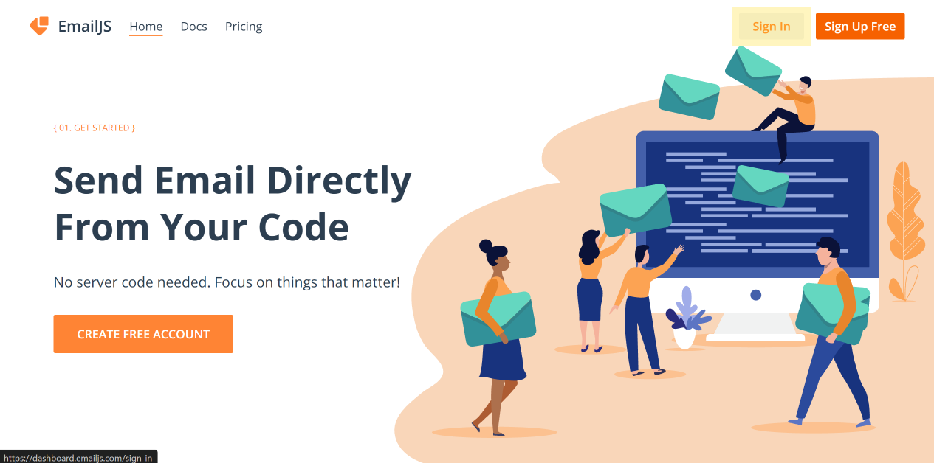
- In the “Email Services” tab, select “Add New Service”
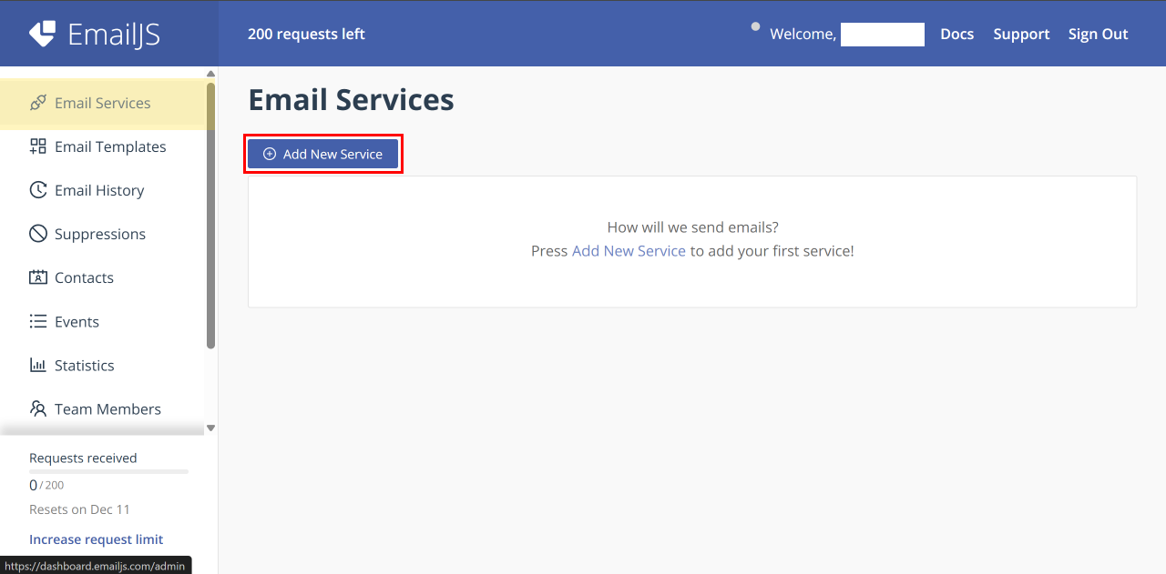
- Next, choose which email address you want to send you mail. This needs to be an email address you have access to.
- Select the service that email address uses. We’ll use Gmail for this example.
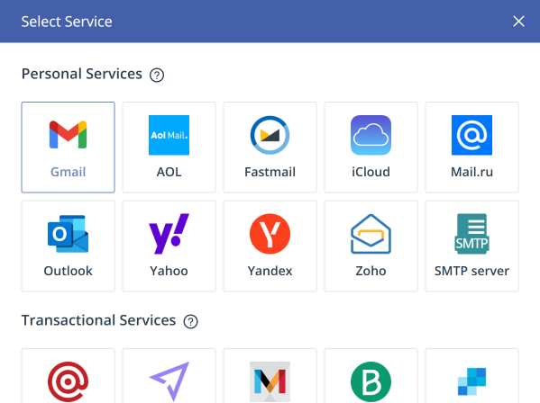
- Select “connect account”
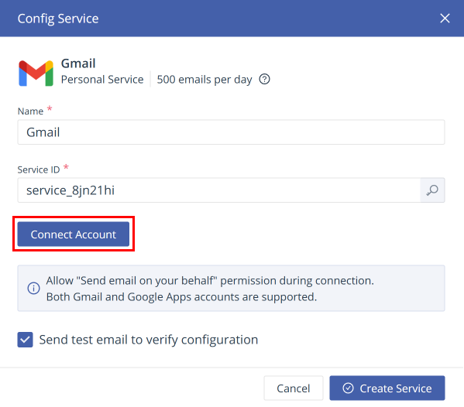
- Connect the email mentioned previously, and allow it to send messages on your behalf.
- Select “Create Service.” Note the service ID for later
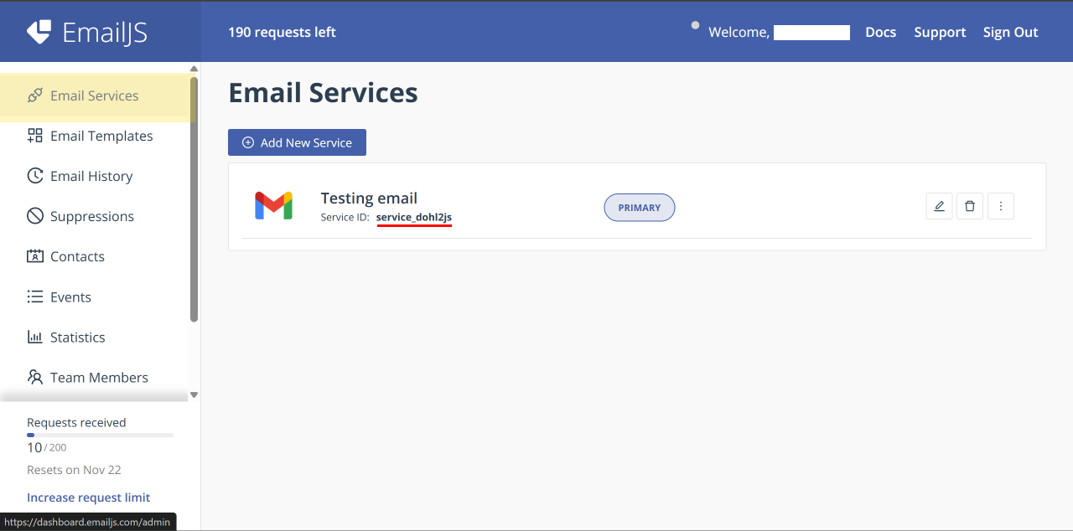
- In the “Email Templates” tab, select “Create New Template”
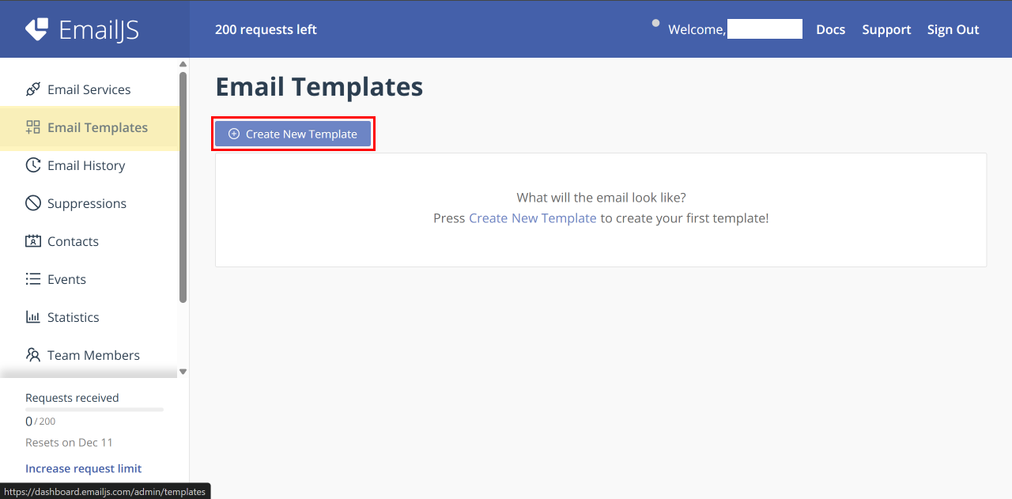
- Select the “contact us” template and click “Create Template”
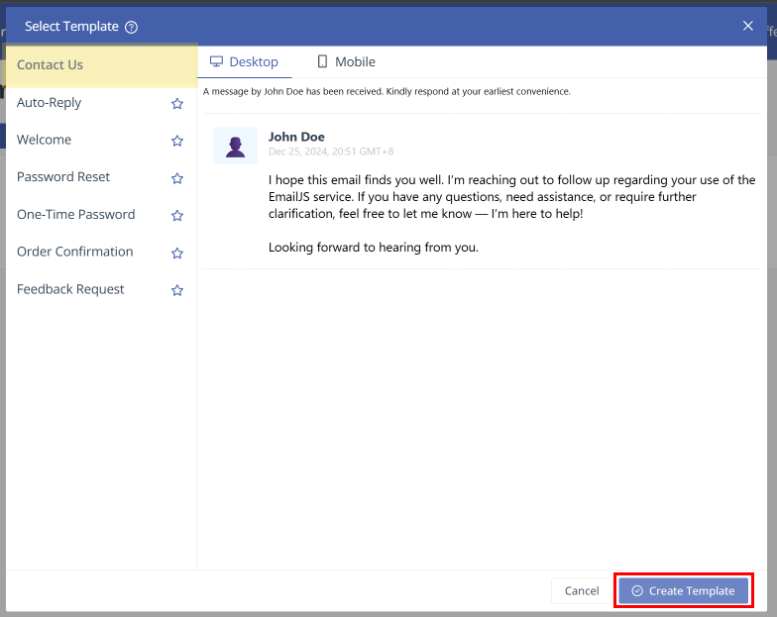
- Fill in the template with the information in template.md and then click “Save.” Note the Template ID for later
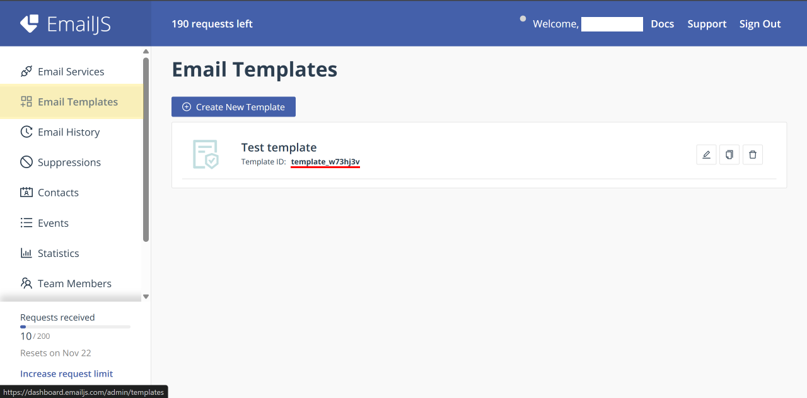
- In the “Account” tab, note the Public Key (Make sure not to use the private key!)
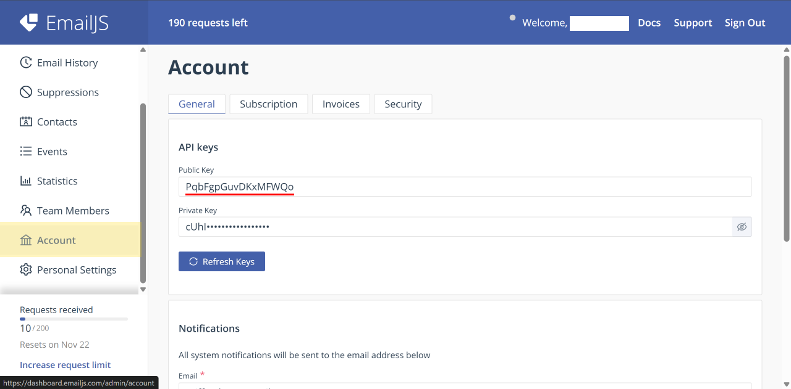
- Finally, fill in the three codes you noted NEED TO WRITE A GUIDE ON THIS PART
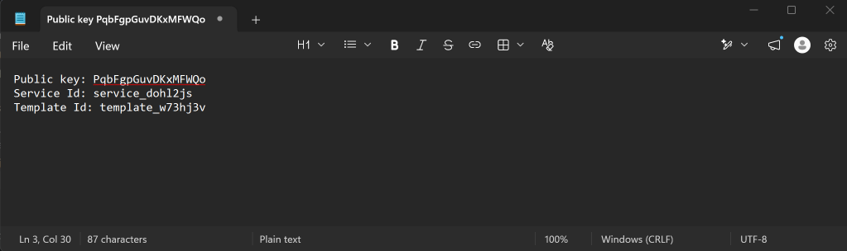

Troubleshooting error: An error occurred while submitting the form. Please try again.
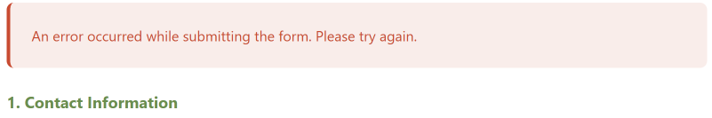
If this issue happens only occasionally, it is likely the result of poor internet connection on the part of clients. However, if it persists, the error is instead with your EmailJS setup. Take the following steps:
- Log in to your EmailJS account
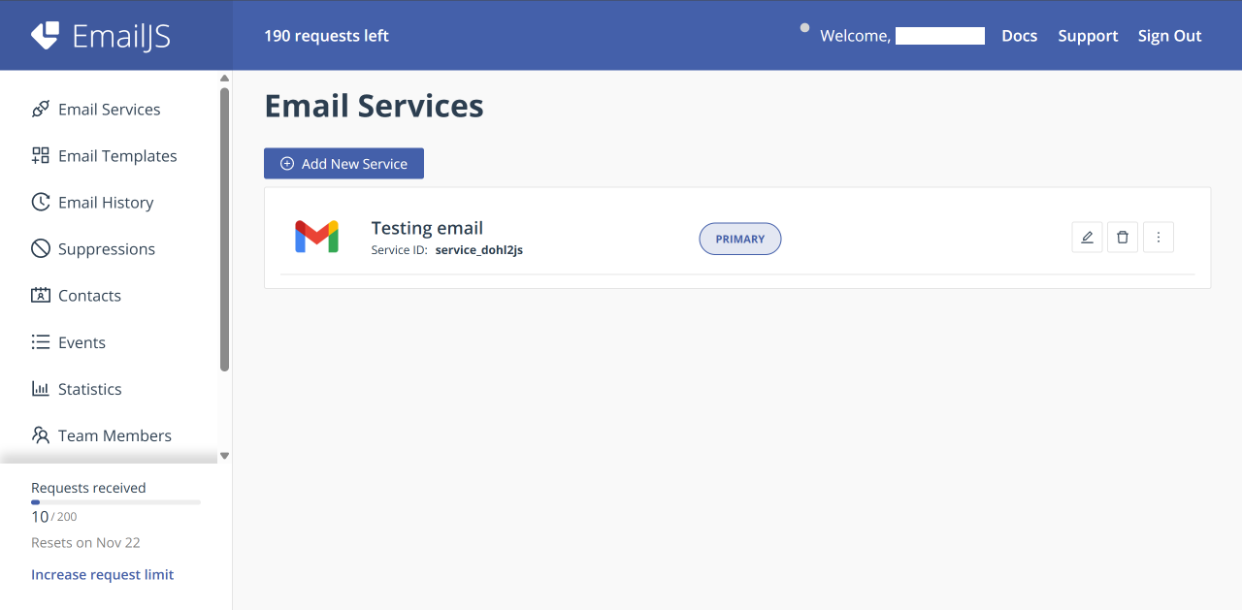
- Check that the request limit hasn’t been reached
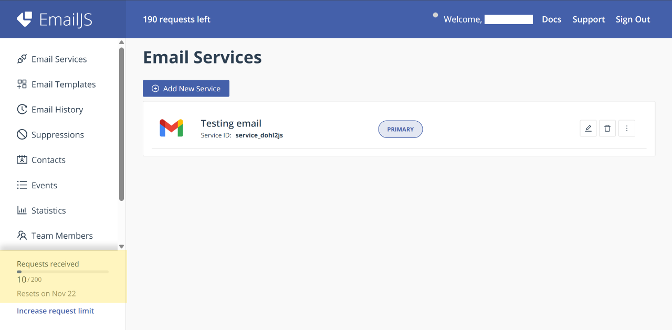
If it has been reached, you may need to apply for a paid account
- Select the Email Services tab and note the Service ID
- Select the Email Templates tab and note the Template ID
- Select the Account tab and note the Public Key (NOTE: Don’t copy the private key)
Now, make sure all 3 values are equal to the values in the code: NEED TO MAKE A GUIDE ON THIS PART

