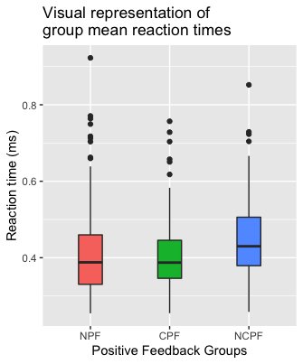

The CPF group obtained slightly faster accurate reaction times compared to the other groups.

| ANOVA - Reaction_time | | | | | | | | | | | | | | |
| --- | --- | --- | --- | --- | --- | --- | --- | --- | --- | --- | --- | --- | --- | --- |
|  |  |  |  |  |  |  |  |  |  |  |  |  |  |
|  | | **Sum of Squares** | | **df** | | **Mean Square** | | **F** | | **p** | | **η²** | | |
| Group |  | 0.154 |  | 2 |  | 0.0769 |  | 6.47 |  | 0.002 |  | 0.022 |  |
|  |  |  |  |  |  |  |  |  |  |  |  |  |  |
|  | | | | | | | | | | | | | | |

| Post Hoc Comparisons - Group | | | | | | | | | | | | | | | |
| --- | --- | --- | --- | --- | --- | --- | --- | --- | --- | --- | --- | --- | --- | --- | --- |
| **Comparison** | | | | | |  | | | | | | | | | |
| **Group** | |  | | **Group** | | **Mean Difference** | | **SE** | | **df** | | **t** | | **ptukey** | |
| NPF |  | - |  | CPF |  | 0.00690 |  | 0.0103 |  | 553 |  | 0.670 |  | 0.781 |  |
|  |  | - |  | NCPF |  | -0.03771 |  | 0.0106 |  | 553 |  | -3.550 |  | 0.001 |  |
| CPF |  | - |  | NCPF |  | -0.04461 |  | 0.0112 |  | 553 |  | -3.988 |  | < .001 |  |
|  | | | | | | | | | | | | | | | |

*Distribution of Group Mean Reaction Times*