**Boostmyshop**

**Prestashop module Documentation**

Summary

Overview **Erreur ! Signet non défini.**

Installation 2

BMS Menu 2

Configuration 2

MyFulfillment configuration 3

Import catalog section 3

MyAds configuration 4

# Installation

Boostmyshop module installation does not require anything special, simply go in Prestashop module page, and click on button “Add a new module”.

# BMS Menu

Once the module is installed, a new menu entry Boostmyshop is available :

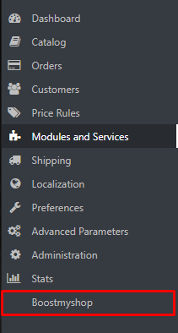

Clicking on this menu show the main Boostmyshop page, from here you can :

* Understand Boostmyshop feature advantages watching the video
* Access to the module configuration click in on the Configure button
* Change language with the top left flags
* Access Boostmyshop App using the Login button

# Configuration

To access to configuration page, select Boostmyshop menu on the left and click on Configure button :

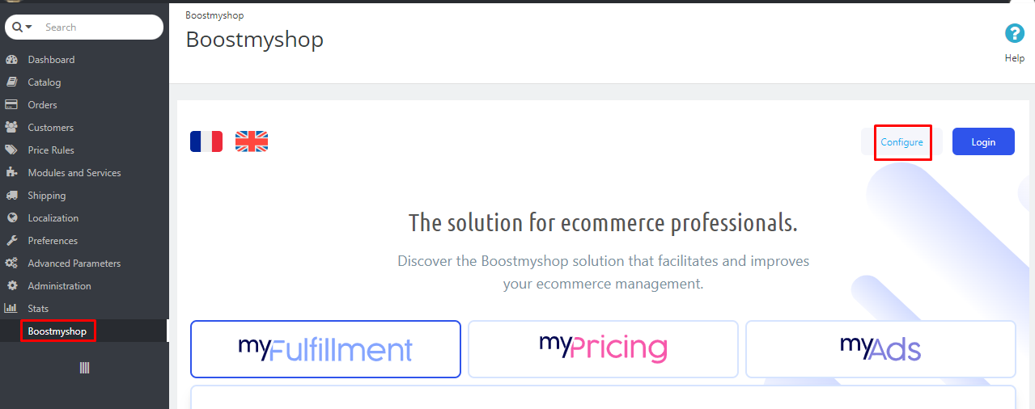

## MyFulfillment configuration

This section allows to link your Prestashop store with MyFulfillment to get orders and product information in Prestashop.

To configure the connection, fill the 3 fields :

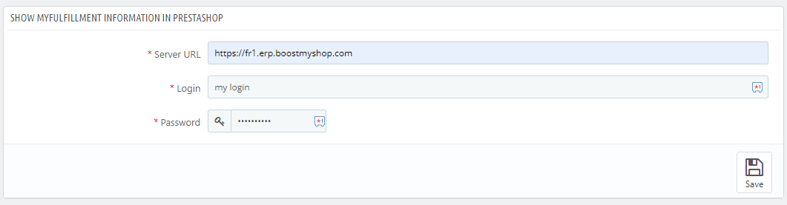

* **Server url** : your myfulfillment server url (starting from https until .com)
* **Login** : your myfulfillment login
* **Password** : your myFulfillment password

## Import catalog section

This section allows to get the token to import your catalog in Boostmyshop.

When asked on app.boostmyshop.com, simply copy this token and paste it

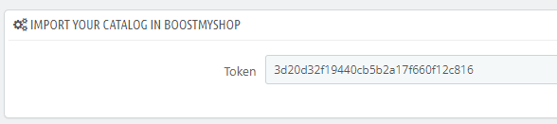

## MyAds configuration

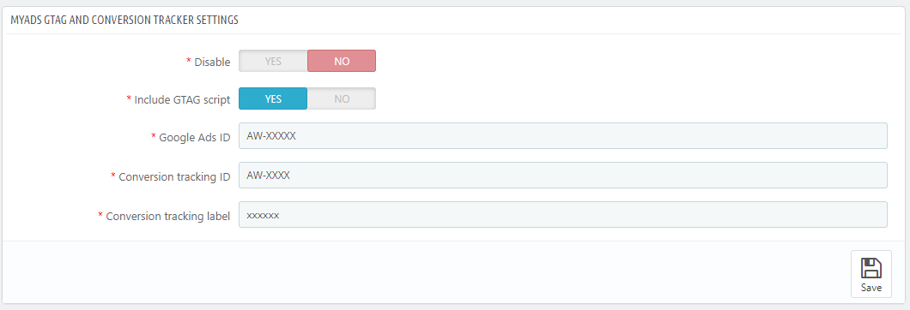

This section allows to configure MyAds conversion tracking.

Available settings :

* Disable: click here if you don’t want to add Google conversion trackings on your website
* Include GTAG script : disable this option if you already own a prestashop module adding the Google JS libraries
* Google Ads ID : this is your googls Ads ID
* Conversion tracking : this is your google Ads conversion tracking ID
* Conversion tracking label : same as above, but for the label