毕 业 论 文（设计）开 题 报 告
题目 (Topic): The Impact of AI Literacy on Upward Influence Behavior among Generation Z Employees: A Resource Dependence Perspective
一、选题意义及国内外研究状况
Ⅰ. Research Background
The rapid advancement of artificial intelligence technologies, exemplified by the emergence of ChatGPT and other generative AI tools, has fundamentally transformed the modern workplace. China's national "AI+" strategy has accelerated the integration of AI into organizational processes, making AI literacy an increasingly critical competency for employees. Notably, Generation Z employees (born 1995-2010), as "digital natives," often possess higher levels of AI literacy compared to their managers and senior colleagues, creating a generational asymmetry in technological competence. This asymmetry has the potential to reshape traditional power dynamics within organizations, enabling younger employees to exert upward influence on their supervisors—a phenomenon that challenges conventional top-down leadership models.
Ⅱ. Research Objectives
This study aims to:
(1) Explore how AI literacy enables Generation Z employees to engage in upward influence behavior.
(2) Investigate the role of perceived resource advantage as a psychological mechanism linking AI literacy to upward influence.
(3) Examine how supervisor openness moderates the relationship between AI literacy and upward influence behavior.
(4) Provide theoretical insights and practical recommendations for talent management in AI-driven organizations.
Ⅲ. Research Significance
Theoretical Significance: This study extends Resource Dependence Theory (Pfeffer & Salancik, 1978) to the employee-supervisor dyad by examining how AI literacy creates dependency relationships that enable upward influence. It also contributes to the emerging literature on AI literacy by exploring its organizational behavior outcomes beyond educational settings.
Practical Significance: The findings will inform organizational practices regarding talent development, leadership training, and intergenerational collaboration in the context of digital transformation, particularly in the Chinese context characterized by high power distance.
Ⅳ. Research Review
Resource Dependence Theory and Upward Influence: Resource Dependence Theory posits that power within organizations is shaped by the control of scarce and valuable resources (Pfeffer & Salancik, 1978). Tripathi (2021) extended this framework to the employee-supervisor relationship, arguing that employees who possess unique, firm-specific resources can leverage these assets to exert upward influence on managers.
AI Literacy: AI literacy has been conceptualized as a multidimensional construct encompassing knowledge, skills, attitudes, and ethical awareness (Ng et al., 2023; Cetindamar et al., 2022). Zhong et al. (2024) proposed a three-dimensional framework comprising AI Knowledge, AI Affectivity, and AI Thinking.
Research Gaps: Despite growing interest in AI literacy and generational dynamics, few studies have examined AI literacy as an antecedent of upward influence behavior among Generation Z employees in the Chinese context.
Ⅴ. References
Bandura, A. (1997). Self-efficacy: The exercise of control. W.H. Freeman.
Braun, V., & Clarke, V. (2006). Using thematic analysis in psychology. Qualitative Research in Psychology, 3(2), 77-101.
Cetindamar, D., et al. (2022). Explicating AI literacy of employees at digital workplaces. IEEE Transactions on Engineering Management, 69(6), 3144-3158.
DeRue, D. S., & Ashford, S. J. (2010). Who will lead and who will follow? Academy of Management Review, 35(4), 627-647.
Detert, J. R., & Burris, E. R. (2007). Leadership behavior and employee voice. Academy of Management Journal, 50(4), 869-884.
Guest, G., Namey, E., & Chen, M. (2020). A simple method to assess and report thematic saturation. PLoS ONE, 15.
Malterud, K., et al. (2016). Sample size in qualitative interview studies. Qualitative Health Research, 26, 1753-1760.
Naeem, M., et al. (2023). A step-by-step process of thematic analysis. International Journal of Qualitative Methods, 22.
Ng, D., et al. (2023). Design and validation of the AI literacy questionnaire. British Journal of Educational Technology, 55(3), 1082-1104.
Pfeffer, J., & Salancik, G. R. (1978). The external control of organizations. Harper & Row.
Tripathi, N. (2021). Reverse the lens, set focus on the followers. Frontiers in Psychology, 12, 699340.
Zhong, B., et al. (2024). 何谓人工智能素养. 华东师范大学学报（教育科学版）, (1), 71-84.
二、研究内容和方法
Ⅰ. Research Framework
This study adopts a qualitative research approach to explore how AI literacy influences upward influence behavior among Generation Z employees. The conceptual framework is presented below:
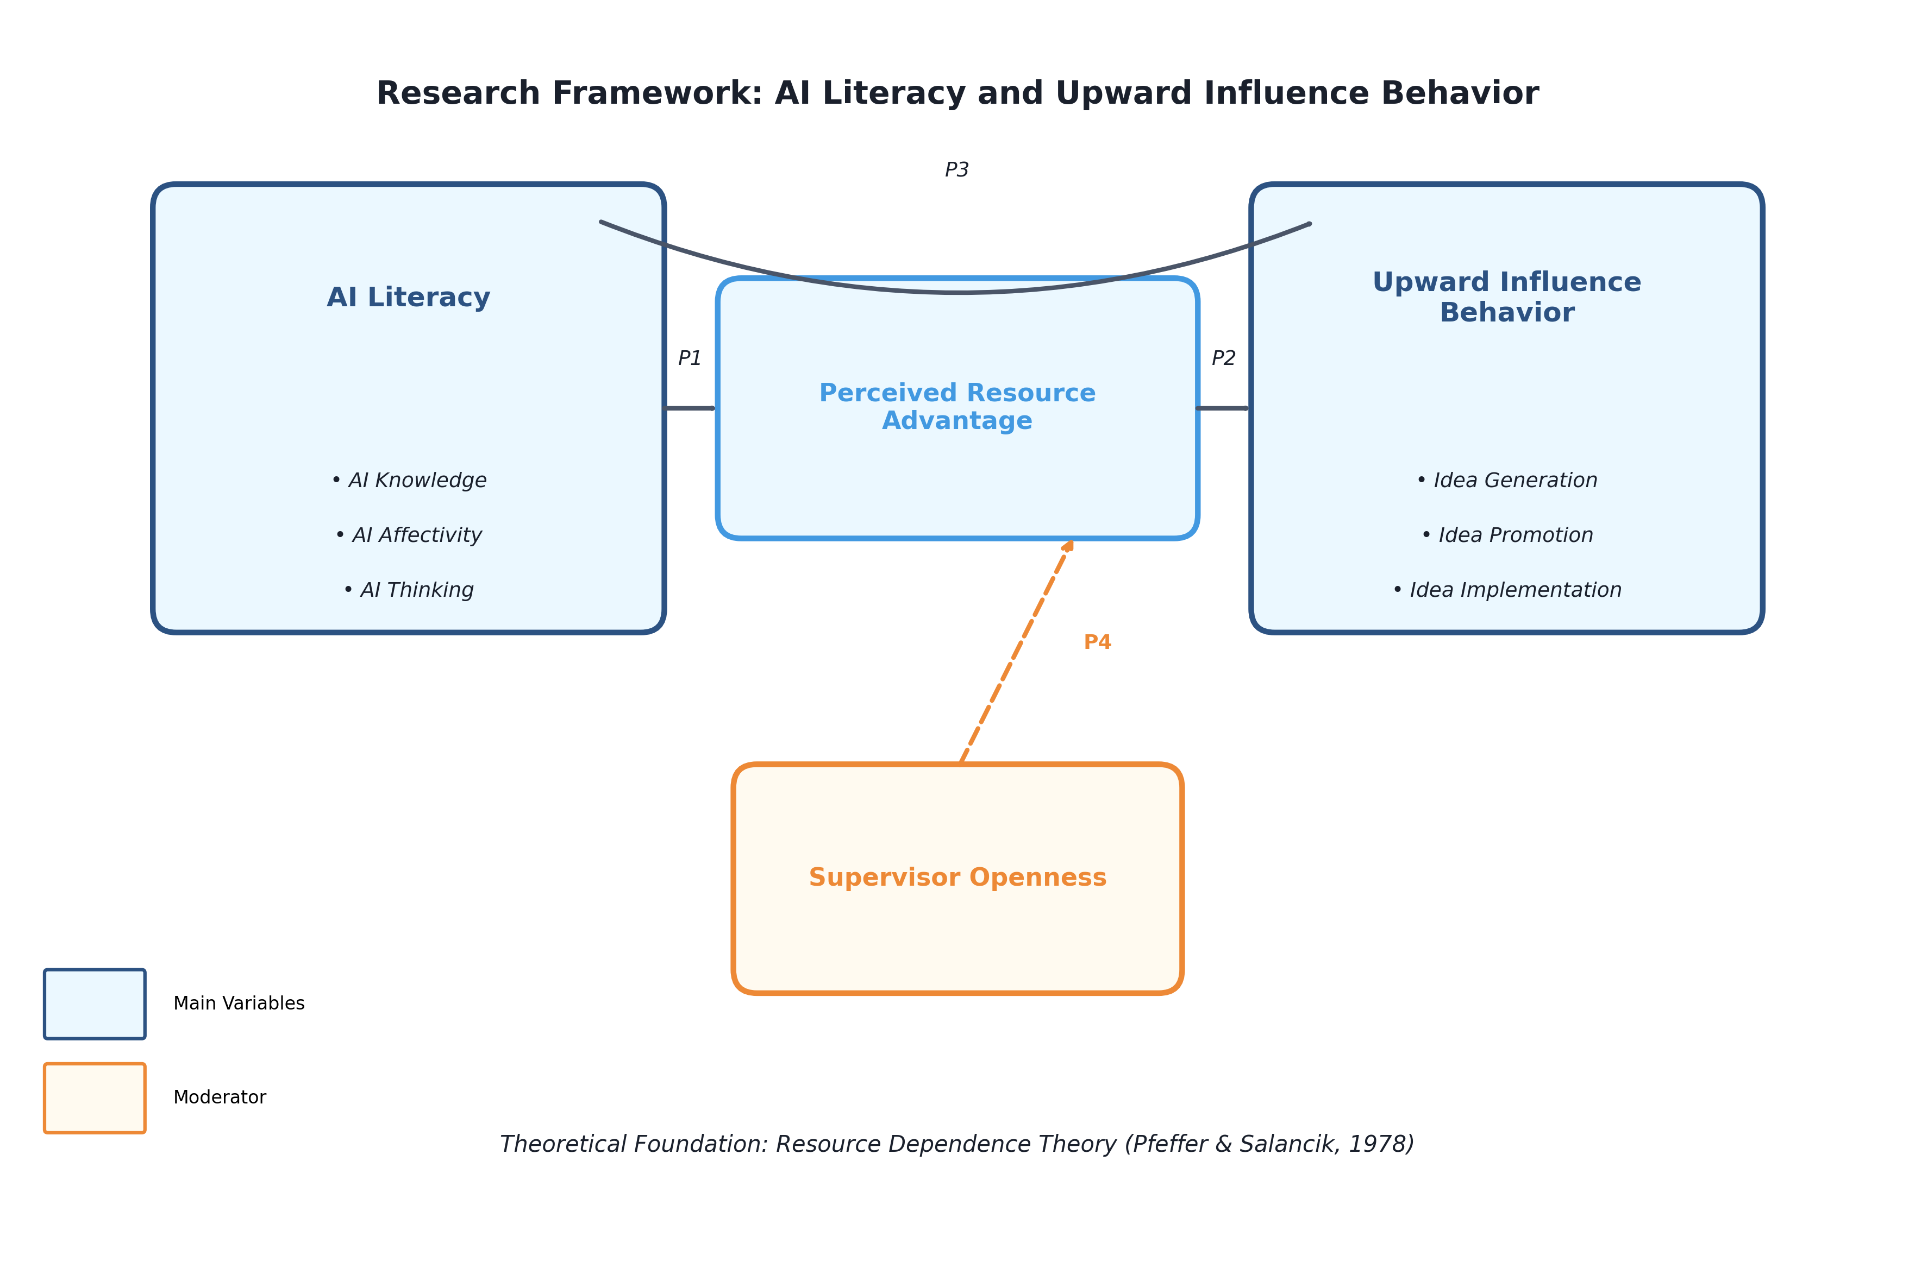
Figure 1. Research Framework
[See Figure 1: Research Framework]
Research Propositions:
P1: AI literacy positively relates to employees' perceived resource advantage.
P2: Perceived resource advantage enables employees to engage in upward influence behavior.
P3: Perceived resource advantage mediates the relationship between AI literacy and upward influence behavior.
P4: Supervisor openness moderates the relationship between perceived resource advantage and upward influence behavior.
Ⅱ. Research Methodology
Research Design: This study adopts a qualitative research approach using semi-structured in-depth interviews to explore how AI literacy influences upward influence behavior among Generation Z employees.
Sampling:
• Target population: Generation Z knowledge workers (born 1995-2010) who use AI tools in daily work
• Sample size: 15-20 participants (following saturation principle, Guest et al., 2020)
• Sampling strategy: Purposive sampling combined with snowball sampling
• Selection criteria: (1) Born 1995-2010; (2) At least 6 months full-time work experience; (3) Regular use of AI tools at work
Data Collection: Semi-structured interviews lasting 45-60 minutes, audio-recorded with participant consent. Interview guide covers AI literacy experience, perceived resource advantage, upward influence behaviors, and supervisor openness.
Data Analysis: Thematic analysis following Braun & Clarke's (2006) six-phase approach: (1) familiarization with data, (2) generating initial codes, (3) searching for themes, (4) reviewing themes, (5) defining themes, and (6) producing the report.
Quality Assurance: Credibility through member checking; transferability through thick description; dependability through audit trail; confirmability through researcher reflexivity.
三、写作进度与安排
Time | Tasks
December 2024 | Complete literature review and finalize interview guide
January 2025 | Conduct pilot interview and refine interview questions
February 2025 | Complete data collection (15-20 interviews)
March 2025 | Complete data analysis and identify key themes
April 2025 | Write first draft of thesis
May 2025 | Revise thesis based on supervisor feedback
June 2025 | Submit final thesis and prepare for defense

指导教师审核意见

签名：________________
年 月 日

