VIT VELLORE
OPERATING SYSTEMS

HawkOS
A Lightweight x86 Operating System, Built from Scratch

PROJECT REVIEW – I

Submitted by
Name | Registration Number
Priyanshu Ghosh | 24BDE0138
Leya Susan Vargheese | 24BDE0134

Under the guidance of: Dr. Balasubramani M

Abstract
HawkOS is a hobby operating system built from first principles in x86 assembly and C, without relying on any existing kernel or OS framework. The project's long-term goal is a graphical desktop environment capable of running a lightweight web browser, with the entire system operating within a 128 MB RAM budget. This report (Project Review – I) documents the work completed to date: bootstrapping the kernel into 32-bit protected mode via GRUB and the Multiboot specification, setting up interrupt and exception handling, implementing core device drivers (keyboard, VGA text console, serial UART), building a minimal interactive shell, and — the centerpiece of this review — a working memory management subsystem consisting of a physical frame allocator, paging, and a kernel heap.

1. Introduction
Modern operating systems hide an enormous amount of complexity behind system calls and standard libraries. The motivation behind HawkOS is to build that complexity back up from nothing — starting at the CPU reset vector — to genuinely understand how a computer boots, how interrupts and hardware devices are managed, how memory is virtualized, and eventually how a full desktop environment and a browser are constructed on top of those primitives.
HawkOS targets the x86 (32-bit, IA-32) architecture in protected mode. It is booted by GRUB using the Multiboot 1 specification, which allows the kernel to be loaded as a standard ELF binary on a bootable ISO, and is developed and tested primarily in the QEMU emulator before any eventual testing on real hardware.

2. Objectives
Long-term project objective:
- To design and implement a lightweight operating system with a functioning graphical desktop environment and a working web browser as its centerpiece application, engineered to run entirely within 128 MB of RAM.
Scope covered in this review (Review – I):
- Bootstrap a protected-mode kernel from a Multiboot-compliant bootloader (GRUB).
- Implement interrupt handling: IDT setup, CPU exception handlers, PIC remapping, PIT timer.
- Implement core device drivers: PS/2 keyboard, VGA text-mode console, serial (UART) output.
- Build a minimal interactive shell for testing and diagnostics.
- Implement the memory management foundation every later subsystem depends on: a physical memory manager, paging, and a kernel heap allocator.
- Establish a reproducible build system and continuous integration pipeline.

3. Development Environment and Toolchain
Component | Tool / Standard Used
Assembler | NASM (Netwide Assembler), ELF32 object output
Compiler | GCC, freestanding 32-bit build (-m32 -ffreestanding -fno-pic)
Linker | GNU ld with a custom linker script (linker.ld)
Bootloader | GRUB, via the Multiboot 1 specification
Boot media | Bootable ISO (BIOS + UEFI) built with grub-mkrescue
Emulator | QEMU (qemu-system-i386), with serial console passthrough
Continuous Integration | GitHub Actions — builds the ISO on every push

4. System Architecture Overview
HawkOS follows a classic monolithic-kernel boot flow. The layers implemented so far are summarised below, in the order execution passes through them at boot time:
Layer | Responsibility
GRUB (Multiboot) | Loads the kernel ELF binary, hands control to _start with a memory map
boot.s (entry point) | Captures Multiboot info, loads the GDT, sets up the stack, calls kernel_main
GDT | Flat code/data segment descriptors for ring-0 execution
IDT / ISRs | Routes CPU exceptions and hardware interrupts to C handlers
Drivers | PIC, PIT, PS/2 keyboard, VGA console, serial UART
Memory Management | Physical memory manager, paging, kernel heap
Shell | Line-editing TTY layer and a minimal command interpreter

5. Work Completed (Review – I)

5.1 Bootloader and Protected-Mode Entry
A Multiboot 1 header (boot.s) advertises HawkOS as loadable by GRUB. On entry, the CPU is already in 32-bit protected mode courtesy of GRUB; the kernel's own entry point loads a flat GDT (gdt.asm) with ring-0 code and data descriptors, switches to a dedicated kernel stack, and calls into the C kernel. As of this review, the Multiboot magic number and information structure pointer passed by GRUB in EAX/EBX are captured into kernel globals and forwarded to kernel_main(), rather than being discarded — this is what makes real memory detection possible (see Section 5.6).

5.2 Interrupt and Exception Handling
A 256-entry IDT is initialised with a default handler for every vector, then overridden with specific handlers for the 32 CPU exception vectors (divide-by-zero, page fault, general protection fault, etc.) and for the timer and keyboard hardware interrupts (IRQ0/IRQ1). Exceptions are decoded and reported by name with their error code over both the VGA console and the serial port, instead of silently triple-faulting. The 8259 PIC is remapped away from its conflicting default vectors, and the Programmable Interval Timer (PIT) is programmed to a 100 Hz tick used for uptime tracking.

5.3 Device Drivers
A PS/2 keyboard driver decodes Set-1 scancodes into ASCII, with shift/caps-lock state tracking and a ring buffer for input. A VGA text-mode console driver provides a scrolling 80×25 text display with cursor tracking and backspace handling. A 16550 UART serial driver provides an independent output channel used for boot diagnostics, which is essential for debugging before any display output is trustworthy.

5.4 Kernel Debug Output (kprintf)
A small printf-style formatter (kprintf) supports %c, %s, %d, %u, %x and %p, writing simultaneously to the VGA console and the serial port. This is the primary diagnostic tool used throughout development and is what the memory-management subsystem uses to report its state at boot.

5.5 Interactive Shell
A blocking line-editor (tty_readline) built on the keyboard driver feeds a minimal command shell supporting help, echo <text>, and uptime (derived from the PIT tick counter). This provides a live, interactive way to exercise the kernel.

5.6 Memory Management — Physical Allocator, Paging, and Heap
This is the headline addition of Review – I, and the foundation every future subsystem (multitasking, user-mode processes, a filesystem, graphics, and eventually the browser) depends on.
- Multiboot memory-map capture:
The Multiboot info structure supplied by GRUB is now parsed to obtain the BIOS memory map (which physical regions are usable RAM versus reserved), with a graceful fallback to the simpler mem_lower/mem_upper fields, and a last-resort hardcoded guess if neither is available.
- Physical Memory Manager (PMM):
A bitmap allocator tracks every 4 KB physical frame as free or used. It reserves the first 1 MB of memory (BIOS/EBDA/VGA region) and the kernel image's own frames automatically, using linker-exported kernel_start/kernel_end symbols, so the allocator can never hand out memory the kernel itself occupies.
- Paging:
A page directory and page tables are built and identity-mapped across all physical RAM the PMM detected, after which the CPU's paging unit (CR3/CR0.PG) is enabled. Page tables are themselves allocated from the physical memory manager, and the mapping routine (paging_map) is a reusable primitive that later phases (user-mode processes, a graphics framebuffer) will build on.
- Kernel Heap:
A first-fit, coalescing free-list allocator (kmalloc/kfree) provides dynamic memory allocation inside the kernel, verified at boot with a live allocation/deallocation test whose result is printed via kprintf.

5.7 Build System and Continuous Integration
A single Makefile drives the whole build: assembling with NASM, compiling with GCC, linking with a custom linker script, and packaging a bootable ISO with grub-mkrescue (built to support both legacy BIOS and UEFI boot). A GitHub Actions workflow rebuilds the ISO automatically on every push, catching toolchain and build regressions early.

5.8 Shell Diagnostics and Live Introspection
Beyond the original help / echo / uptime trio, the shell now exposes live introspection commands that exercise already-built subsystems interactively rather than only at boot: meminfo (physical RAM and kernel heap usage, read live from pmm.c / kheap.c), cpuinfo (CPUID vendor and brand string), date / time (a new CMOS RTC driver on ports 0x70/0x71), clear, and crash — which deliberately executes a divide-by-zero (via int $0x0) so the exception handler from Section 5.2 can be demonstrated live, catching and reporting it cleanly, rather than only described on paper.

5.9 Storage: ATA Driver and Read-Only FAT32
A new ATA PIO driver (LBA28, primary bus, master drive) gives the kernel its first access to a disk. On top of it, fat32.c implements a genuine read-only FAT32 filesystem: BPB parsing, FAT cluster-chain walking, and directory traversal that handles the root directory and subdirectories identically — in FAT32 the root is itself just a cluster chain like any other directory. VFAT long-filename entries are correctly recognised and skipped so real, normally-formatted FAT32 images parse cleanly.
Read-only is a deliberate scope choice for this review: write support means safely allocating clusters and updating the FAT (in both mirrored copies) and FSInfo without risking silent volume corruption, and is planned as a controlled follow-up once the read path is proven, rather than rushing both at once.
The shell now has ls, cd <dir>, and cat <file>, reading real files off a standard FAT32 image prepared entirely with ordinary host tools (mkfs.vfat, mtools) — no custom tooling is needed to test it.

5.10 Graphics: Linear Framebuffer, Bitmap Console, and a GUI Preview
HawkOS now requests a linear graphics framebuffer directly in the Multiboot header (a video-mode tag in boot.s); GRUB negotiates the actual mode before handing off, and reports the real address/pitch/resolution it granted. gfx.c provides pixel, rectangle, character and string drawing primitives on top of that framebuffer, and font8x8.c is a hand-authored 5×7 bitmap font covering upper- and lower-case letters, digits, and the punctuation the kernel's own output actually uses.
This replaced the legacy VGA text-mode console entirely: console.c's backend was rewritten to render through gfx.c while keeping its exact original public functions, so kprintf, the shell, and exception reporting needed zero changes elsewhere. This was necessary rather than optional — requesting a linear framebuffer via Multiboot commits the whole boot to graphics mode from the first instruction; there is no BIOS call available in 32-bit protected mode to toggle back to text mode at runtime.
A new PS/2 mouse driver (IRQ12) and a gui shell command add the first visual, non-text surface: a static desktop scene (a taskbar and two labelled window panels) with a live, accurately-tracking mouse cursor, restored back to the text shell cleanly on ESC. It is deliberately non-interactive for now (no dragging or clicking yet) — the goal of this pass was proving the framebuffer, font, and input pipeline work end-to-end together, which is the direct foundation Review 2/3's window manager and browser rendering will build on.

6. Screenshots
The placeholders below mark where screenshots should be inserted (Insert → Pictures in Word, or paste directly into the shaded box).
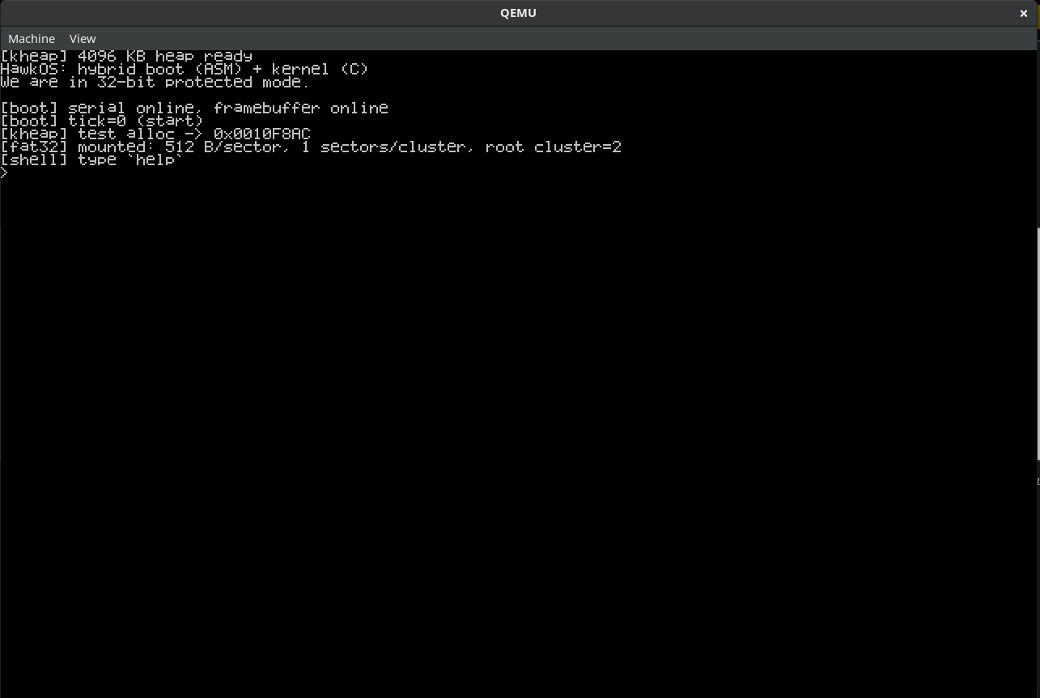
Fig. 1 — QEMU window at boot: banner, boot/memory-manager log, and shell prompt

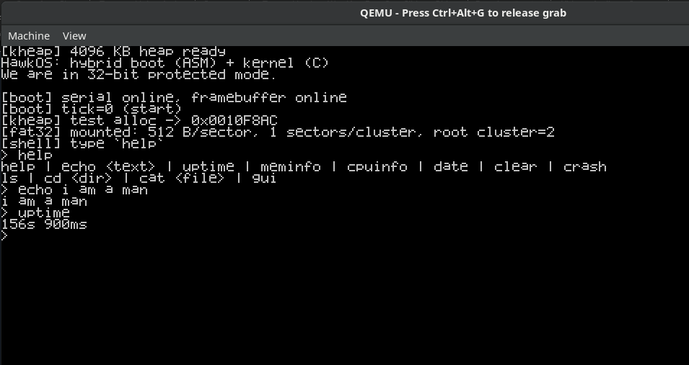
Fig. 2 — The QEMU window after typing a few commands: help, echo hello hawkOS, uptime

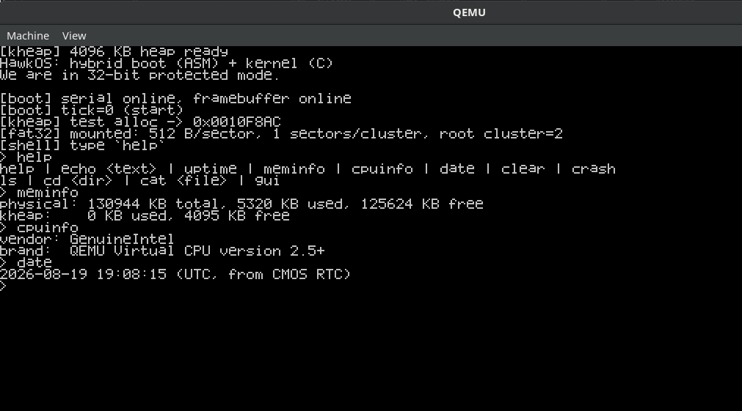
Fig. 3 — meminfo / cpuinfo / date output in the shell

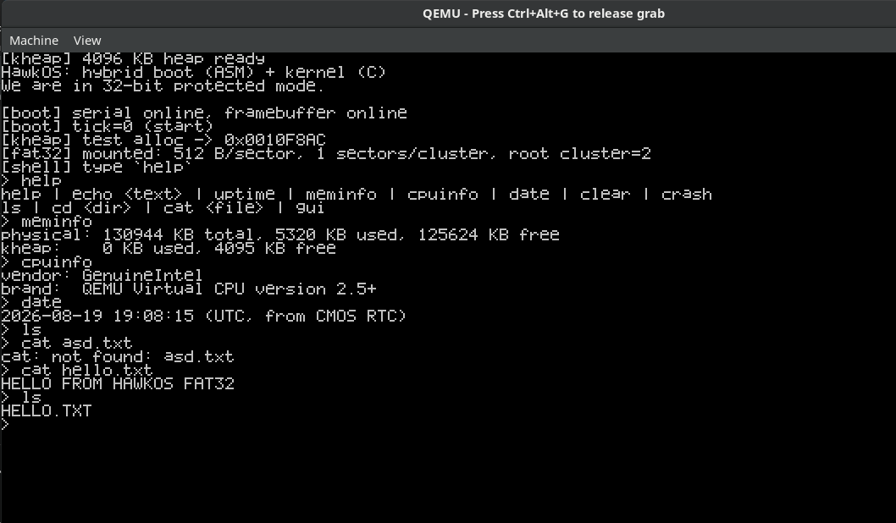
Fig. 4 — ls and cat reading a real file off the FAT32 disk image

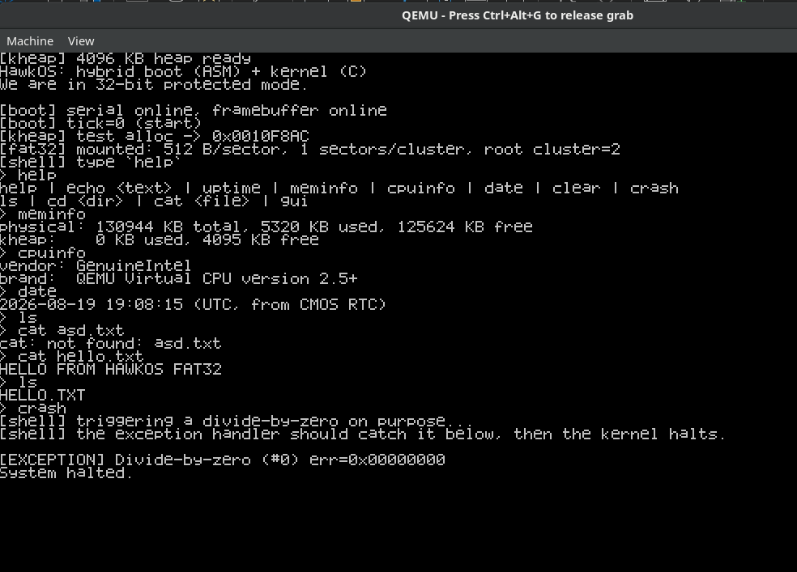
Fig. 5 — crash command: the exception handler catching a live divide-by-zero

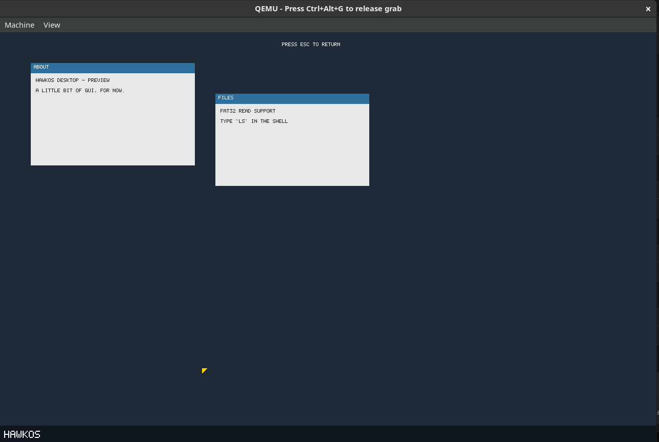
Fig. 6 — gui desktop preview (taskbar, window panels, live mouse cursor)

7. Results and Current Status
- Working end-to-end as of this review:
- Kernel boots via GRUB (BIOS and UEFI) into 32-bit protected mode, in QEMU.
- CPU exceptions are caught and reported by name instead of triple-faulting.
- Keyboard input, VGA text output, and serial diagnostic output all function correctly.
- The interactive shell accepts and responds to commands in real time.
- The physical memory manager correctly detects installed RAM from the real BIOS memory map and reports free/used frame counts at boot.
- Paging is enabled with a full identity map, and the kernel heap allocator passes its boot-time smoke test.
- Known limitations at this stage:
- Single flat identity-mapped address space; no higher-half kernel or user-mode processes yet.
- No disk driver or filesystem — the whole kernel currently lives inside the boot image.
- Single-tasking only; no scheduler or process model.
- Text-mode display only; no graphics or windowing yet.
- No networking stack.

8. Future Scope
HawkOS is being developed across three project reviews, moving from the protected-mode kernel foundation established in this review toward a graphical desktop environment whose centerpiece deliverable is a working web browser — the explicit, stated objective of this project, not an optional stretch goal. Every phase below is scoped so that Review 3 ends with a browser that can fetch and render a real page over a real network connection, not just a set of standalone subsystems demoed in isolation.
128 MB RAM constraint — enforced at the software level: HawkOS is not restricted by 128 MB of physical hardware; the constraint is a deliberate design budget the kernel is engineered to respect regardless of how much RAM is actually present on the host machine or given to QEMU. The physical memory manager (Section 5.6) already tracks and reports usage precisely for this reason, and the meminfo command added in Section 5.8 is the tool used to verify it: every later subsystem — the kernel heap, FAT32 read buffers, the framebuffer, and eventually the network stack and the browser itself — is being built to stay within that self-imposed ceiling, not allowed to grow unbounded just because more memory happens to be available.

Review 2 — Multitasking, Storage Maturity, and a Real Desktop
- Multitasking — a process/thread model with context switching and a round-robin scheduler.
- User mode and syscalls — ring-3 execution, a syscall interface, and a minimal ELF loader.
- FAT32 write support, as the controlled follow-up flagged in Section 5.9: cluster allocation, FAT and FSInfo updates, done carefully rather than rushed.
- A real window manager — z-ordering, dirty-rect redraw, and a minimal widget set — built directly on the framebuffer, font, and PS/2 mouse driver already delivered in Section 5.10, turning the current static GUI preview into something interactive.
- Start the network stack here if there's any schedule slack, even just Ethernet/ARP/IP — it is Review 3's single biggest risk item and benefits most from an early start.

Review 3 — Networking and the Web Browser
- A network stack targeting one well-emulated NIC under QEMU (virtio-net or RTL8139): our own Ethernet → ARP → IP → ICMP → UDP → TCP implementation with a socket layer.
- An HTTP client built on that TCP stack.
- HTML and CSS parsing via reused third-party libraries, a deliberate scope decision: Gumbo (a small, dependency-light HTML5 parser) for HTML, and NetSurf's own support libraries (libcss / libparserutils / libwapcaplet) for CSS — chosen specifically because they are designed for portable, low-memory, non-POSIX targets, which fits the 128 MB budget by construction rather than by luck.
- Our own code stays focused on OS integration, the TCP/HTTP layer, and painting the parsed layout onto the Section 5.10 framebuffer inside a real window in the Review 2 window manager — a substantial, defensible “we built this” scope even with a reused parser underneath it.
- To confirm early, not at the review itself: check with the faculty guide that embedding third-party parsing libraries is acceptable for grading.
The Review 3 deliverable is a browser window, inside the HawkOS desktop, fetching and rendering a real page over a real network connection — not a simulation, and not a standalone demo kept separate from the rest of the operating system.

9. Conclusion
Review – I establishes a working, bootable protected-mode kernel with interrupt handling, core device drivers, an interactive shell, and — most importantly — a complete memory management foundation: real memory detection from the bootloader, a physical frame allocator, paging, and a kernel heap. Every subsystem planned for the remaining phases (multitasking, storage, graphics, networking, and the browser itself) depends directly on this foundation, which is now in place and verified working in QEMU.

10. References
- OSDev Wiki — https://wiki.osdev.org
- Multiboot Specification, GNU GRUB Project — https://www.gnu.org/software/grub/manual/multiboot/
- Intel® 64 and IA-32 Architectures Software Developer's Manual, Volume 3A (System Programming Guide)
- NetSurf Browser Project — https://www.netsurf-browser.org
- BearSSL — https://bearssl.org

