OBJECTIVE :

**IOT INSTANT CONTACTLESS COVID TESTING BOOTH AUTOMATION**:-

In view of current pandemic covid testing plays a key role in fighting the pandemic. The main aim of this project is to design a completely automated instant contactless covid testing booth system by which person details is monitored using RFID technology. This project makes use of micro controller. It acts as heart of the project. This onboard computer can efficiently communicate with the output and input modules which are being used. We use controller memory to dump some set of assembly instructions into the controller. And the controller function is dependent on these assembly instructions. When the Micro controller gets the data from the RFID Reader, Automatically the tag details related to the person along with the sample collection details will be sent as an SMS along with the test results to the stored mobile number. The system also provide both audible and visual alerts using LCD and Buzzer.

**SCOPE OF THE PROJECT:**

In order to reduce the spread of the Corona Virus, an Automatic Testing centre needs to be developed. This Automation of the Contactless Test Centre reduces the spread of the virus as well as man power. It reduces the time needed to wait for the results and manages errors. It is a fully automated system with a micro-controller interface to the button, sensors and IOT module. It makes results easier to handle. Some of the major fields in which our project finds its applications are:-

* **Schools & Colleges:**

Social distancing has been regarded as a key method by the authorities worldwide to manage the pandemic of COVID-19. Digital technologies play a crucial role to support the social, professional and economic activities when people are forced to stay locked-down in their homes. Internet of things (IoT) technologies have a track of providing high quality remote health care and automation services which could guarantee social distancing while maintaining health and well-being of populations in the School and colleges premises.

* **Entertainment Zones & Areas:**

With the help of this project we can ensure the public health safety in areas like Entertainment zones like Movie Theatres, public parks, Malls and shopping areas.

* **Transport Locations:**

We can ensure public health safety in highly crowded locations like railway station, bus stops, air ports, etc. As these locations are very sensitive so this project can be very useful.

* **Religious Spots:**

In the religious spots, a huge amount of population come every day to praise so in these situation project like these are very helpful.

* **Companies &Industries:**

This project is really very useful as people come every day to earn their living so we can provide this facility.

**INTRODUCTION**:

Internet of Things (IoT) is rapidly increasing technology. IoT is the network of physical objects or things embedded with electronics, software, sensors, and network connectivity, which enables these objects to collect and exchange data. In this paper, we are developing a system which will automatically test the person with covid instantly with contactless testing booth. This project makes use of an on board computer, which is commonly termed as micro controller. It acts as heart of the project. This on board computer can efficiently communicate with the output and input modules which are being used. The controller is provided with some internal memory to hold the code. This memory is used to dump some set of assembly instructions into the controller. And the functioning of the controller is dependent on these assembly instructions.

The design of this system is very much sensitive and should be handled with utmost care because interfacing RFID reader and GSM to the micro controller is sensitive. So every small parameter should be given high importance while designing the interfacing circuit because if we use single sided board then lot of parts are being used in a small space then it may be difficult to make a single sided board without jumping over traces with a cable. The main idea is to design a completely automated instant contactless COVID testing booth system by which person details is monitored using RFID technology. It is used for ensuring the person details like name, aadhar scan specific information by which the system totally isolates the test person from the user and also makes the process fast and error free by automating registration process too. When the Micro controller gets the data from the RFID Reader, Automatically the tag details related to the person along with the sample collection details will be sent as an SMS along with the test results to the stored mobile number. Thus we fully automate the Covid booth testing process, making it faster, safer and error free to help fight the pandemic in a better manner.

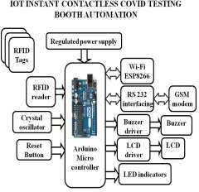 **IMPLEMENTATION:**

The design can be implemented with following as we No need for separate registration, the system uses RFID technology for instant aadhar card scan registration details monitoring. The Test person provides the sample number of the person from inside the booth using provided RFID tag. The system uses buzzer to inform patient that his test is done and next person to come forward. The data collected by the time is transferred over to Lab using IOT ESP8266 Wi-Fi module automatically before next person comes ahead. The lab in-charge can view the no of samples tested in real time and can update sample test results too on IOT server through Wi-Fi module. When lab in-charge updates test result of a sample, an SMS using GSM modem is instantly sent to the respective person by the system itself. Thus we fully automate the Covid booth testing process, making it faster, safer and error free to help fight the pandemic in a better manner. This project makes use of an on board computer, which is commonly termed as micro controller. It acts as heart of the project. This on board computer can efficiently communicate with the output and input modules which are being used. The controller is provided with some internal memory to hold the code. This memory is used to dump some set of assembly instructions into the controller. And the functioning of the controller is dependent on these assembly instructions.

The brief introduction of different modules used in this project is discussed below:

* **GSM Modem:**

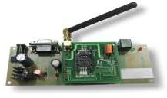

SIM 300 is a GSM modem with a simple serial interface. SIM 300 modem can accept any GSM network operator SIM card and act just like a mobile phone with its own unique phone number. With this module one can send/receive sms, connect to internet via GPRS and receive calls. The modem can either be connected to PC serial port directly or to any microcontroller. When purchasing purchase the entire board.

* LCD Module:

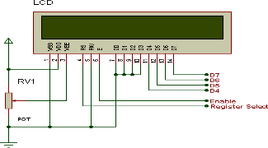

One of the most common devices attached to a micro controller is an LCD display. Some of the most common LCD’s connected to the many microcontrollers are 16x2 and 20x2 displays. This means 16 characters per line by 2 lines and 20 characters per line by 2 lines, respectively. As previously mentioned, it takes a certain amount of time for each instruction to be executed by the LCD. The delay varies depending on the frequency of the crystal attached to the oscillator input of the LCD as well as the instruction which is being executed. The "Get LCD Status" command will return to us two tidbits of information; the information that is useful to us right now is found in DB7. In summary, when we issue the "Get LCD Status" command the LCD will immediately raise DB7 if it's still busy executing a command or lower DB7 to indicate that the LCD is no longer occupied. Thus our program can query the LCD until DB7 goes low, indicating the LCD is no longer busy. At that point we are free to continue and send the next command.

* **Buzzer:**

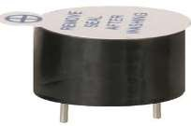

A buzzer or beeper is an audio signaling device, which may be mechanical, electromechanical, or piezoelectric. Typical uses of buzzers and beepers include alarm devices, timers and confirmation of user input such as a mouse click or keystroke. A piezoelectric element may be driven by an oscillating electronic circuit or other audio signal source, driven with a piezoelectric audio amplifier. Sounds commonly used to indicate that a button has been pressed are a click, a ring or a beep. Piezo buzzer is an electronic device commonly used to produce sound. Light weight, simple construction and low price make it usable in various applications like car/truck reversing indicator, computers, call bells etc.

* **Arduino Uno:**

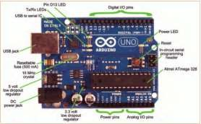

Arduino Uno The Arduino Uno is a microcontroller board based on the ATmega328. It has 20 digital input/output pins (of which 6 can be used as PWM outputs and 6 can be used as analog inputs), a 16 MHz resonator, a USB connection, a power jack, an in-circuit system programming (ICSP) header, and a reset button. The Arduino Uno is an open-source microcontroller board based on the Microchip ATmega328P microcontroller and developed by Arduino.cc. The board is equipped with sets of digital and analog input/output (I/O) pins that may be interfaced to various expansion boards (shields) and other circuits.

# Radio Frequency Identification:

# 

Radio Frequency Identification (RFID) is the application of radio waves to read and capture information stored on tags affixed to objects. RFID readers are installed at tracking points and can read information from tags when they come

into range, which can be of several feet radius. A tag need not be within direct line-of-sight of the reader to be tracked. RFID is used to check identities and track inventory, assets and people. RFID tags can be attached to a variety of objects like cash, clothing, baggage, parcels, and even implanted in animals and people.

# Wi-Fi Module:

# 

The ESP8266 Wi-Fi Module is a self-contained SOC with integrated TCP/IP protocol stack that can give any microcontroller access to your Wi- Fi network. The ESP8266 is capable of either hosting an application or offloading all Wi-Fi networking functions from another application processor. Each ESP8266 module comes pre- programmed with an AT command set firmware, meaning, you can simply hook this up to your Arduino device and get about as much Wi-Fi- ability as a Wi-Fi Shield offers. The ESP8266 module is an extremely cost effective board with a huge, and ever growing, community.

**BLOCK DIAGRAM:**

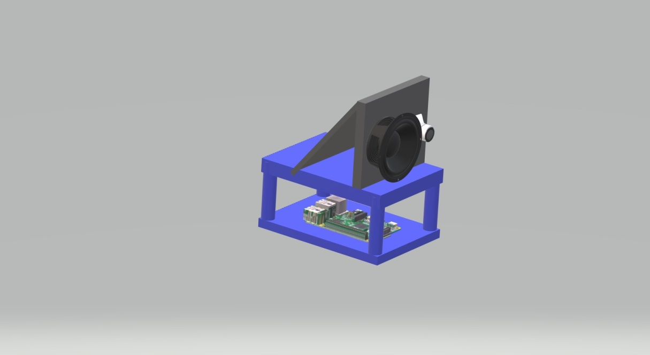

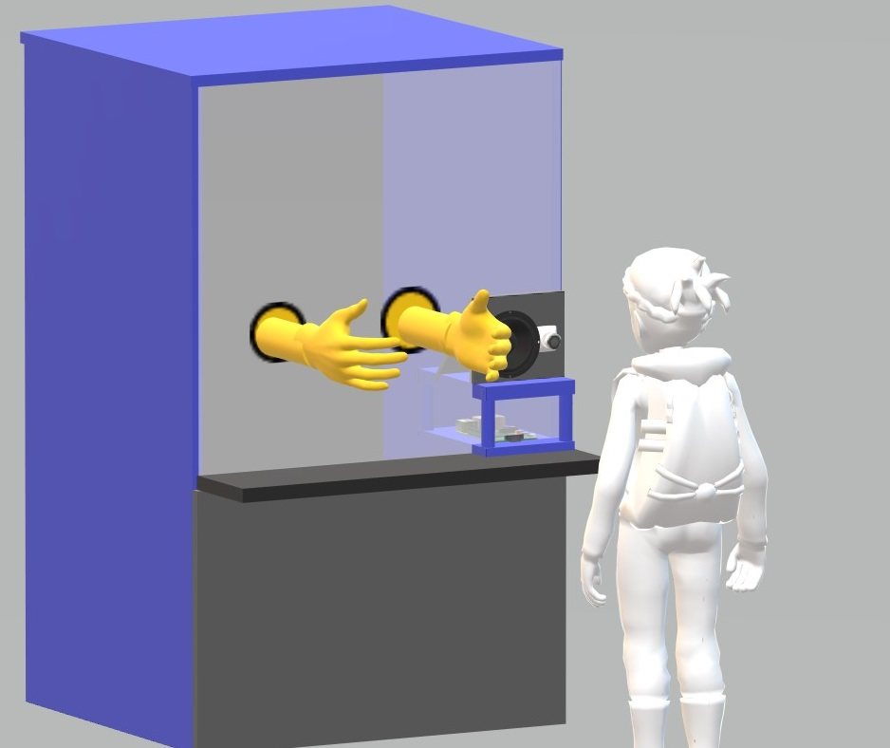

# RESULT:

The project “**IOT INSTANT CONTACTLESS COVID TESTING BOOTH AUTOMATION**”

was designed a completely automated instant contactless COVID testing booth system by which person details are monitored using RFID technology. The data collected by the time is transferred over to Lab using IOT ESP8266 Wi- Fi module automatically before next person comes ahead. The lab in-charge can view the no of samples tested in real time and can update sample test results too on IOT server through Wi-Fi module along with test result of a sample, an SMS using GSM modem is instantly sent to the respective person by the system itself.

We can see how perfectly the package works. The patient information is recorded by using the picture processing technique to capture the aadhar card. Then the body temperature is sensed and the breathing sensor control the individual's breathing rate. Completion of the test tells the voice module. The IOT module transfers the data obtained to the laboratory. The laboratory charge will display a number of samples evaluated on an IOT server in real time and update the results. The device itself would immediately send an SMS to the particular person. The individual's natural body temperature must range from 97.5 degrees Fahrenheit to 99.6 degrees Fahrenheit. If the body's temperature is over 100 degrees Fahrenheit, the person suffers from viral fever. The person's average breathing rate is between 12 and 16 breathes a minute. It means that a particular person has pneumonic infection when the number of breaths per minute reaches 30 breaths.

# CONCLUSION:

The existing model presents an Integrating feature of all the hardware components which has been used and developed in it with Arduino.

The Presence of each and every module has been reasoned out and placed very carefully. Hence the contributing to the best working unit for “**IOT INSTANT CONTACTLESS COVID TESTING BOOTH AUTOMATION**”

Secondly, using highly advanced IC’s with the help of growing technology, the project has been successfully implemented. Thus the project has been successfully designed and tested.

In an indoor scenario this patient surveillance system will simultaneously track many patient parameters. Testing was performed with numerous patient cardiac readings. This system is so effective, simple to use, and can therefore be used in hospitals. Doctors or nurses may connect to a central server in order to obtain multiple tracked patients with health status and values. It makes diagnosis simple. The device also retains the patient's comfort since conventional cable and instrument control tools are no longer needed. Furthermore, wireless connectivity allows rapid data sharing, which provides instant outcomes in a critical situation for many patients in real time.

**REFERENCES:**

* Jingyi Xiao Non-pharmaceutical Measures for Pandemic Influenza in Non-healthcare Settings— Personal Protective and Environmental Measures.
* World Health Organization. Comparative analysis of national pandemic influenza preparedness plans,2011[cited 2019 Jun 25]
* Aerosol transmission of influenza A virus: a review of new studies [Raymond Tellier](https://royalsocietypublishing.org/doi/10.1098/rsif.2009.0302.focus), Published:22 September 2009.
* Guyatt G, Oxman AD, Akl EA, Kunz R, Vist G, Brozek J, et al. GRADE guidelines: 1. Introduction-GRADE evidence profiles and summary of findings tables. J Clin Epidemiol. 2011;64:383–94.
* Published:January 03, 2011
* Wong VW, Cowling BJ, Aiello AE. Hand hygiene and risk of influenza virus infections in the
* community: a systematic review and meta-analysis. Epidemiol Infect. 2014;142:922–32.
* Hand hygiene and risk of influenza virus infections in the community: a systematic review and meta-analysis Published online by Cambridge University Press: 23 January 20
* Aiello AE, Murray GF, Perez V, Coulborn RM, Davis BM, Uddin M, et al. Mask use, hand hygiene, and seasonal influenza-like illness among young adults: a randomized intervention trial. J Infect Dis. 2010;201:491–8, 15 February 2010.
* Suess T, Remschmidt C, Schink SB, Schweiger B, Nitsche A, Schroeder K, et al. The role of facemasks and hand hygiene in the prevention of influenza transmission in households: results from a cluster randomised trial; Berlin, Germany, 2009- 2011. BMC Infect Dis. 2012;12:26 Article number: 26 (2012).