**Meta Title:** What are thetop integrated development environments in 2021?

**Meta Description:** We’re sharing a list of the most popular IDEs in 2021 with their basic features, major advantages, and prices.

**Key Phrase:** top IDE 2021

Top IDEs in 2021 with Features and Prices

Which IDE to choose in 2021?

We believe everyone has heard at least once about the integrated development environment called “Visual Studio,” and we all know that it’s the most popular one. There have been lots of lists of the best IDEs. Such lists are highly popular as they are incredibly useful. However, with every IDE release, these lists should be updated. For example, Xcode is used all over the world, but we’re coming across negative reviews on its design like “there are too many visuals” more and more often. That’s why, having some [experience in this area](https://andersenlab.com/services/custom-software-development?utm_source=article&utm_medium=itigic.com), we decided to make our own list of the best IDEs in 2021.

1. [Visual Studio](http://visualstudio.microsoft.com)

This is an IDE by Microsoft that uses its own software development platforms. As far as we know, many people start coding with C/C++ to get a good base, so this IDE is good for both beginners and professionals.

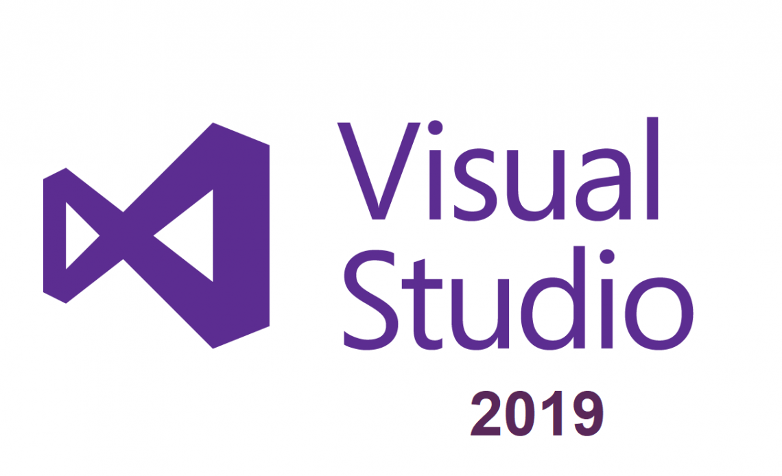

**Advantages:**

* 36 programming languages,
* Debugger support and code editor,
* A host of visual designers.

**Price:**

* **For individuals:** free,
* **For businesses:** $45/month (Visual Studio Professional, Azure DevOps basic),
* **For enterprises:** $250/month (Visual Studio Enterprise, Azure DevOps basic + test).

2. [Eclipse](https://www.eclipse.org/downloads/)

Eclipse is written mostly in Java and used primarily for developing Java applications. However, it may also serve to develop applications in other programming languages. It ranks second in terms of popularity and is used by approximately 24% of programmers.



**Advantages:**

* Java development tools,
* Free and open-source software,
* Rich Client Platform.

**Price:**

* Free to download and use.

3. [Android Studio](https://developer.android.com)

This IDE is built on JetBrains' IntelliJ IDEA and designed specifically for Android development. Android Studio is developed by a Czech company that calls itself the best IDE provider in 2021.

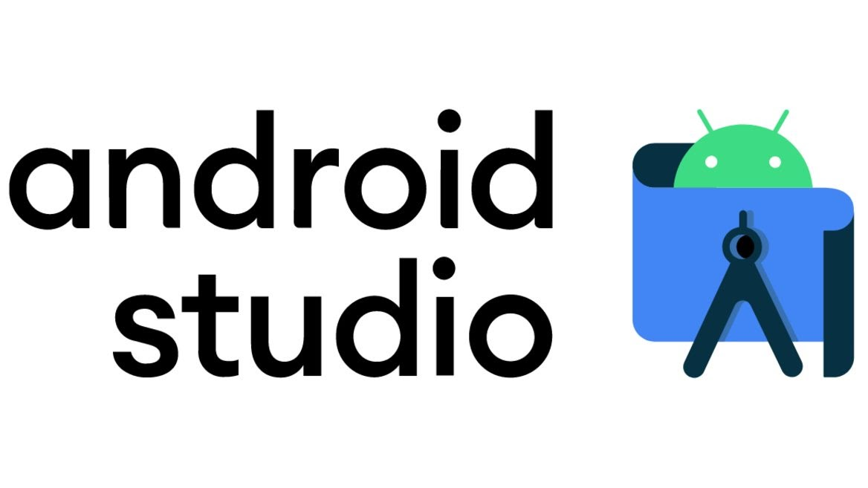

**Advantages:**

* Android-specific refactoring and quick fixes,
* Gradle-based build support,
* Template-based wizards to create common Android designs and components,
* A rich layout editor that allows users to drag-and-drop UI components with an option to preview layouts on multiple screen configurations.

**Price:**

* Free to download and use.

4. [IntelliJ IDEA](https://www.jetbrains.com)

This IDE is written in Java for developing desktop software. The Community and Ultimate editions have different support for various programming languages. It’s the best visually designed IDE and hence quite easy to use.

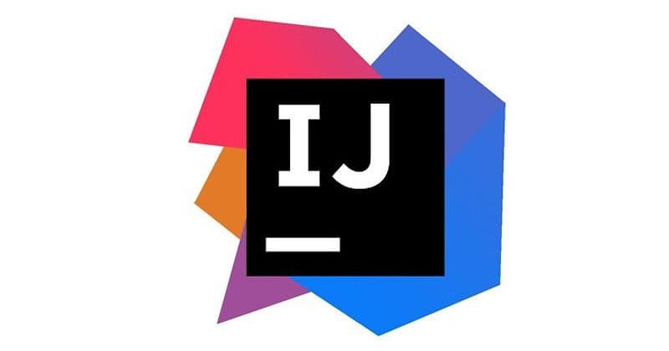

**Advantages:**

* Coding assistance,
* Built-in tools and integration,
* Plugin ecosystem,
* Software versioning and revision control.

**Price:**

* **For students, teachers, those who are learning Java, non-commerce organizations, courses, startups:** free,
* **For individuals:** $149-299 in the first year with a discount each subsequent year,
* **For professionals:** $499-699 in the first year with a discount each subsequent year.

5. [PhpStorm](https://www.jetbrains.com/phpstorm/)

PhpStorm is a commercial cross-platform IDE that provides an editor with on-the-fly code analysis and error prevention. In our opinion, it is the best IDE for web projects, as it’s built of WebStorm and SQL with PHP. PhpStorm is like an upgraded version of WebStorm.

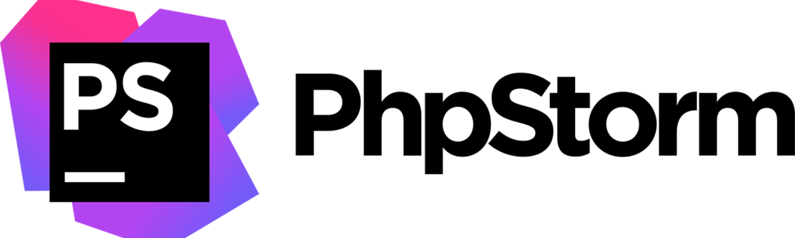

**Advantages:**

* Rich code editor for PHP,
* Coding Style Support,
* Duplicated Code Detector,
* SQL and database support,
* Easy-to-configure visual debugger.

**Price:**

* **For students, teachers, those who are learning Java, non-commerce organizations, courses, startups**: free,
* **For individuals**: $89 in the first year with a discount each subsequent year,
* **For professionals**: $199 in the first year with a discount each subsequent year.

6. [NetBeans](https://netbeans.apache.org/download/index.html)

NetBeans allows for the development of applications from a set of modular software components called modules. It supports the development of all types of Java applications. NetBeans is used by 7% of programmers and it ranks fourth in terms of popularity.

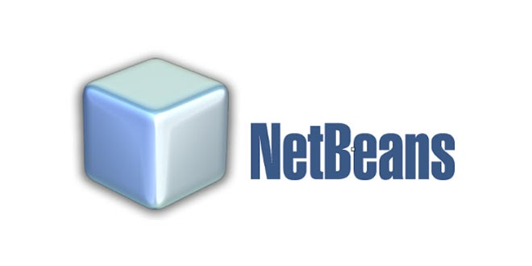

**Advantages:**

* Modularity,
* GUI design tool,
* In addition to Java development, it can be applied to other languages.

**Price:**

* Free to download and use.

7. [WebStorm](https://www.jetbrains.com/webstorm/download/#section=windows)

This IDE is designed for JavaScript development. According to the reviews (and in our own opinion), it’s the best IDE for JS because of its simple design and rich tools. As for us, its best features are auto-complete and plugins. But like all other IDEs from this company, WebStorm is a bit slow, so it’s not a good option to start with.

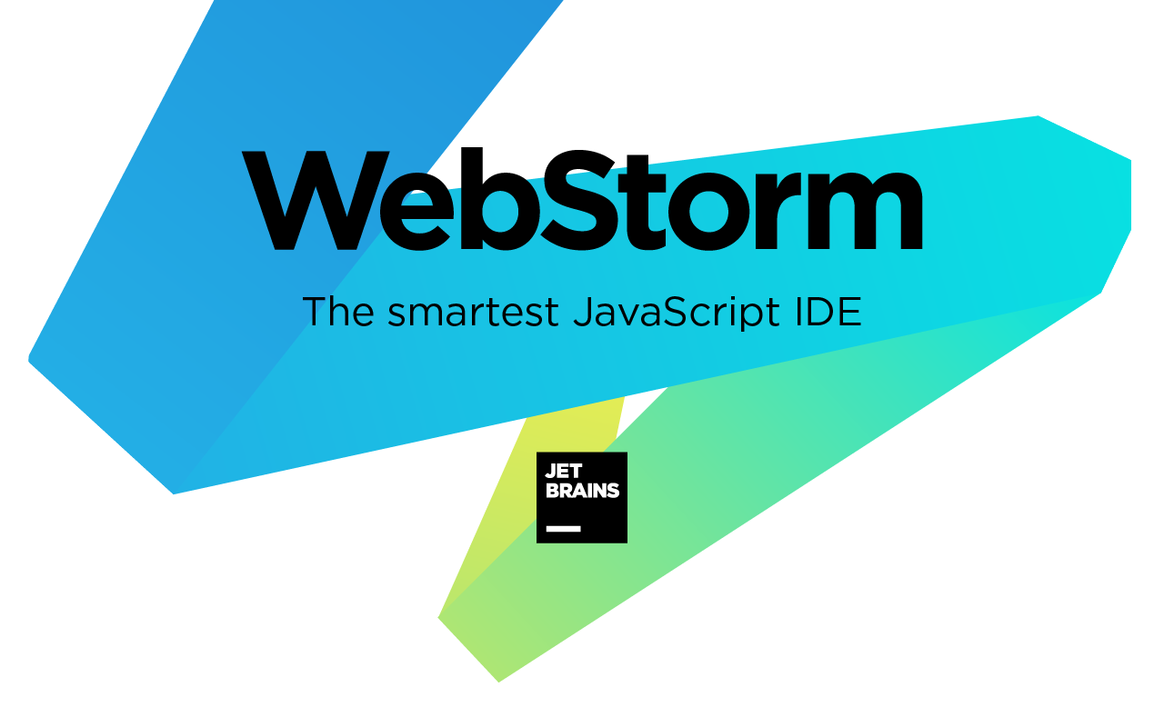

**Advantages:**

* Code editor support,
* Co-working,
* JSON Lines,
* Preview.

**Price:**

* **For students, teachers, those who are learning Java, non-commerce organizations, courses, startups:** free,
* **For individuals: $**59 in the first year with a discount each subsequent year,
* **For professionals:** $129 in the first year with a discount each subsequent year.

8. [RubyMine](https://www.jetbrains.com/ruby)

This IDE is designed for Ruby, Ruby on Rails, and web development. Its logo faithfully says that it’s the most intelligent IDE. RubyMine offers effective project management as it has a powerful debugger and perfect customization, which is all you need for a project.

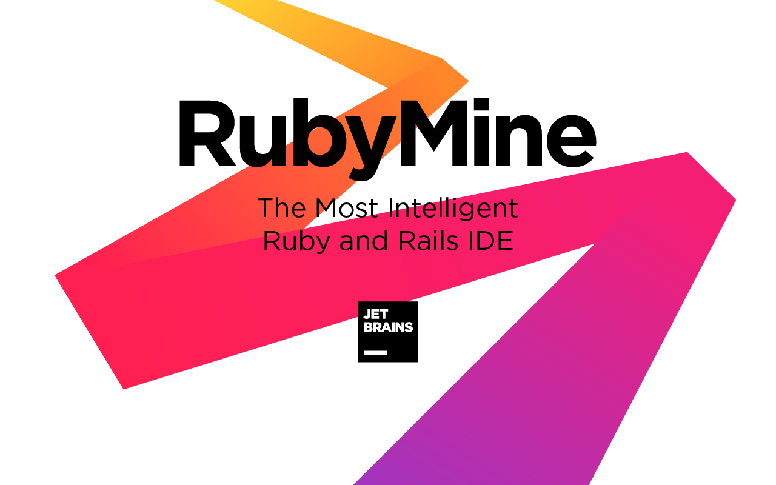

**Advantages:**

* Rich code editor with highlights,
* Fast code analysis,
* Debugger support,
* Test frameworks support.

**Price:**

* **For students, teachers, those who are learning Java, non-commerce organizations, courses, startups:** free,
* **For individuals:** $89 in the first year with a discount each subsequent year,
* **For professionals:** $199 in the first year with a discount each subsequent year.

9. [Xcode](https://developer.apple.com/xcode/)

Xcode is Apple's IDE used to develop software for macOS, iOS, iPadOS, watchOS, and tvOS. Released by Apple, Xcode is the best IDE to develop software for Apple products.



**Advantages:**

* Supports source code for C, C++, Objective-C, Objective-C++, Java, AppleScript, Python, Ruby, Rez, and Swift,
* Fat binary files,
* The GUI tool Instruments,
* Integrates built-in support for source code management.

**Price:**

* If you have an Apple ID: free,
* Apple Developer Program: $99 per year.

10. [Arduino IDE](https://www.arduino.cc/en/software)

This cross-platform application is written using functions from C and C++. The IDE is used for writing and uploading programs to Arduino-compatible boards. It’s not the only IDE for Arduino, but it’s the most trusted one. However, it doesn’t have any clear advantages and it doesn’t support any plugins.

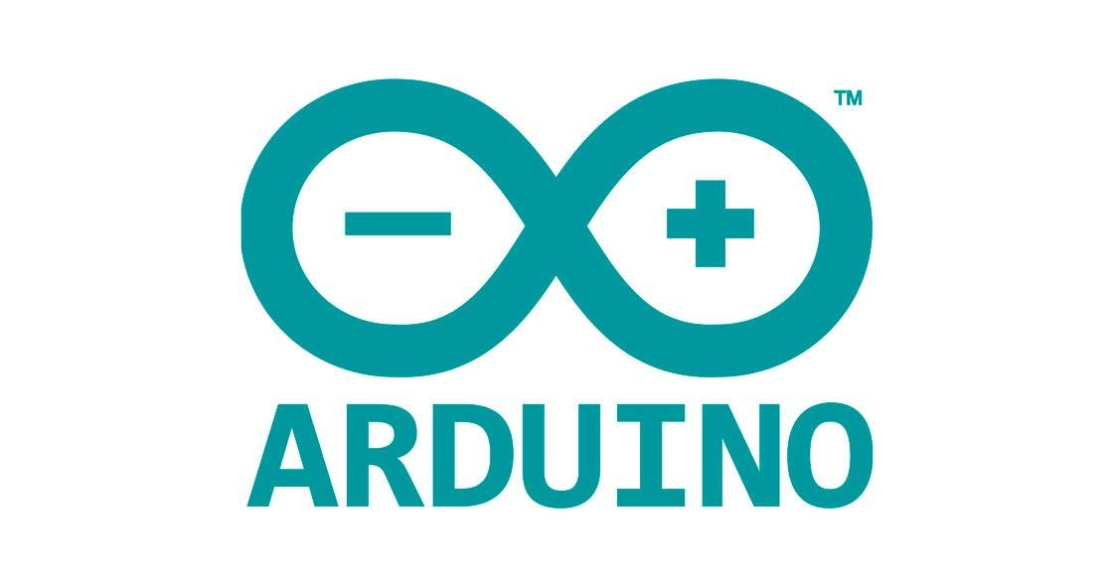

**Advantages:**

* Supports C/C++ languages using special rules of code structuring,
* Supplies a software library from the Wire project,
* Employs AVRDude program.

**Price:**

* Free to download and use.

Conclusion

The above list is our opinion. Currently we think IntelliJ IDEA and all of its products are those that truly rank first. That’s because today the trends in IDEs are good customization and cross-platform support.