# 股权平台用户统计

* **查询：注册机构名单：名称、代码、注册时间、注册状态、最近一次更新时间、联系人姓名、电话**

select name as '机构名称',certno as '证件号',create_time as '注册时间',case when audit_status='0' then '未补录'

when audit_status='1' then '补充完成待审核'

when audit_status='2' then '初审审核通过'

when audit_status='3' then '初审审核未通过'

when audit_status='22' then '激活通过'

when audit_status='23' then '激活未通过'

when audit_status='4' then '修改代审核'

when audit_status='5' then '修改审核通过'

when audit_status='6' then '修改审核未通过'

end

as '审核状态',rel_name '联系人姓名',rel_phone as '联系人电话' from rp_investor;

* **查询：注册机构名单：名称、代码、注册时间、注册状态、最近一次更新时间、联系人姓名、电话----金服同步企业**

select DISTINCT q.USERID as '用户id',name as '机构名称',code as '证件',q.BEGINTIME as '注册时间',case

when audit_status='00' then '未补录'

when audit_status='01' then '注册初审未审核'

when audit_status='02' then '注册初审通过'

when audit_status='03' then '注册初审不通过'

when audit_status='11' then '注册复审未审核'

when audit_status='12' then '注册复审通过'

when audit_status='13' then '注册复审不通过'

when audit_status='14' then '修改未审核'

when audit_status='15' then '修改通过'

when audit_status='16' then '修改不通过'

when audit_status='22' then '已激活'

when audit_status='23' then '激活不通过'

end

as '审核状态',stockName '股权事宜联系人姓名',stockCal as '股权事宜联系人电话' from rp_company_base ba

LEFT JOIN rp_querylog q on q.certno=ba.code and q.QUERYTYPE='4';

* **查询：注册机构名单：名称、代码、注册时间、注册状态、最近一次更新时间、联系人姓名、电话----股权平台注册企业**

SELECT

ba.name as '机构名称',ba.code as '证件',sys.create_time as '注册时间',case

when ba.audit_status='00' then '未补录'

when ba.audit_status='01' then '注册初审未审核'

when ba.audit_status='02' then '注册初审通过'

when ba.audit_status='03' then '注册初审不通过'

when ba.audit_status='11' then '注册复审未审核'

when ba.audit_status='12' then '注册复审通过'

when ba.audit_status='13' then '注册复审不通过'

when ba.audit_status='14' then '修改未审核'

when ba.audit_status='15' then '修改通过'

when ba.audit_status='16' then '修改不通过'

when ba.audit_status='22' then '已激活'

when ba.audit_status='23' then '激活不通过'

end

as '审核状态',ba.stockName '股权事宜联系人姓名',ba.stockCal as '股权事宜联系人电话'

FROM

rp_company_base ba,

system_user sys

WHERE

ba.platform_flag = '00'

AND sys.user_name = ba. CODE;

* **查询：单户查询机构补充信息情况**

select case when baseedit_flag ='0' then '基本信息未补充'

when baseedit_flag ='1' then '基本信息补充完成' end '基本信息补充情况',

case when performancedit_flag ='0' then '业绩信息未补充'

when performancedit_flag ='1' then '业绩信息补充完成' end '业绩信息补充情况',

case when audit_status ='0' then '映像信息未补充'

when audit_status ='1' then '映像信息补充完成' end '映像信息补充情况'

from rp_investor r where certno='证件号';

* **查询：统计**

select desssc as '统计',num1 as '数量' from (

select '平台企业总数' as desssc, COUNT(1) AS num1 from rp_company_base -- 平台企业总数

UNION ALL

select '股权注册企业数' as desssc, COUNT(1) AS num1 from rp_company_base where platform_flag='00' -- 股权注册企业数

UNION ALL

select '当月平台企业新增' as desssc, sb.count AS num1

from (

select count(1) count from rp_company_base ba,system_user sys where ba.platform_flag='00' and sys.user_name=ba.code and DATE_FORMAT( sys.create_time, '%Y%m' ) = DATE_FORMAT( CURDATE( ) , '%Y%m' )

) sb

UNION ALL

select '当月存量企业新增' as desssc,count(DISTINCT q.USERID) as num1 from rp_company_base ba

LEFT JOIN rp_querylog q on q.certno=ba.code and q.QUERYTYPE='4' where ba.platform_flag='01' and DATE_FORMAT( q.BEGINTIME, '%Y%m' ) = DATE_FORMAT( CURDATE( ) , '%Y%m' )

UNION ALL

select '平台机构总数' as desssc,COUNT(1) AS num1 from rp_investor -- 平台机构总数

UNION ALL

select '当月机构新增' as desssc,COUNT(1) AS num1 from rp_investor where DATE_FORMAT( create_time, '%Y%m' ) = DATE_FORMAT( CURDATE( ) , '%Y%m' )-- 当月机构新增

) countdate;

* **查询操作：**

1. **打开nacicat，点击查询按钮，新建查询如下图**

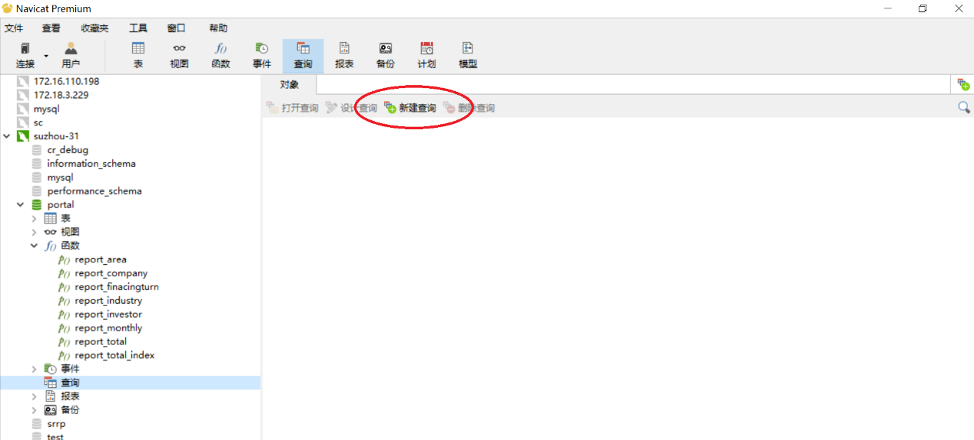

**2.复制下列语句到nacicat，如下图**

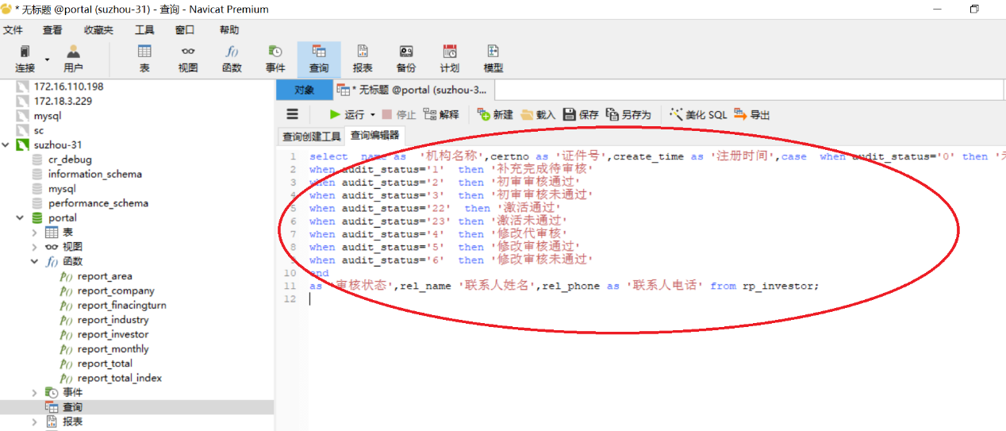

**3.选中sql语句，键盘Ctrl+Shift+R 执行sql语句查询结果，如下图**

