9/7/2026
Ruan Helgaard Hartman
ST10453370

Caleb Forbes
ST10438433

Alexandro Ornelas
ST10437348

Clifford Naude
ST10258513

(All Members Are In Group 1)
INSY7314
FORMATIVE 1 PART 1

Table of Content

Contents
Table of Content 1
Section 1 - Classroom50 Repo Link 2
Section 2 - Video Demonstration Link 2
Section 3 - API Responses Screenshots 3
Reject Unknown Route 3
Reject Protected Route Without JWT 3
Reject Protected Route With Invalid JWT 4
Reject Missing Registration Fields 4
Reject Missing Login Fields 5
Reject Malformed JSON 6
Reject Invalid Registration Values 6
Reject Invalid Login Credentials 7
Reject Duplicate Registration 7
Power Shell Test Passing Proof 8
Register Valid User 9
Postman Collection Tests Passed 10
Password Policy Validation Iterations Passed Proof 11
Password Policy Validation 11
Login Valid User And Save JWT 12
HTTPS Health Check 12
Bearer Token 13
Access Protected Route With JWT 14
Reference List 15

Section 1 - Classroom50 Repo Link

https://github.com/EMGPRS/insy7314-2026-insy7314-poe-classroom-st10437348.git

Section 2 - Video Demonstration Link

https://www.youtube.com/watch?v=_TZ8-mItvcw

Section 3 - API Responses Screenshots

Reject Unknown Route
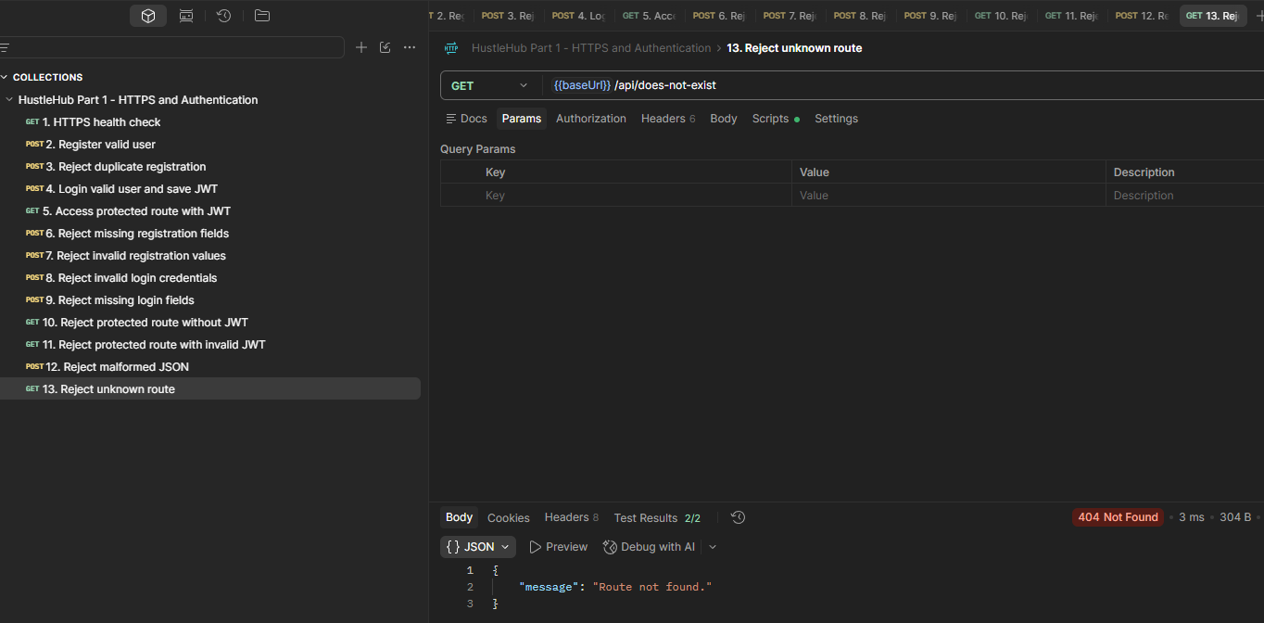
Figure 1: Reject Unknown Route

Reject Protected Route Without JWT
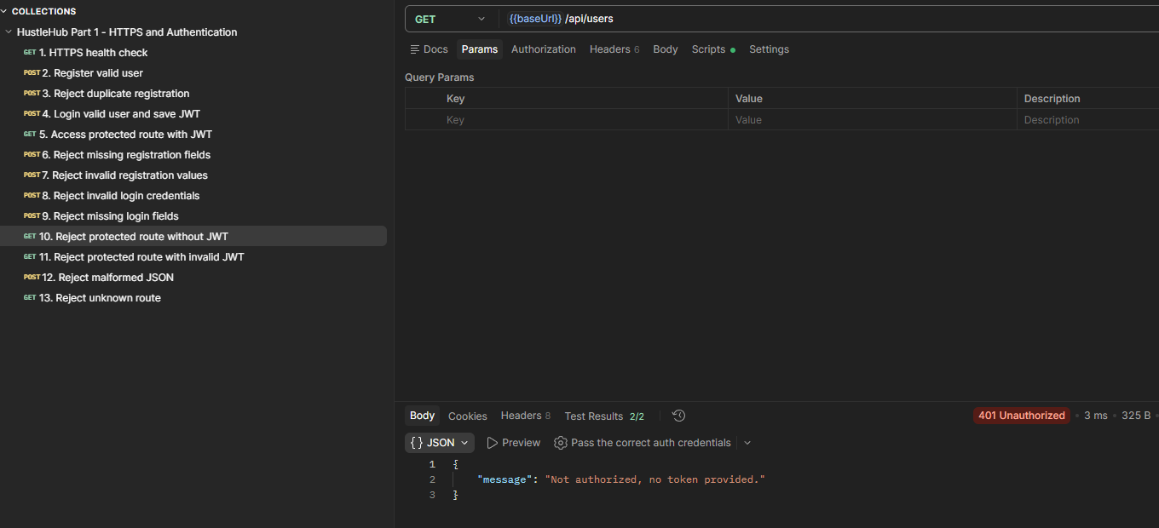
Figure 2 : Reject Protected Route Without JWT

Reject Protected Route With Invalid JWT
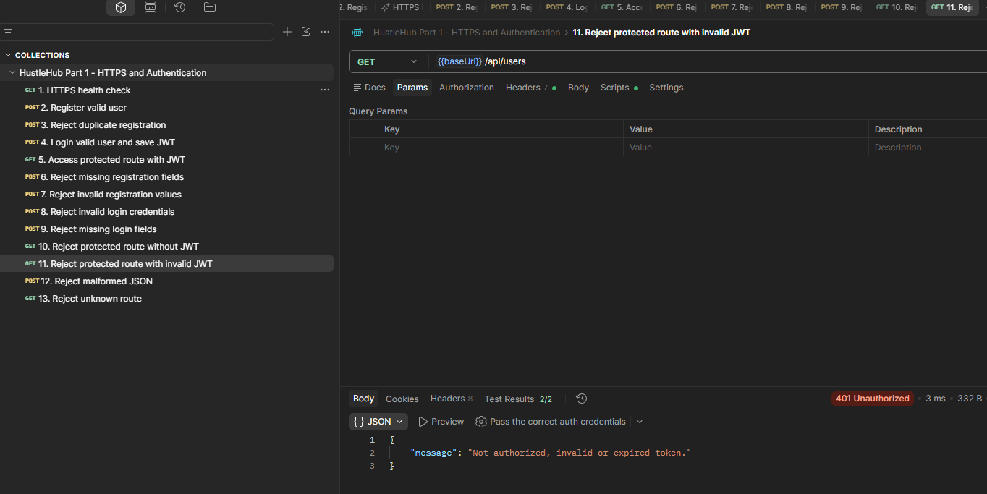
Figure 3 : Reject Protected Route With Invalid JWT

Reject Missing Registration Fields
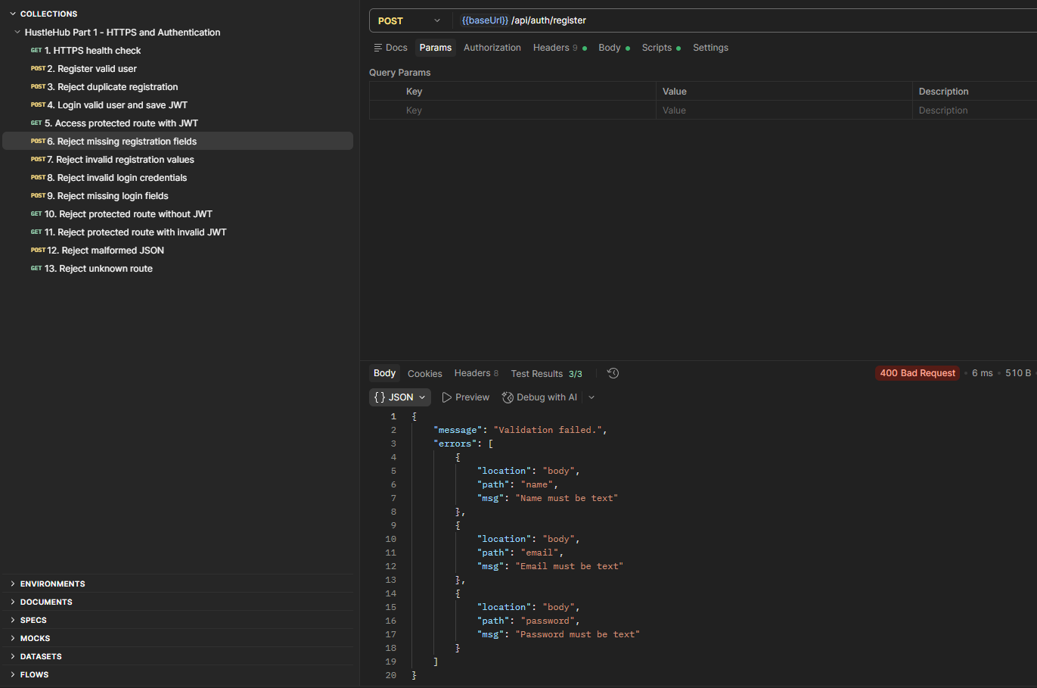
Figure 4 : Reject Missing Registration Fields

Reject Missing Login Fields
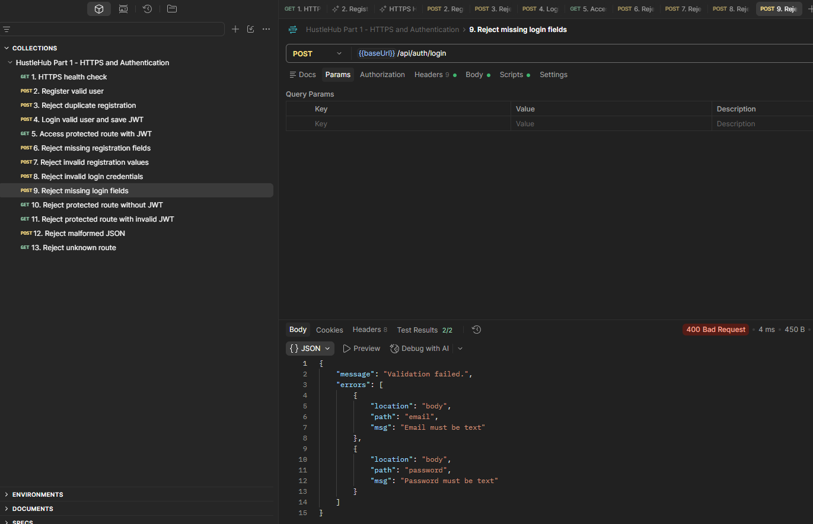
Figure 5 : Reject Missing Login Fields

Reject Malformed JSON
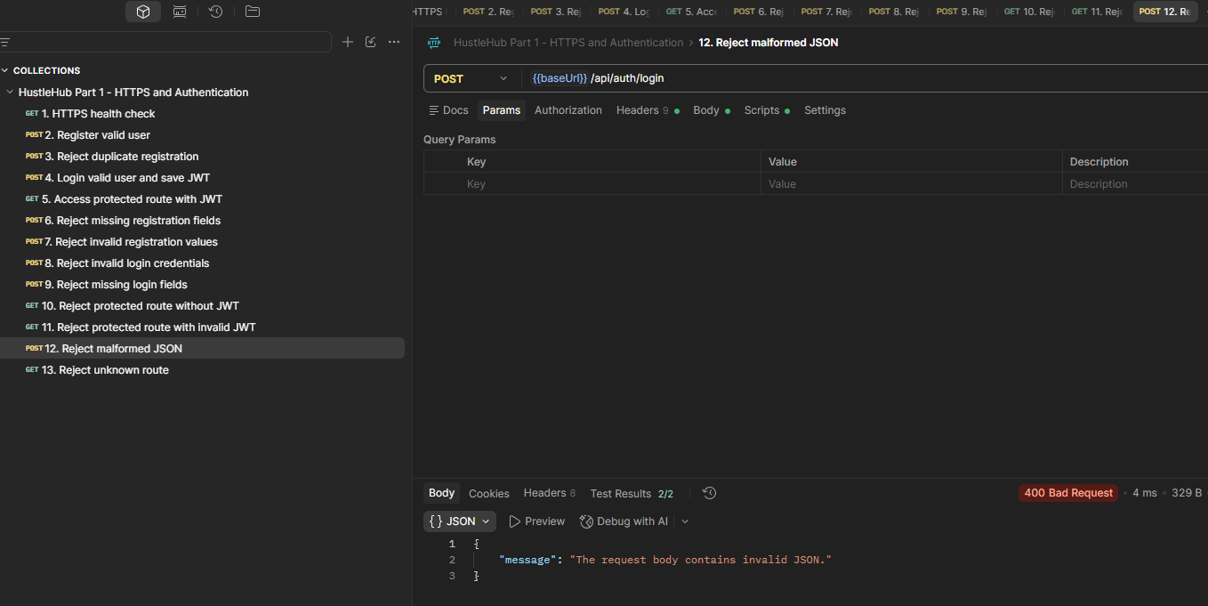
Figure 6 : Reject Malformed JSON

Reject Invalid Registration Values
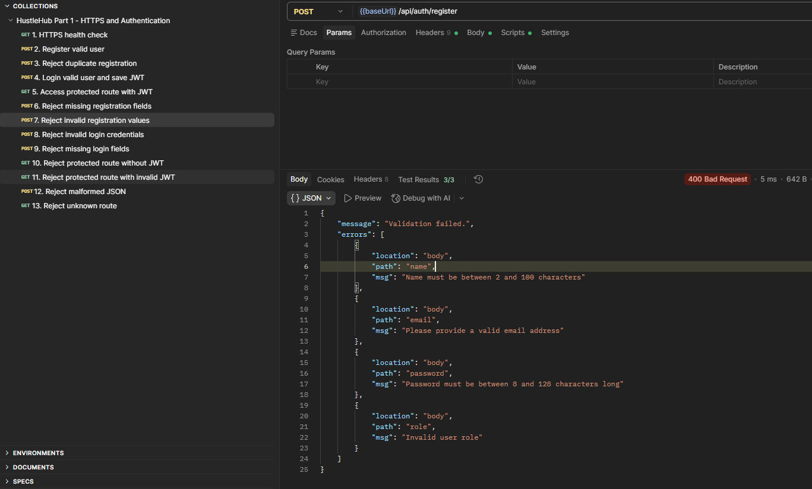
Figure 7 : Reject Invalid Registration Values

Reject Invalid Login Credentials
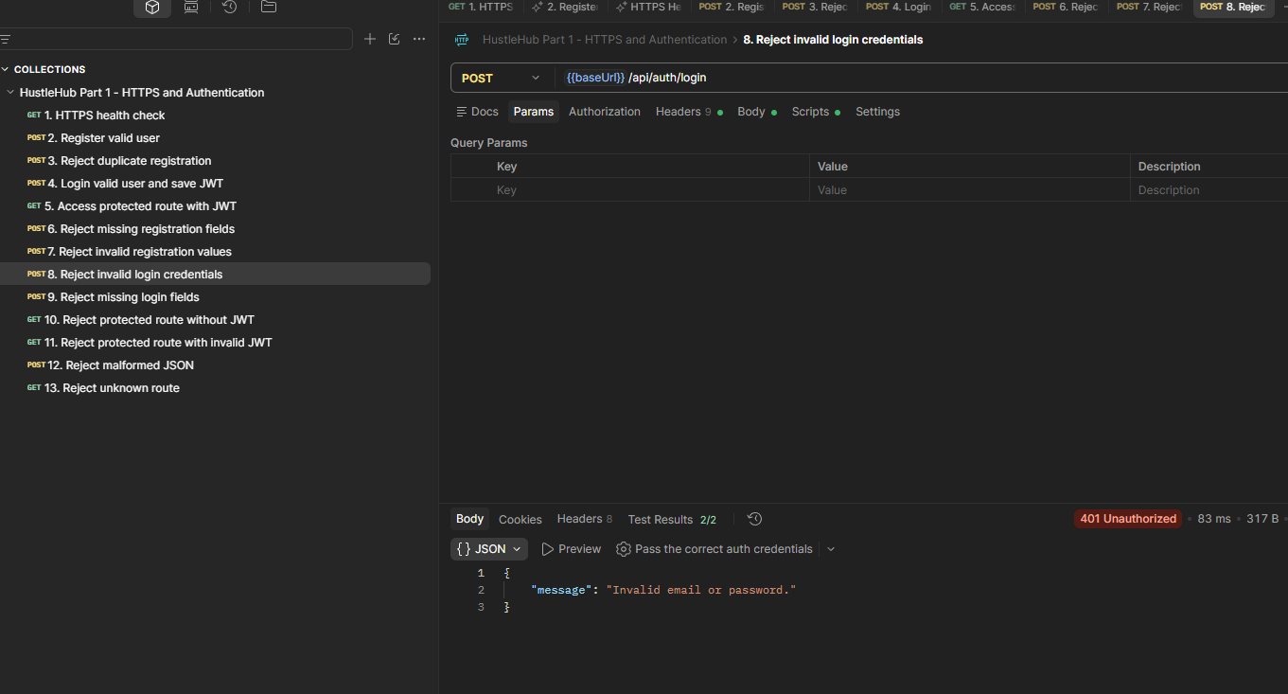
Figure 8 : Reject Invalid Login Credentials

Reject Duplicate Registration
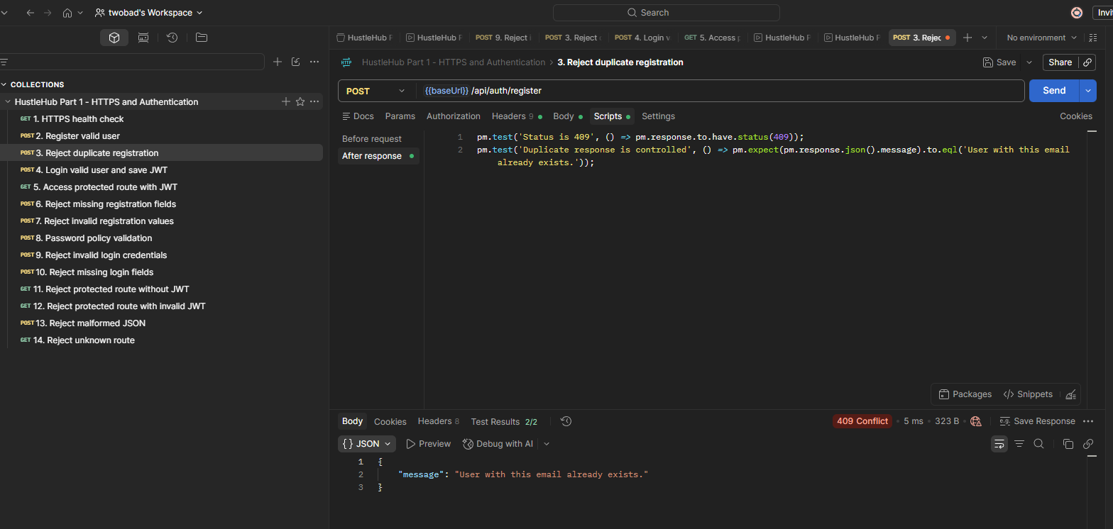
Figure 9 : Reject Duplicate Registration

Power Shell Test Passing Proof
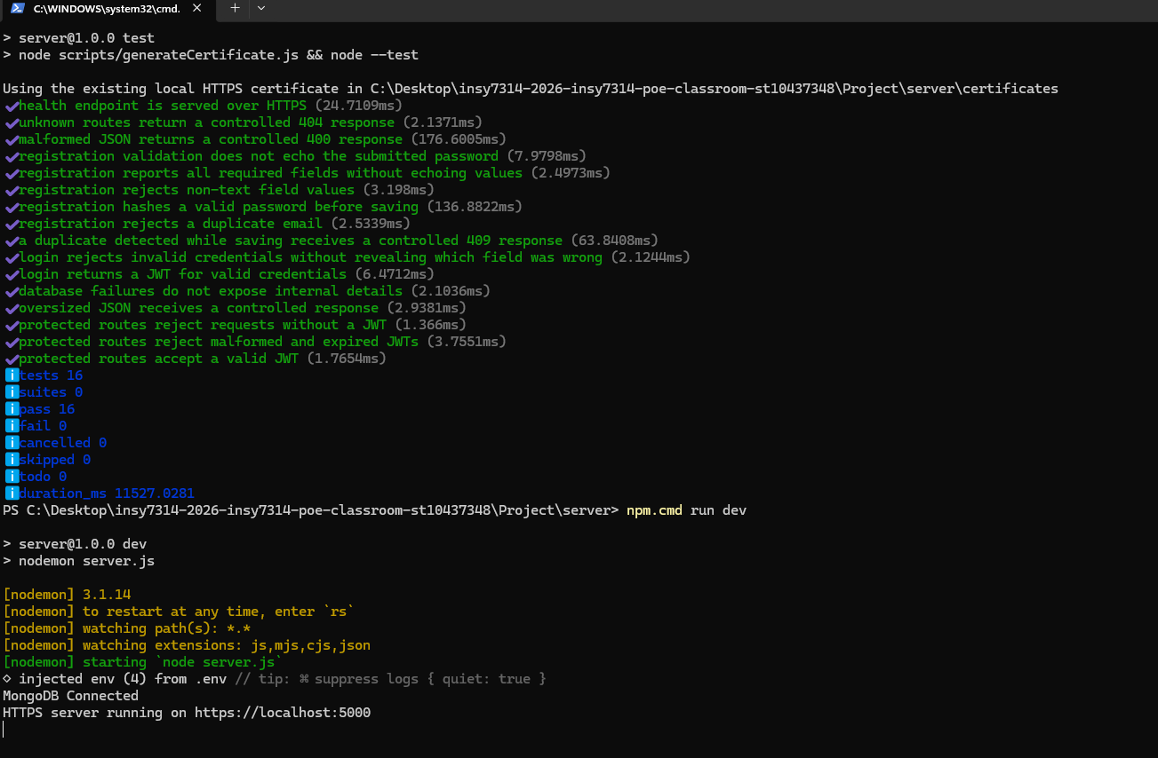
Figure 10 : Power Shell Test Passing Proof

Register Valid User
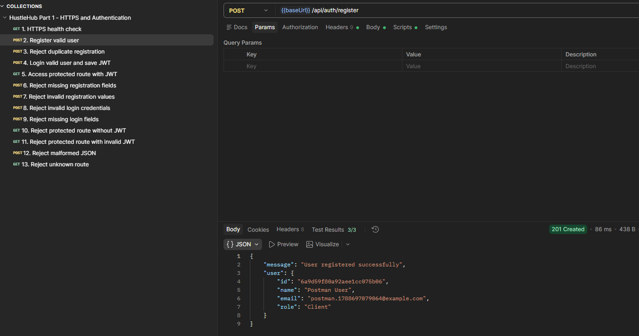
Figure 11: Register Valid User

Postman Collection Tests Passed
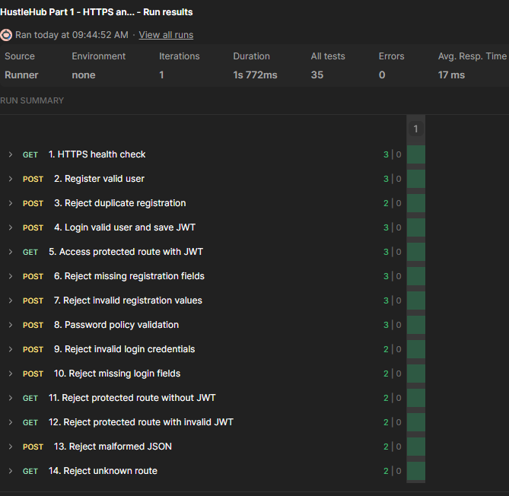
Figure 12 : Postman Collection Tests Passed

Password Policy Validation Iterations Passed Proof
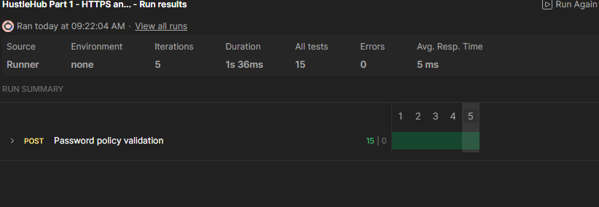
Figure 13 : Password Policy Validation Iterations Passed Proof

Password Policy Validation
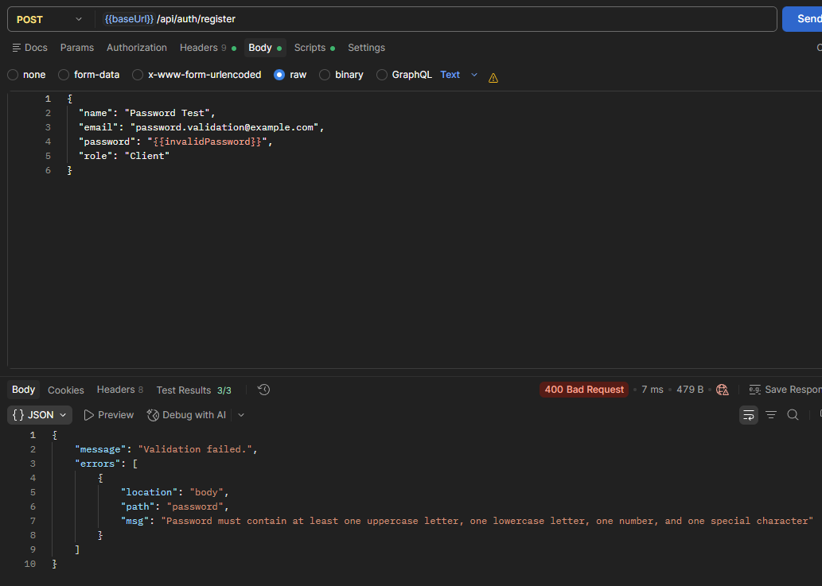
Figure 14 : Password Policy Validation

Login Valid User And Save JWT
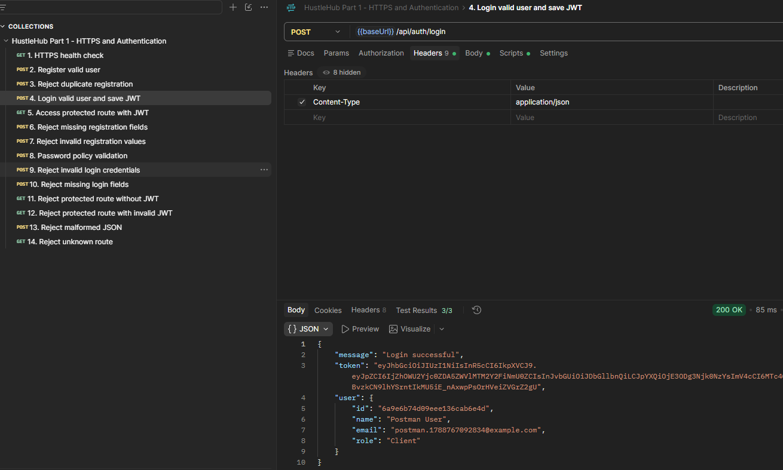
Figure 15 : Login Valid User and Save JWT

HTTPS Health Check
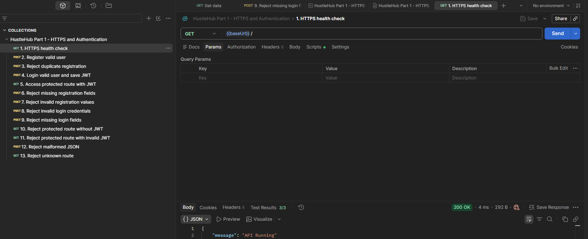
Figure 16 : HTTPS Health Check

Bearer Token
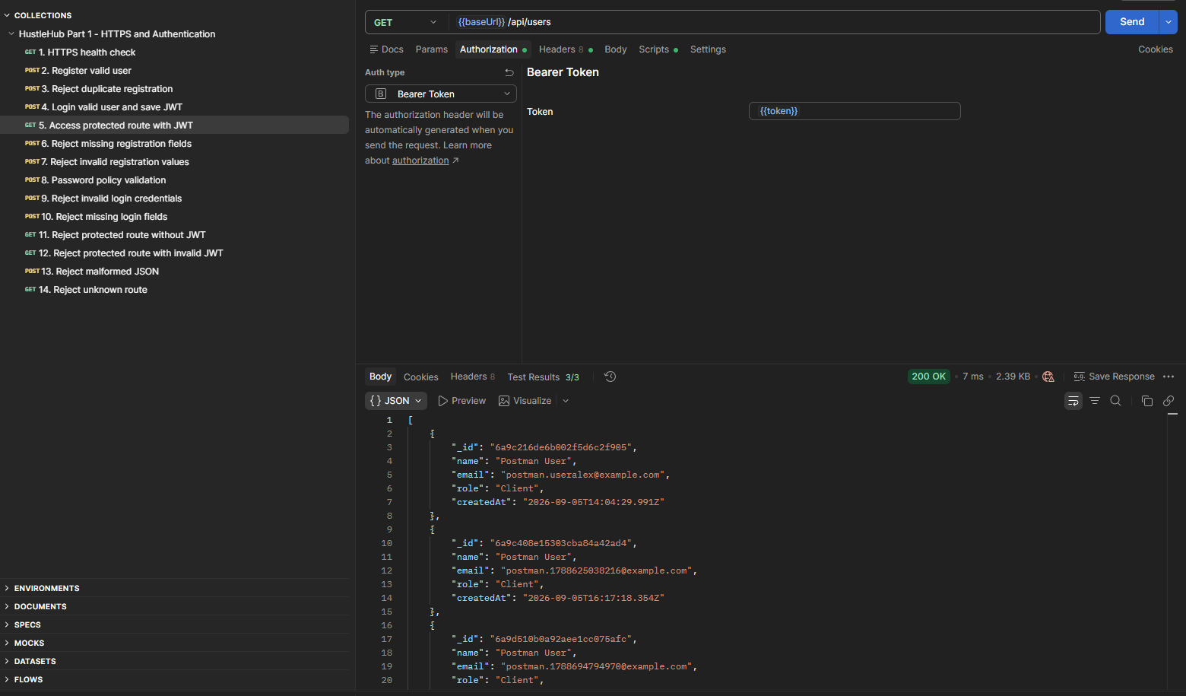
Figure 17 : Bearer Token

Access Protected Route With JWT
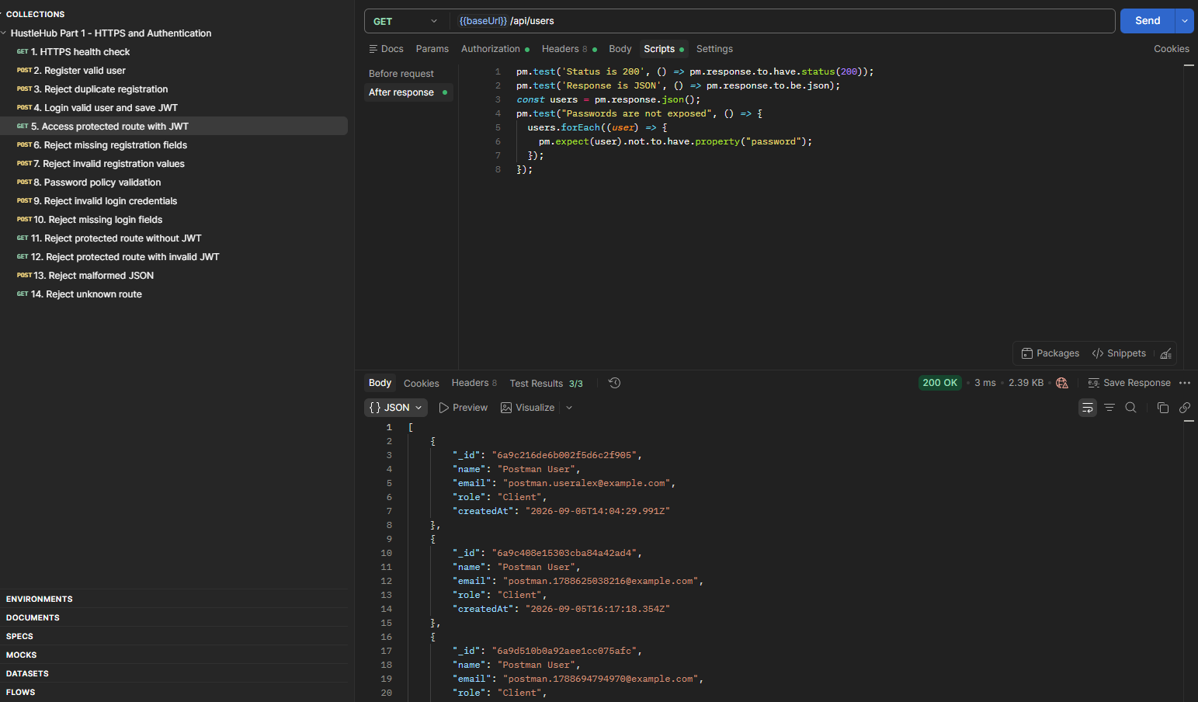
Figure 18 : Access protected Route with JWT

Reference List

Crudu, V., & Team, M. R. (2026, June 15). Enhancing Node.js Application Security with Environment Variables. Retrieved from MoldStud: https://moldstud.com/articles/p-enhancing-nodejs-application-security-with environment-variables Dennis Temoye Charity. (2024, April 3). How to Hash Passwords with bcrypt in Node.js. Retrieved from freeCodeCamp: https://www.freecodecamp.org/news/how-to hash-passwords-with-bcrypt-in-nodejs/ Dhananjaya, K. (2025, February 8). Implementing Security in a Node.js Express Server: An OWASP Guide. Retrieved from Medium: https://medium.com/@kumar62.shivu/implementing-security-in-a-node-js express-server-an-owasp-guide-8d4c62733164 express. (2026, January 1). Home Page. Retrieved from expressjs: https://expressjs.com/ geeksforgeeks. (2026, June 3). MERN Stack. Retrieved from geeksforgeeks: https://www.geeksforgeeks.org/mern/understand-mern-stack/ geeksforgeeks. (2026, June 29). React Introduction. Retrieved from geeksforgeeks: https://www.geeksforgeeks.org/reactjs/reactjs-introduction/ MongoDB. (2026, January 1). MongoDB Atlas: Multi-Cloud Database Service. Retrieved from MongoDB: https://www.mongodb.com/docs/ mozilla. (2026, January 1). Cross-Origin Resource Sharing (CORS). Retrieved from mozilla: https://developer.mozilla.org/en-US/docs/Web/HTTP/Guides/CORS Node.js. (2026, January 1). Introduction to Node.js. Retrieved from Node.js: https://nodejs.org/learn/getting-started/introduction-to-nodejs#introduction-to nodejs Patel, R. (2024, November 27). Top 5 Ways to Secure Your Express.js APIs. Retrieved from DEV: https://dev.to/rigalpatel001/top-5-ways-to-secure-your-expressjs apis-13i5 Tanner, M. (2025, August 25). Node.js SQL Injection Guide: Examples and Prevention. Retrieved from StackHawk: https://www.stackhawk.com/blog/node-js-sql injection-guide-examples-and-prevention/

