Basic Tutorials

LS-DYNA / LS-PrePost

Ex. 0. Introduction

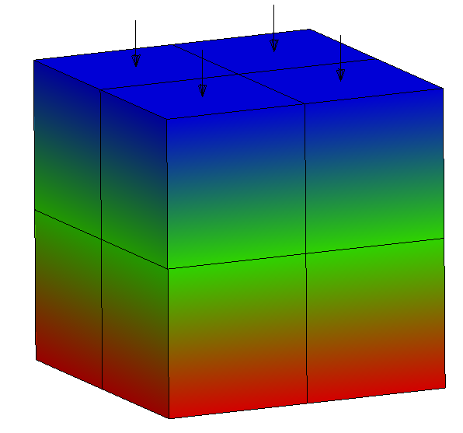

Optional – Centered image
Contents
1 Introduction 1
1.1 Subheading 1
1.2 Example 2
1.2.1 Another level 3
1.2.2 Newest level 3

Introduction
LS-DYNA from Livermore Software Technology Corporation (LSTC), is a highly advanced general purpose nonlinear finite element program that is capable of simulating complex real world problems. The distributed and shared memory solver provides very short turnaround times on desktop computers and clusters operated using Linux, Windows and UNIX.

LS-DYNA is suitable to investigate phenomena involving large deformations, sophisticated material models and complex contact conditions for structural dynamic problems. LS-DYNA allows switching between explicit and different implicit time stepping schemes. Disparate disciplines, such as coupled thermal analyses, Computational Fluid Dynamics (CFD), fluid-structure interaction, Smooth Particle Hydrodynamics (SPH), Element Free Galerkin (EFG), Corpuscular Method (CPM), Discrete Element Method (DEM) and the Boundary Element Method (BEM) can be combined with structural dynamics.
By determining product characteristics before a prototype is built, LS-DYNA is the key to reducing time to market for many products. Carrying out investigations with the aid of LS-DYNA supports the design of robust products with superior performance. For pre- and post-processing, LS-DYNA comes with the LS-PrePost tool. LS-PrePost can be utilized to generate inputs and visualize numerical results.

Subheading
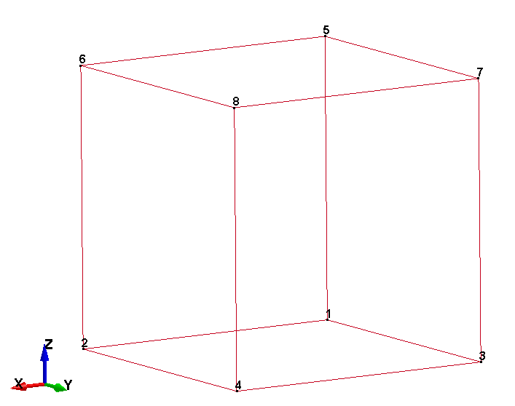
A finite element model in LS-DYNA consists of different keywords, which is defined for all ingoing definitions and parameters in a model (e.g. *PART, *NODE). The following description and the map on next page may help to understand the data structure in LS-DYNA.

Consider a cube consisting of one element with eight node points as shown in the figure. We have 1 part, the cube, and use the *PART keyword to begin the definition of the finite element model. The keyword *PART contains data that points to other attributes of this part, e.g. material properties. Keywords for these other attributes, in turn, point elsewhere to additional attribute definitions. The organization of the keyword input for the cube looks like this:

.

Example
LS-DYNA from Livermore Software Technology Corporation (LSTC), is a highly advanced general purpose nonlinear finite element program that is capable of simulating complex real world problems. The distributed and shared memory solver provides very short turnaround times on desktop computers and clusters operated using Linux, Windows and UNIX.

LS-DYNA is suitable to investigate phenomena involving large deformations, sophisticated material models and complex contact conditions for structural dynamic problems. LS-DYNA allows switching between explicit and different implicit time stepping schemes. Disparate disciplines, such as coupled thermal analyses, Computational Fluid Dynamics (CFD), fluid-structure interaction, Smooth Particle Hydrodynamics (SPH), Element Free Galerkin (EFG), Corpuscular Method (CPM), Discrete Element Method (DEM) and the Boundary Element Method (BEM) can be combined with structural dynamics.
By determining product characteristics before a prototype is built, LS-DYNA is the key to reducing time to market for many products. Carrying out investigations with the aid of LS-DYNA supports the design of robust products with superior performance. For pre- and post-processing, LS-DYNA comes with the LS-PrePost tool. LS-PrePost can be utilized to generate inputs and visualize numerical results.

Below is a lot of items:

- Item 1
- Item 2

And numbered items:

- Number 1
- Number 2, see also Figure 1.
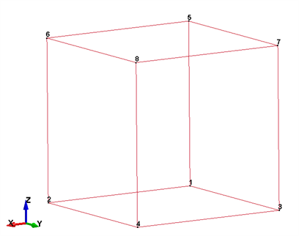
Figure 1 This is a single element.

Table 1 This is the small table
Item | 1 | 2
Whatever | 3 | 4

Another level
This is a new section

Newest level
Tjo

