**Language**: HTML

**what is it about?** keywords & key information

**Focus**: Vocabulary & Translation

**expected outcome**: understand how to use this tool (check with the quiz)!

HTML is the standard markup language for creating Web pages.

* HTML stands for Hyper Text Markup Language
* HTML is the standard markup language for creating Web pages
* HTML describes the structure of a Web page
* HTML consists of a series of elements
* HTML elements tell the browser how to display the content
* HTML elements label pieces of content such as "this is a heading", "this is a paragraph", "this is a link", etc.
* The <!DOCTYPE html> declaration defines that this document is an HTML5 document
* The <html> element is the root element of an HTML page
* The <head> element contains meta information about the HTML page
* The <title> element specifies a title for the HTML page (which is shown in the browser's title bar or in the page's tab)
* The <body> element defines the document's body, and is a container for all the visible contents, such as headings, paragraphs, images, hyperlinks, tables, lists, etc.
* The <h1> element defines a large heading
* The <p> element defines a paragraph

## What is an HTML Element?

* An HTML element is defined by a start tag, some content, and an end tag:
* <tagname> Content goes here... </tagname>
* The HTML **element** is everything from the start tag to the end tag:
* <h1>My First Heading</h1>
* <p>My first paragraph.</p>

**Note:** Some HTML elements have no content (like the <br> element). These elements are called empty elements. Empty elements do not have an end tag!

Web Browsers

The purpose of a web browser is to read HTML documents and display them correctly. A browser does not display the HTML tags, but uses them to determine how to display the document.

HTML Page Structure

Below is a visualization of an HTML page structure:

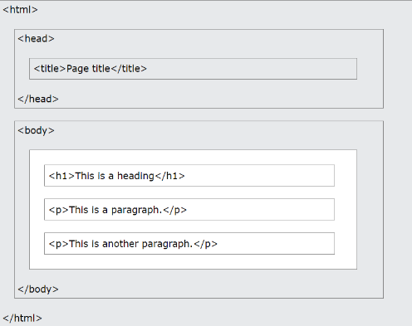

**Note:** The content inside the <body> section (the white area above) will be displayed in a browser. The content inside the <title> element will be shown in the browser's title bar or in the page's tab.

## Learn HTML Using Notepad or TextEdit

Web pages can be created and modified by using professional HTML editors.

However, for learning HTML we recommend a simple text editor like Notepad (PC) or TextEdit (Mac).

We believe in that using a simple text editor is a good way to learn HTML.

Follow the steps below to create your first web page with Notepad or TextEdit.

Step 1: Open Notepad (PC)

**Windows 8 or later:**

Open the **Start Screen** (the window symbol at the bottom left on your screen). Type **Notepad**.

**Windows 7 or earlier:**

Open **Start** >**Programs >** **Accessories >** **Notepad**

Step 1: Open TextEdit (Mac)

Open **Finder > Applications > TextEdit**

**Also** change some preferences to get the application to save files properly. In **Preferences > Format >**choose**"Plain Text"**

**Then** under "Open and Save", check the box that says "Display HTML files as HTML code instead of formatted text".

**Then open a new document to place the code.**

Step 2: Write Some HTML

Write or copy the following HTML code into Notepad:

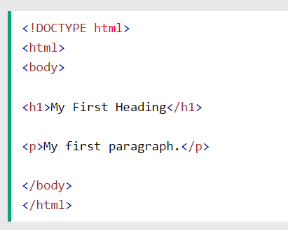 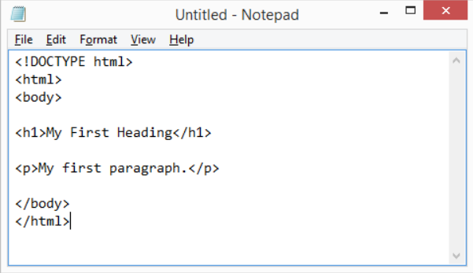

Step 3: Save the HTML Page

Save the file on your computer. Select **File > Save as** in the Notepad menu.

Name the file **"index.htm"** and set the encoding to **UTF-8** (which is the preferred encoding for HTML files).

**Tip:** You can use either .htm or .html as file extension. There is no difference, it is up to you.

Step 4: View the HTML Page in Your Browser

Open the saved HTML file in your favorite browser (double click on the file, or right-click - and choose "Open with").

**All HTML documents** must start with a document type declaration: <!DOCTYPE html>.

The HTML document itself begins with <html> and ends with </html>.

The visible part of the HTML document is between <body> and </body>.

The <!DOCTYPE> Declaration

The <!DOCTYPE> declaration represents the document type, and helps browsers to display web pages correctly.

It must only appear once, at the top of the page (before **any** HTML tags).

The <!DOCTYPE> declaration is not case sensitive.

The <!DOCTYPE> declaration for HTML5 is: <!DOCTYPE html>

**HTML headings** are defined with the <h1> to <h6> tags.

<h1> defines the most important heading. <h6> defines the least important heading.

**HTML paragraphs** are defined with the <p> tag:

**HTML links** are defined with the <a> tag.

The link's destination is specified in the href attribute.

Attributes are used to provide additional information about HTML elements.

**HTML images** are defined with the <img> tag.

The source file (src), alternative text (alt), width, and height are provided as attributes.

View HTML Source Code:

Right-click in an HTML page and select "View Page Source" (in Chrome) or "View Source" (in Edge), or similar in other browsers. This will open a window containing the HTML source code of the page.

Inspect an HTML Element:

Right-click on an element (or a blank area), and choose "Inspect" or "Inspect Element" to see what elements are made up of (you will see both the HTML and the CSS). You can also edit the HTML or CSS on-the-fly in the Elements or Styles panel that opens.

HTML Elements

The HTML **element** is everything from the start tag to the end tag:

<tagname>Content goes here...</tagname>

Examples of some HTML elements:

<h1>My First Heading</h1>

<p>My first paragraph.</p>

HTML elements can be nested (this means that elements can contain other elements).

All HTML documents consist of nested HTML elements.

Never Skip the End Tag

Some HTML elements will display correctly, even if you forget the end tag. **However, never rely on this! Unexpected results and errors may occur if you forget the end tag!**

**HTML elements** with no content are called empty elements.

The <br> tag defines a line break, and is an empty element without a closing tag.

**HTML tags are not case sensitive:** <P> means the same as <p>.

The HTML standard does not require lowercase tags, but W3C **recommends** lowercase in HTML, and **demands** lowercase for stricter document types like XHTML.

HTML Attributes

* All HTML elements can have **attributes**
* Attributes provide **additional information** about elements
* Attributes are always specified in **the start tag**
* Attributes usually come in name/value pairs like: **name="value"**

## The href Attribute

The <a> tag defines a hyperlink. The href attribute specifies the URL of the page the link goes to:

There are two ways to specify the URL in the src attribute:

**1. Absolute URL** - Links to an external image that is hosted on another website. Example: src="https://www.w3schools.com/images/img_girl.jpg".

**Notes:** External images might be under copyright. If you do not get permission to use it, you may be in violation of copyright laws. In addition, you cannot control external images; it can suddenly be removed or changed.

**2. Relative URL** - Links to an image that is hosted within the website. Here, the URL does not include the domain name. If the URL begins without a slash, it will be relative to the current page.

The width and height Attributes

The <img> tag should also contain the width and height attributes, which specifies the width and height of the image (in pixels).

**The required alt attribute** for the <img> tag specifies an alternate text for an image, if the image for some reason cannot be displayed. This can be due to slow connection, or an error in the src attribute, or if the user uses a screen reader.

You should always include **the lang attribute** inside the <html> tag, to declare the language of the Web page. This is meant to assist search engines and browsers.

Country codes can also be added to the language code in the lang attribute. So, the first two characters define the language of the HTML page, and the last two characters define the country.

**The title attribute** defines some extra information about an element.

The value of the title attribute will be displayed as a tooltip when you mouse over the element.

Single or Double Quotes?

Double quotes around attribute values are the most common in HTML, but single quotes can also be used.

HTML Headings

HTML headings are titles or subtitles that you want to display on a webpage.

HTML headings are defined with the <h1> to <h6> tags.

<h1> defines the most important heading. <h6> defines the least important heading.

**Note:** Browsers automatically add some white space (a margin) before and after a heading.

Headings Are Important

Search engines use the headings to index the structure and content of your web pages.

Users often skim a page by its headings. It is important to use headings to show the document structure. <h1> headings should be used for main headings, followed by <h2> headings, then the less important <h3>, and so on.

Each **HTML heading** has a default size. However, you can specify the size for any heading with the style attribute, using the CSS font-size property.

HTML Display

You cannot be sure how HTML will be displayed.

Large or small screens, and resized windows will create different results.

With HTML, you cannot change the display by adding extra spaces or extra lines in your HTML code.

The browser will automatically remove any extra spaces and lines when the page is displayed:

HTML Styles

The HTML style attribute is used to add styles to an element, such as color, font, size, and more.

Background Color

The CSS background-color, CSS color, CSS font-family, CSS font-size, CSS text-align property defines the background color, the text color, the font to be used, the text size, & the horizontal text alignment for an HTML element.

HTML Comments

You can add comments to your HTML source by using the following syntax: <!-- Write your comments here -->

Notice that there is an exclamation mark (!) in the start tag, but not in the end tag.

**Note:** Comments are not displayed by the browser, but they can help document your HTML source code.

Comments can be used to hide content. With comments you can place notifications and reminders in your HTML code:

Comments are also great for debugging HTML, because you can comment out HTML lines of code, one at a time, to search for errors.

Comments can be used to hide parts in the middle of the HTML code.

HTML Colors

In HTML, a color can be specified by using a color name:

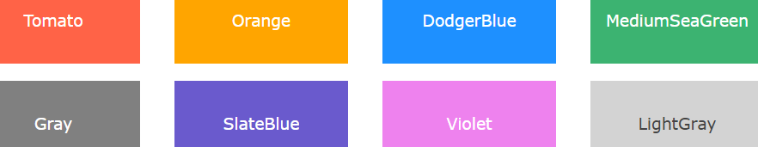

HTML supports [140 standard color names](https://www.w3schools.com/colors/colors_names.asp).

You can set the background color, the color of text, the color of border for HTML elements.

In HTML, colors can also be specified using RGB values, HEX values, HSL values, RGBA values, and HSLA values.

The following three <div> elements have their background color set with RGB, HEX, and HSL values.

An RGB color value represents RED, GREEN, and BLUE light sources.

An RGBA color value is an extension of RGB with an Alpha channel (opacity).

In HTML, a color can be specified as an RGB value, using this formula: **rgb(*red,* *green*, *blue*)**

Each parameter (red, green, and blue) defines the intensity of the color with a value between 0 and 255.

This means that there are 256 x 256 x 256 = 16777216 possible colors!

For example, rgb(255, 0, 0) is displayed as red, because red is set to its highest value (255), and the other two (green and blue) are set to 0.

Another example, rgb(0, 255, 0) is displayed as green, because green is set to its highest value (255), and the other two (red and blue) are set to 0.

To display black, set all color parameters to 0, like this: rgb(0, 0, 0).

To display white, set all color parameters to 255, like this: rgb(255, 255, 255

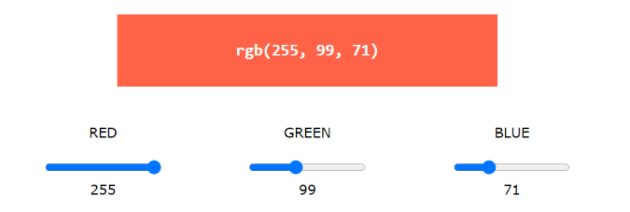).

***Source****: https://www.w3schools.com/html/html_comments.asp*

**Vocabulary search**

|  |  |  |  |
| --- | --- | --- | --- |
| **Nouns** |  | **Verbs** |  |
| L’ arrière-plan | Background | Afficher | display |
| Une balise | tag | Ajouter | To add |
| Le but | The purpose | Cacher | To hide |
| Des éléments vides | Empty elements | Définir / régler | To define/to set |
| Un en-tête | header | Dépanner | To debug |
| Une étape | Step/ stage | Etre sensible aux minuscules et majuscules | To be Case sensitive |
| Un fichier | file | Héberger | To host |
| Le contenu | content | Fournir | To provide |
| Des guillemets | Quotation marks | Modifier | To edit |
| La hauteur | The height | Nécessiter | To require |
| Une infobulle | tooltip | Parcourir | to skim |
| La largeur | The width | Pointer (souris) | To mouse hover |
| Un lien | link | Rappeler | To remind |
| Un moyen | A way | Retirer | To remove |
| Un moteur de recherche | Searsh engine | Sauvegarder | To save/ to back up |
| Le navigateur | browser | Visualiser | To view |
| Un onglet | the tab |  |  |
| La police | The font |  |  |
| Un rappel | A reminder |  |  |
| Une taille par défaut | Default size |  |  |
| Un utilisateur | user |  |  |
| Une zone vide | Blank area |  |  |

|  |  |
| --- | --- |
| **Miscellaneous** |  |
| Aussi | also |
| Cependant | However |
| ci-dessus | Above (contraire Belong |
| Correctement | correctly |
| Une fois | once |
| En haut de la page | At the top of the page |
| Les deux | The both |
| Majuscule | Upper case / capital |
| Minuscule | Lowercase /small lettre |
| Soit … ou ….. | Either …or |
| Tel que | Such as |



Now this is your go! Test your knowledge with the quiz!