TUGAS 2

Nama : Naufal Khalifanny Andriyanto

NIM : 20230140067

Kelas : B

Hasil run

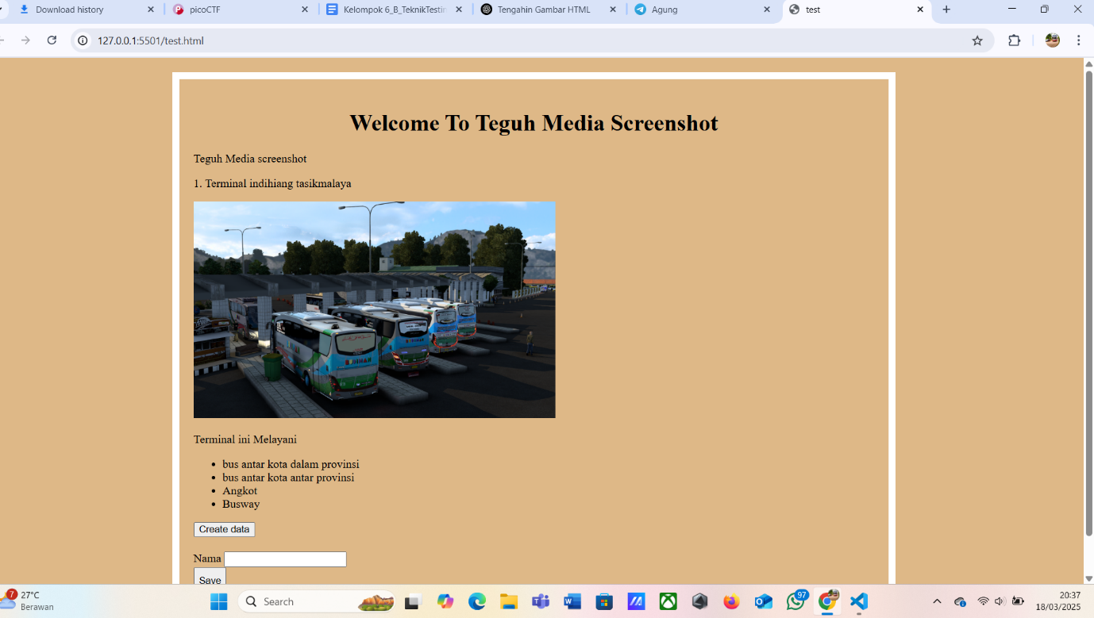

Code HTML

<!DOCTYPE html>

<html lang="en">

<head>

    <meta charset="UTF-8">

    <meta name="viewport" content="width=device-width, initial-scale=1.0">

    <title>test</title>

    <style>

        body {

            background-color: burlywood;

        }

        h1 {

            color: rgb(0, 0, 0);

            text-align: center;

        }

    </style>

    <link rel="stylesheet" href="style.css">

</head>

<body>

<div class="border">

    <h1>Welcome To Teguh Media Screenshot</h1>

    <p>Teguh Media screenshot</p>

    <p>1. Terminal indihiang tasikmalaya</p>

    <img class="center" src="img/budimangank.png" alt="Budiman Gank" width="500" height="300">

    <br>

    <p>Terminal ini Melayani</p>

    <ul>

        <li style= "color: black;">bus antar kota dalam provinsi</li>

        <li style= "color: black;"> bus antar kota antar provinsi</li>

        <li>Angkot</li>

        <li>Busway</li>

    </ul>

    <button>Create data</button>

    <form style="padding-top: 20px;" action="/">

        <div>

        <label for="name">Nama</label>

        <input type="text" name="name" id="name">

        </div>

        <button style="padding-top: 10px;">Save</button>

    </form>

</body>

</html>

Code style.css

body {

    background-color: burlywood;

}

.border {

    border: 10px solid white;

    width: 1000px;

    height: auto;

    margin: 20px auto;

    padding: 20px;

    box-sizing: border-box;

}