pythonDB_067

Nama : Naufal Khalifanny Andriyanto

NIM : 20230140067

Kelas : B

* Screenshot semua code python beserta dengan penjelasan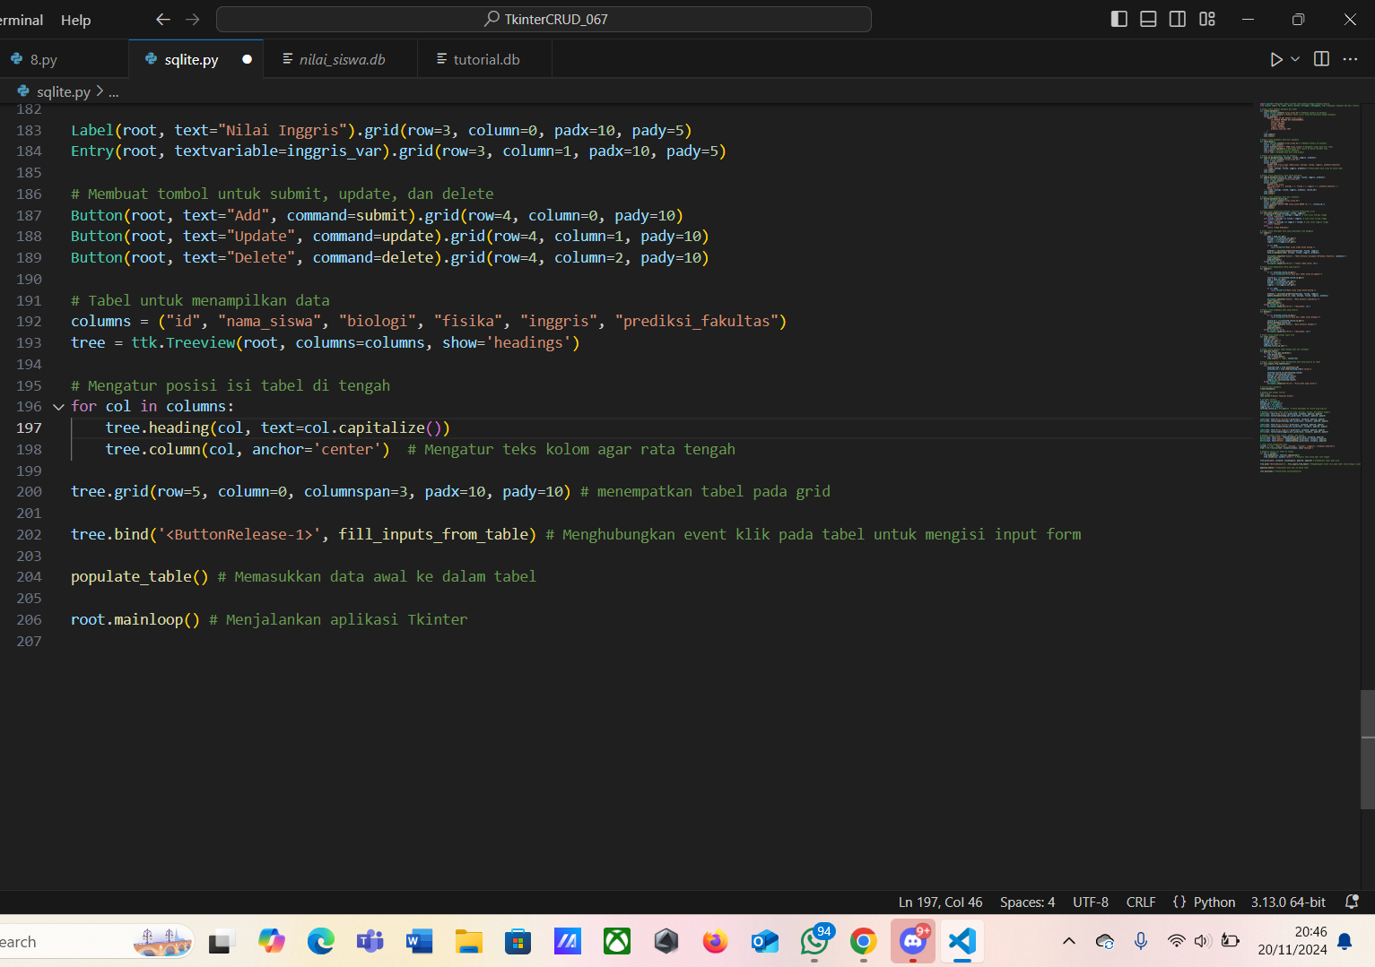

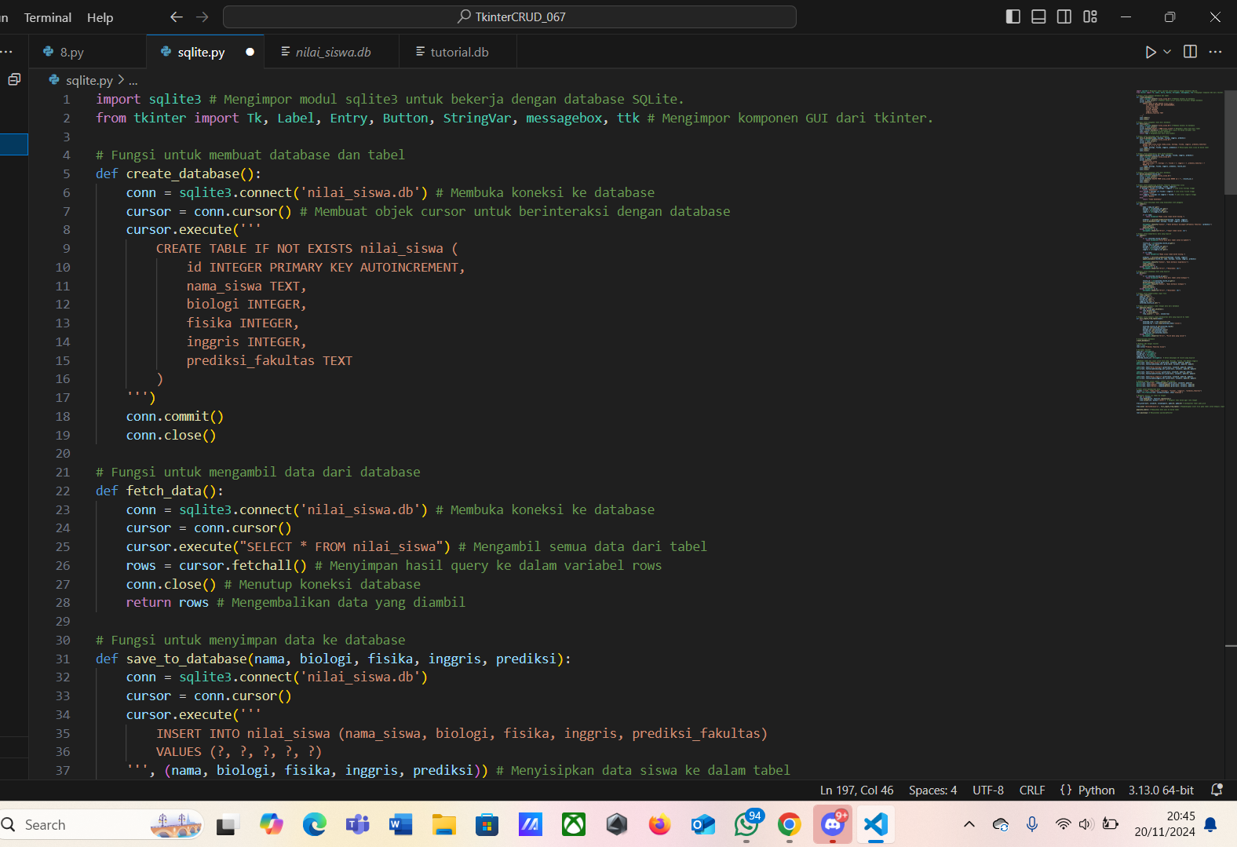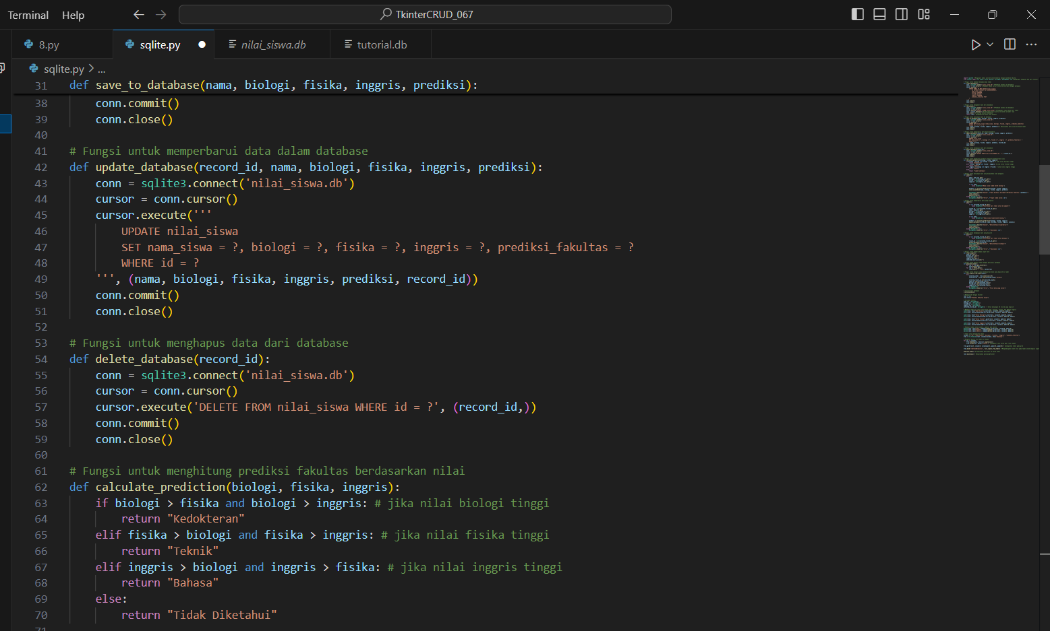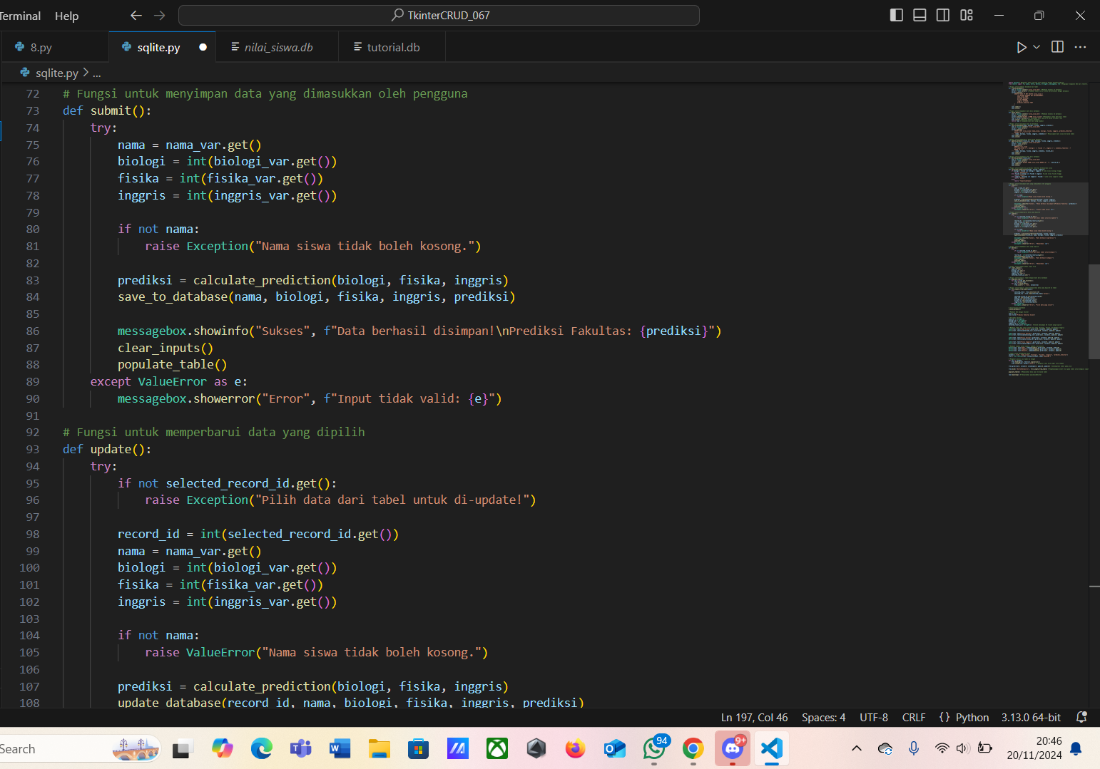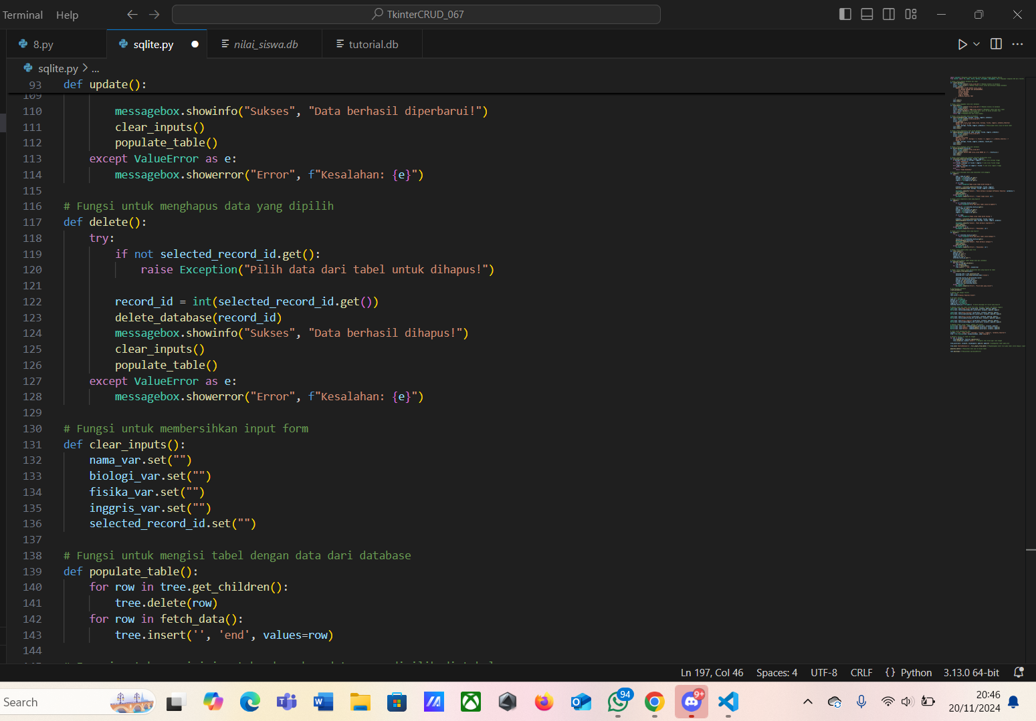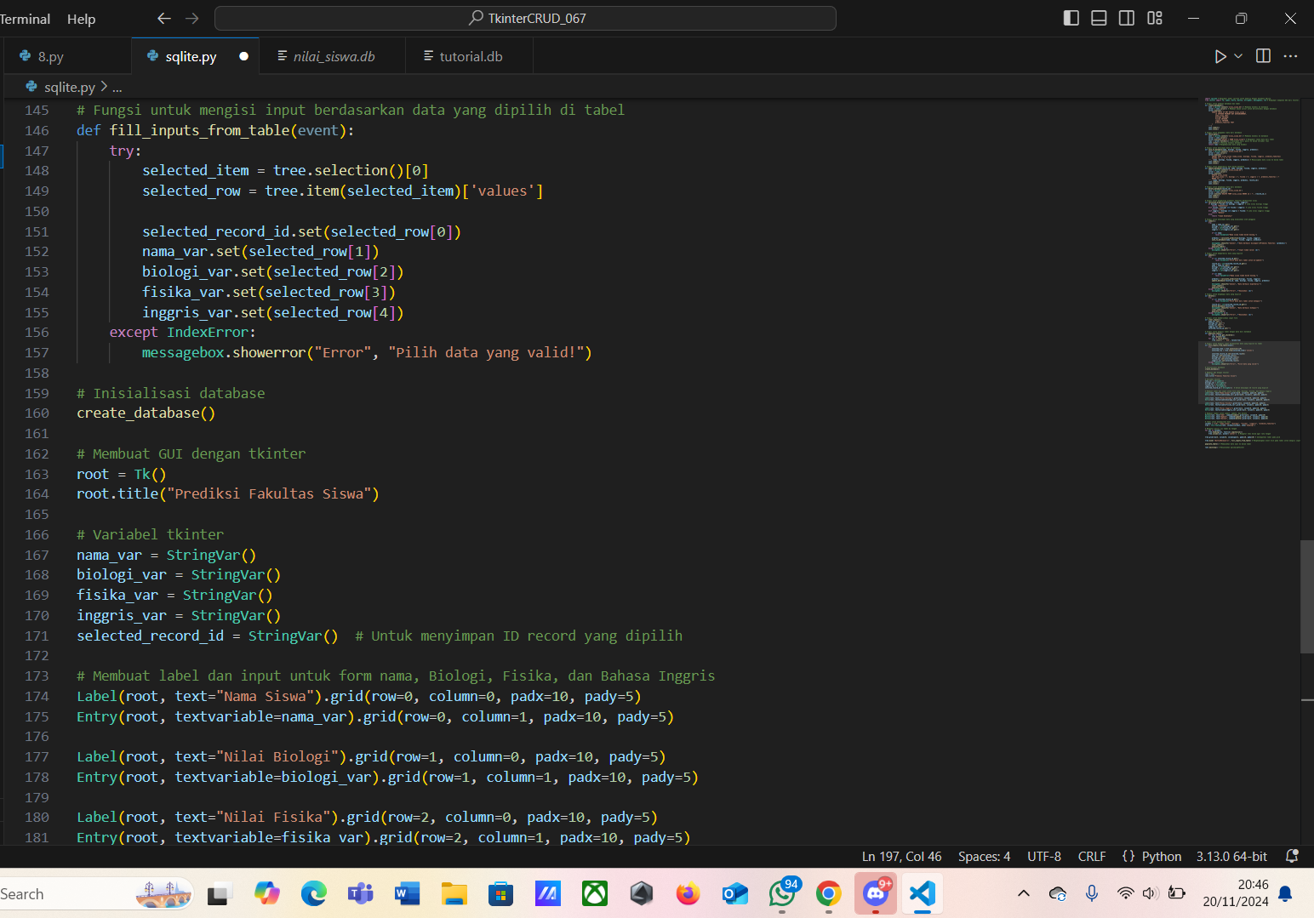

* Screenshot hasil tkinter

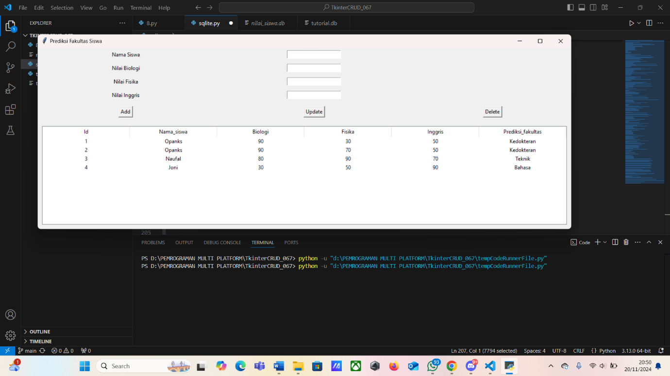

* Screenshot database sqlite data structure dan execute sql (select * from table)

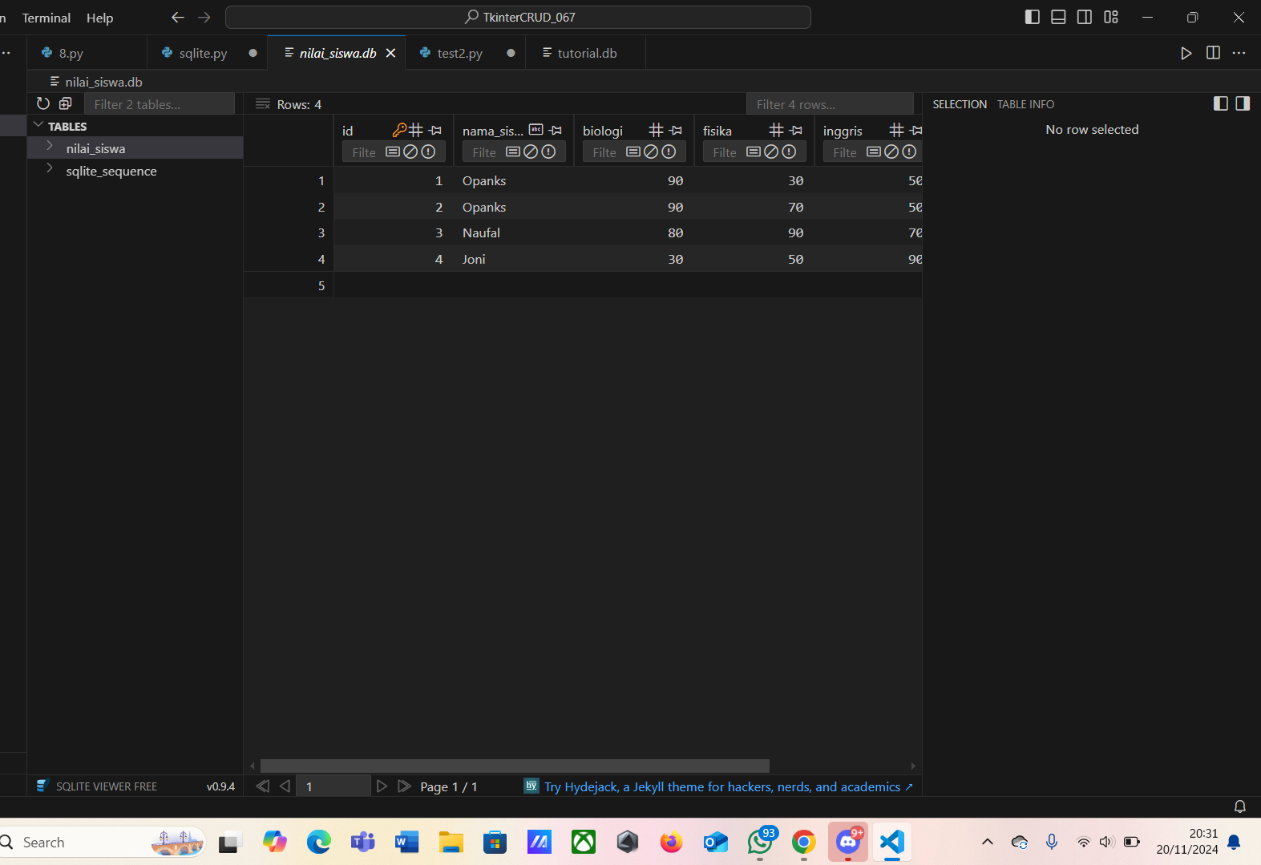

* Link github :

https://github.com/Naufal0067/TkinterCRUD_067.git