Kelompok:

1. Naufal

2. Galang

3. Rizki

---------------------------------------------------------------------------------------------------------

**Pseudocode:**

**Program** Soal Matematika A

**Kamus**

x, y, hasil: real

**Algoritma**

input (x, y)

hasil <- 1/3x^2+10+10y+7

output(hasil)

**Endprogram**

**GOLANG:**

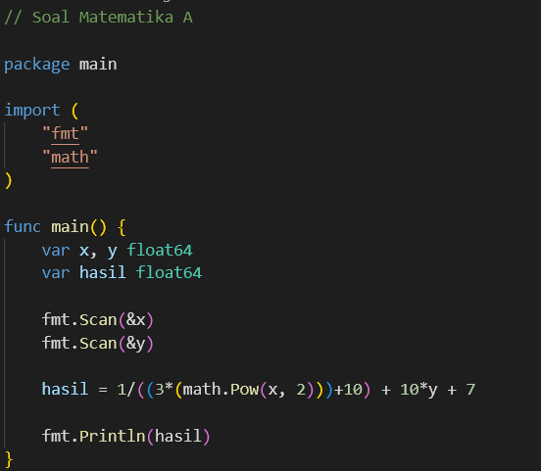

--------------------------------------------------------------------------------------------------------------------------------------

**Pseudocode:**

**Program** Soal Matematika B

**Kamus**

X,hasil: integer

**Algoritma**

input(x)

hasil <- x^3+3x/x^4-3x^2+4

output(hasil)

**Endprogram**

**GOLANG:**

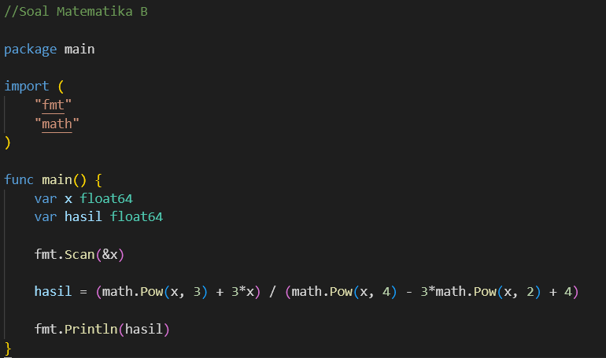

--------------------------------------------------------------------------------------------------------------------------------------**Pseudocode:**

**Program** Soal Tiga Digit

**Kamus**

d1, d2, d3, x: integer

**Algoritma**

input(x)

d1 <- x div 100 mod 10

d2 <- x div 10 mod 10

d3 <- x div 1 mod 10

output(d1, d2, d3)

**Endprogram**

**GOLANG:**

