**Quiz 3: Thermodynamic property calculation for oxygen [Due for submission at 5 pm September 30, 2022]**

Name: Naufran Neyas

Role number: 210020083

The Peng-Robinson equation of state is

|  |  |
| --- | --- |
|  | where |
|  |  |

For oxygen

|  |  |  |
| --- | --- | --- |
|  |  |  |

This EOS can be written in a cubic polynomial form as

where

|  |  |  |
| --- | --- | --- |
|  |  |  |
|  |  |  |

MAIN PROGRAM

%options

%1)the vapor pressure 𝑃 (𝑇) at temperatures 𝑇 = −125, −150 and −175 °C

%2)Plot the isotherm 𝑃 − 𝑉 curve at temperatures 𝑇 = −125, −150 and −175 °C

%3)Make a plot for 𝑃𝑣𝑎𝑝 versus 𝑇 for the vapor-liquid coexistence for given

%temperatures

%4)Fit a polynomial curve to 𝑃𝑣𝑎𝑝 versus T,also for Δ𝑉(𝑇)

%5)Plot Δ𝐻 and Δ𝑆 as a function of temperature

%6)Enthalpy calculations

%7)Entropy calculations

option = input("Enter the option no.:- ");

if option == 1

temp = [148.15 123.15 98.15];

p_vap = zeros(3,1);

for i = 1:3

p_vap(i) = P_vap(temp(i));

end

for i = 1 : 3

fprintf('The vapor pressure at %.2f K is %.4f bar \n',temp(i),p_vap(i))

end

end

if option == 2

temp = [148.15 123.15 98.15];

p_vap = zeros(3,1);

c = ['r' 'b' 'g'];

for i = 1:3

p_vap(i) = P_vap(temp(i));

end

PVplot(p_vap(1),temp(1),c(1));

hold on

PVplot(p_vap(2),temp(2),c(2));

hold on

PVplot(p_vap(3),temp(3),c(3));

hold off

end

if option == 3

temp = [148.15 143.15 133.15 123.15 113.15 103.15 98.15 93.15 90.15];

p_vap = zeros(9,1);

for i = 1:9

p_vap(i) = P_vap(temp(i));

end

plot(temp,p_vap,'linewidth',2.5)

hold on

plot(temp,p_vap,'.r',MarkerSize=15)

hold off

title("P_v_a_p vs T","FontSize",20)

xlabel("Temperature(K)","FontSize",20)

ylabel("P_v_a_p(bar)","FontSize",20)

end

if option == 4

curve_fitting

temp = [148.15 143.15 133.15 123.15 113.15 103.15 98.15 93.15 90.15];

delH = zeros(9,1);

delS = zeros(9,1);

for i = 1:9

[dH,dS] = clapeyron(temp(i));

delH(i) = dH*10^-3;

delS(i) = dS*10^-3;

end

for j = 1:9

fprintf('At T = %.2f K, ΔH/mole is %.4f (KJ/mole) and ΔS/mole is %.4f (KJ/K/mol) \n',temp(j),delH(j),delS(j));

end

end

if option == 5

temp = [148.15 143.15 133.15 123.15 113.15 103.15 98.15 93.15 90.15];

delH = zeros(9,1);

delS = zeros(9,1);

for i = 1:9

[dH,dS] = clapeyron(temp(i));

delH(i) = dH*10^-3;

delS(i) = dS*10^-3;

end

figure(1)

plot(temp,delH,'linewidth',2.5)

hold on

plot(temp,delH,'.r',MarkerSize=15)

hold off

title("ΔH/mol vs T","FontSize",20)

xlabel("Temperature(K)","FontSize",20)

ylabel("ΔH/mol(KJ/mol)","FontSize",20)

figure(2)

plot(temp,delS,'linewidth',2.5)

hold on

plot(temp,delS,'.r',MarkerSize=15)

hold off

title("ΔS/mol vs T","FontSize",20)

xlabel("Temperature(K)","FontSize",20)

ylabel("ΔS/mol(KJ/mol/K)","FontSize",20)

end

if option == 6

pressenthalpy

end

if option == 7

pressentropy

end

**(a) Find the vapor pressure at temperatures and .**

**Hint: To find the vapor pressure you require and a guess value of . Figure 6.4-3 can be used to obtain a guess value. Solve for and using the cubic equation . We shall employ fugacity. For vapor, calculate the vapor fugacity with the help of**

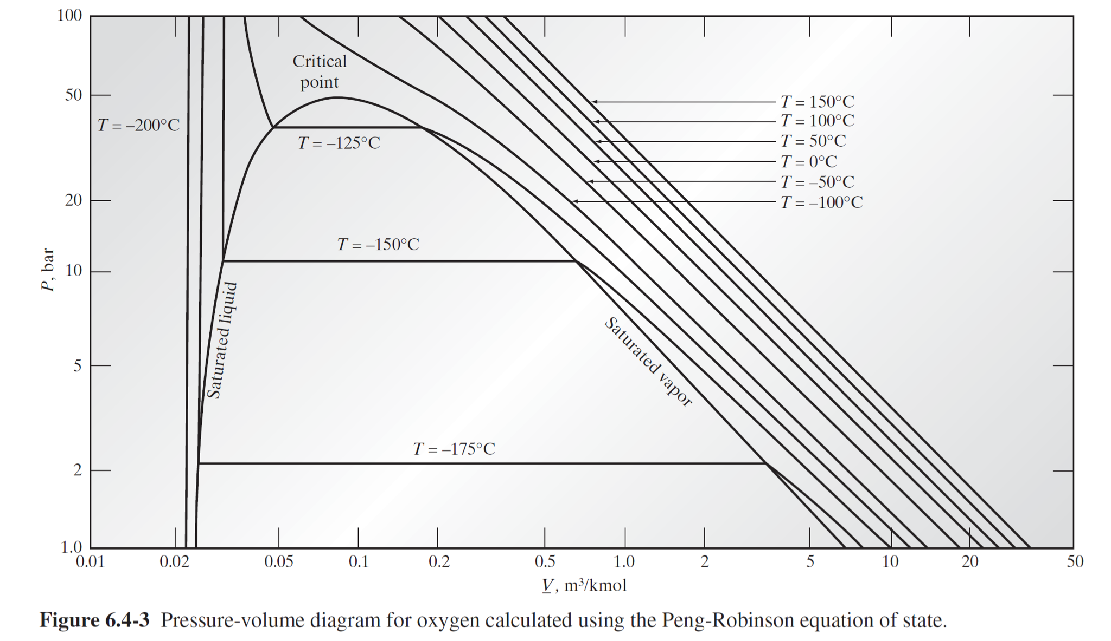

**For liquid, calculate the liquid fugacity with the help of**

**Recall that and depend on and . Therefore, they have to be calculated each time for a new value of and .**

**For vapor-liquid coexistence we require . Therefore, check whether . If so, then you can stop – you have a solution for at the selected temperature. Otherwise, set . The flowchart below will help:**

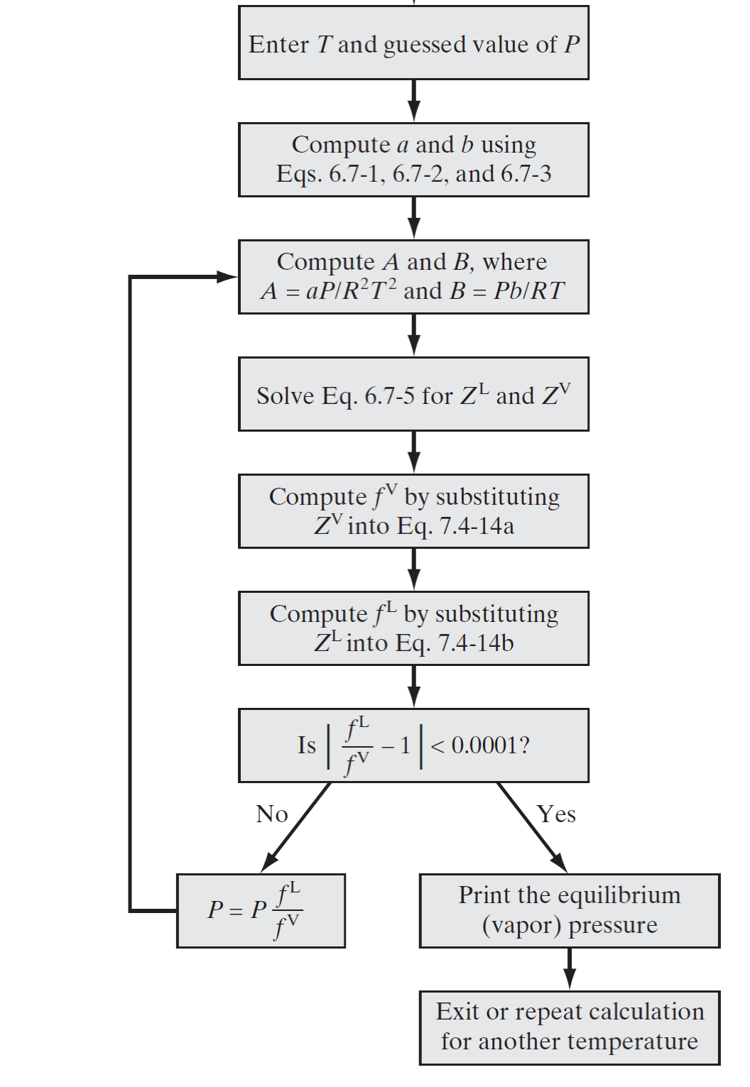

CODE:- PART A

# P_vap.m :-

function y = P_vap(T)

Tc = 154.6;

Pc = 5.046*10^6;

R = 8.314;

P = Pc;

b = 0.0778*R*Tc*(1/Pc);

A = (a(T)*P)/(R*T)^2;

B = (b*P)/(R*T);

alpha = B-1;

beta = A - 3*B^2 - 2*B;

gamma = B^3 + B^2 - A*B;

c = [1 alpha beta gamma];

z = real(roots(c));

Zv = max(z);

Zl = min(z);

f_l = fug(Zl,P,T);

f_v = fug(Zv,P,T);

while abs(f_l/f_v - 1) > 10^(-4)

P = P*(f_l/f_v);

b = 0.0778*R*Tc*(1/Pc);

A = (a(T)*P)/(R*T)^2;

B = (b*P)/(R*T);

alpha = B-1;

beta = A - 3*B^2 - 2*B;

gamma = B^3 + B^2 - A*B;

c = [1 alpha beta gamma];

z = real(roots(c));

Zv = max(z);

Zl = min(z);

f_l = fug(Zl,P,T);

f_v = fug(Zv,P,T);

end

y = P/10^5;

fug.m:-

function y = fug(Z , P , T)

Tc = 154.6;

Pc = 5.046*10^6;

R = 8.314;

b = 0.0778*R*Tc*(1/Pc);

A = (a(T)*P)/(R*T)^2;

B = (b*P)/(R*T);

sq = sqrt(2);

y = exp(Z-1-log(Z-B)-A/B/2/sq*log((Z + (1+sq)*B)./(Z + (1-sq)*B)));

a.m:-

function y = a(T)

Tc = 154.6;

Pc = 5.046*10^6;

R = 8.314;

k = 0.4069;

r = (T/Tc);

b =sqrt(r);

y = 0.45724*(R^2)*((Tc)^2)*(1/Pc)*(1 + k*(1-b))^2;

# PR_main_program.m :-

if option == 1

temp = [148.15 123.15 98.15];

p_vap = zeros(3,1);

for i = 1:3

p_vap(i) = P_vap(temp(i));

end

for i = 1 : 3

fprintf('The vapor pressure at %.2f K is %.4f bar \n',temp(i),p_vap(i))

end

end

FIGURES(OUTPUT):-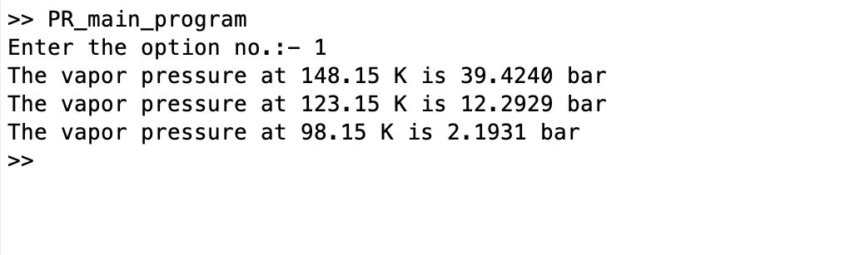

COMMENTS/INSTRUCTIONS:-

* FILES(PROGRAMS) TO BE OPENED:-

1)P_vap.m

2)fug.m

3)a.m

4)PR_main_program.m

* Run the main program :- PR_main_program.m
* Enter 1 as the option no.

**(b) Plot the isotherm curve at temperatures and as shown in Figure 6.4-3 (page 1).**

CODE:- PART B

# P_vap.m :-

function y = P_vap(T)

Tc = 154.6;

Pc = 5.046*10^6;

R = 8.314;

P = Pc;

b = 0.0778*R*Tc*(1/Pc);

A = (a(T)*P)/(R*T)^2;

B = (b*P)/(R*T);

alpha = B-1;

beta = A - 3*B^2 - 2*B;

gamma = B^3 + B^2 - A*B;

c = [1 alpha beta gamma];

z = real(roots(c));

Zv = max(z);

Zl = min(z);

f_l = fug(Zl,P,T);

f_v = fug(Zv,P,T);

while abs(f_l/f_v - 1) > 10^(-4)

P = P*(f_l/f_v);

b = 0.0778*R*Tc*(1/Pc);

A = (a(T)*P)/(R*T)^2;

B = (b*P)/(R*T);

alpha = B-1;

beta = A - 3*B^2 - 2*B;

gamma = B^3 + B^2 - A*B;

c = [1 alpha beta gamma];

z = real(roots(c));

Zv = max(z);

Zl = min(z);

f_l = fug(Zl,P,T);

f_v = fug(Zv,P,T);

end

y = P/10^5;

fug.m:-

function y = fug(Z , P , T)

Tc = 154.6;

Pc = 5.046*10^6;

R = 8.314;

b = 0.0778*R*Tc*(1/Pc);

A = (a(T)*P)/(R*T)^2;

B = (b*P)/(R*T);

sq = sqrt(2);

y = exp(Z-1-log(Z-B)-A/B/2/sq*log((Z + (1+sq)*B)./(Z + (1-sq)*B)));

a.m:-

function y = a(T)

Tc = 154.6;

Pc = 5.046*10^6;

R = 8.314;

k = 0.4069;

r = (T/Tc);

b =sqrt(r);

y = 0.45724*(R^2)*((Tc)^2)*(1/Pc)*(1 + k*(1-b))^2;

PV_plot.m:-

function y = PVplot(P,T,c)

k = linspace(P,50,20);

j = linspace(1,P,20);

v1 = zeros(20,1);

v2 = zeros(20,1);

p_sat = [P ,P];

for i = 1:20

z = Z(k(i),T,'l');

v1(i) = Vbar(z,T,k(i));

end

v_sat = zeros(2,1);

[zl,zv] = Z_sat(T);

z_sat = [zl,zv];

for i = 1:2

v_sat(i) = Vbar(z_sat(i),T,P);

end

for i = 1:20

z = Z(j(i),T,'v');

v2(i) = Vbar(z,T,j(i));

end

loglog(v1,k,c,'Linewidth',1.5)

hold on

loglog(v_sat,p_sat,c,'Linewidth',1.5)

hold on

loglog(v2,j,c,'Linewidth',1.5)

hold off

xlabel("Volume/mole(m^3/kmol)",FontSize=20)

ylabel("Pressure(bar)",FontSize=20)

title('PRESSURE VS MOLAR VOLUME’,FontSize=25)

Vbar.m:-

function y = Vbar(Z,T,P)

R = 8.314;

P = P*10^5;

y = (Z*R*T*10^3)/P;

Z.m:-

function y = Z(P,T,phase)

Tc = 154.6;

Pc = 5.046*10^6;

R = 8.314;

P = P*10^5;

b = 0.0778*R*Tc*(1/Pc);

A = (a(T)*P)/(R*T)^2;

B = (b*P)/(R*T);

alpha = B-1;

beta = A - 3*B^2 - 2*B;

gamma = B^3 + B^2 - A*B;

s = 0;

c = [1 alpha beta gamma];

z = roots(c);

for i = 1:3

if imag(z(i)) == 0

s = s+1;

k = z(i);

end

end

if s == 3

if phase == 'l'

k = min(z);

end

if phase == 'v'

k = max(z);

end

end

if phase == 'n'

k = real(k);

end

y = k;

PR_main_program.m :-

if option == 2

temp = [148.15 123.15 98.15];

p_vap = zeros(3,1);

c = ['r' 'b' 'g'];

for i = 1:3

p_vap(i) = P_vap(temp(i));

end

PVplot(p_vap(1),temp(1),c(1));

hold on

PVplot(p_vap(2),temp(2),c(2));

hold on

PVplot(p_vap(3),temp(3),c(3));

hold off

end

FIGURES(OUTPUT):-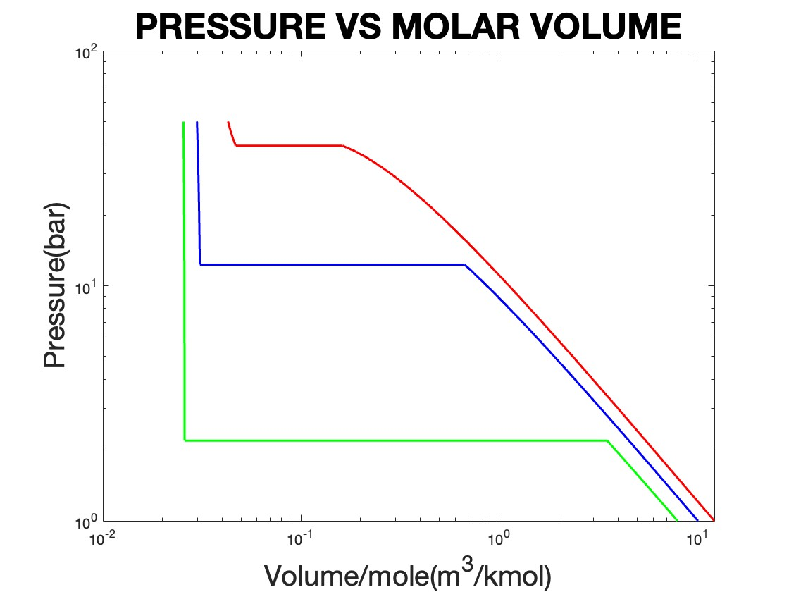

COMMENTS/INSTRUCTIONS:-

* FILES(PROGRAMS) TO BE OPENED:-

1)P_vap.m

2)fug.m

3)a.m

4)Z.m

5)Vbar.m

6)PVplot.m

7)PR_main_program.m

* Run the main program :- PR_main_program.m
* Enter 2 as the option no.

**(c) Make a plot for versus for the vapor-liquid coexistence. Choose temperatures and .**

CODE:- PART C

# P_vap.m :-

function y = P_vap(T)

Tc = 154.6;

Pc = 5.046*10^6;

R = 8.314;

P = Pc;

b = 0.0778*R*Tc*(1/Pc);

A = (a(T)*P)/(R*T)^2;

B = (b*P)/(R*T);

alpha = B-1;

beta = A - 3*B^2 - 2*B;

gamma = B^3 + B^2 - A*B;

c = [1 alpha beta gamma];

z = real(roots(c));

Zv = max(z);

Zl = min(z);

f_l = fug(Zl,P,T);

f_v = fug(Zv,P,T);

while abs(f_l/f_v - 1) > 10^(-4)

P = P*(f_l/f_v);

b = 0.0778*R*Tc*(1/Pc);

A = (a(T)*P)/(R*T)^2;

B = (b*P)/(R*T);

alpha = B-1;

beta = A - 3*B^2 - 2*B;

gamma = B^3 + B^2 - A*B;

c = [1 alpha beta gamma];

z = real(roots(c));

Zv = max(z);

Zl = min(z);

f_l = fug(Zl,P,T);

f_v = fug(Zv,P,T);

end

y = P/10^5;

fug.m:-

function y = fug(Z , P , T)

Tc = 154.6;

Pc = 5.046*10^6;

R = 8.314;

b = 0.0778*R*Tc*(1/Pc);

A = (a(T)*P)/(R*T)^2;

B = (b*P)/(R*T);

sq = sqrt(2);

y = exp(Z-1-log(Z-B)-A/B/2/sq*log((Z + (1+sq)*B)./(Z + (1-sq)*B)));

a.m:-

function y = a(T)

Tc = 154.6;

Pc = 5.046*10^6;

R = 8.314;

k = 0.4069;

r = (T/Tc);

b =sqrt(r);

y = 0.45724*(R^2)*((Tc)^2)*(1/Pc)*(1 + k*(1-b))^2;

# PR_main_program.m :-

if option == 3

temp = [148.15 143.15 133.15 123.15 113.15 103.15 98.15 93.15 90.15];

p_vap = zeros(9,1);

for i = 1:9

p_vap(i) = P_vap(temp(i));

end

plot(temp,p_vap,'linewidth',2.5)

hold on

plot(temp,p_vap,'.r',MarkerSize=15)

hold off

title("P_v_a_p vs T","FontSize",20)

xlabel("Temperature(K)","FontSize",20)

ylabel("P_v_a_p(bar)","FontSize",20)

end

FIGURES(OUTPUT):-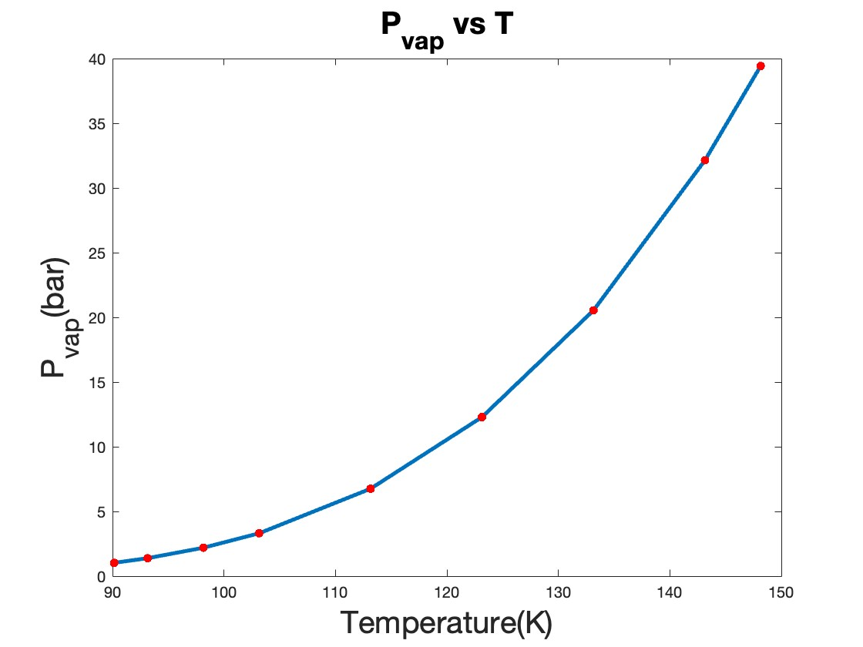

COMMENTS/INSTRUCTIONS:-

* FILES(PROGRAMS) TO BE OPENED:-

1)P_vap.m

2)fug.m

3)a.m

2)Z.m

3)PR_main_program.m

* Run the main program :- PR_main_program.m
* Enter 3 as the option no.

(d) Fit a polynomial curve to versus . Make sure that the polynomial curve fits your data well. Recall that according to the Clapeyron equation

Calculate , and from the information you have collected so far. For this you can also fit a curve through .Compare your value of to the value given in the figure below: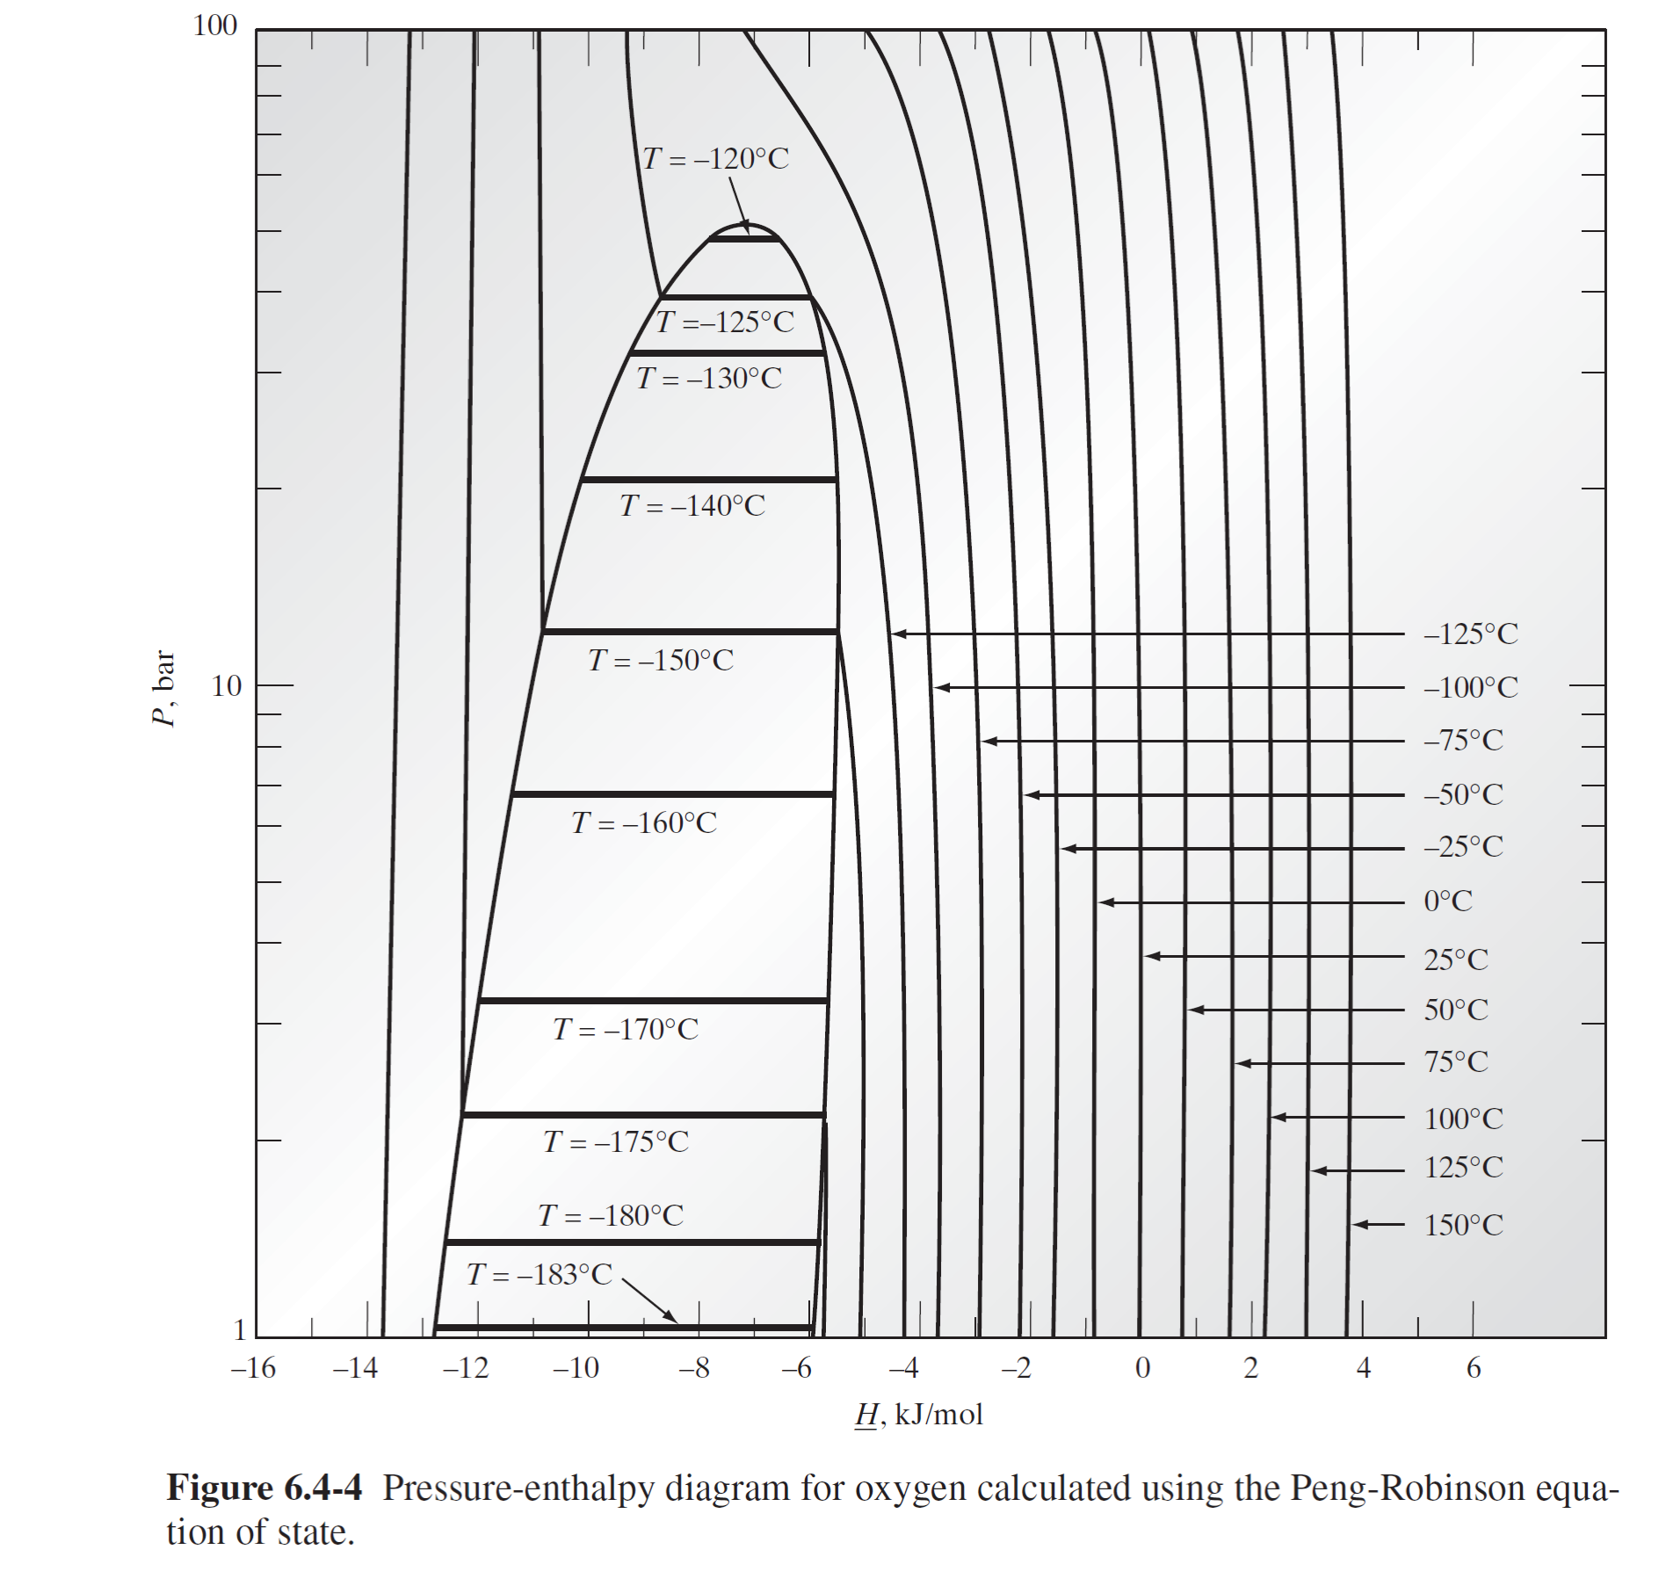

Note that in general the pressure where the transition happens from one phase to another is also called saturation pressure . For vapor-liquid equilibrium (VLE) .

CODE:- PART D

# P_vap.m :-

function y = P_vap(T)

Tc = 154.6;

Pc = 5.046*10^6;

R = 8.314;

P = Pc;

b = 0.0778*R*Tc*(1/Pc);

A = (a(T)*P)/(R*T)^2;

B = (b*P)/(R*T);

alpha = B-1;

beta = A - 3*B^2 - 2*B;

gamma = B^3 + B^2 - A*B;

c = [1 alpha beta gamma];

z = real(roots(c));

Zv = max(z);

Zl = min(z);

f_l = fug(Zl,P,T);

f_v = fug(Zv,P,T);

while abs(f_l/f_v - 1) > 10^(-4)

P = P*(f_l/f_v);

b = 0.0778*R*Tc*(1/Pc);

A = (a(T)*P)/(R*T)^2;

B = (b*P)/(R*T);

alpha = B-1;

beta = A - 3*B^2 - 2*B;

gamma = B^3 + B^2 - A*B;

c = [1 alpha beta gamma];

z = real(roots(c));

Zv = max(z);

Zl = min(z);

f_l = fug(Zl,P,T);

f_v = fug(Zv,P,T);

end

y = P/10^5;

fug.m:-

function y = fug(Z , P , T)

Tc = 154.6;

Pc = 5.046*10^6;

R = 8.314;

b = 0.0778*R*Tc*(1/Pc);

A = (a(T)*P)/(R*T)^2;

B = (b*P)/(R*T);

sq = sqrt(2);

y = exp(Z-1-log(Z-B)-A/B/2/sq*log((Z + (1+sq)*B)./(Z + (1-sq)*B)));

a.m:-

function y = a(T)

Tc = 154.6;

Pc = 5.046*10^6;

R = 8.314;

k = 0.4069;

r = (T/Tc);

b =sqrt(r);

y = 0.45724*(R^2)*((Tc)^2)*(1/Pc)*(1 + k*(1-b))^2;

curve_fitting.m:-

x = [148.15 143.15 133.15 123.15 113.15 103.15 98.15 93.15 90.15];

y = zeros(9,1);

for i = 1:9

y(i) = P_vap(x(i));

end

p = polyfit(x,y,3);

x2 = 148.15:-5:88.15;

y2 = polyval(p,x2);

figure(1)

plot(x,y,'o')

hold on

plot(x2,y2)

hold off

xlabel("Temperature(K)","FontSize",20)

ylabel("P_v_a_p(bar)","FontSize",20)

s = sprintf('P_v_a_p = %.8f T^3 + %.8f T^2 + %.8f T + %.8f',p(1),p(2),p(3),p(4));

title(s);

y1 = zeros(9,1);

for i = 1:9

y1(i) = delVbar(x(i))*10^-6;

end

p1 = polyfit(x,y1,4);

x_2 = 148.15:-5:88.15;

y_2 = polyval(p1,x_2);

figure(2)

plot(x,y1,'o')

hold on

plot(x_2,y_2)

hold off

xlabel("Temperature(K)","FontSize",20)

ylabel("V/mol(m^3/mol)","FontSize",20)

s1 = sprintf('V/mol = %.8f T^4 + %.8f T^3 + %.8f T^2 + %.8f T + %.8f ',p1(1),p1(2),p1(3),p1(4),p1(5));

title(s1);

clapeyron.m:-

function [dH , dS ] = clapeyron(T)

dH = diffPvap(T)*T*delVbar(T);

dS = diffPvap(T)*delVbar(T);

delVbar.m:-

function y = delVbar(T)

[zl,zv] = Z_sat(T);

z = zv - zl;

R = 8.314;

y = (z*R*T)/P_vap(T);

diffPvap.m:-

function y = diffPvap(T)

x = 0.0001;

y1 = P_vap(T-x);

y2 = P_vap(T+x);

y = (y2-y1)/(2*x);

H.m:-

function y = H(P,T,phase)

z = Z(P,T,phase);

Tc = 154.6;

Pc = 5.046*10^6;

R = 8.314;

b = 0.0778*R*Tc*(1/Pc);

B = (b*P*10^5)/(R*T);

Tr = 298.15;

c = 25.46*(T -Tr) + (0.7595*10^(-2))*(T^2 - (Tr)^2) - (0.7151*(1/3)*10^(-5))*(T^3 -(Tr)^3) + (0.32775*10^(-9))*(T^4-(Tr)^4);

d = T*diff_a(T);

sq = sqrt(2);

s = ((d-a(T))/(b*2*sq))*log((z + (1+sq)*B)./(z + (1-sq)*B));

v = R*T*(z-1);

y = v + s + c;

S.m:-

function y = S(P,T,phase)

z = Z(P,T,phase);

Tc = 154.6;

Pc = 5.046*10^6;

R = 8.314;

b = 0.0778*R*Tc*(1/Pc);

B = (b*P*10^5)/(R*T);

Tr = 298.15;

c = 25.46*log(T/Tr) + (1.519*10^(-2))*(T - (Tr)) - (0.7151*(1/2)*10^(-5))*(T^2 -(Tr)^2) + (1.311*(1/3)*10^(-9))*(T^3-(Tr)^3);

d = diff_a(T);

e = R*log(P);

sq = sqrt(2);

s = (d/(b*2*sq))*log((z + (1+sq)*B)./(z + (1-sq)*B));

v = R*log(z-B);

y = v + s + c - e;

Z_sat.m:-

function [zl,zv] = Z_sat(T)

Tc = 154.6;

Pc = 5.046*10^6;

R = 8.314;

P = Pc;

b = 0.0778*R*Tc*(1/Pc);

A = (a(T)*P)/(R*T)^2;

B = (b*P)/(R*T);

alpha = B-1;

beta = A - 3*B^2 - 2*B;

gamma = B^3 + B^2 - A*B;

c = [1 alpha beta gamma];

z = real(roots(c));

Zv = max(z);

Zl = min(z);

f_l = fug(Zl,P,T);

f_v = fug(Zv,P,T);

while abs(f_l/f_v - 1) > 10^(-4)

P = P*(f_l/f_v);

b = 0.0778*R*Tc*(1/Pc);

A = (a(T)*P)/(R*T)^2;

B = (b*P)/(R*T);

alpha = B-1;

beta = A - 3*B^2 - 2*B;

gamma = B^3 + B^2 - A*B;

c = [1 alpha beta gamma];

z = real(roots(c));

Zv = max(z);

Zl = min(z);

f_l = fug(Zl,P,T);

f_v = fug(Zv,P,T);

end

zl = Zl;

zv = Zv;

PR_main_program.m:-

if option == 4

curve_fitting

temp = [148.15 143.15 133.15 123.15 113.15 103.15 98.15 93.15 90.15];

delH = zeros(9,1);

delS = zeros(9,1);

for i = 1:9

[dH,dS] = clapeyron(temp(i));

delH(i) = dH*10^-3;

delS(i) = dS*10^-3;

end

for j = 1:9

fprintf('At T = %.2f K, ΔH/mole is %.4f (KJ/mole) and ΔS/mole is %.4f (KJ/K/mol) \n',temp(j),delH(j),delS(j));

end

end

FIGURES(OUTPUT):-

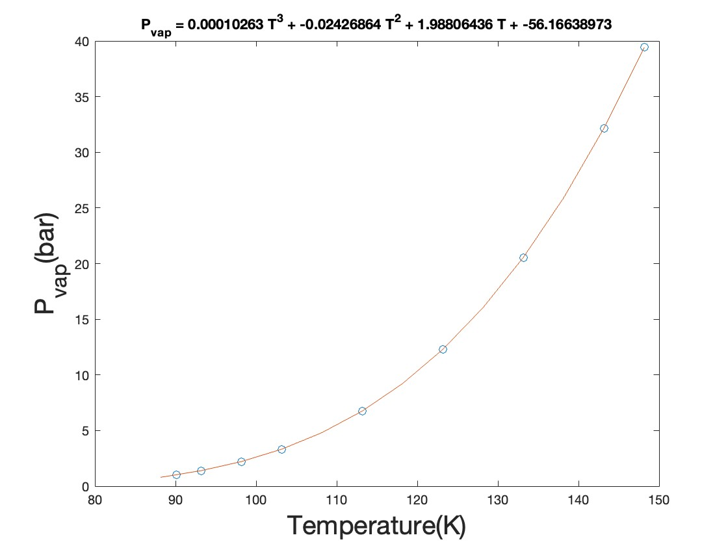

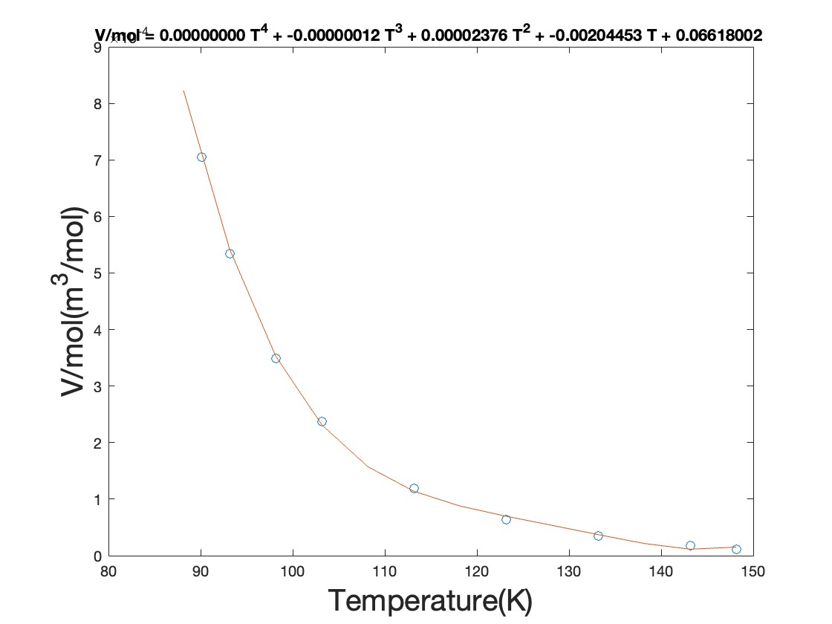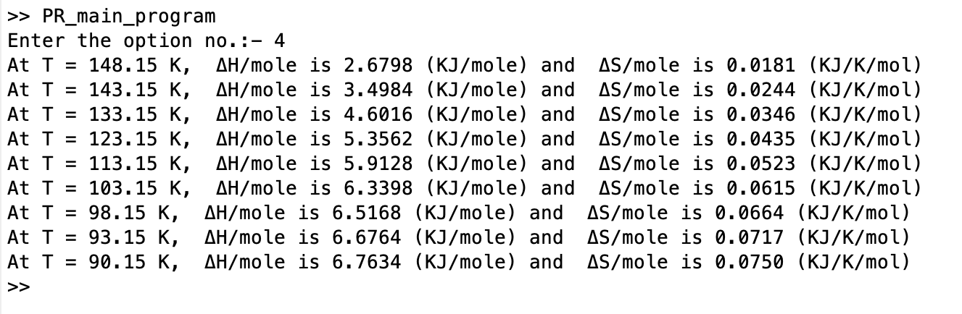

COMMENTS/INSTRUCTIONS:-

* FILES(PROGRAMS) TO BE OPENED:-

1)P_vap.m

2)fug.m

3)a.m

4)curve_fitting.m

5)claypeyron.m

6)delVbar.m

7)diffPvap.m

8)H.m

9)S.m

10)Z_sat.m

11)Z.m

11)PR_main_program.m

* Run the main program :- PR_main_program.m
* Enter 4 as the option no.

(e) Plot and as a function of temperature.

CODE:- PART E

# P_vap.m :-

function y = P_vap(T)

Tc = 154.6;

Pc = 5.046*10^6;

R = 8.314;

P = Pc;

b = 0.0778*R*Tc*(1/Pc);

A = (a(T)*P)/(R*T)^2;

B = (b*P)/(R*T);

alpha = B-1;

beta = A - 3*B^2 - 2*B;

gamma = B^3 + B^2 - A*B;

c = [1 alpha beta gamma];

z = real(roots(c));

Zv = max(z);

Zl = min(z);

f_l = fug(Zl,P,T);

f_v = fug(Zv,P,T);

while abs(f_l/f_v - 1) > 10^(-4)

P = P*(f_l/f_v);

b = 0.0778*R*Tc*(1/Pc);

A = (a(T)*P)/(R*T)^2;

B = (b*P)/(R*T);

alpha = B-1;

beta = A - 3*B^2 - 2*B;

gamma = B^3 + B^2 - A*B;

c = [1 alpha beta gamma];

z = real(roots(c));

Zv = max(z);

Zl = min(z);

f_l = fug(Zl,P,T);

f_v = fug(Zv,P,T);

end

y = P/10^5;

fug.m:-

function y = fug(Z , P , T)

Tc = 154.6;

Pc = 5.046*10^6;

R = 8.314;

b = 0.0778*R*Tc*(1/Pc);

A = (a(T)*P)/(R*T)^2;

B = (b*P)/(R*T);

sq = sqrt(2);

y = exp(Z-1-log(Z-B)-A/B/2/sq*log((Z + (1+sq)*B)./(Z + (1-sq)*B)));

a.m:-

function y = a(T)

Tc = 154.6;

Pc = 5.046*10^6;

R = 8.314;

k = 0.4069;

r = (T/Tc);

b =sqrt(r);

y = 0.45724*(R^2)*((Tc)^2)*(1/Pc)*(1 + k*(1-b))^2;

clapeyron.m:-

function [dH , dS ] = clapeyron(T)

dH = diffPvap(T)*T*delVbar(T);

dS = diffPvap(T)*delVbar(T);

delVbar.m:-

function y = delVbar(T)

[zl,zv] = Z_sat(T);

z = zv - zl;

R = 8.314;

y = (z*R*T)/P_vap(T);

diffPvap.m:-

function y = diffPvap(T)

x = 0.0001;

y1 = P_vap(T-x);

y2 = P_vap(T+x);

y = (y2-y1)/(2*x);

H.m:-

function y = H(P,T,phase)

z = Z(P,T,phase);

Tc = 154.6;

Pc = 5.046*10^6;

R = 8.314;

b = 0.0778*R*Tc*(1/Pc);

B = (b*P*10^5)/(R*T);

Tr = 298.15;

c = 25.46*(T -Tr) + (0.7595*10^(-2))*(T^2 - (Tr)^2) - (0.7151*(1/3)*10^(-5))*(T^3 -(Tr)^3) + (0.32775*10^(-9))*(T^4-(Tr)^4);

d = T*diff_a(T);

sq = sqrt(2);

s = ((d-a(T))/(b*2*sq))*log((z + (1+sq)*B)./(z + (1-sq)*B));

v = R*T*(z-1);

y = v + s + c;

S.m:-

function y = S(P,T,phase)

z = Z(P,T,phase);

Tc = 154.6;

Pc = 5.046*10^6;

R = 8.314;

b = 0.0778*R*Tc*(1/Pc);

B = (b*P*10^5)/(R*T);

Tr = 298.15;

c = 25.46*log(T/Tr) + (1.519*10^(-2))*(T - (Tr)) - (0.7151*(1/2)*10^(-5))*(T^2 -(Tr)^2) + (1.311*(1/3)*10^(-9))*(T^3-(Tr)^3);

d = diff_a(T);

e = R*log(P);

sq = sqrt(2);

s = (d/(b*2*sq))*log((z + (1+sq)*B)./(z + (1-sq)*B));

v = R*log(z-B);

y = v + s + c - e;

Z_sat.m:-

function [zl,zv] = Z_sat(T)

Tc = 154.6;

Pc = 5.046*10^6;

R = 8.314;

P = Pc;

b = 0.0778*R*Tc*(1/Pc);

A = (a(T)*P)/(R*T)^2;

B = (b*P)/(R*T);

alpha = B-1;

beta = A - 3*B^2 - 2*B;

gamma = B^3 + B^2 - A*B;

c = [1 alpha beta gamma];

z = real(roots(c));

Zv = max(z);

Zl = min(z);

f_l = fug(Zl,P,T);

f_v = fug(Zv,P,T);

while abs(f_l/f_v - 1) > 10^(-4)

P = P*(f_l/f_v);

b = 0.0778*R*Tc*(1/Pc);

A = (a(T)*P)/(R*T)^2;

B = (b*P)/(R*T);

alpha = B-1;

beta = A - 3*B^2 - 2*B;

gamma = B^3 + B^2 - A*B;

c = [1 alpha beta gamma];

z = real(roots(c));

Zv = max(z);

Zl = min(z);

f_l = fug(Zl,P,T);

f_v = fug(Zv,P,T);

end

zl = Zl;

zv = Zv;

Z.m:-

function y = Z(P,T,phase)

Tc = 154.6;

Pc = 5.046*10^6;

R = 8.314;

P = P*10^5;

b = 0.0778*R*Tc*(1/Pc);

A = (a(T)*P)/(R*T)^2;

B = (b*P)/(R*T);

alpha = B-1;

beta = A - 3*B^2 - 2*B;

gamma = B^3 + B^2 - A*B;

s = 0;

c = [1 alpha beta gamma];

z = roots(c);

for i = 1:3

if imag(z(i)) == 0

s = s+1;

k = z(i);

end

end

if s == 3

if phase == 'l'

k = min(z);

end

if phase == 'v'

k = max(z);

end

end

if phase == 'n'

k = real(k);

end

y = k;

PR_main_program.m:-

if option == 5

temp = [148.15 143.15 133.15 123.15 113.15 103.15 98.15 93.15 90.15];

delH = zeros(9,1);

delS = zeros(9,1);

for i = 1:9

[dH,dS] = clapeyron(temp(i));

delH(i) = dH*10^-3;

delS(i) = dS*10^-3;

end

figure(1)

plot(temp,delH,'linewidth',2.5)

hold on

plot(temp,delH,'.r',MarkerSize=15)

hold off

title("ΔH/mol vs T","FontSize",20)

xlabel("Temperature(K)","FontSize",20)

ylabel("ΔH/mol(KJ/mol)","FontSize",20)

figure(2)

plot(temp,delS,'linewidth',2.5)

hold on

plot(temp,delS,'.r',MarkerSize=15)

hold off

title("ΔS/mol vs T","FontSize",20)

xlabel("Temperature(K)","FontSize",20)

ylabel(“ΔS/mol(KJ/mol/K)","FontSize",20)

end

FIGURES(OUTPUT):-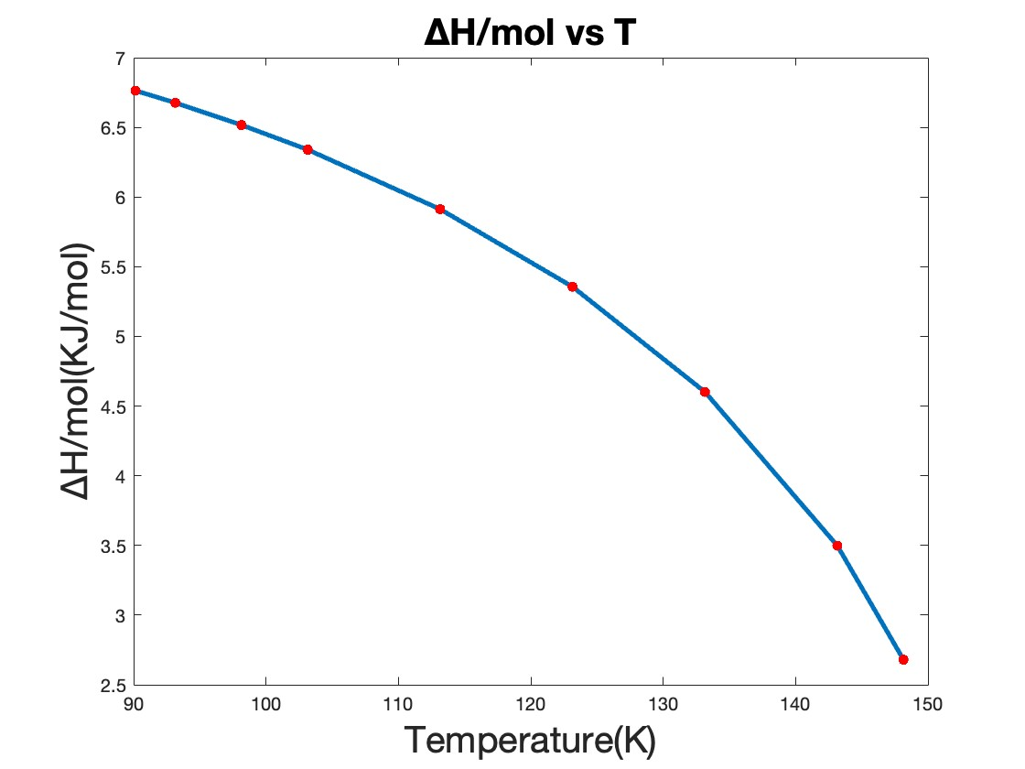

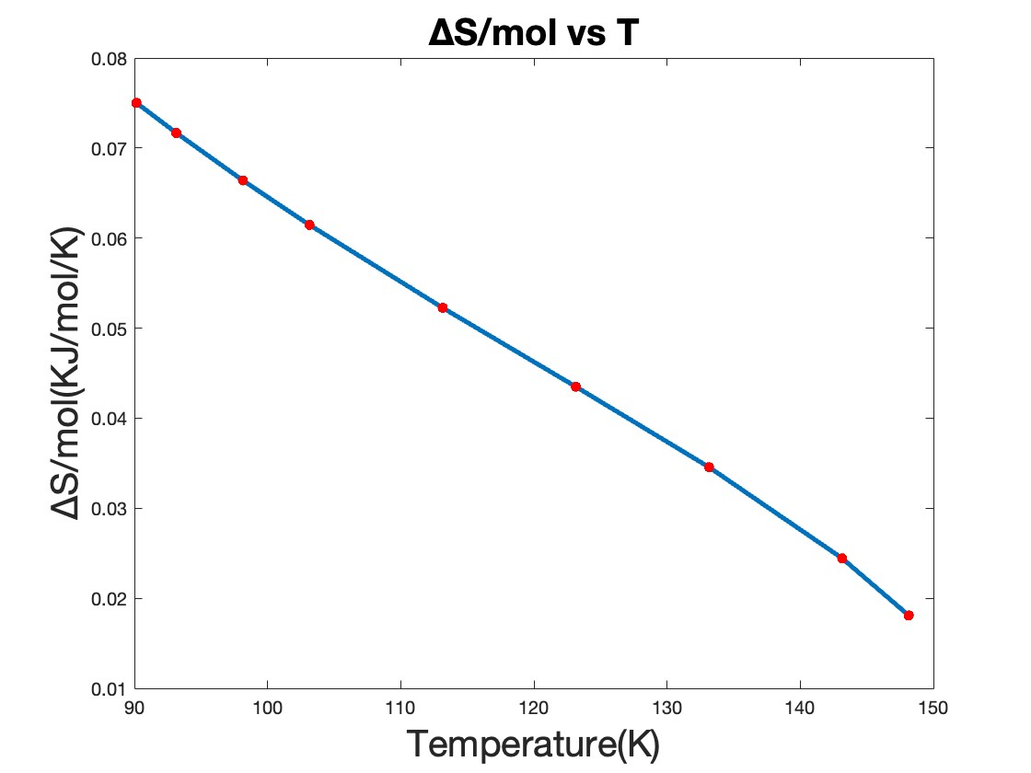

COMMENTS/INSTRUCTIONS:-

* FILES(PROGRAMS) TO BE OPENED:-

1)P_vap.m

2)fug.m

3)a.m

4)curve_fitting.m

5)claypeyron.m

6)delVbar.m

7)diffPvap.m

8)H.m

9)S.m

10)Z_sat.m

11)Z.m

11)PR_main_program.m

* Run the main program :- PR_main_program.m
* Enter 5 as the option no.

(f) Enthalpy calculations:

Choose . implies ideal gas. This sets our reference state. Now calculate enthalpy as

Here has a value zero therefore it has been struck through.

For Peng-Robinson equation, the departure function for enthalpy or residual enthalpy

Also

where

for oxygen and is in K.

Obtain the pressure-enthalpy along the isotherm as shown in Figure 6.4-4 in page 3.

Hint:

For saturated liquid, we write

For liquid,

where

CODE:- PART F

* ALL SUBPROGRAMS USED IN PART e IS REQUIRED

pressenthalpy.m:-

temp = [148.15 143.15 133.15 123.15 113.15 103.15 98.15 93.15 90.15];

h_1 = zeros(9,1);

h_2 = zeros(9,1);

p_2 = zeros(9,1);

for i = 1:9

p = P_vap(temp(i));

p1 = linspace(p,1,20);

p2 = linspace(100,p,20);

p3 = [p,p];

h1 = zeros(20,1);

h2 = zeros(20,1);

h3 = [H(p,temp(i),'l') H(p,temp(i),'v')];

h_1(i) = H(p,temp(i),'l')*10^-3;

h_2(i) = H(p,temp(i),'v')*10^-3;

p_2(i) = p;

c = ['b' 'g' 'r' 'c' 'm' 'r' 'b' 'g' 'r'];

for j = 1:20

h1(j) = H(p1(j),temp(i),'v');

end

for k = 1:20

h2(k) = H(p2(k),temp(i),'l');

end

h1 = h1*10^-3;

h2 = h2*10^-3;

h3 = h3*10^-3;

semilogy(h1,p1,c(i),'LineWidth',2)

hold on

semilogy(h2,p2,c(i),'LineWidth',2)

hold on

semilogy(h3,p3,c(i),'LineWidth',2)

hold on

title("PRESSURE VS ENTHALPY",'FontSize',25)

xlabel("Enthalpy(KJ/mol)",'FontSize',15)

ylabel("Pressure(bar)",'FontSize',15)

end

semilogy(h_1,p_2,'--k','LineWidth',2.5)

hold on

semilogy(h_2,p_2,'--k','LineWidth',2.5)

hold on

temp2 = [-100 -75 -50 -25 0 25 50 75 100 125 150]+273.15;

p_1 = linspace(100,1,10);

for i = 1:10

h = zeros(10,1);

for j = 1:10

h(j) = H(p_1(j),temp2(i),'n');

end

h = h*10^-3;

semilogy(h,p_1,'LineWidth',2)

hold on

end

hold off

PR_main_program.m:-

if option == 6

pressenthalpy

end

FIGURES(OUT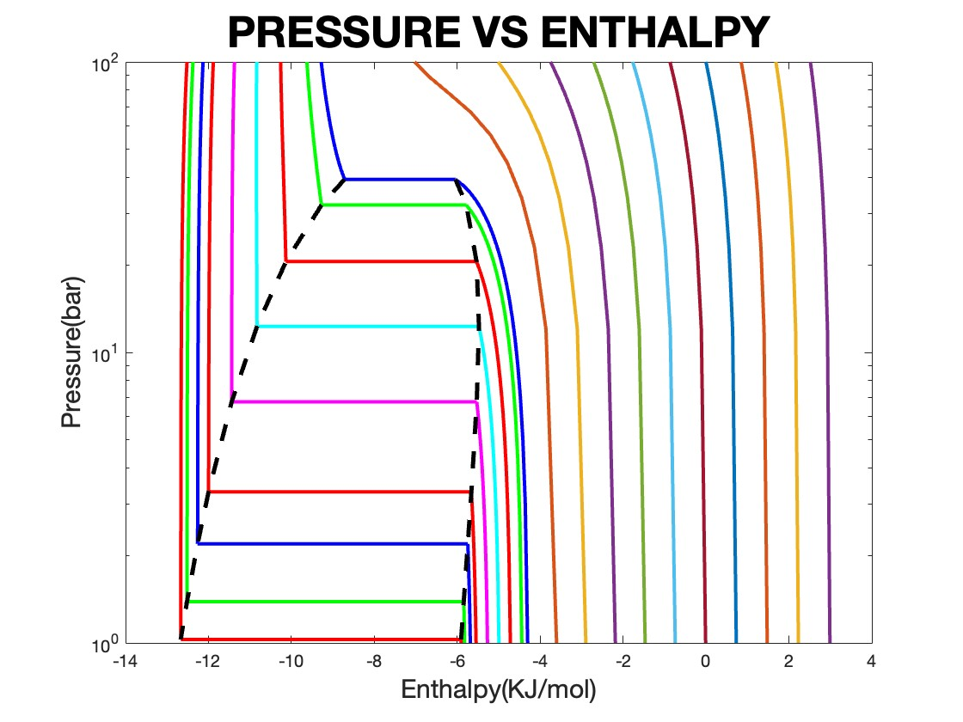PUT):-

COMMENTS/INSTRUCTIONS:-

* FILES(PROGRAMS) TO BE OPENED:-

1)pressenthalpy

2)PR_main_program.m

* Run the main program :- PR_main_program.m
* Enter 6 as the option no.

(g) Entropy calculations:

Choose . implies ideal gas. This sets our reference state. Now calculate entropy as

Here has a value zero therefore it has been struck through.

For Peng-Robinson equation, the departure function for entropy or the residual entropy

Also

Obtain the pressure-entropy along the isotherm.

CODE:- PART G

* ALL SUBPROGRAMS USED IN PART e IS REQUIRED

pressentropy.m:-

temp = [148.15 143.15 133.15 123.15 113.15 103.15 98.15 93.15 90.15];

s_1 = zeros(9,1);

s_2 = zeros(9,1);

p_2 = zeros(9,1);

for i = 1:9

p = P_vap(temp(i));

p1 = linspace(p,1,20);

p2 = linspace(100,p,20);

p3 = [p,p];

s1 = zeros(20,1);

s2 = zeros(20,1);

s3 = [S(p,temp(i),'l') S(p,temp(i),'v')];

s_1(i) = S(p,temp(i),'l')*10^-3;

s_2(i) = S(p,temp(i),'v')*10^-3;

p_2(i) = p;

c = ['b' 'g' 'r' 'c' 'm' 'r' 'b' 'g' 'r'];

for j = 1:20

s1(j) = S(p1(j),temp(i),'v');

end

for k = 1:20

s2(k) = S(p2(k),temp(i),'l');

end

s1 = s1*10^-3;

s2 = s2*10^-3;

s3 = s3*10^-3;

semilogy(s1,p1,c(i),'LineWidth',2)

hold on

semilogy(s2,p2,c(i),'LineWidth',2)

hold on

semilogy(s3,p3,c(i),'LineWidth',2)

hold on

title("PRESSURE VS ENTROPY",'FontSize',25)

xlabel("Entropy(KJ/mol/K)",'FontSize',15)

ylabel("Pressure(bar)",'FontSize',15)

end

semilogy(s_1,p_2,'--k','LineWidth',2.5)

hold on

semilogy(s_2,p_2,'--k','LineWidth',2.5)

hold on

temp2 = [-100 -75 -50 -25 0 25 50 75 100 125 150]+273.15;

p_1 = linspace(100,1,10);

for i = 1:10

s = zeros(10,1);

for j = 1:10

s(j) = S(p_1(j),temp2(i),'n');

end

s = s*10^-3;

semilogy(s,p_1,'LineWidth',2)

hold on

end

hold off

PR_main_program.m:-

if option == 7

pressentropy

end

FIGURES(OUTPUT):-

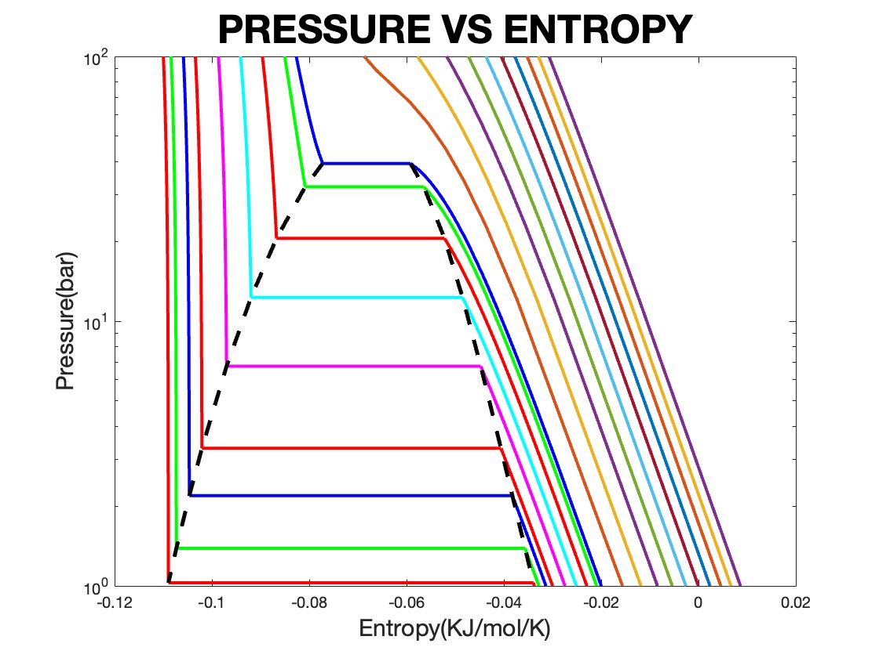

COMMENTS/INSTRUCTIONS:-

* FILES(PROGRAMS) TO BE OPENED:-

1)pressentropy

2)PR_main_program.m

* Run the main program :- PR_main_program.m
* Enter 7 as the option no.