Richfield Graduate Institute of Technology
Mobile Application Development 700
Assignment Report
Smart Pantry Manager
An Android application that tracks pantry stock and suggests recipes that can be cooked with the ingredients on hand.
Student Name: [Your Full Name]
Student Number: [Your Student Number]
Date: 23 October 2026
GitHub Repository: github.com/Naughtyboy25/Smart-Pantry-Mobile

Table of Contents

1. Introduction 3
2. System Design 4
3. Screenshots of Application Output 7
4. Code Snippets 15
5. Challenges and Solutions 18
6. Conclusion and Reflection 19
7. References 20

Page numbers are refreshed automatically when the document opens in Word (or right-click the table and choose "Update Field").

1. Introduction
The Smart Pantry Manager is a native Android application developed in Java for the Mobile Application Development 700 assignment. The application addresses a common household problem: food is bought, stored in the pantry, and forgotten until it expires, while the question "what can I cook tonight?" usually ends in takeaway. The app keeps a digital record of the user's pantry and answers that question directly by suggesting recipes that can be prepared using only the ingredients already in stock.
The application was built with the Android SDK in Java, following the Model-View-ViewModel (MVVM) architecture recommended by Google. Persistent storage uses SQLite through the Room persistence library, with LiveData providing reactive, lifecycle-aware updates to the user interface. Material Design Components (Material 3) were used for the date picker, text fields and bottom navigation so the app looks and behaves like a modern Android application.
The functional scope of the application covers:
- Pantry management: adding, editing and deleting pantry items with a name, quantity, unit (g, kg, ml, tbsp, tsp, cups or pieces) and an optional expiry date;
- Strict recipe matching: the Suggested screen lists only recipes whose every required ingredient is present in the pantry in at least the required quantity;
- A bonus "Almost There" list: recipes missing exactly one ingredient are shown separately so the user knows what to buy next;
- Recipe detail view: ingredients with required quantities and numbered preparation steps.

2. System Design

2.1 Architecture
The app follows the MVVM pattern. Fragments (Pantry, Suggested, Settings, Add/Edit, Recipe Detail) observe LiveData exposed by ViewModels. ViewModels delegate to Repositories, which in turn call Room Data Access Objects (DAOs). Because every query returns LiveData, the UI updates automatically whenever the underlying SQLite data changes; no manual refresh is needed after an insert, update or delete.
The matching engine lives in a utility class, IngredientMatcher. Before comparing a recipe against the pantry it normalises both sides: ingredient names are trimmed, lower-cased and singularised (for example "tomatoes" becomes "tomato"), and quantities are converted to base units (grams, millilitres or pieces) so that "200 g butter" can be compared against a pantry entry of "0.25 kg butter". A recipe is a strict match only when every required ingredient exists in the pantry in a compatible unit and in a sufficient quantity.

2.2 Screen Flow
The application has three top-level destinations reachable through bottom navigation: Pantry (the start destination), Suggested and Settings. The Pantry screen opens the Add/Edit form, which in turn hosts the Material date picker for the expiry field. Long-pressing a pantry item opens a delete confirmation dialog with an undo snackbar. The Suggested screen opens the Recipe Detail screen when a recipe row is tapped.
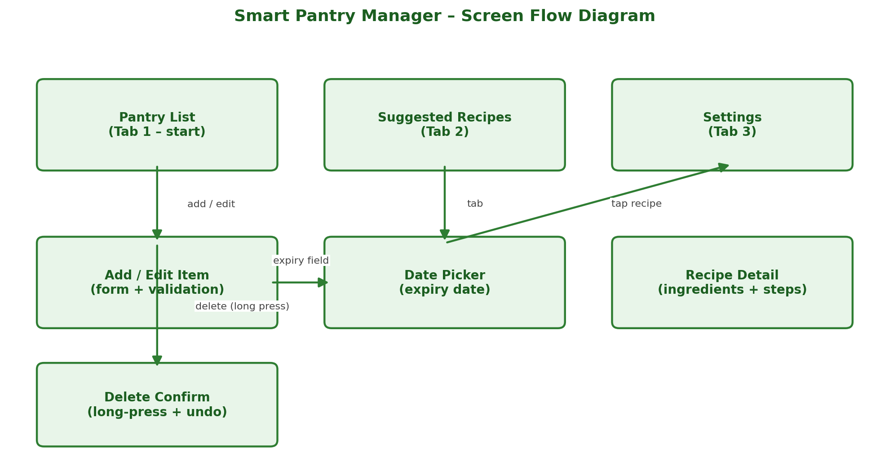
Figure 1: Screen flow diagram of the Smart Pantry Manager.

2.3 Data Model (ER Diagram)
The Room database contains four entities. recipes is the parent of recipe_ingredients and recipe_steps through one-to-many foreign key relationships with ON DELETE CASCADE. pantry_items stands alone: it is deliberately not linked by a foreign key, because recipes are matched to stock at query time by comparing normalised ingredient names rather than fixed identifiers. This makes matching tolerant of spelling differences such as plurals.
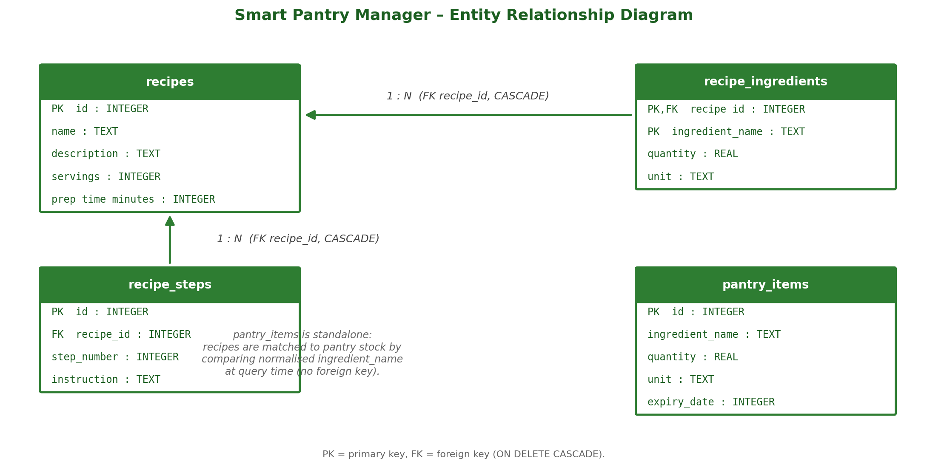
Figure 2: Entity-relationship diagram of the Room database.

3. Screenshots of Application Output
All screenshots below were captured on a physical Android device running the final build of the application.
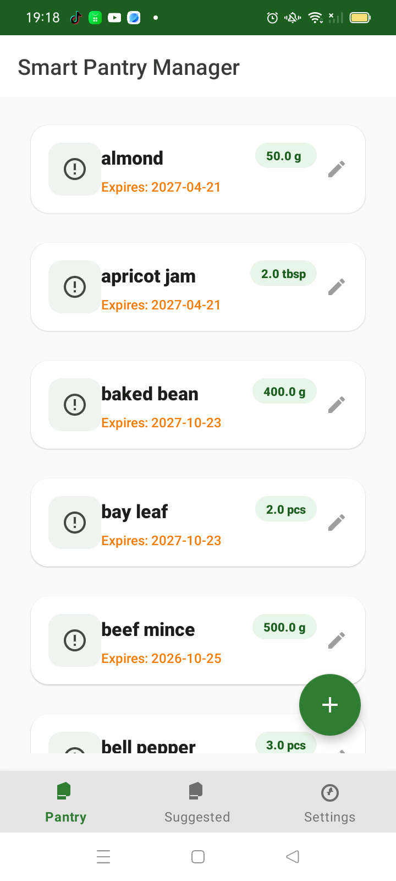
Figure 3: Pantry list showing stored items with quantity badges and edit actions.
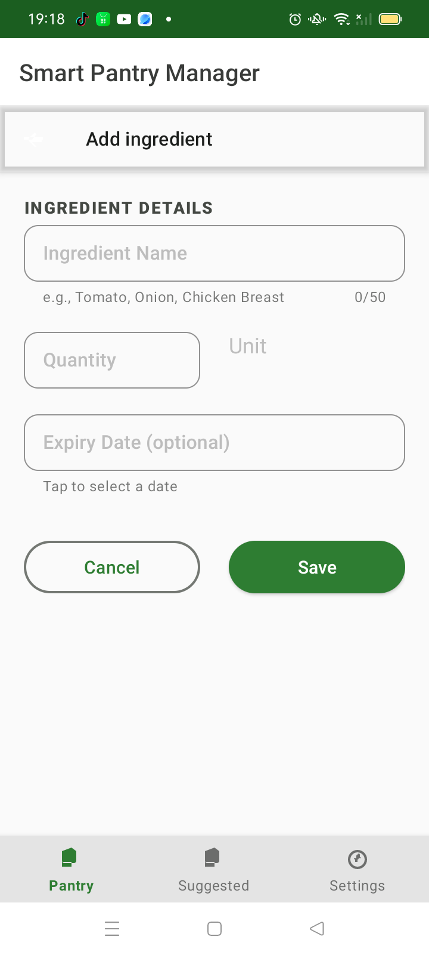
Figure 4: Add Ingredient form with name, quantity, unit and expiry date fields.
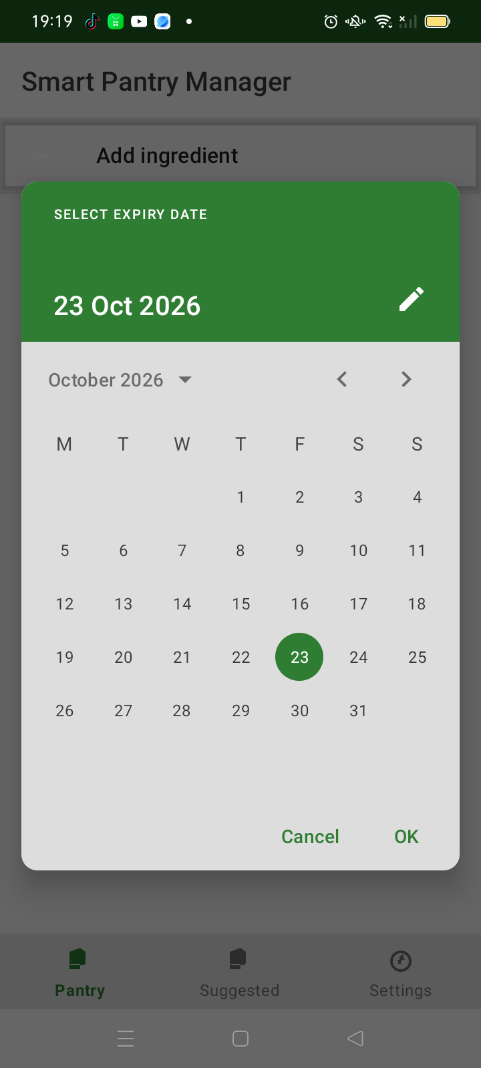
Figure 5: Material date picker for selecting the expiry date.
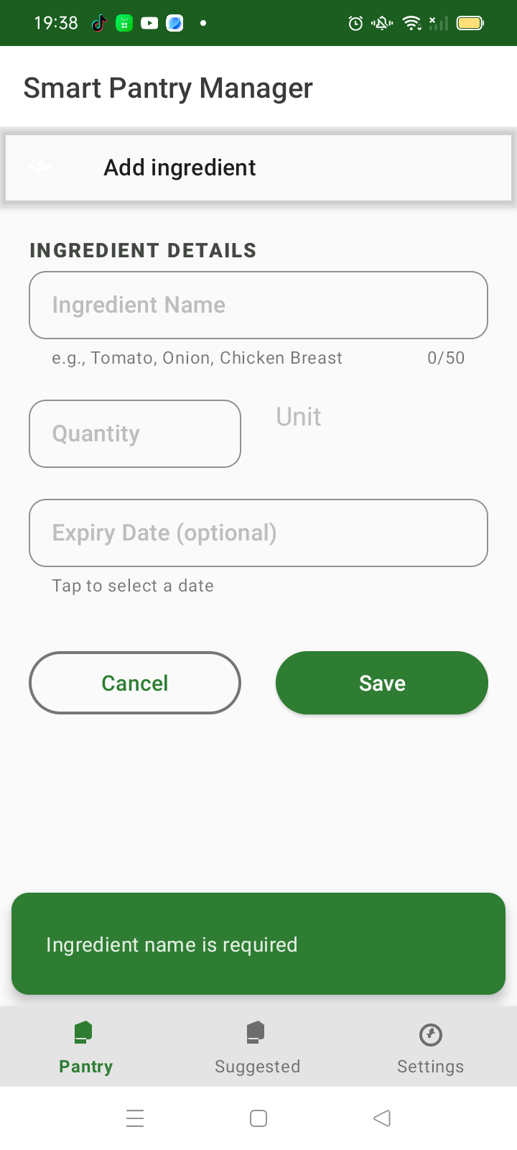
Figure 6: Validation error shown when a required field is left empty.
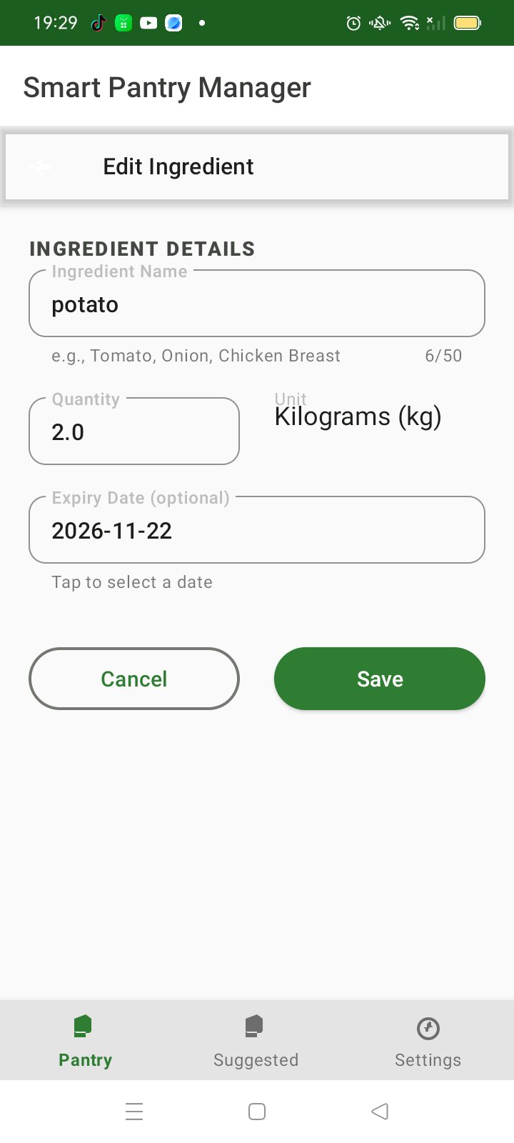
Figure 7: Edit screen pre-filled with the existing pantry item's data.
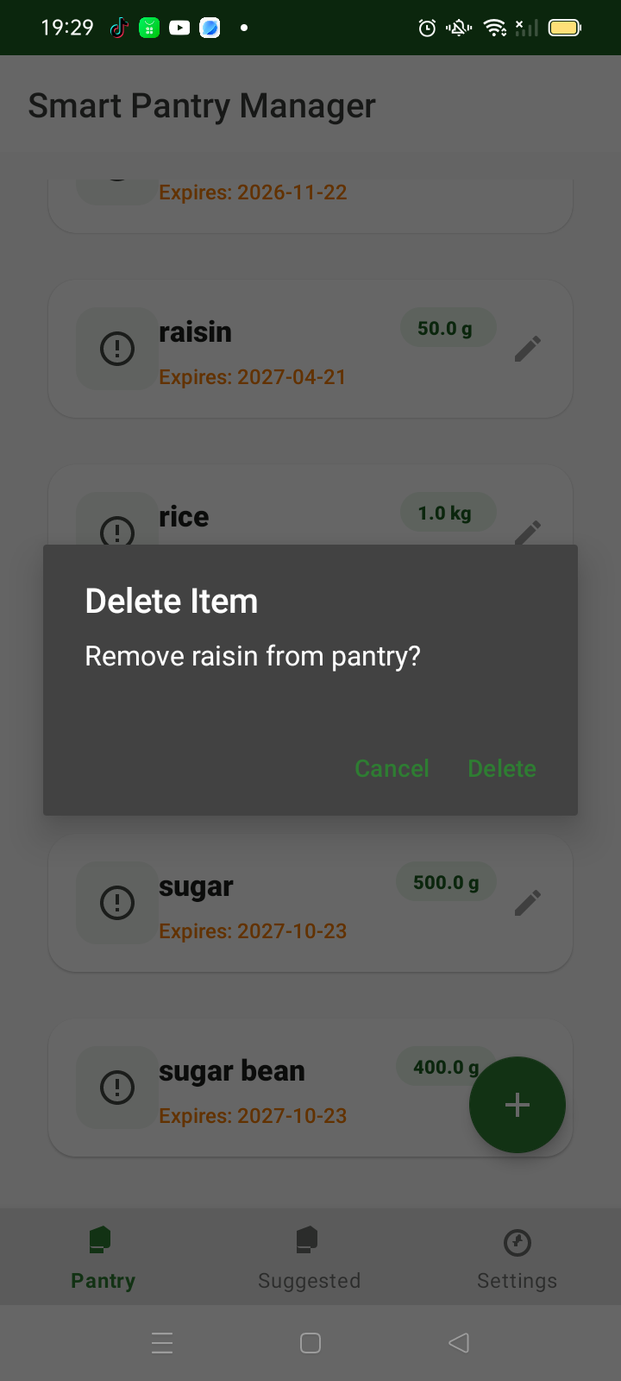
Figure 8: Delete confirmation dialog triggered by a long-press on a pantry item.
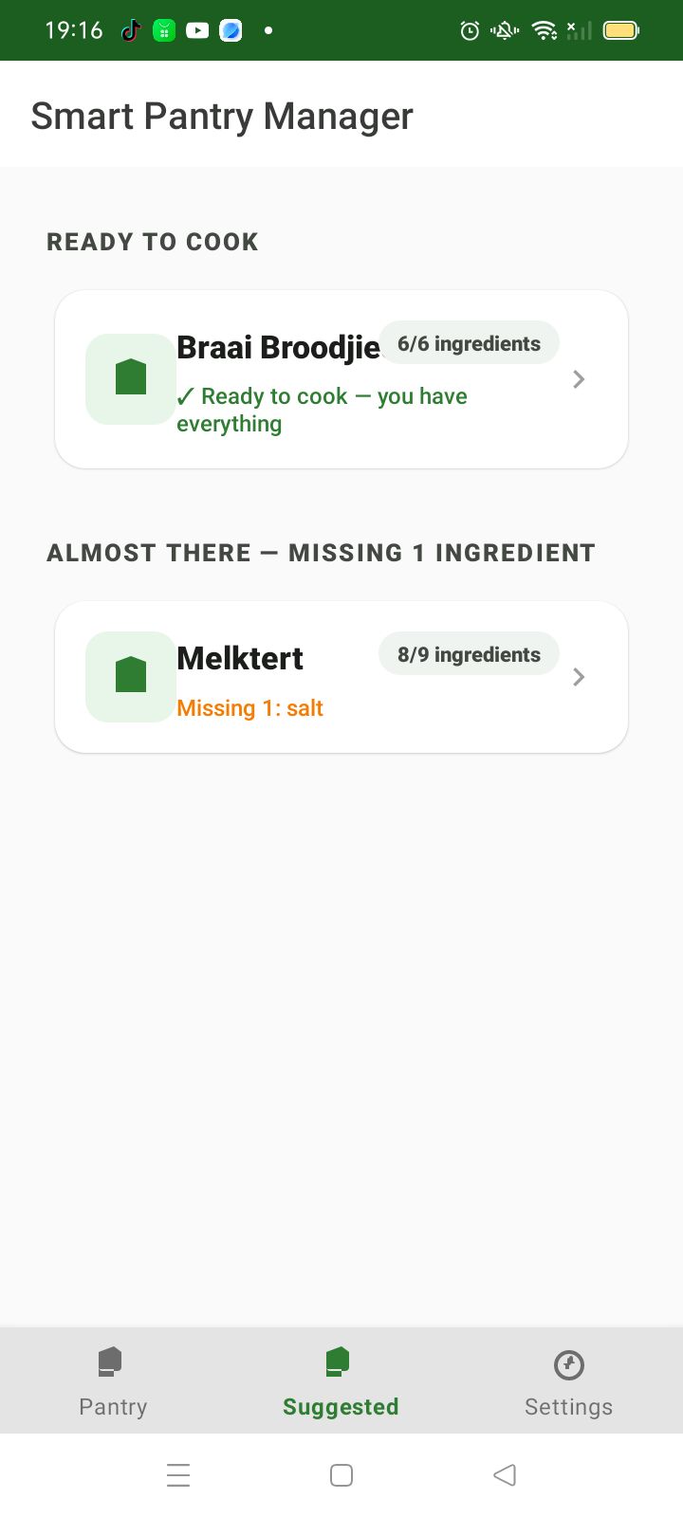
Figure 9: Suggested recipes with the strict 'Ready to Cook' list and the bonus 'Almost There' list.
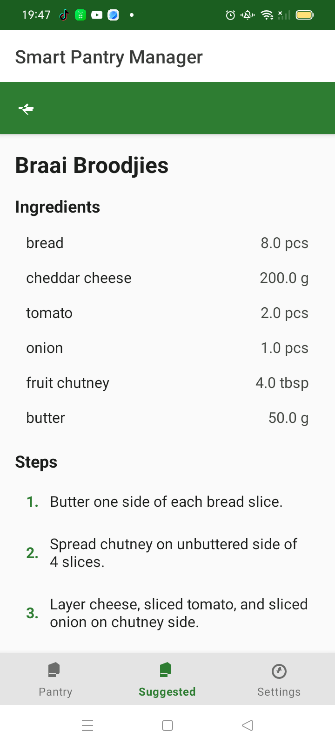
Figure 10: Recipe detail screen showing required ingredients and preparation steps.
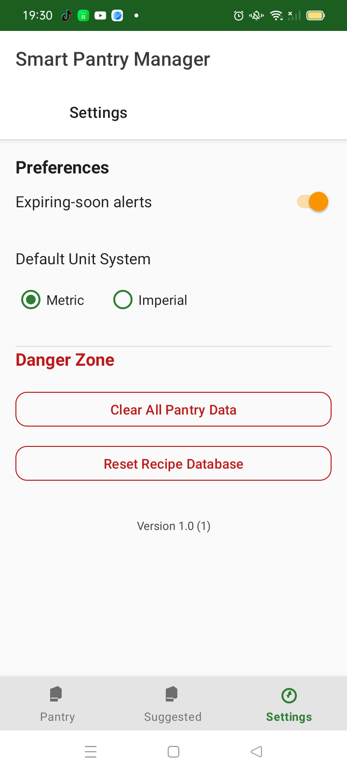
Figure 11: Settings screen.

4. Code Snippets
The following five snippets illustrate the core logic of the application.

4.1 Data Access Object (CRUD)
PantryItemDao.java
@Dao
public interface PantryItemDao {

@Insert(onConflict = OnConflictStrategy.REPLACE)
long insert(PantryItem item);

@Update
int update(PantryItem item);

@Delete
int delete(PantryItem item);

@Query("DELETE FROM pantry_items WHERE id = :itemId")
int deleteById(long itemId);

@Query("SELECT * FROM pantry_items ORDER BY ingredient_name ASC")
LiveData<List<PantryItem>> getAllLive();

@Query("SELECT * FROM pantry_items WHERE id = :itemId")
LiveData<PantryItem> getByIdLive(long itemId);
}

4.2 Strict Ingredient Matching
IngredientMatcher.java
public static MatchResult checkRecipeMatch(Recipe recipe,
List<RecipeIngredient> recipeIngredients,
Map<String, PantryItem> pantryLookup) {

List<String> missing = new ArrayList<>();

for (RecipeIngredient ri : recipeIngredients) {
String normName = normalizeName(ri.ingredientName);
PantryItem pantryItem = pantryLookup.get(normName);

if (pantryItem == null) { // not in pantry at all
missing.add(ri.ingredientName + " (not in pantry)");
continue;
}
if (!areUnitsCompatible(pantryItem.unit, ri.unit)) {
missing.add(ri.ingredientName + " (unit mismatch)");
continue;
}

// Compare in base units (g, ml or pcs)
double haveBase = convertToBaseUnit(pantryItem.quantity, pantryItem.unit);
double needBase = convertToBaseUnit(ri.quantity, ri.unit);

if (haveBase + 1e-9 < needBase) { // epsilon for floating point
missing.add(ri.ingredientName + " (quantity too low)");
}
}

return new MatchResult(recipe.id, missing.isEmpty(),
missing.size(), missing);
}

4.3 Reactive Suggestions with MediatorLiveData
SuggestedViewModel.java
private void setupMediatorLiveData() {
LiveData<List<PantryItem>> pantryLive =
pantryRepository.getAllPantryItems();
LiveData<List<Recipe>> recipesLive =
recipeRepository.getAllRecipes();

// Recompute matches whenever the pantry OR the recipes change
suggestedRecipes.addSource(pantryLive, pantryItems -> {
List<Recipe> recipes = recipesLive.getValue();
if (recipes != null) computeMatchesAsync(pantryItems, recipes);
});
suggestedRecipes.addSource(recipesLive, recipes -> {
List<PantryItem> pantry = pantryLive.getValue();
if (pantry != null) computeMatchesAsync(pantry, recipes);
});
}

// Inside computeMatchesAsync(...) on a background thread:
if (mr.isStrictMatch) {
// MAIN list: strictly matchable recipes only
strictMatches.add(new RecipeWithMatch(r.id, r.name,
totalIng, totalIng, true, 0, mr.missingIngredients));
} else if (mr.missingCount == 1) {
// Bonus list: missing exactly one ingredient
almostMatches.add(new RecipeWithMatch(r.id, r.name,
totalIng, totalIng - 1, false, 1, mr.missingIngredients));
}

4.4 Date Picker (Crash Fix)
AddEditPantryFragment.java
private void showDatePicker() {
// Guard against rapid double-taps showing the picker twice
if (getChildFragmentManager()
.findFragmentByTag(DATE_PICKER_TAG) != null) {
return;
}

// Theming comes from the materialCalendarTheme attribute in the
// app theme (a ThemeOverlay). Passing a full dialog theme to
// setTheme() here crashed layout inflation on some devices.
MaterialDatePicker<Long> picker = MaterialDatePicker.Builder.datePicker()
.setTitleText("Select Expiry Date")
.setSelection(selectedExpiryDate != null
? selectedExpiryDate
: MaterialDatePicker.todayInUtcMilliseconds())
.build();

picker.addOnPositiveButtonClickListener(selection -> {
selectedExpiryDate = selection;
SimpleDateFormat sdf =
new SimpleDateFormat("yyyy-MM-dd", Locale.getDefault());
binding.etExpiryDate.setText(sdf.format(new Date(selection)));
});

picker.show(getChildFragmentManager(), DATE_PICKER_TAG);
}

4.5 Efficient List Updates with DiffUtil
SuggestedAdapter.java
private static final DiffUtil.ItemCallback<ListItem> DIFF_CALLBACK =
new DiffUtil.ItemCallback<ListItem>() {
@Override
public boolean areItemsTheSame(@NonNull ListItem oldItem,
@NonNull ListItem newItem) {
if (oldItem.getType() != newItem.getType()) return false;
if (oldItem instanceof HeaderItem) {
return ((HeaderItem) oldItem).headerType
== ((HeaderItem) newItem).headerType;
}
return ((RecipeItem) oldItem).recipe.recipeId
== ((RecipeItem) newItem).recipe.recipeId;
}

@Override
public boolean areContentsTheSame(@NonNull ListItem oldItem,
@NonNull ListItem newItem) {
RecipeWithMatch a = ((RecipeItem) oldItem).recipe;
RecipeWithMatch b = ((RecipeItem) newItem).recipe;
return a.name.equals(b.name)
&& a.matchedIngredients == b.matchedIngredients
&& a.missingCount == b.missingCount;
}
};

5. Challenges and Solutions

5.1 Date Picker Crash on Theme Conflict
The most severe defect found during testing was a hard crash when tapping the expiry date field. The MaterialDatePicker was being given a full MaterialComponents dialog theme through Builder.setTheme(). On affected devices the picker's internal layout inflated against that theme and threw an InflateException ("You must supply a layout_width attribute"), killing the app. The fix was to stop passing a theme at build time and instead declare a proper ThemeOverlay (ThemeOverlay.MaterialComponents.MaterialCalendar based) under the materialCalendarTheme attribute of the application theme. A fragment-tag guard was also added so rapid double-taps cannot stack two picker dialogs.

5.2 Strict Matching vs Usable Suggestions
The brief requires the main suggestions list to contain only strictly matchable recipes. Early builds showed partial matches mixed into the same list, which both violated the requirement and produced confusing results (a recipe missing three ingredients looked identical to one missing none). The solution was to compute two separate lists in the ViewModel — strict matches and recipes missing exactly one ingredient — and to render them under clearly separated section headers with colour-coded match indicators. The "Almost There" list turned the strict-match limitation into a useful shopping suggestion feature.

5.3 Normalising Names and Units
Pantry entries and recipe ingredients are written by humans in different forms: "Tomatoes" vs "tomato", "1 kg" vs "1000 g", "2 tbsp" vs "30 ml". Matching had to be tolerant of all of these. IngredientMatcher normalises names (lowercase, trim, singularise via a mapping plus simple suffix rules) and converts every quantity to a base unit — grams for mass, millilitres for volume, pieces for count — before comparing. Units of incompatible categories (for example grams vs millilitres) are treated as a mismatch rather than guessed.

5.4 Lifecycle Bugs Behind the Scenes
Two subtler bugs were fixed during the hardening pass. The Add/Edit ViewModel observed a LiveData with observeForever but never removed the observer, leaking the ViewModel; the observer is now removed in onCleared(). In the original Suggested adapter the row click listener was bound in a way that never fired, making recipe detail unreachable; the adapter was rebuilt as a ListAdapter with the listener wired into the ViewHolder.

6. Conclusion and Reflection
The finished application meets the core requirement: given a populated pantry, it reliably lists only the recipes that can be cooked with the ingredients on hand, keeps partial matches out of the main list, and adds a helpful "Almost There" section as a bonus. Full CRUD for pantry items works, with validation, a themed date picker, delete confirmation and an undo snackbar.
The biggest lesson from this project was that framework theming is not cosmetic — an incorrect theme on a single component crashed the entire app, and finding the root cause required reading the Material Components source rather than guessing. The project also reinforced the value of the MVVM pattern: once the pantry, recipes and matching results were modelled as LiveData, features such as the two-section suggestion list and automatic re-matching after every edit fell out naturally. If the project were extended, the next features would be expiry notifications for soon-to-expire items and a barcode scanner for adding pantry items.

7. References
Android Developers (2024) Room persistence library. Available at: https://developer.android.com/training/data-storage/room (Accessed: 23 October 2026).
Android Developers (2024) LiveData overview. Available at: https://developer.android.com/topic/libraries/architecture/livedata (Accessed: 23 October 2026).
Android Developers (2024) RecyclerView. Available at: https://developer.android.com/develop/ui/views/layout/recyclerview (Accessed: 23 October 2026).
Material Design (2024) Material Components for Android: Date picker. Available at: https://github.com/material-components/material-components-android (Accessed: 23 October 2026).
GitHub (2026) Smart Pantry Manager – source repository. Available at: https://github.com/Naughtyboy25/Smart-Pantry-Mobile (Accessed: 23 October 2026).

