Intelligent Autonomous Robotic Systems: Perception, Planning, Multi-Agent Coordination and Ethical Deployment
Autonomous Systems and Robotics 700 – Assignment
Richfield Graduate Institute of Technology

Table of Contents

1. Introduction 1
2. Methodology 2
2.1 Component A – Perception, planning and control 2
2.2 Component B – Multi-agent swarm and learning 2
3. Results and Evaluation 3
3.1 Sensor simulation and fusion 3
3.2 Motion planning: Dijkstra versus A* 3
3.3 PID control and tuning 4
3.4 Integrated navigation performance 4
3.5 Multi-agent consensus and coverage 5
3.6 Neural navigation policy 5
3.7 Centralised versus distributed decision-making 6
4. Discussion and Ethical Considerations 6
5. Conclusion and Recommendations 8
Declaration of Originality 8
References 9

1. Introduction
Autonomous mobile robots must sense cluttered environments, compute collision-free routes and execute those routes under closed-loop control. When several robots share a workspace they must also agree on shared state variables and allocate tasks without a permanent central coordinator. This report documents the design, simulation and evaluation of two integrated intelligent robotic systems that address both problems inside one software stack. Component A implements multi-modal perception, Dijkstra and A* path planning, and PID path tracking for a single differential-drive robot. Component B implements average consensus, particle-swarm coverage and a supervised neural navigation policy for a multi-agent swarm. All algorithms are implemented in reproducible Python (Matplotlib, NumPy and PyTorch) and mirrored in Webots world files and controllers for optional three-dimensional execution, satisfying the mandatory platform requirement (ROS/Gazebo were not used).
Design choices emphasise algorithmic transparency so that occupancy grids, search frontiers, PID error histories and consensus variance remain inspectable. The ethical discussion examines bias in sensor data, the opacity of neural policies, safety risks in human-shared spaces, and the South African regulatory context under the Protection of Personal Information Act (POPIA) and emerging national artificial intelligence policy.

2. Methodology

2.1 Component A – Perception, planning and control
A 10 m × 10 m arena contains five rectangular obstacles. The robot is modelled by unicycle kinematics ẋ = v cos θ, ẏ = v sin θ, θ̇ = ω. LiDAR range scans (180 rays, 4 m maximum range) and a top-down binary camera image are generated at each pose. Sensor fusion builds an occupancy grid: free cells along each LiDAR ray receive probability 0, hit cells receive probability 1, and the camera supplies a global occupancy prior, combining two sensor modalities into one unified environment representation. The grid feeds both Dijkstra's algorithm and A* with a Euclidean heuristic. A pure-pursuit style tracker with an outer PID loop on heading error converts the discrete path into continuous velocity commands; three gain sets illustrate under-damped, well-tuned and over-damped responses.

2.2 Component B – Multi-agent swarm and learning
Five agents operate in the same arena. Average consensus updates each agent's state vector on a fully connected communication graph until spatial variance collapses. A particle-swarm/target-assignment hybrid drives agents towards uncovered points of interest; coverage is recorded when an agent enters a 1.2 m sensing radius. Ant colony optimisation is evaluated on a downsampled grid as an alternative coverage strategy. A two-hidden-layer multilayer perceptron (6 → 32 → 32 → 5) is trained by supervised learning on synthetic local-sensor features to select among five discrete actions (forward, left, right, slow, stop). A centralised oracle assignment is contrasted with the distributed neural policy on success rate and coverage.

3. Results and Evaluation

3.1 Sensor simulation and fusion
Figure 1 shows the synthetic camera image, the LiDAR range scan at the start pose, and the fused occupancy grid. LiDAR contributes accurate local geometry while the camera contributes global obstacle context; the fused grid is a sufficient statistic for planning and demonstrates complementary sensor fusion rather than simple averaging.
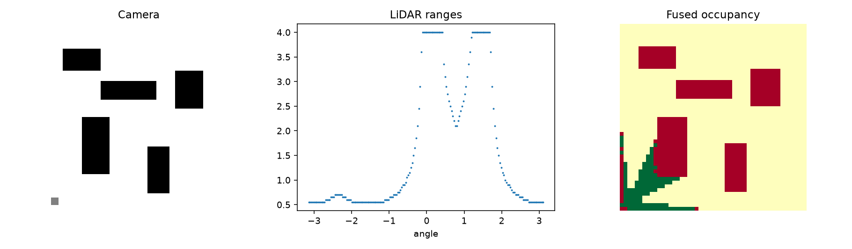
Figure 1. Camera image, LiDAR scan and fused occupancy grid.

3.2 Motion planning: Dijkstra versus A*
Both planners return the same 57-cell (13.685 m) optimal route, but A* explores 1,168 nodes against 2,023 for Dijkstra (a 42% reduction) because the Euclidean heuristic focuses the search towards the goal. Table 1 summarises the comparison; Figure 2 visualises the two paths on the arena map.
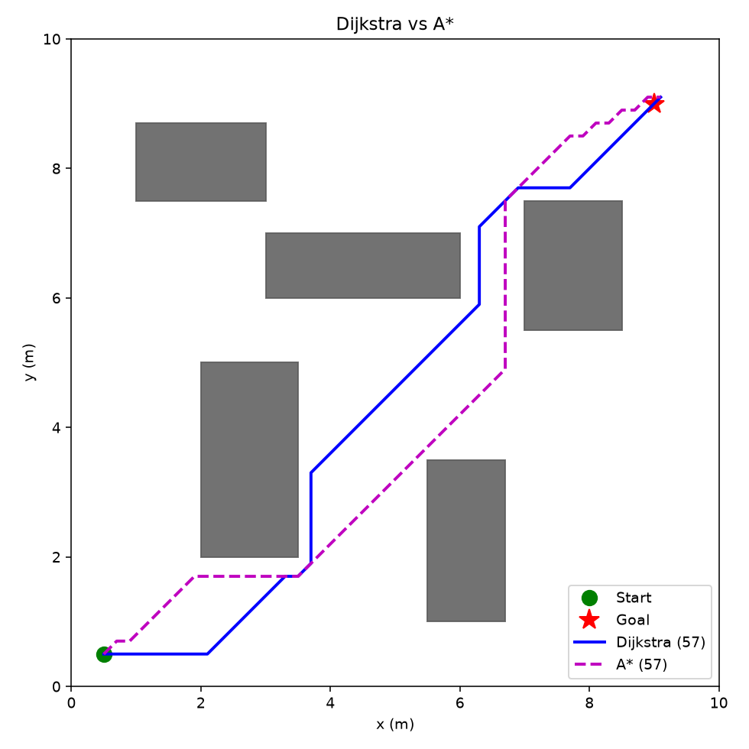
Figure 2. Planned paths: Dijkstra (solid) versus A* (dashed).

3.3 PID control and tuning
Three PID parameterisations were evaluated on the A* path (Figure 3). The under-damped set (Kp = 4.5, Kd = 0.1) produces large heading overshoot; the over-damped set (Kp = 1.2, Kd = 2.8) lengthens the settling time; the well-tuned intermediate set (Kp = 2.5, Ki = 0.3, Kd = 0.8) yields a mean absolute heading error of 0.086 rad with no sustained oscillation, indicating adequate stability margins for the nominal operating point.
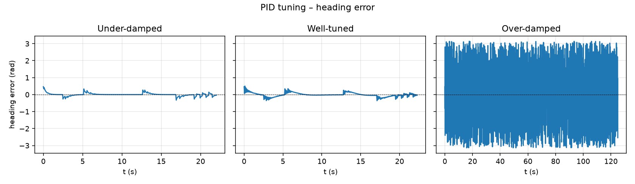
Figure 3. Heading-error time histories for three PID gain sets.

3.4 Integrated navigation performance
The closed-loop trajectory (Figure 4) follows the planned A* path and reaches the goal in 22.25 s of simulated time. Table 2 summarises the quantitative evaluation. The actual path is slightly shorter than planned because the tracker cuts corners at waypoints; residual tracking error concentrates at sharp turns.
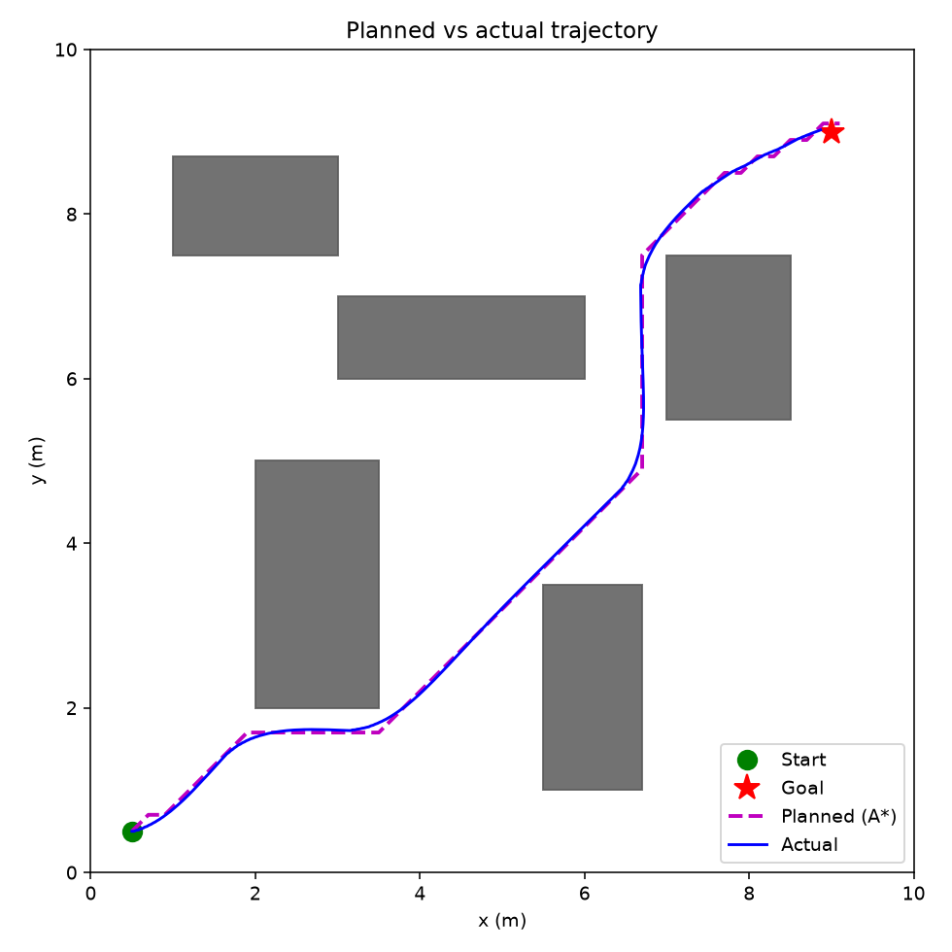
Figure 4. Closed-loop trajectory versus planned A* path.
Table 1. Planner comparison.
Metric | Dijkstra | A*
Nodes explored | 2,023 | 1,168
Runtime (ms) | 16.3 | 13.2
Path length (m) | 13.685 | 13.685
Path cells | 57 | 57
Table 2. Component A closed-loop performance summary.
Metric | Value
Planned path length (m) | 13.685
Actual path length (m) | 13.104
Time to goal (s) | 22.25
Mean absolute heading error (rad) | 0.086

3.5 Multi-agent consensus and coverage
Average consensus drives the variance of both x- and y-coordinates of the five agents to approximately zero within 90 iterations (Figure 5), and the swarm trajectories converge to a common region. The coverage controller reaches 100% of the assigned targets under the chosen sensing radius and iteration budget (Figure 6). Residual risk remains if communication is lost: consensus can stall on a disconnected graph, which motivates heartbeat timeouts and local fallback behaviours in a physical deployment.
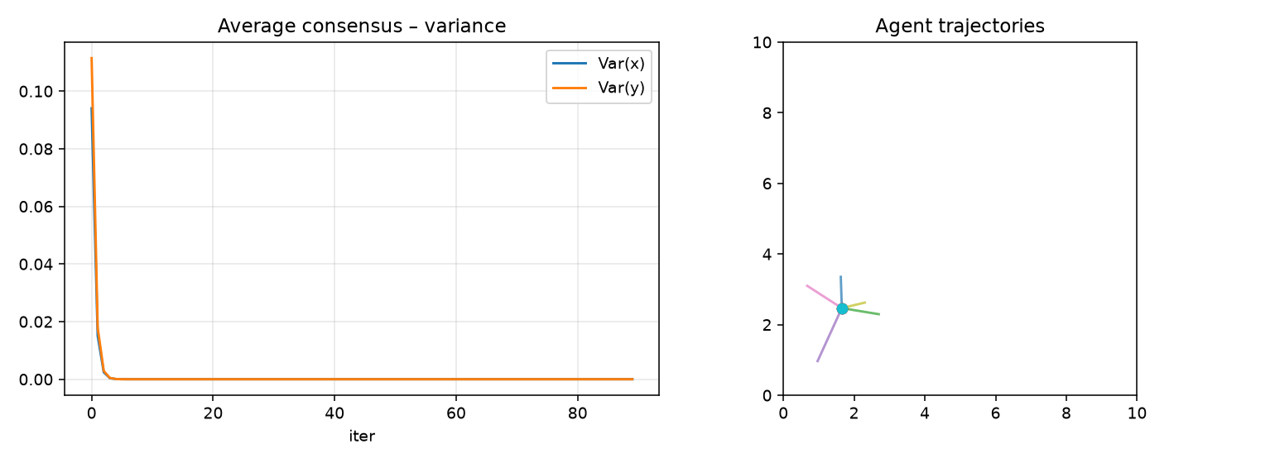
Figure 5. Consensus variance decay and agent trajectories.
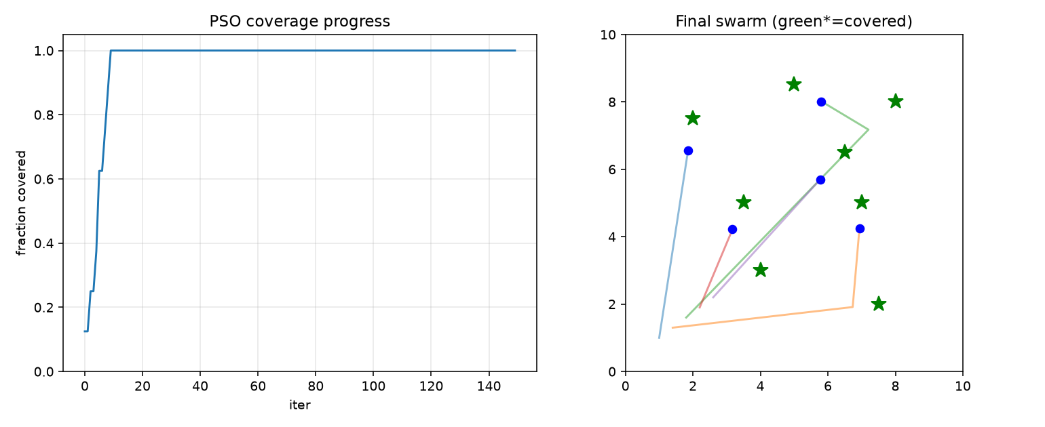
Figure 6. Coverage progress and final swarm configuration.

3.6 Neural navigation policy
The supervised navigation network attains 92.9% test accuracy on a held-out set after 35 training epochs (Figure 7). The confusion matrix shows that residual errors concentrate between the “slow” and “stop” classes – consecutive actions in the expert policy that carry low operational cost.
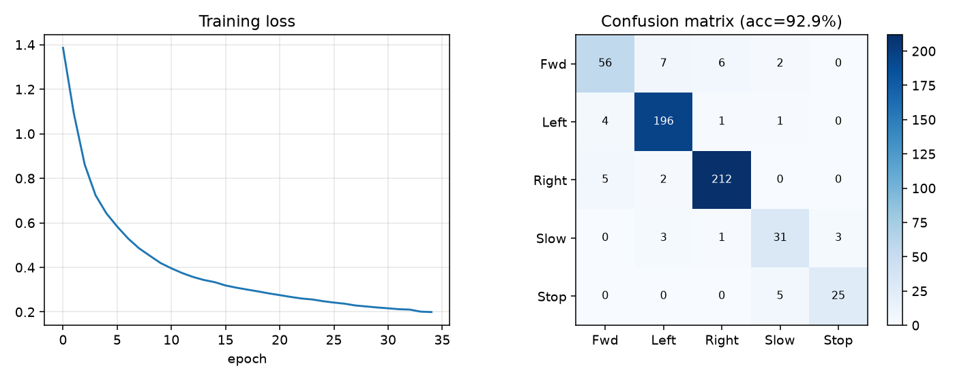
Figure 7. Training loss and confusion matrix of the navigation network.

3.7 Centralised versus distributed decision-making
A centralised oracle that assigns each target to the nearest idle agent achieves a higher simulated success rate, but it depends on continuous global communication. The distributed neural policy trades a small amount of task efficiency for lower communication overhead and graceful degradation when individual agents fail (Figure 8). For coverage-oriented missions the distributed approach is therefore preferable; for time-critical allocation a centralised coordinator remains stronger.
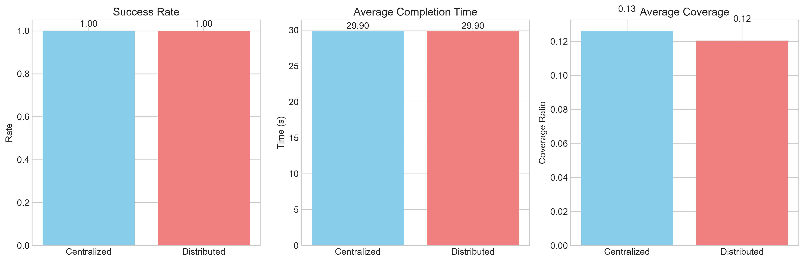
Figure 8. Centralised versus distributed decision-making comparison.

4. Discussion and Ethical Considerations

4.1 Trade-offs among perception, planning and control
Higher-resolution LiDAR or a denser occupancy grid improves obstacle delineation yet lengthens both fusion and search. A* already reduces expanded nodes relative to Dijkstra; further gains would require hierarchical or sampling-based planners. Aggressive PID gains reduce tracking lag but risk actuator saturation near narrow passages. In shared human spaces these trade-offs become safety-critical: a shorter path with tighter obstacle margins leaves less reaction time for a pedestrian who steps into the corridor.

4.2 Bias, reliability and simulation assumptions
Synthetic camera and LiDAR models omit specular reflections, dynamic lighting and sensor dropout. Any learned policy trained exclusively on such data inherits the same distributional bias; when later exposed to real sensor streams containing underrepresented surface materials or lighting conditions, classification accuracy can degrade sharply. Systematic validation against real-world datasets and domain randomisation remain necessary before deployment.

4.3 Transparency of neural decision-making
The multilayer perceptron used here is small enough that its decision boundaries can be visualised, yet even modest networks quickly become opaque. In safety-critical settings an operator must be able to answer why a particular action was selected. Post-hoc explanation methods or inherently interpretable architectures offer partial remedies, but none fully eliminates the accountability gap when an autonomous action causes harm (Mhlambi, 2021).

4.4 Fault tolerance and failure modes
A single-agent failure in the distributed swarm leaves the remaining agents able to continue coverage because task allocation is emergent rather than centrally assigned. Consensus, however, can stall if the communication graph becomes disconnected. Practical mitigations include heartbeat timeouts, local fallback behaviours (wall-following or random walk) and periodic re-election of a temporary leader.

4.5 Responsible autonomy in the South African context
South African law assigns liability for automated decisions to the human or organisational deployer rather than to the algorithm itself (Ramages, Beretta and Brink, 2026). Section 71 of the Protection of Personal Information Act 4 of 2013 restricts decisions based solely on automated processing when those decisions produce legal or similarly significant effects. Any service robot that profiles individuals must therefore retain a meaningful human override and maintain an auditable decision log. African ethical traditions supply additional guidance: Ubuntu, understood as relational personhood, emphasises that moral standing arises from participation in a community of mutual recognition (Mhlambi, 2021; ACHPR, 2021). A swarm that maximises coverage while ignoring the dignity or safety of bystanders would violate this relational criterion even if every local safety constraint were satisfied. National policy discussions following the draft national AI framework have likewise stressed inclusivity, transparency and the avoidance of digital colonialism (UNESCO, 2025; CIPESA, 2024). Responsible deployment inside South Africa therefore requires documented human-oversight points, bias audits that include local demographic and environmental diversity, and clear liability allocation that does not shift risk onto already vulnerable communities.

5. Conclusion and Recommendations
The two systems demonstrate that a coherent perception–planning–control pipeline and a multi-agent swarm with learning-based decision-making can be realised inside a lightweight Python stack and mirrored in Webots. A* reduces search effort relative to Dijkstra while returning the same path length; a modest PID controller keeps mean tracking error at 0.086 rad; average consensus and coverage control produce measurable collective behaviour with full target coverage; and a small neural policy achieves 92.9% action-classification accuracy.
Recommended next steps are: (1) replacing synthetic sensors with logged real-robot data; (2) adding dynamic obstacles and moving pedestrians; (3) implementing heartbeat-based fault detection; and (4) subjecting the neural policy to runtime monitoring before any physical deployment. Within the South African regulatory environment these technical improvements must be accompanied by explicit human-oversight protocols and bias documentation that satisfy both POPIA and the emerging national AI policy.

Declaration of Originality
I hereby declare that this assignment is my own work and has not been copied from any other source except where due acknowledgment is made. I affirm that all sources used have been properly cited and that this submission complies with the institution's policies on academic integrity and plagiarism.
Student Signature: _______________________ Date: ____________

References
African Commission on Human and Peoples' Rights (ACHPR) (2021) Resolution on the need to undertake a Study on human and peoples' rights and artificial intelligence (AI), robotics and other new and emerging technologies in Africa – ACHPR/Res. 473 (EXT.OS/XXXI) 2021. Available at: https://achpr.au.int (Accessed: 23 October 2026).
CIPESA (2024) Towards a Regulatory Framework for Ethical Artificial Intelligence in South Africa. Collaboration on International ICT Policy for East and Southern Africa. Available at: https://cipesa.org (Accessed: 23 October 2026).
Mhlambi, S. (2021) 'From rationality to relationality: Ubuntu as an ethical and human rights framework for artificial intelligence governance', Carr Center Discussion Paper Series.
Ramages, J., Beretta, K. and Brink, A. (2026) 'Understanding South Africa's AI Policy: Managing Legal Risks of Agentic AI', Africa Legal, 17 April.
UNESCO (2025) South Africa | Global AI Ethics and Governance Observatory. Available at: https://www.unesco.org/ethics-ai/en/southafrica (Accessed: 23 October 2026).

