Q. As agreed with you, in the below code for soil moisture sensor, the values 550,0 is dependent on several factors and may have to be changed depending on the environment, type of soil etc. Hence, I would like this value to be fetched from the website instead of hardcoding. int sensor_pin = 2; int value; void setupSoilMoisture() { } String getSoilMoisture() { value = analogRead(sensor_pin); value = map(value, 550, 0, 0, 100); Serial.print("Moisture : "); Serial.print(value); Serial.println("%"); delay(10); return String(value); }

A: Sure, we can work on that.

Waiting for the update. Please confirm how, and when we can have it done

Working on that, will need sometime.

Need time on this will be done with relay control part.

Q. How can I add my logo in the mobile app (Also in the WebApp)

A: You should have provided the logos at the start of the project. The whole project now

needs to be recompiled with new logos in order to change them,

Can you send me the code and all raw files, I will have someone do it for me.

Already shared everything including complete source code. Everything can be found here

<https://github.com/Nauman3S/SmartAgri>

Are the files ready to be compiled and create the apk? What software do you use to compile?

APK file is already created and delivered and it is ready to be used without compilation. You can edit it with Android Studio.

Q. Now devices in the website are represented by Mac addresses. Can we add a name

for each Mac address? If a user has more than one device, it is difficult to identify with Mac

address

A: yes it is possible but it will require modifications both in the backend and frontend.

Will you be doing this?

Sure, we can do this but will charge for this feature as there are many modifications

required.

How much is the charge for this?

$150(Changes required in the frontend, backend and the database)

Q. Please add date / time in the table and date in chart also as the time of reading

cannot be identified from the current table.

A: Updating it

Thanks.. waiting

Updated

It shows too much information like “Tue Nov 23 2021 09:01:22 GMT+0000 (Coordinated Universal Time)” I only need the Date the time. Also, can the date and time show based on user time zone?

Need modifications for that. I can put a single timezone but editable timezone will require a number of changes. I will charge $200 for it.

Q. There is one more point I missed, which we agreed in the preliminary document.. how can I control valves, actuators etc via webapp? Attached screenshot of preliminary document.. I would like to have an output pin in the ES32 go HIGH when the value goes above or below a set value

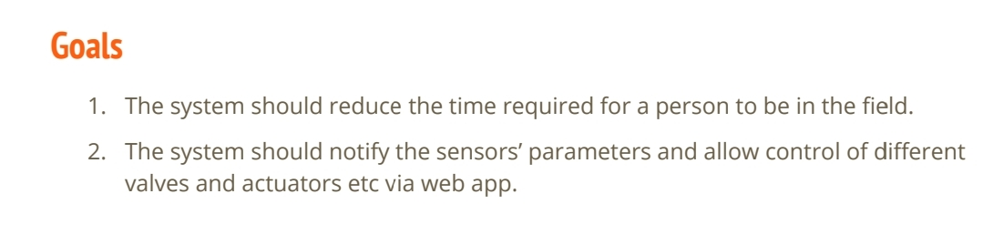

Awaiting Update

Need time on this.

Q. Now the values in the chart is reverse..

The latest reading is towards the left side.. ideally chart should update new values to the right..

Awaiting Update

Already updated Clear your browser cache so that you can see the new changes. Ref <https://support.google.com/accounts/answer/32050?hl=en&co=GENIE.Platform%3DDesktop>

Comment from chat: Moreover, I have talked to my team and we can make the dashbaord much better without getting PRO version of the dashbaord.

We will provide

-Updated user dashbaord with main page, charts page, graphs page, devices page(online/offline status)

-An admin panel for you using which you can change the logo, add or remove the users, see all the user's list

Are you working on this?

No, it is a time consuming task and we will charge $600 for refactoring the dashboard and creating an admin panel for changing timezones and updating the logos etc.